Manual for the Pharmacokinetics Program

PCModfit (with Several Examples)

**Version 7.8**

**Graham D. Allen**

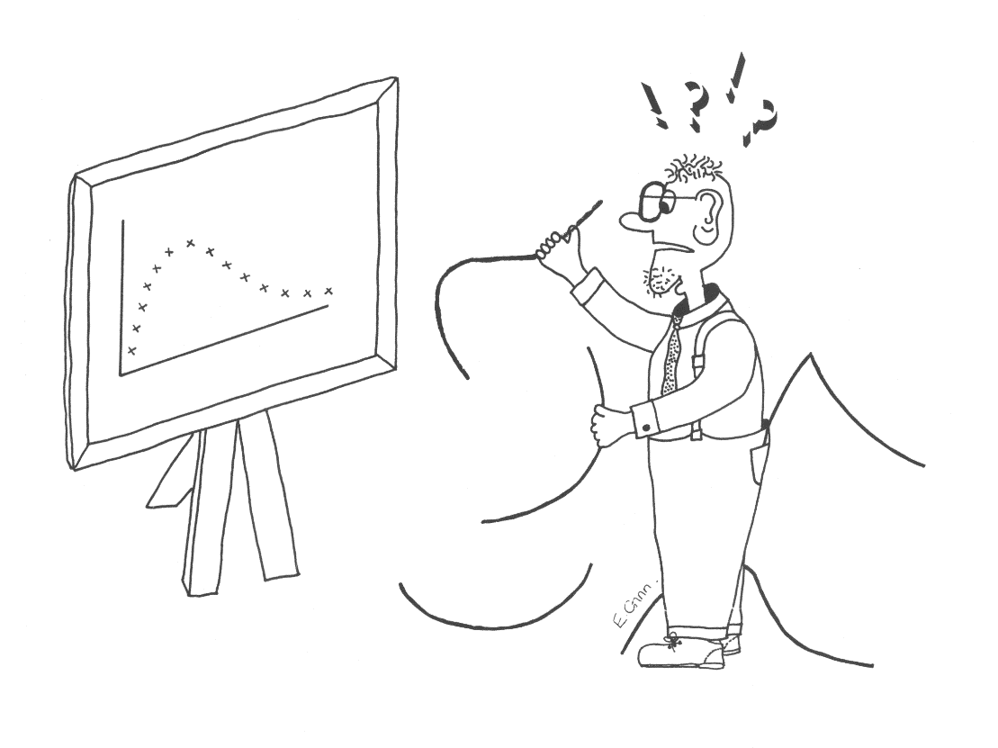

**Update history is detailed further, as version summaries which are shown in Section 8, p. 126.**

**Latest**

**Version 7.8 (1st September 2023)**

The Non-Compartmental module (NCA) has been further updated in V7.8. There was a minor anomaly in earlier versions, which was noticed by a very astute user, in the NCA graphs only (Dr Tony Jarman from Category 1 Pharma Consulting Pty Ltd Australia) wherein; the λz value was shown as a minus value when it should have been positive. None of the numerical results were affected but just the sign of λz values on the graphs! The numerical examples in all sections (including NCA) of the manual have been re-analysed using V7.8 and yield the correct results.

**Version 7.7 (1st March 2023)**

Compartmental modelling has been further updated. Using option ‘Mixed models’, profiles containing no i.v. models but oral models only (mixing with and without lag-time dosing) can now be analysed. This may be useful when for example, when oral doses are administered alternately, with and without a lag-time. There are example data sets on p. 105 and p. 108 to demonstrate that this option is working and yields the correct answer. As long as the number of compartments remain the same, this will work for 1, 2 and 3-compartment oral models. The λn values are also calculated as for the other possible Mixed models.

The subtitles for each profile can now contain spaces as previous versions sometimes got muddled with these. They have also been expanded to 30 characters/profile whereas previous versions only allowed for 20.

All of the examples in the Modelling sections of the manual have been re-analysed using V7.7 and yield the correct results.

**Version 7.6 (1st February 2023)**

Compartmental modelling has been further upgraded. In the results summary Excel file, the lambda values (λ1, λ2 and λ3 for relevant compartmental models) are now calculated, being generated from the rate constants k12, k21 etc., as this was requested by several users (example on p.102). This applies to Single, Repeat and Mixed model dosing. Further testing for all fitting options (Single, Repeat and Mixed) has been expedited and some minor bugs when clicking the ‘Keywords’ button have been corrected. A couple of users experienced an ‘out of memory’ message when the Modelling summary file was generated in V7.5. In the ‘Fitting Options Selected’ details, which was added as a helpful reminder for the settings used in a particular run, the size of picture was apparently the culprit. This has now been fixed by using a different and more efficient method. It has been tested on several computers with no further warning or error messages. The Modelling Summary output file now has the file names of the pictures generated from a run which are detailed at the top of the Excel file at the request of several users. The same addition is also added to the NCA module as a complete record. The ‘Stats’ spreadsheet for CI’s etc. has been expanded to allow for up to 100 values (previous versions only allowed for 50).

**Version 7.5 (1st January 2023)**

Compartmental modelling has been significantly upgraded as described in Section 4 of this new manual. This is a new option, and examples are included to demonstrate its validity. The program now permits data to be fitted from a combination of i.v. bolus, infusion, and oral dosing regimens in any sequence and with varying doses and intervals. Several users have requested this facility wherein; a repeat dose profile may comprise, for example, a bolus and infusion followed by oral maintenance dosing with different doses and intervals. This can now be accomplished easily as help is given, in more detail, within the Modelling spreadsheet and the setup procedure has been completely reworked to make life easier for all modelling options. The new Fitting Options section, shown below for information, with more explanation in Section 4. Note that the user must enter the number of profiles and the number of doses prior to clicking ‘Keywords’ to setup the layout. The new option for ‘Mixed models’ is shown under ‘Profile type’ if required.



In addition to the upgrades above, the modelling output, which is automatically generated as an Excel file, now has more information added including the ‘Fitting Options’ choices used, and the cells where Doses, Parameters, Titles etc. are added as a complete record should the user wish to access these as a reminder. Also, after completion of a Fitting run (when the ‘Next’ button is clicked) the names of the Plot files are sent to the end of the Summary file as well, for completeness. It is no longer necessary to highlight the cells in the Keywords area for the setup section or for the time-concentration data. The parameter labels that were previously erased (‘User estimates’ selected) when ‘Activate’ was clicked are now retained in the Sheet and sent to the Summary file, at the request of several users.

**Version 7.4 (1st October 2022)**

PCModfit V7.4 with updates from previous versions is now released (still runs on 32 or 64-bit PC computers). The NCA module has been upgraded so the user can now have up to 100 profiles with 1000 points in each (previously 100) as some users requested this update. There is now a red ‘Cancel’ button in the NCA spreadsheet to stop a run at any point during analysis (also a request from a couple of users) which is useful if there are many profiles, and the user decides to abort the run for whatever the reason.

Modelling has been updated so that the Summary Excel file that now opens automatically after a completed run now specifies the parameter names instead of just numbers e.g., Parameters 1, 2, 3, 4 etc. becomes Parameters V1, k12, k21 k10 etc. In addition, the Summary file now contains individual profile data and the fitted data at the same time points with %Differences so users don’t have to manipulate text files (this was often bothersome for some users). The fitted parameters and errors together with brief statistics, if more than one profile is analysed, are still displayed. The summary file is often used as a tracking mechanism as it shows the date, time and records the fitting information (algorithm, weighting etc.) used for a particular run.

**Program PCModfit Copyright © GD Allen 1990-2023**

**Original publication reference: GD Allen 'Modfit: a pharmacokinetics computer program', Biopharm. & Drug Disp., Vol. 11, 477-498, 1990.**

**Secure Website:** [**https://www.pcmodfit.co.uk/**](https://www.pcmodfit.co.uk/) **Forum;** [**https://www.pcmodfit.co.uk/forum/index.php**](https://www.pcmodfit.co.uk/forum/index.php)

**Author E-mail: graham.allen@pcmodfit.co.uk**

**Contents**

1. Copyright notices (program, documentation etc.) 6

2. Brief overview 7

Figure 1: PCModfit available spreadsheet tabs. 7

3. Available facilities (detailed) 8

3.1 Non-compartmental analysis (NCA) 8

Figure 2: Options for NCA. 8

Figure 3: Data layout options in Excel® NCA spreadsheet. 8

Figure 4: Data layout options in Excel® NCA spreadsheet. 9

Figure 5: Points selected in the 1st profile for NCA. 9

Figure 6: Points selected in the 1st profile for NCA (note extra values chosen). 10

Figure 7: Example NCA results in the created Excel file and the NCA spreadsheet. 11

3.2 NCA from V6.9 onwards (bolus intercept and handling zero values) 12

Figure 8: Bolus i.v. profile (first 3-points) to estimate C0 value. 12

Figure 9: Use of zero concentration values in oral dosing profiles. 13

Figure 10: ‘Stats’ spreadsheet containing data (left) and example output (right). 14

3.3 Single Dose (SD) Simulator 15

3.3.1 Using built in explicit models. 15

Figure 11: Example SD simulation input/output (4 profiles, 1-compt oral, 1 with lag-time) 15

Figure 12: Example SD simulation graphic output from Figure 11 data 16

Figure 13: Example SD simulation (4 profiles, 3-compt infusions over 5 to 20 h) 16

Figure 14: Example SD simulation graphic output from Figure 13 data 17

Figure 15: Calculator for getting λn values from k12. k21 etc. and the reverse 17

3.3.2 User defined ‘Differential Equation’ models (SD simulations) 18

Figure 16: Pictorial example of a 3-compartment infusion model 18

Figure 17: Example setup using a 3-compartment infusion model 19

Figure 18: Output from a 3-compartment infusion model simulation 19

Figure 19: Graphics output from a 3-compartment infusion model simulation 20

Figure 20: Run time Window displaying the user’s equations and variables 20

3.4 Repeat Dose (RD) Simulator 21

3.4.1 Using built in explicit models 21

Figure 21: Simulation RD (10 doses 1-compt oral) 2 Subjects: 1 same dose and different dose. 21

Figure 22: Example RD simulation concentration output 22

Figure 23: Example RD simulation graphic output 22

Figure 24: Simulation (2-compt. model; bolus+infusion then oral) for 2 Subjects (input). 23

Figure 25: Simulation (2-compt. model; bolus+infusion then oral) for 2 Subjects (output). 23

Figure 26: Simulation (2-compt. model; bolus+infusion then oral) for 2 Subjects (output graphics) 24

3.4.2 User defined ‘Differential Equation’ models (RD simulations) 25

Figure 27: Symbols used in the 2-compartment model equations (bolus, infusion and oral) 25

Figure 28: Pictorial example of a 2-compartment bolus model 25

Figure 29: Equations for a 2-compartment bolus model 25

Figure 30: Pictorial example of a 2-compartment infusion model 26

Figure 31: Equations for a 2-compartment infusion model 26

Figure 32: Pictorial example of a 2-compartment oral model 26

Figure 33: Equations for a 2-compartment oral model 26

Figure 34: Spreadsheet information required for Step 1 of the simulation 27

Figure 35: Screen clip from spreadsheet detailing some values for the current simulation 27

Figure 36: Screen clip from spreadsheet detailing parameter values for the current simulation 28

Figure 37: Screen clip from spreadsheet detailing C0 values for the current simulation 28

Figure 38: Screen clip from spreadsheet detailing Volume values for the current simulation 28

Figure 39: Message showing no errors were found after Initialisation 29

Figure 40: Screen clip from spreadsheet showing ‘Initialise’ and ‘Run’ buttons 29

Figure 41: Simulation result graphic for compartment 1 30

Figure 42: Simulation result graphic for all 3-compartments 30

Figure 43: Numerical results from the bolus + infusion followed by oral maintenance simulation 31

3.5 Superposition option 32

Figure 44: Example 1 - input data (time, concentrations, intervals and no. of doses etc.) 33

Figure 45: Output graphics from Example 1 simulation (10 doses) 33

Figure 46: Results showing Cmin and Cmax in addition to AUC0-τ for all doses (Example 1) 34

Figure 47: Example 2 setup parameters showing different doses and intervals. 35

Figure 48: Output graphics from Example 2 simulation (different doses and intervals) 36

3.6 Deconvolution 37

Figure 49: Example profiles of oral data for Deconvolution analysis (parameters included) 38

Figure 50: PCModfit input for a 2-compt. model data set (with NCA results for estimating AUC0-∞) 39

Figure 51: Example LR analysis (input and options) 40

Figure 52: Example graphic output (% Absorbed) for 2-compartment oral data 40

Figure 53: Both types of Deconvoluted results from 1, 2 and 3-compartment oral data (1 % cut off) 41

Figure 54: Deconvoluted graphic results from 1, 2 and 3-compartment oral data (1 % cut off) 41

Figure 55: Results of ka estimates from %Absorbed and %Remaining data 42

3.7 Time above an MIC option 43

Figure 56: Example time-concentration data (ng/mL) sets used for analysis (n=7) 43

Figure 57: Time and exposure results and graph 44

3.8 Compartmental analysis (principles and modelling data) 45

3.8.1 Control data set up and initialisation 46

Figure 58: Keyword information for Control parameters (user options) 47

Figure 59: Examples of Control layout for various models using single a dose 48

Figure 60: Examples of Control layout for repeat dose scenarios 49

3.8.2 Concentration-time data layout for modelling 49

Figure 61: Concentration-time data layout for modelling (two options) 49

Figure 62: Data layout for analysing more than 1 profile in a single run. 50

3.9 Compartmental analysis (Example data and results) 52

3.9.1 3-exponential i.v. bolus repeat dose (Model 6). 52

3.9.2 1-Compt. bolus (Model 11) 54

3.9.3 2-Compt. bolus (Model 12) 56

3.9.4 3-Compt. bolus (Model 13) 58

3.9.5 1-Compt. infusion (Model 15) 60

3.9.6 2-Compt. infusion (Model 17) 62

3.9.7 3-Compt. infusion (Model 19, using V7.6 onwards) 64

3.9.8 1-Compt. infusion + bolus (Model 14) 66

3.9.9 2-Compt. infusion + bolus (Model 16) 68

3.9.10 3-Compt. infusion + bolus (Model 18) 70

3.9.11 1-Compt. oral (Model 8) 72

3.9.12 1-Compt. oral with lag-time (Model 7) 74

3.9.13 2-Compt. oral (Model 10) 76

3.9.14 2-Compt. oral with lag-time (Model 9) 78

3.9.15 3-Compt. oral (Model 43) 80

3.9.16 3-Compt. oral with lag-time (Model 42) 82

3.9.17 Repeat dose infusion, varying rate, time, & interval (Model 17: 2-Compt., V7.7) 84

3.9.18 Repeat dose infusion, varying rate, time, & interval (with constraints, V7.7) 86

3.9.19 Repeat dose oral, varying dose and interval (Model 10: 2-Compt.) 88

3.9.20 IVIVC using published data. RD i.v., varying dose and interval. 90

4. Compartmental analysis using Mixed inputs (i.v. and oral) 92

4.1 Introduction 92

4.2 Examples 93

4.2.1 2-compartment bolus + infusion followed by oral maintenance (varying doses and intervals) 93

4.2.2 1-compartment bolus + infusion, oral (lag), bolus, oral (lag) then bolus + infusion (V7.6) 96

4.2.3 3-compartment bolus + infusion followed by oral maintenance (varying doses and intervals) 99

4.2.4 2-compt. bolus + infusion followed by oral maintenance V7.6, varying dose, and interval. 102

4.2.5 2-compt. Oral, varying with and without lag-time models and doses and intervals. 105

4.2.6 3-compartment oral with and without lag-time (varying doses and intervals, V7.7) 108

5. Models and symbols 111

6 Appendix 1 (Modelling Approaches) 113

7 Appendix 2 (creating differential equations from models) 124

8 Brief history updates 126

9 A few words about the author 130

10 Brief list of publications referencing PCModfit 130

11 Symbols used throughout document 136

# Copyright notices (program, documentation etc.)

**PCModfit**

Technical Documentation, System Design, Equation Derivation and Programming:

Created by Graham D. Allen

Please read the manual carefully before using PCModfit.

Information in this document is subject to change without notice. Companies, names and data used in examples are fictitious unless otherwise stated.

All rights are reserved. No part of this publication, either the whole or any part of the program or documentation, may be reproduced, transmitted, transcribed, stored in a retrieval system or translated into any language or computer language in any form or by any means. These include electronic, mechanical, optical, chemical, manual or otherwise, for any purpose, without the prior express written permission of the author.

GD Allen provides the program PCModfit and associated modules under the laws of copyright and licences its use to the user. This licence means that, unless you have GD Allen’s permission to the contrary: you may use the downloaded program on a single computer or move the program and use it on another computer, but you may not use the program on more than one computer at a time; you may make one copy only of the program for backup purposes.

If the user/company wishes to use the program on several computers then each computer should use a fresh downloaded version from the PCModfit website.

You may not make any copy of the documentation without prior permission from GD Allen.

There is no charge for the program but small donations can be made on the Website (download page) to help maintain the program and documentation.

**Acknowledgement**

The picture of the ‘confused modelling man’ shown on the Webpages, Forum and in this documentation (front cover) should not be used without acknowledgement or reference to GD Allen and PCModfit. The talented artist who drew the original cartoon, at the request of GD Allen, was Ms E. Ginn (at that time) and her name has been retained on the amusing sketch ever since it was originally hand drawn in black ink (> 30 years ago!).

**Disclaimer**

No warranty is made with respect to the program, its quality or performance, its merchantability or fitness for any particular purpose. The program is provided ‘as is’. You, the user, assume responsibility for the selection of the program to achieve your intended results, and for installation, use and results obtained from the program.

**Copyrights**

PCModfit Copyright © 1990-2023 GD Allen.

PCModfit Manual Copyright © 1990-2023 GD Allen.

Equations and Coding © 1990-2023 GD Allen (all programming code rewritten since original publication).

Website for PCModfit Copyright © 2017-2023 GD Allen.

All trademarks and other proprietary rights are acknowledged, where known.

# Brief overview

PCModfit has several options open to the user and this section gives a brief overview of the facilities. Parameters and/or data are all entered through Excel® within a PCModfit spreadsheet. The spreadsheet ‘tabs’ in PCModfit are shown below in Figure 1 which allows the user to select the appropriate option e.g., Modelling, Simulations, Superposition, NCA etc. when the Excel® PCModfit file is opened. Users must allow macros and Firewalls to run all modules (thoroughly tested for viruses using up-to-date software). The program runs under Microsoft® Windows® 7 and upwards with Office® 2013 onwards, including 365. Earlier versions of Windows® and Office® may be compatible but the user will just have to try it! The PCModfit website location, [**https://www.pcmodfit.co.uk/**](https://www.pcmodfit.co.uk/) has a download link for the installation file which will install the program in directory C:\PCModfit Vx.x\ which is the default option and required (x.x is the version number). Do not install it in any other directory as it will not work! There is a detailed manual, this document, for using the program which can also be downloaded separately.

#### Figure 1: PCModfit available spreadsheet tabs.



Briefly, drug concentration-time can be numerically analysed using a variety of models or simulations generated on a single or repeated dose basis (with different doses, parameters, and dosing intervals). For fitting data, many of the models have parameter starting estimate routines available to save a significant amount of time. The available models and whether they include starting estimate routines together with many of the equations are detailed in later chapters and within each spreadsheet.

In addition to ‘Modelling’ data and generating ‘Simulations’, there are additional options for ‘Deconvolution Analysis’ (Wagner’s modification of the Loo-Riegelman method) requiring intravenous parameters. ‘Time and Exposure’ above a user defined concentration (e.g., MIC) for a profile is also available. ‘Superposition’ (major upgrades in V7.1 onwards) for repeated doses (when only a half-life is calculable) and a ‘Stats’ spreadsheet which calculates arithmetic and geometric means and Confidence Intervals etc. for a quick estimate of these and other descriptive statistics.

In V6.8 onwards, there is now a facility for conducting single dose and repeated dose simulations using differential equations which can be entered in the ‘Diff. Eqn. Simulator (SD or RD)’ tab. The program will parse the equations into the PCModfit code automatically from Excel® without having to re-compile the program. This step is very quick as the equations are Tokenised in high memory for repetitive access and rapid solution in real time. There are detailed instructions on the spreadsheet with further examples in Section 3.3.2 of this manual and but does require the user to be comfortable with defining such differential equations from models. This option will also be made available for modelling repeat dose data (still being worked on).

There is a non-compartmental option (NCA) which has been completely revamped to generate those parameters which are commonly used in reports etc. all within the NCA PCModfit spreadsheet. The assignment of half-life is interactive to ensure that a visual plot in addition to the numbers generated, are representative of the data. This module has been tested independently and gives the same results as some commercial programs. The author would like to thank Angus McLean, Ph.D., from the USA and Dr med. Christian de Mey from ACPS in Germany, for their valuable suggestions and help with verification of some aspects of the program over the past few years.

The Excel® front-end has numerous lines of VBA code for ease of use but the main number crunching routines are written in 32/64-bit optimised Fortran compiler (FTN95 from Silverfrost; free version is available but not required for running) and modelling is surprisingly fast using computers with Intel i5 and i7 processors. As an example, 100 data sets for a 3-compartment infusion model were analysed on a computer with an i7 processor and the whole process took less than 3 seconds in real time including generation of starting estimates for the 6-parameters followed by the complete minimisation procedure.

Finally, the program is free to use but there is a facility on the Website Download page for making a donation to help the author to maintain the program and manual should the user feel generous!

# Available facilities (detailed)

## **Non-compartmental analysis (NCA)**

The technique of NCA is certainly one of the most common approaches for calculating and then comparing and contrasting pharmacokinetic parameters from both clinical and non-clinical studies. Parameters such as a concentration maximum (Cmax) and various areas under curve (trapezoidal AUC as linear, logarithmic, or linear up logarithmic down) in addition to half-life (t½) and AUMC (linear trapezoidal moment area) are the usual parameters and can easily be estimated using the program. In version 7.1 onwards, additional parameters such as CL, MRT, Vd and Vss are also calculated with all results displayed in an Excel® spreadsheet which is saved in directory /Results/ as NCA*.xls or .xlsx files, which opens automatically after the data set(s) are analysed, and in the NCA spreadsheet. The graphs are also stored in the /Results/ directory as NCA*.png files as a graphical record of the points chosen for t½ determination in addition to these points being listed in the NCA* Excel® results file. There are a couple of ‘Row n’ buttons to help moving around the spreadsheet more conveniently.

To setup a NCA run, the following example should help the user conduct such an analysis without too many problems. Although most of the following is obvious, it is probably worth taking the time to follow the example below, at least to begin with.

Initially, in the spreadsheet there is an Options region (shown in Figure 2 below and Row 15 in the spreadsheet) and this should be populated before adding data, doses etc. Select the appropriate Checkboxes e.g., ‘t½ and AUC infinity’, ‘Last actual (usual)’ or ‘Predicted point’ and the concentration-time layout for the data. When the ‘Data layout’ Checkboxes are activated, Row 74 will show yellow shaded cells to help with Dose entry and a dropdown ComboBox for the Dose units. The correct choice of ‘Data layout’ is essential, otherwise the user could end up with wrong results! There are 2-options available as some studies require the same nominal time points across all profiles or, for many others, different time points are required for each profile (e.g., in clinical studies). Once the selections are chosen, the titles for both axes on the Chart(s) can be entered (Row 26/27 in the spreadsheet and in Figure 3 below) and these will be updated on all graphs at run-time. Once this is completed, click the ‘Go’ button to move down to Row 72 to select the concentration units, infusion times (if relevant) and the doses/units in the yellow highlighted cells.

Finally, the concentration-time data can be entered (either typed or copied from another source, Figure 4) together with a profile title for each data set which will be shown at run-time on the graph and in the results summary (an Excel® file which automatically opens) at the end of the analysis as a record.

**Note:** deleting cell contents in the data region and pasting data is ok but don’t drag or move/remove cells as it will corrupt the spreadsheet! If a conc. value is absent, just leave the cell blank as shown in this example (96 h).

#### Figure 2: Options for NCA.



#### Figure 3: Data layout options in Excel® NCA spreadsheet.

|  |  |  |  |
| --- | --- | --- | --- |
| **Enter axis titles** |  | **Time (min)** | **for X-axis** |
| **(Graph updated at runtime)** | | **Conc. (µg/mL)** | **for Y-axis** |

#### Figure 4: Data layout options in Excel® NCA spreadsheet.

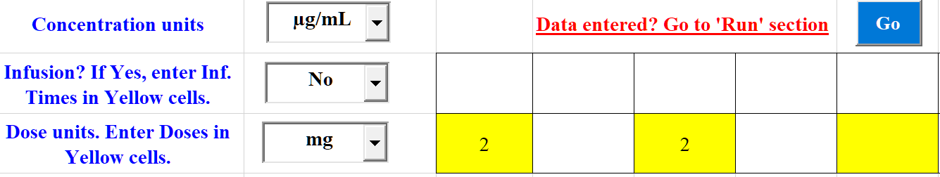

|  |  |  |  |  |  |  |
| --- | --- | --- | --- | --- | --- | --- |
| **Time-Conc. Data** | Time | Vol.1 | Time | Vol.2 |  |  |
|  | 0 | 0 | 0 | 0 |  |  |
|  | 1 | 1.26 | 1 | 0.623 |  |  |
|  | 2 | 2.02 | 2 | 1.18 |  |  |
|  | 3 | 2.54 | 3 | 1.44 |  |  |
|  | 4 | 4.09 | 4 | 2.72 |  |  |
|  | 4.25 | 4.77 | 4.25 | 2.27 |  |  |
|  | 4.5 | 4.29 | 4.5 | 2.25 |  |  |
|  | 5 | 2.76 | 5 | 1.44 |  |  |
|  | 5.5 | 1.54 | 5.5 | 1.19 |  |  |
|  | 6 | 1.27 | 6 | 1.1 |  |  |
|  | 7 | 0.87 | 7 | 0.786 |  |  |
|  | 8 | 0.99 | 8 | 0.733 |  |  |
|  | 10 | 0.639 | 10 | 0.506 |  |  |
|  | 12 | 1.05 | 12 | 0.465 |  |  |
|  | 24 | 0.43 | 24 | 0.201 |  |  |
|  | 36 | 0.376 | 36 | 0.12 |  |  |
|  | 48 | 0.355 | 48 | 0.0531 |  |  |
|  | 72 | 0.196 | 72 | 0.0213 |  |  |
|  | 96 | 0.124 | 96 |  |  |  |

Once the data have been entered, click the ‘Go’ button to return to the section of the spreadsheet for running the NCA module. In this example, the PCModfit ‘NCA’ spreadsheet contains two separate profiles (for missing conc. values, if not sure then leave blank). To initiate the NCA, click the ‘Run’ then ‘Update’ in the sheet which will produce a layout similar to that shown in Figure 5. PCModfit V7.4 has an additional button ‘Cancel’ which will terminate the run at any stage should the user wish to do so (a message box will appear informing the user).

#### Figure 5: Points selected in the 1st profile for NCA.

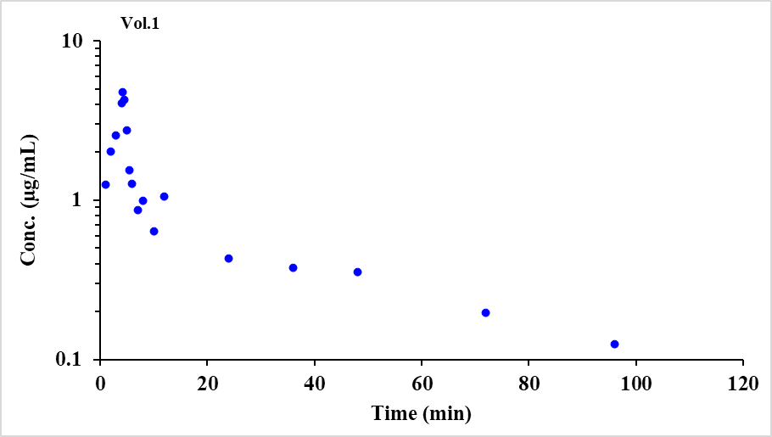

The default is 3 points but if more points are required, then single click on the additional ones in the ‘Current Data Set’ box which will highlight or deactivate; then click ‘Update’ and ‘Continue’ to produce Figure 6.

#### Figure 6: Points selected in the 1st profile for NCA (note extra values chosen).

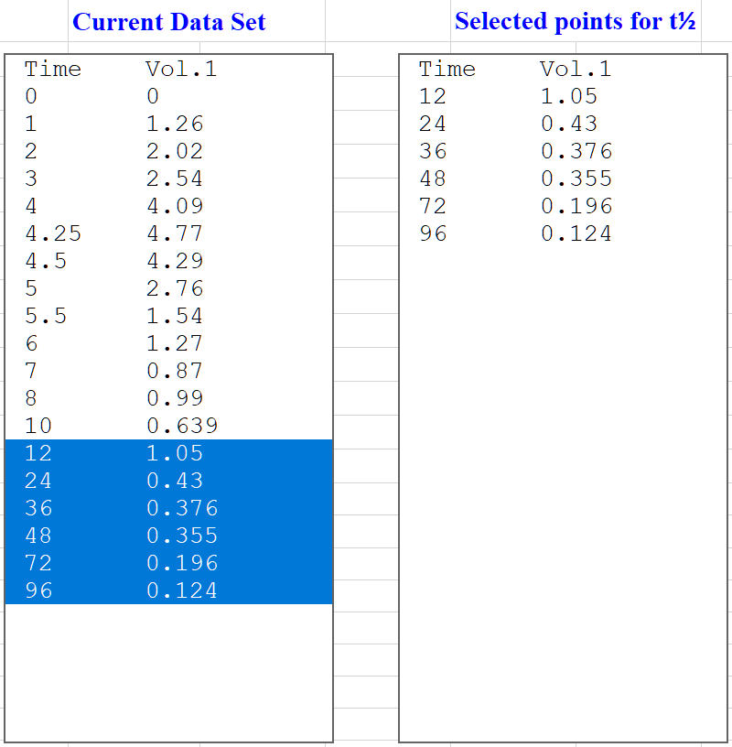

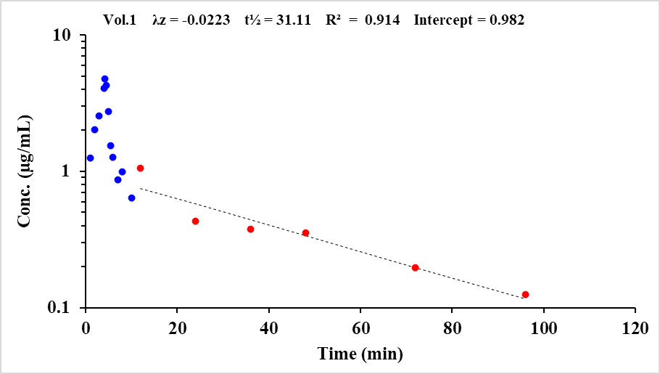

V7.8 onwards will now show λz as a positive number on the graphs. All other numbers are unaffected by this change.

If a further change is required, then select or deselect values in the ‘Current Data Set’ box and single click the ‘Update’ button followed by the ‘Continue’.

If all is well, click ‘Continue’ again and the next profile will be displayed.

As the process continues, the parameter values will update, together with the picture in the NCA sheet reflecting the changes in t½ (with λz) and R2, for an estimate of fit, interactively.

The final user accepted pictures from the NCA will be stored as NCA*.png files of high quality in directory C:\PCModfit Vx.x\Results\ (x.x being the version number) with names such as NCA08.png or NCA128.png with corresponding Excel® files (PCModfit V7.1 onwards) as a record (worth mentioning that these files will need cleaning up from time to time to stop so many files being produced).

Once both profiles have been analysed, the sheet will display all of the results starting at Row 50 onwards and in the created Excel® file which will automatically open at the end of the analysis. In this example, the results file will look very similar to the one shown in the following Figure 7. It’s worth mentioning that the time and date is shown in the file together with the results and the points selected for t½ determination for each profile as a record of the users’ selections (useful as a paper trail). Obviously, for a single profile the descriptive statistics will be absent, but the NCA results will still be shown.

#### Figure 7: Example NCA results in the created Excel file and the NCA spreadsheet.

|  |  |  |  |  |  |  |  |  |  |  |
| --- | --- | --- | --- | --- | --- | --- | --- | --- | --- | --- |
| **21/04/2021 15:43** | **V7.6 will show the plotting file names here.** | | |  |  |  |  |  |  |  |
| **Results** | **Profile** | **Vol.1** | **Vol.2** |  |  |  |  |  |  |  |
|  | AUC time range | 0 to 96 | 0 to 72 | Min. | Max. | Mean | GMean | Median | SD | CV |
| **Comments** | Tmax | 4.25 | 4 | 4 | 4.25 |  |  | 4.125 |  |  |
|  | Cmax | 4.8 | 2.7 | 2.7 | 4.8 | 3.7 | 3.6 | 3.7 | 1.4 | 38.7 |
| (Usual) | Lin AUCt | 47.5 | 19.7 | 19.7 | 47.5 | 33.6 | 30.6 | 33.6 | 19.7 | 58.5 |
|  | Log AUCt | 46.5 | 19.2 | 19.2 | 46.5 | 32.8 | 29.9 | 32.8 | 19.3 | 58.7 |
|  | Lin/Log AUCt | 46.6 | 19.3 | 19.3 | 46.6 | 33.0 | 30.0 | 33.0 | 19.3 | 58.6 |
|  | Lin AUMCt | 1245.8 | 269.6 | 269.6 | 1245.8 | 757.7 | 579.6 | 757.7 | 690.2 | 91.1 |
|  | Lin AUMC∞ | 2030.0 | 311.3 | 311.3 | 2030.0 | 1170.6 | 794.9 | 1170.6 | 1215.3 | 103.8 |
|  | λz | 0.0223 | 0.0476 | 0.0223 | 0.0476 | 0.0349 | 0.0326 | 0.0349 | 0.0179 | 51.2 |
| (Ln(2) / λz) | t½ | 31.1 | 14.6 | 14.6 | 31.1 | 22.8 | 21.3 | 22.8 | 11.7 | 51.2 |
| (Usual) | Lin AUC∞ | 53.1 | 20.2 | 20.2 | 53.1 | 36.6 | 32.7 | 36.6 | 23.3 | 63.6 |
|  | Log AUC∞ | 52.0 | 19.6 | 19.6 | 52.0 | 35.8 | 32.0 | 35.8 | 22.9 | 63.9 |
|  | Lin/Log AUC∞ | 52.2 | 19.7 | 19.7 | 52.2 | 36.0 | 32.1 | 36.0 | 22.9 | 63.8 |
|  | R² | 0.914 | 0.987 | 0.914 | 0.987 | 0.950 | 0.950 | 0.950 | 0.052 | 5.4 |
|  | No. pts. for t½ | 6 | 4 | 4 | 6 |  |  |  |  |  |
|  | No. pts. (total) | 19 | 18 | 18 | 19 |  |  |  |  |  |
|  | Intercept | 1.0 | 0.6 | 0.6 | 1.0 | 0.8 | 0.8 | 0.8 | 0.3 | 32.5 |
| (Dose/AUC∞) | CL /F | 37.7 | 99.2 | 37.7 | 99.2 | 68.4 | 61.1 | 68.4 | 43.5 | 63.6 |
| (AUMC∞/AUC∞) | MRT | 38.2 | 15.4 | 15.4 | 38.2 | 26.8 | 24.3 | 26.8 | 16.1 | 60.1 |
| (CL/λz) | Vd /F | 1691.2 | 2085.1 | 1691.2 | 2085.1 | 1888.2 | 1877.9 | 1888.2 | 278.5 | 14.8 |
| (CL x MRT) | Vss /F | 1440.8 | 1532.0 | 1440.8 | 1532.0 | 1486.4 | 1485.7 | 1486.4 | 64.5 | 4.3 |
| Concentration units | µg/mL |  |  |  |  |  |  |  |  |  |
| Infusion? | No |  |  |  |  |  |  |  |  |  |
| Dose units | mg | 2 |  | 2 |  |  |  |  |  |  |
| **Time-Conc. Data** | **Time** | **Vol.1** | **Time** | **Vol.2** |  |  |  |  |  |  |
|  | 0.0000 | 0.0000 | 0.0000 | 0.0000 |  |  |  |  |  |  |
|  | 1.0000 | 1.2600 | 1.0000 | 0.6230 |  |  |  |  |  |  |
|  | 2.0000 | 2.0200 | 2.0000 | 1.1800 |  |  |  |  |  |  |
|  | 3.0000 | 2.5400 | 3.0000 | 1.4400 |  |  |  |  |  |  |
|  | 4.0000 | 4.0900 | 4.0000 | 2.7200 |  |  |  |  |  |  |
|  | 4.2500 | 4.7700 | 4.2500 | 2.2700 |  |  |  |  |  |  |
|  | 4.5000 | 4.2900 | 4.5000 | 2.2500 |  |  |  |  |  |  |
|  | 5.0000 | 2.7600 | 5.0000 | 1.4400 |  |  |  |  |  |  |
|  | 5.5000 | 1.5400 | 5.5000 | 1.1900 |  |  |  |  |  |  |
|  | 6.0000 | 1.2700 | 6.0000 | 1.1000 |  |  |  |  |  |  |
|  | 7.0000 | 0.8700 | 7.0000 | 0.7860 |  |  |  |  |  |  |
|  | 8.0000 | 0.9900 | 8.0000 | 0.7330 |  |  |  |  |  |  |
|  | 10.0000 | 0.6390 | 10.0000 | 0.5060 |  |  |  |  |  |  |
|  | 12.0000 | 1.0500 | 12.0000 | 0.4650 |  |  |  |  |  |  |
|  | 24.0000 | 0.4300 | 24.0000 | 0.2010 |  |  |  |  |  |  |
|  | 36.0000 | 0.3760 | 36.0000 | 0.1200 |  |  |  |  |  |  |
|  | 48.0000 | 0.3550 | 48.0000 | 0.0531 |  |  |  |  |  |  |
|  | 72.0000 | 0.1960 | 72.0000 | 0.0213 |  |  |  |  |  |  |
|  | 96.0000 | 0.1240 | 96.0000 |  |  |  |  |  |  |  |
| **Actual and predicted points selected for half-life assignment(s)** | | | |  |  |  |  |  |  |  |
| **Profile title** |  |  |  |  |  |  |  |  |  |  |
| **Vol.1** | **Time** | **Conc.(actual)** | **Conc.(pred.)** |  |  |  |  |  |  |  |
|  | 12 | 1.05 | 0.7515 |  |  |  |  |  |  |  |
|  | 24 | 0.43 | 0.5752 |  |  |  |  |  |  |  |
|  | 36 | 0.376 | 0.4403 |  |  |  |  |  |  |  |
|  | 48 | 0.355 | 0.3370 |  |  |  |  |  |  |  |
|  | 72 | 0.196 | 0.1974 |  |  |  |  |  |  |  |
|  | 96 | 0.124 | 0.1157 |  |  |  |  |  |  |  |
| **Vol.2** | **Time** | **Conc.(actual)** | **Conc.(pred.)** |  |  |  |  |  |  |  |
|  | 24 | 0.201 | 0.1963 |  |  |  |  |  |  |  |
|  | 36 | 0.12 | 0.1109 |  |  |  |  |  |  |  |
|  | 48 | 0.0531 | 0.0627 |  |  |  |  |  |  |  |
|  | 72 | 0.0213 | 0.0200 |  |  |  |  |  |  |  |

## **NCA from V6.9 onwards (bolus intercept and handling zero values)**

PCModfit V6.9 and later versions will now display the Y-intercept value (C0) which can be useful in calculations and often assists with estimating bolus C0 values (at time 0) but for the terminal t½ of course, this would only be for the λz line. The correct method to use for a C0 estimate is very debatable as some people prefer to conduct modelling of a complete profile (unweighted) to extrapolate back to the Y-axis (can overestimate C0) and others who just use the first few points within NCA to achieve the desired result. Whichever method is selected, it will always be approximate, and inspection of each individual profile should be examined to see if the C0 value generated, is reasonable. The data will usually dictate which method is most appropriate but in the author’s experience, either approach can be used. Alternatively, a bolus dose has a time delay before a ‘true’ value of concentration can be established because, for example, if a human volunteer is dosed into a peripheral vein in the left arm, there will be a delay before levels of drug can be detected in the right arm. On this basis, one could argue that the model defining the dosing/distribution may be exhibiting an infusion situation (albeit very short) and perhaps a concentration at time zero is in fact zero. So now there are 3-approaches, all of which are approximate, and it’s left to the reader to decide which option is ‘best’.

As a simple example, the early part of a bolus profile is shown (Figure 8) and the intercept value estimated by NCA (using the 3-points) yielded a value of 99.902 which is close to the theoretical value of 100.0 for these data. The intercept will be shown on the NCA graph, in the results .txt file and in the spreadsheet results and can then be used to estimate AUC0-t and AUC0-∞ values for the complete profile by inserting the intercept concentration value at time zero (shown in blue).

#### Figure 8: Bolus i.v. profile (first 3-points) to estimate C0 value.

|  |  |
| --- | --- |
| Time | Vol.1 |
| 0 | **99.902** |
| 0.05 | 96.22 |
| 0.1 | 92.61 |
| 0.2 | 85.91 |

It is important to understand how zero values are handled by programs (often quite different) when for example, calculating AUC estimates for oral profiles. There has, and still is, debate on the correct approach. The approach used in PCModfit can be demonstrated using a specific example (Figure 9) but can be briefly described as follows:

* Zero values at the end of a profile should not be used as the real value would be unknown and should be left blank or use a hyphen.
* Zero values in the middle of a profile again should not be used, particularly if there are positive values either side of the zero. Leave the cell blank or use a hyphen.
* At the beginning of a profile e.g., oral data, care needs to be taken as the wrong approach will yield incorrect values for AUC etc. The example data sets with their associated results, shown in Figure 9, should help to explain this in more detail.

The same 5-data sets were used from 0.5 h to 10 h for simplicity but labelled Vol.1 to Vol.5 to help with the discussion. The concentration-time values used for half-life determinations were the same for all profiles and utilised the last 4 values for consistency. However, the zero values at the beginning of the profiles are shown differently to demonstrate how the program handles these data sets and what impact it has on the results.

The AUC values for sets Vol.1, Vol.2 and Vol.3 are the same as would be expected and show the data layout using zero and - values for concentrations. For these, the first non-zero data point is at 0.25 h and all values before this time are either absent or zero so the AUC would be expected to be equal. For profiles Vol.4 and Vol.5 however, they both have zero values at time zero but no value at 0.25 h so the AUC will be calculated

from time zero to 10 h. Both of these are equal but different from Vol.1 to Vol.3 due to the extra area calculated from time zero to 0.5 h.

So, in summary, Vol.1 to Vol.3 profiles all start contributing to the AUC from 0.25 h onwards but Vol.4 and Vol.5 start from zero, hence the increase in AUC for the latter two. At the end of Figure 9 there is a picture of a NCA plot, for information, to show the reader what one of the profiles looks like.

#### Figure 9: Use of zero concentration values in oral dosing profiles.

|  |  |  |  |  |  |  |
| --- | --- | --- | --- | --- | --- | --- |
| **Results** | **Profile** | Vol.1 | Vol.2 | Vol.3 | Vol.4 | Vol.5 |
|  | **AUC time range** | 0 to 10 | 0.25 to 10 | 0.25 to 10 | 0 to 10 | 0 to 10 |
|  | **Tmax** | 0.50 | 0.50 | 0.50 | 0.50 | 0.50 |
|  | **Cmax** | 510.00 | 510.00 | 510.00 | 510.00 | 510.00 |
|  | **Lin AUC** | 2907.75 | 2907.75 | 2907.75 | 2971.50 | 2971.50 |
|  | **Log AUC** | 2898.72 | 2898.72 | 2898.72 | 2962.47 | 2962.47 |
|  | **Lin/Log AUC** | 2898.72 | 2898.72 | 2898.72 | 2962.47 | 2962.47 |
|  | **Lin AUMC** | 12203.2 | 12203.2 | 12203.2 | 12962.0 | 12962.0 |
|  | **Lin AUMC∞** | 244276.9 | 244276.9 | 244276.9 | 245035.7 | 245035.7 |
|  | **λz** | 0.0361 | 0.0361 | 0.0361 | 0.0361 | 0.0361 |
|  | **t½** | 19.20 | 19.20 | 19.20 | 19.20 | 19.20 |
|  | **Lin AUC∞** | 9063.02 | 9063.02 | 9063.02 | 9126.77 | 9126.77 |
|  | **Log AUC∞** | 9053.99 | 9053.99 | 9053.99 | 9117.74 | 9117.74 |
|  | **Lin/Log AUC∞** | 9053.99 | 9053.99 | 9053.99 | 9117.74 | 9117.74 |
|  | **R²** | 0.909 | 0.909 | 0.909 | 0.909 | 0.909 |
|  | **No. pts. for t½** | 4 | 4 | 4 | 4 | 4 |
|  | **No. pts. (total)** | 9 | 8 | 8 | 8 | 8 |
|  | **Intercept** | 318.77 | 318.77 | 318.77 | 318.77 | 318.77 |
| **Data** | Time | Vol.1 | Vol.2 | Vol.3 | Vol.4 | Vol.5 |
|  | 0 | 0 |  | - | 0 | 0 |
|  | 0.25 | 0 | 0 | 0 |  | - |
|  | 0.5 | 510 | 510 | 510 | 510 | 510 |
|  | 1.0 | 510 | 510 | 510 | 510 | 510 |
|  | 2.0 | 380 | 380 | 380 | 380 | 380 |
|  | 4.0 | 283 | 283 | 283 | 283 | 283 |
|  | 6.0 | 246 | 246 | 246 | 246 | 246 |
|  | 8.0 | 241 | 241 | 241 | 241 | 241 |
|  | 10.0 | 224 | 224 | 224 | 224 | 224 |

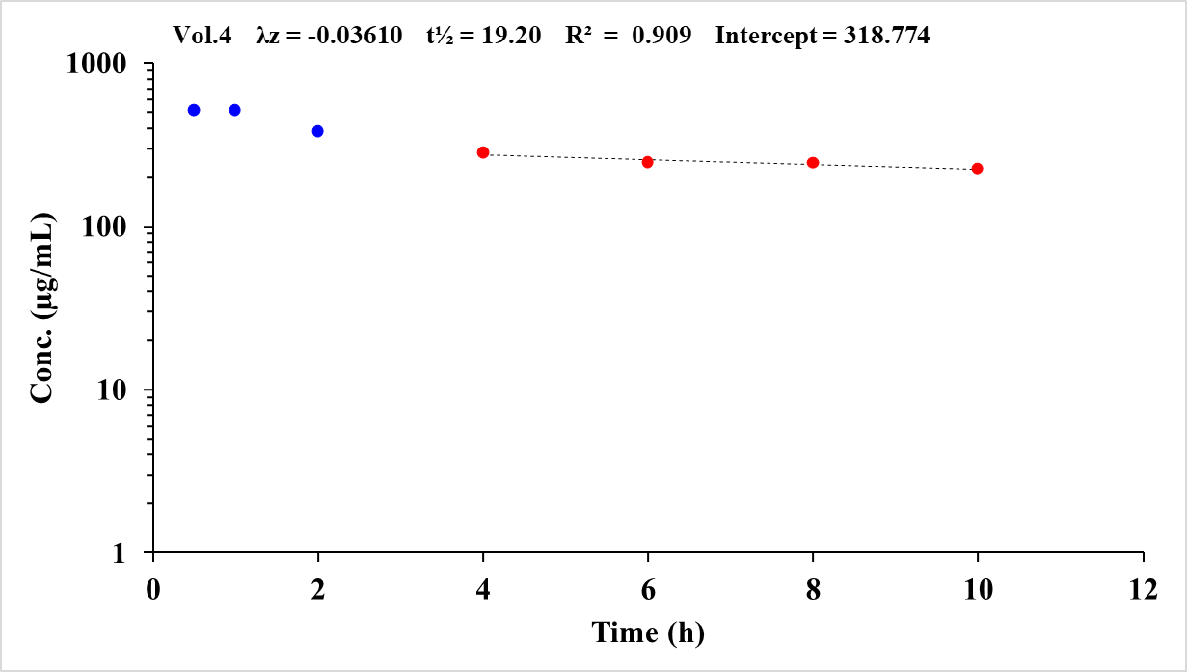

If the user has several profile results and would like further descriptive statistics, there is an additional spreadsheet in PCModfit titled ‘Stats’. This sheet will allow up to 15 different parameters (up to 100 of each from V7.6 onwards) and after the values are entered (typed or pasted) the sheet will automatically update itself to produce further information such as geometric means etc. using log-transformed data together with CI’s (90 and 95 % intervals) such as the example output shown in Figure 10.

#### Figure 10: ‘Stats’ spreadsheet containing data (left) and example output (right).

|  |  |
| --- | --- |
|  |  |

A more detailed example is shown in Figure 9 that includes different ways of how the program will calculate the AUC values when data have zero values during the early part of profiles.

## **Single Dose (SD) Simulator**

### Using built in explicit models.

The SD simulator allows for 10 regimens comprising different models, doses and parameters in a single run over a user defined time period. Select the ‘SD Simulator’ spreadsheet and enter the appropriate values. The models are shown in Row 24, Column N which includes intravenous, infusion and oral functions with the sequence of parameters that need to be entered into the sheet at Row 13 onwards. Other parameters that need user input are dose, model, infusion details if selected, and the profile time. For example, if the profile time is 30 h and the number of points per plot is 30, then the concentrations generated (Row 25) will be every hour. If the number of points per plot is 60, then concentrations every 0.5 h will be produced. Ensure that the no of points per plot is a multiple of the simulation time or some erroneous values may be generated. User specific time points are now permitted from V7.1 onwards and explained within the spreadsheet.

As a specific example (Figure 11 for input and output values and Figure 12 for graphics) a simulation was conducted for 4-different regimens using dissimilar parameters, doses and models (4x 1-compartment oral, one with a lag-time). If a model is chosen has a lag-time and it is omitted, the program will assume a lag-time of zero as shown in Figure 11. After entering the parameters and clicking the ‘Run’ button, the picture in the spreadsheet (containing the 4-profiles) will update automatically at the end of the run and a high-quality graphic file will appear in directory C:\PCModfit Vx.x\Results\ with names like SDSim3.PNG or SDSim156.PNG which can be used in other documents.

#### Figure 11: Example SD simulation input/output (4 profiles, 1-compt oral, 1 with lag-time)

|  |  |
| --- | --- |
| **Model** |  |
| **User selections** |  |
| **Concentration**  **output** | **Etc.** |

#### Figure 12: Example SD simulation graphic output from Figure 11 data

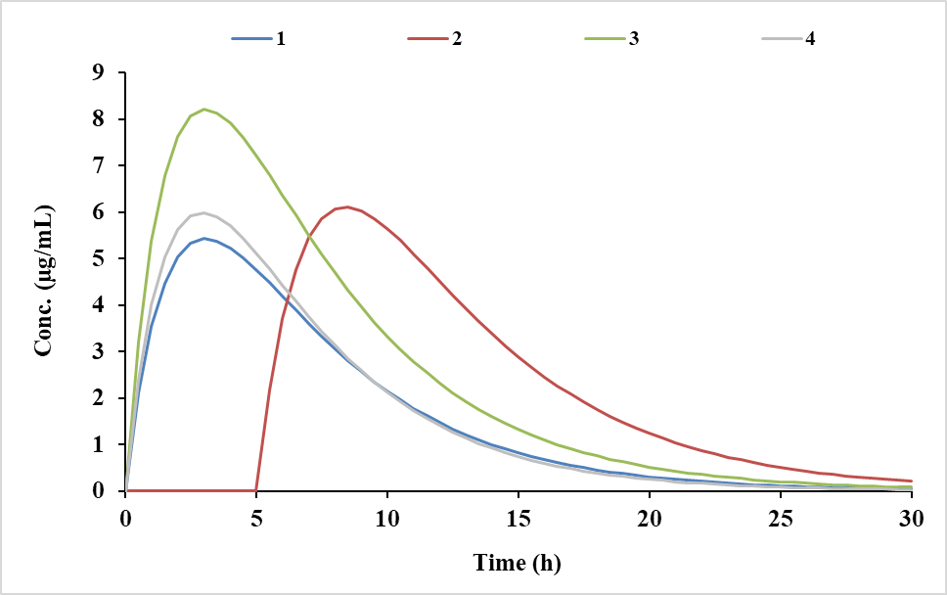

As a further example (Figure 13 for input and output values and Figure 14 for graphics) a simulation was conducted for 4-different infusion regimens (3-compartment model) using the same parameters and doses but with different infusion times (dose = Rate x Infusion time). After entering the parameters and infusion information and clicking the ‘Run’ button, the picture in the spreadsheet (containing the 4-profiles) will update automatically at the end of the run and a high-quality graphic file will be produced in directory C:\PCModfit Vx.x\Results\ (x.x being the version number) with names such as SDSim3.PNG or SDSim156.PNG which can be used in other documents.

#### Figure 13: Example SD simulation (4 profiles, 3-compt infusions over 5 to 20 h)

|  |  |
| --- | --- |
| **Model** |  |
| **User selections** |  |
| **Concentration**  **output** | **Etc.** |

#### Figure 14: Example SD simulation graphic output from Figure 13 data

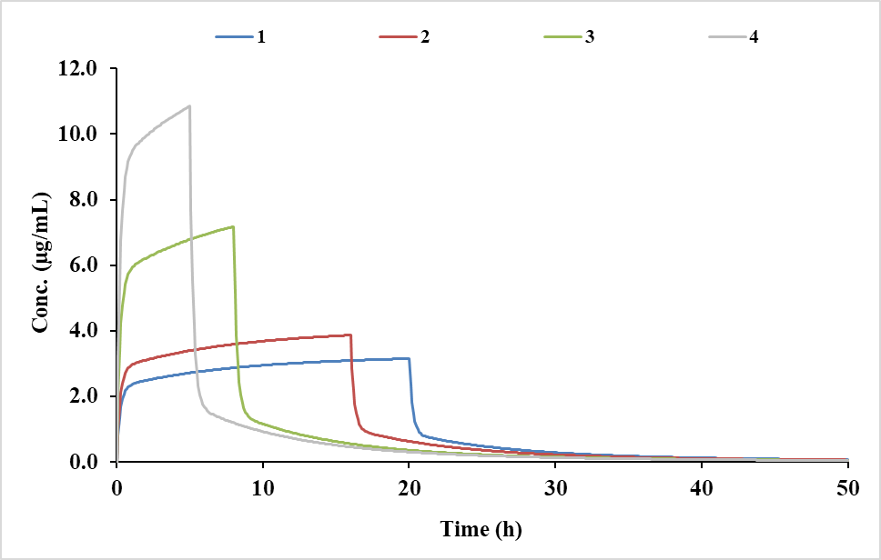

An additional note: in most spreadsheets there is a facility for calculating λn values together with their respective half-lives from the ki,j values as shown in the examples below. If the user enters the ki,j values into the cells (blue characters) in the PCModfit spreadsheet (example shown in Figure 15) then the λ values will automatically update (red characters). The reverse can also be calculated in V7.3 onwards.

#### Figure 15: Calculator for getting λn values from k12. k21 etc. and the reverse

|  |  |  |  |  |  |  |  |  |  |  |  |
| --- | --- | --- | --- | --- | --- | --- | --- | --- | --- | --- | --- |
| **Useful parameters: enter values in blue to calculate red values automatically** | | | | | | | | | | | |
| **Compts.** | **k12** | **k21** | **k10** | **l1** | **l2** | **t1/2 l1** | **t1/2 l2** |  |  |  |  |
| **2** | 0.09194 | 0.14312 | 0.03494 | 0.2500 | 0.0200 | 2.77 | 34.65 |  |  |  |  |
| **3** | **k12** | **k21** | **k13** | **k31** | **k10** | **l1** | **l2** | **l3** | **t1/2 l1** | **t1/2 l2** | **t1/2 l3** |
|  | 0.49013 | 0.26821 | 0.11753 | 0.03579 | 0.20833 | 1.00000 | 0.10000 | 0.02000 | 0.693 | 6.931 | 34.657 |
| **OR (for bolus and infusion models)** | | | | | | | | | | | |
| **Compts.** | **C1** | **l1** | **C2** | **l2** | **k12** | **k21** | **k10** |  |  |  |  |
| **2** | 70.00186 | 1.00002 | 24.99996 | 0.02000 | 0.670155 | 0.277895 | 0.071971 |  |  |  |  |
| **3** | **C1** | **l1** | **C2** | **l2** | **C3** | **l3** | **k12** | **k21** | **k13** | **k31** | **k10** |
|  | 80.0000 | 1.0000 | 15.0000 | 0.1000 | 5.0000 | 0.0200 | 0.49013 | 0.26821 | 0.11753 | 0.03579 | 0.20833 |



### User defined ‘Differential Equation’ models (SD simulations)

There are often times when models cannot, or they would be very difficult to solve algebraically and, in these situations, it is much simpler to set up a series of differential equations and let the program do the hard work to solve them. With this in mind, PCModfit V7.1 now has a facility for conducting single dose simulations using differential equations which can be entered in the ‘Diff. Eqn. Simulator (SD)’ tab.

The program will parse the user entered equations into the PCModfit code automatically from Excel® without having to re-compile the program. This step is very quick even though the code is highly complicated as the typed in equations are essentially Tokenised in high memory at the start of the process for later repetitive access and rapid solution in real time.

There are detailed instructions on the spreadsheet with further examples in Section 7 of this manual and but does require the user to be comfortable with defining such differential equations from models. The author is currently working on a repeat dose differential equation simulator (about 75% complete) which should hopefully be available in the next couple of versions. This option will also be made available for modelling single and repeat dose data using differential equations which is currently being coded.

On the ‘Diff. Eqn. Simulator (SD)’ spreadsheet (starting on Column U) there are examples of how to set up a desired model showing the user what parameters are required. These include an accuracy level, equations, model parameters, volumes, doses (or infusions) and amounts in each compartment at time zero; a necessary requirement.

As a specific example, a 3-compartment single dose infusion model was defined (pictorially represented in Figure 16) and analysed using the differential equation simulator. The data shown in Figure 17 indicates the 3 equations and the other required parameters. Please don’t change any of the blue cells but just enter the required numbers in those marked black.

The figure below shows the rate parameters (p1 to p5) and the labelling of the 3-compartments for information so the reader can relate these to the spreadsheet in Figure 16.

Specifically, p1 is k12, p2 is k21, p3 is k13, p4 is k31 and p5 is k10 where the ki,j parameters are ones often quoted in the literature. T is the infusion time and the cn values correspond to the amount of drug in each of the compartments at time t.

#### Figure 16: Pictorial example of a 3-compartment infusion model

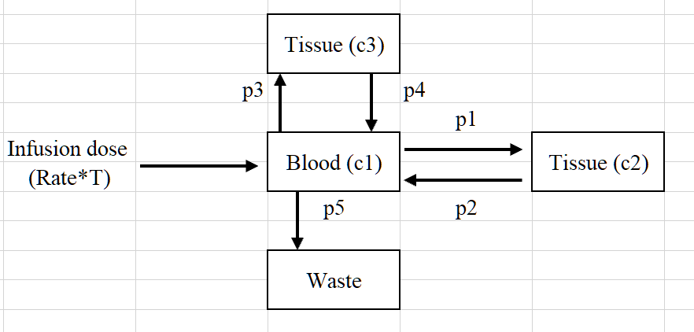

The data shown in Figure 17 sets up the required variables (and constants) for a 3-compartment infusion simulation. The 3-equations are shown together with the 5-parameters and the compartmental volumes. Assuming the volume of compartment 1 is known (V1) the volumes for the other two can be calculated as V2 = V1 x k12/k21 and V3 = V1 x k13/k31. For the profile time, a value of 24 h was required and the No. of points set at 24. This generated concentrations every hour but if the No. of points were set at 48 (a multiple of the time; recommended) then concentrations every 0.5 h would have been produced. The output of the simulation is initiated by clicking the ‘Run’ button and the results for each compartment appear in Row 60 onwards; for this example, the results are shown in Figure 18.

#### Figure 17: Example setup using a 3-compartment infusion model

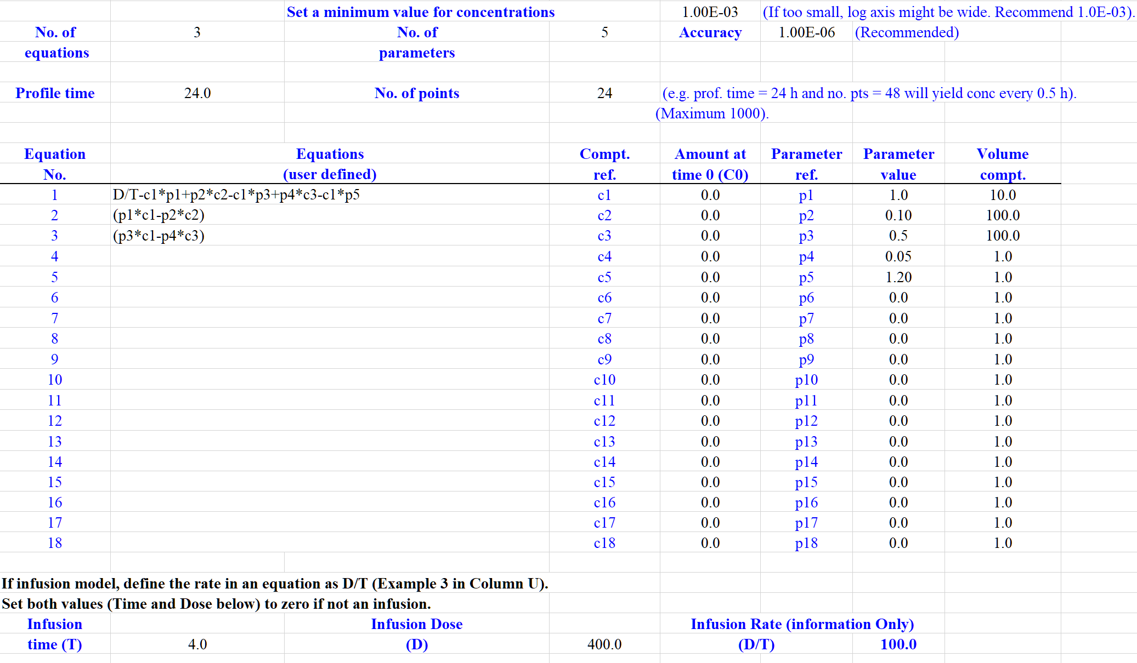

#### Figure 18: Output from a 3-compartment infusion model simulation

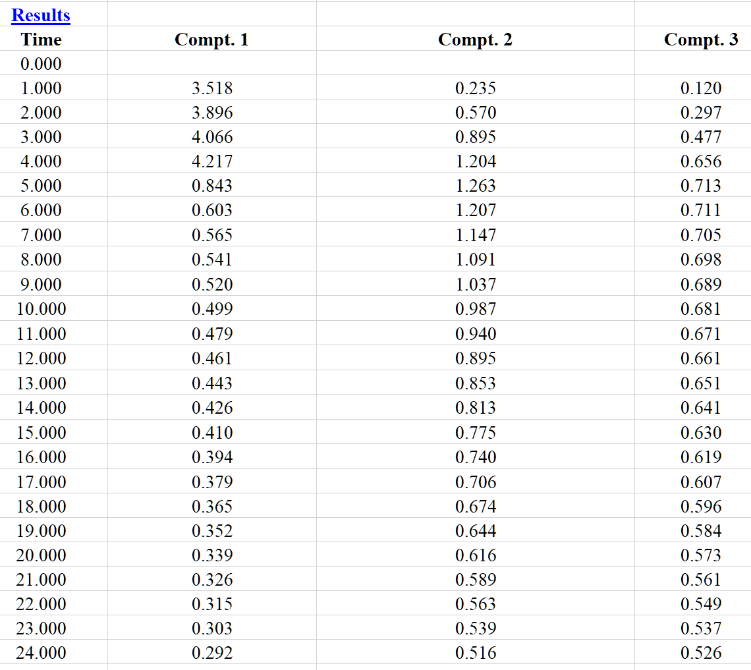

In addition to the numerical output, the graph in the spreadsheet is automatically updated and can be copied or edited into other documents. The graphical output for the infusion simulation is shown in Figure 19 for information.

Note: the concentration axis has a minimum value of 0.001 which corresponds to the value that is user defined prior to running (Row 26) where it says “Set a minimum for concentrations”. If this value is set too low, the y-axis may look odd! The accuracy for the numerical integration is normally 1.0E-06 which seems to work well.

#### Figure 19: Graphics output from a 3-compartment infusion model simulation

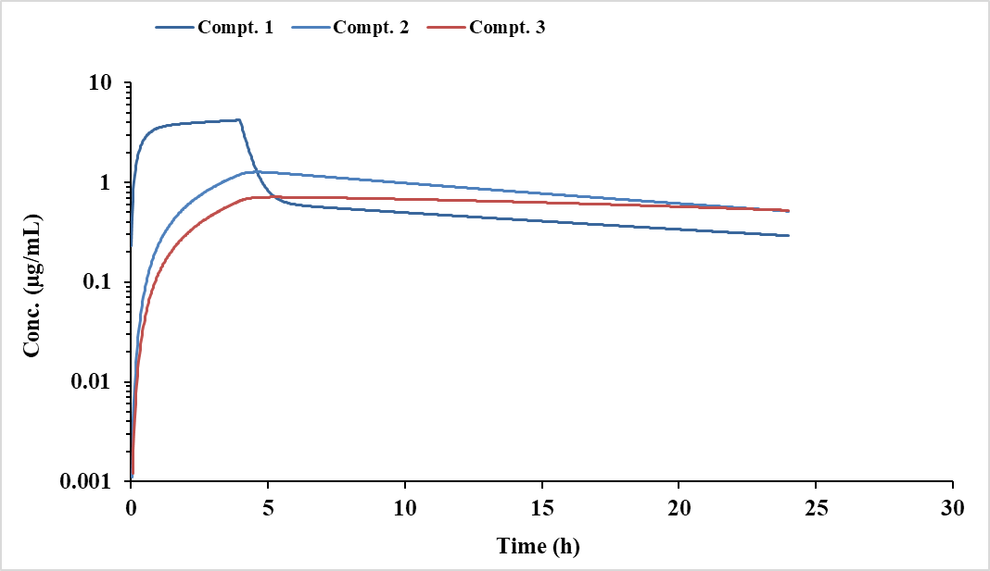

When the ‘Run’ button is clicked, a Window will appear which allows the user to change certain parameters (shown in Figure 20). Note that the equations have been parsed ok from Excel® and the parameters are correct. The 3-compartment infusion simulation on an i7 computer only took 0.02 seconds so it seems very quick!

#### Figure 20: Run time Window displaying the user’s equations and variables

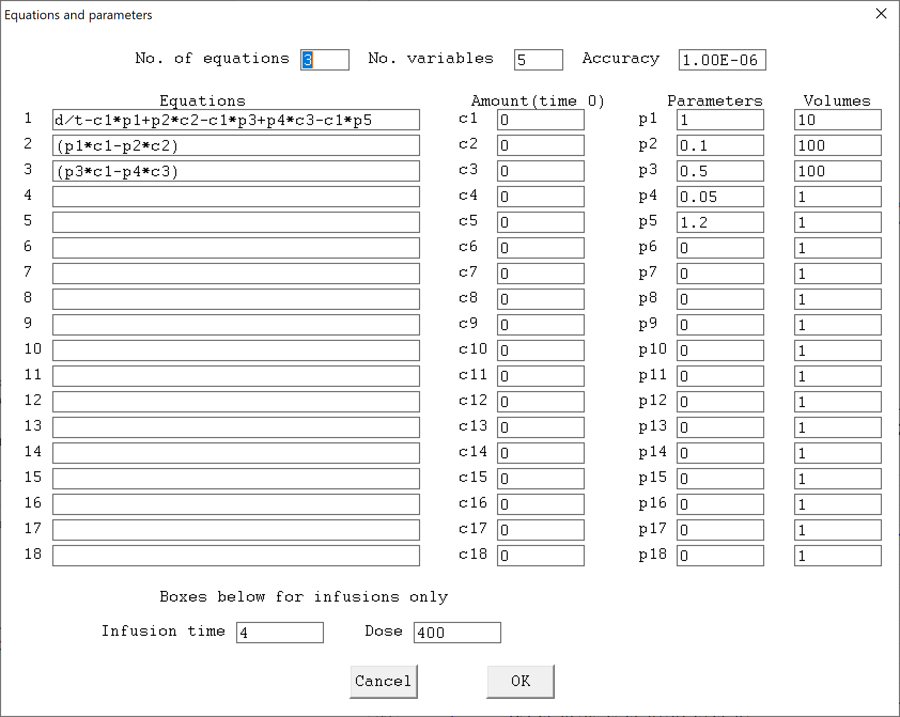

## **Repeat Dose (RD) Simulator**

### Using built in explicit models

The repeat dose simulator will allow dosing regimens comprising different models, doses, dosing intervals and parameters in any sequence and permits up to 10 simulations, each with up to 200 doses, in a single run over a user defined time period. For simulating repeat dose profiles, select the spreadsheet labelled ‘RD Simulator’ and enter the appropriate values. Obviously, there will be more variables to enter the spreadsheet than for SD simulations as additional parameters will be required. User specific time points are now permitted from V7.1 onwards and explained within the spreadsheet.

The models are shown in Row 7, Column K which currently covers multi-compartment intravenous, infusion and oral functions with the sequence of parameters that need to be entered into the sheet at Row 33 onwards. If more than one RD simulation is required, all of the parameter information will have to be entered for each ‘Subject’ number starting at Row 24, Column A. The parameters and doses etc. need to be specified for each dose as the simulator allows for different possibilities. The variables that need user input are dose, dosing interval, model with parameters, infusion details if selected, and the overall profile time. For example, if the profile time is 240 h and the number of points per plot is 240, then the concentrations generated (Row 224) will be every hour. If the number of points per plot is 480, then concentrations every 0.5 h will be produced. Ensure that the no of points per plot is the same for each Subject and a multiple of the simulation time or some erroneous values may be generated.

As a specific example (Figure 21 for input, Figure 22) for output values and Figure 23 for graphics) a simulation was conducted for 2 Subjects using dissimilar doses and dosing intervals (1-compartment oral). After entering the parameters and clicking the ‘Run’ button, the picture in the spreadsheet (containing the 2-profiles) will automatically update and a high-quality graphic file produced in directory C:\PCModfit Vx.x\Results\ (x.x being the version number) with names such as RDSim9.PNG or SDSim125.PNG which can be used in other documents.

#### Figure 21: Simulation RD (10 doses 1-compt oral) 2 Subjects: 1 same dose and different dose.

|  |
| --- |
| **Model 7, 1-compartment oral** |
| Subject 1 |
| Subject 2 |

#### Figure 22: Example RD simulation concentration output

|  |
| --- |
| **Etc.** |
|  |

#### Figure 23: Example RD simulation graphic output

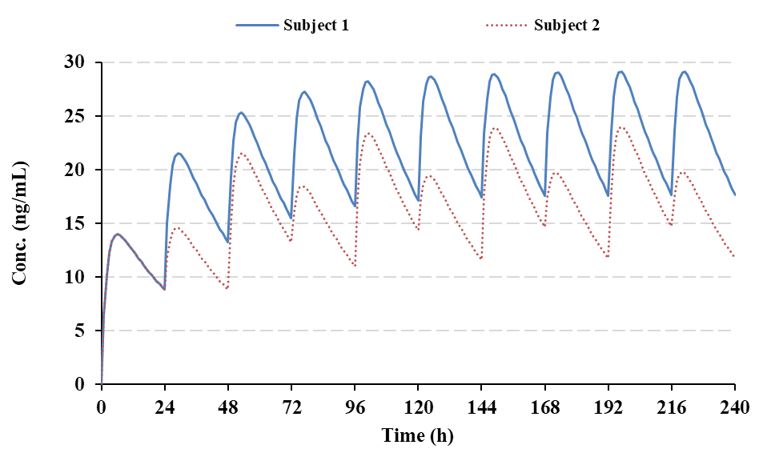

A slightly more complicated simulation is included here to help the user with their own predictions. In this particular example, showing a 2-compartment model, an initial bolus and infusion dose is followed by several oral doses at different dosing intervals. The parameters used in this run are shown in Figure 24 for input, Figure 25 for output and Figure 26 for graphics. The simulation was conducted for 2 Subjects using the same regimen but half the dose throughout (just to demonstrate the layout). After entering the parameters and clicking the ‘Run’ button, the picture in the spreadsheet (containing the 2-profiles) will automatically update and a high-quality graphic file produced in directory C:\PCModfit Vx.x\Results\ (x.x being the version number) with names such as RDSim9.PNG or RDSim125.PNG which can be used in other documents.

#### Figure 24: Simulation (2-compt. model; bolus+infusion then oral) for 2 Subjects (input).

|  |
| --- |
| **2-compartment model, bolus + infusion followed by various oral doses (V1 for oral slightly higher i.e. 120)** |
| Subject 1 |
| Subject 2 |

#### Figure 25: Simulation (2-compt. model; bolus+infusion then oral) for 2 Subjects (output).

|  |
| --- |
| **Etc.** |
|  |

#### Figure 26: Simulation (2-compt. model; bolus+infusion then oral) for 2 Subjects (output graphics)

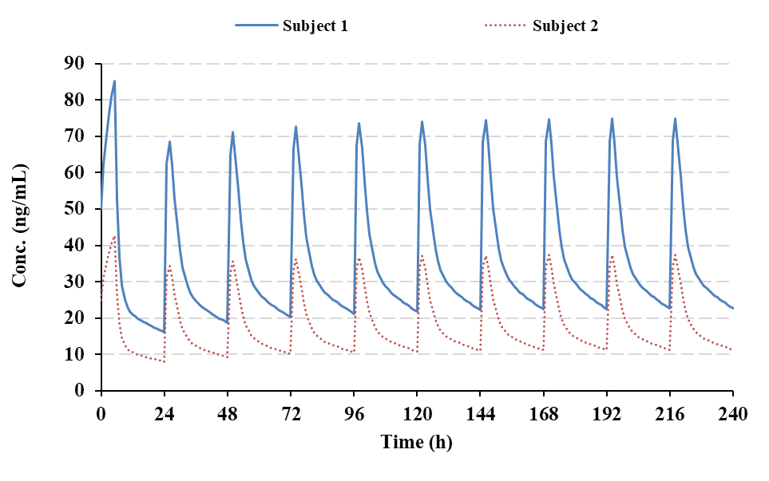

### User defined ‘Differential Equation’ models (RD simulations)

This option for RD simulations will allow users to create dosing regimens with their own differential equations. The module allows for different models, doses, intervals and changes in variables in any sequence within a single run (up to 200 doses and up to 5000 data points) over a user defined time period. For simulating repeat dose profiles, select the spreadsheet labelled ‘Diff. Eqn. Simulator (RD)’ and follow the instructions. There are more variables to enter in the spreadsheet than required for single doses as additional parameters such as dosing intervals, number of doses, models etc. will be required. Users not conversant with creating differential equations in PK may find it useful to read Appendix 7 where an example is shown.

As a specific example, consider a dosing regimen where a drug is to be administered as a bolus + infusion and then a series of oral maintenance doses with different doses and intervals. Hopefully, the following information will be sufficient to help the user to set up a regimen for a successful simulation. The symbols in the equations used by PCModfit for this example are depicted in Figure 27.

As the first dose will be a bolus, the model schematic (shown in Figure 28) and the equations that the program will need are listed in Figure 29.

#### Figure 27: Symbols used in the 2-compartment model equations (bolus, infusion and oral)

|  |  |  |
| --- | --- | --- |
| **Symbols (PCModfit eqns.)** | **Parameter** | **Meaning** |
| p1 | k12 | Transfer rate of drug from Compt. 1 to 2 |
| p2 | k21 | Transfer rate of drug from Compt. 2 to 1 |
| p3 | k10 | Transfer rate of drug from Compt. 1 to Waste |
| p4 | ka | Absorption rate (Compt. 3 to Compt. 1) |
| c1 | A1 | Amount in Compt. 1 at time zero (bolus dose) |
| c2 | A2 | Amount in Compt. 2 at time zero |
| c3 | A3 | Amount in Compt. 3 at time zero (oral dose) |
| D | D | Dose (infusions only) |
| T | T | Infusion time |
| D/T | Rate (k0) | Must be used in infusion models (see Figure 31) |

#### Figure 28: Pictorial example of a 2-compartment bolus model

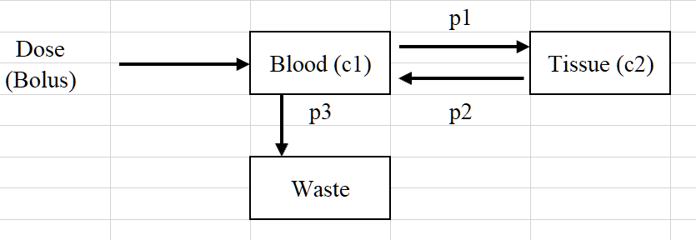

#### Figure 29: Equations for a 2-compartment bolus model

|  |  |
| --- | --- |
| **Compartment** | **Equation** |
| c1 (blood) | -c1*p1-c1*p3+p2*c2 |
| c2 (tissue) | p1*c1-p2*c2 |

The amounts of drug in Compt. 1 (c1) and Compt. 2 (c2) at zero time (c0 values in the spreadsheet, Row 101 onwards) will be the Dose and zero, respectively.

For the infusion model (pictured in Figure 30) the equations are similar to the bolus but with the added term of rate (D/T) for Compt. 1 (Figure 31) and for such models should always be defined.

#### Figure 30: Pictorial example of a 2-compartment infusion model

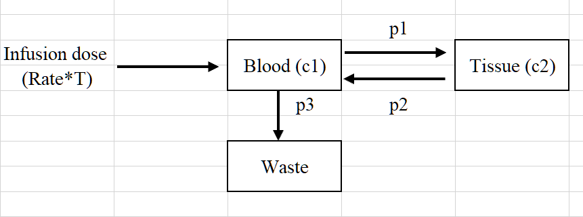

#### Figure 31: Equations for a 2-compartment infusion model

|  |  |
| --- | --- |
| **Compartment** | **Equation** |
| c1 (blood) | D/T-c1*p1-c1*p3+p2*c2 |
| c2 (tissue) | p1*c1-p2*c2 |

The amounts of drug in Compt. 1 (c1) and Compt. 2 (c2) at zero time (c0 values in the spreadsheet, Row 101 onwards) will both be zero.

For the oral model (pictured in Figure 32) the equations are different to the bolus and infusion models due to the addition of Compt. 3 (the gut) and hence the added term of absorption rate (ka) (Figure 33) will need to be defined in the equations.

#### Figure 32: Pictorial example of a 2-compartment oral model

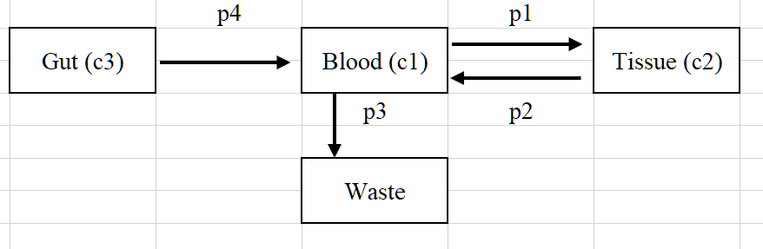

#### Figure 33: Equations for a 2-compartment oral model

|  |  |
| --- | --- |
| **Compartment** | **Equation** |
| c1 (blood) | c3*p4-c1*p1-c1*p3+p2*c2 |
| c2 (tissue) | p1*c1-p2*c2 |
| c3 (gut) | -p4*c3 |

The amount of drug in Compt. 1 (c1) and Compt. 2 (c2) at time zero will both be zero. However, for compt. 3 (the gut) the value at time zero will be the oral dose.

How does the user set up a simulation using the program such as the one described?

**First step**

The cells in the spreadsheet with blue characters should not be moved or changed as the program may end up generating numbers that are completely meaningless! For the simulation, specifically, in the ‘Diff. Eqn. Simulator (RD)’ spreadsheet, Row 16 onwards (in this case) needs to be populated with the numbers of equations, compartments, parameters and actual equations for the simulation.

For this example, Model 1 is the bolus dose, Model 2 is the infusion and finally, Model 3 is the oral model. A screen clip from the spreadsheet is shown in Figure 34 to demonstrate this, with the appropriate data included. At the top of the spreadsheet there is an ‘Examples’ button which will display

several equations that can be copied into the appropriate cells to make things easier. The user may add their own equations if required in Row 21 onwards as shown in Figure 34, below.

#### Figure 34: Spreadsheet information required for Step 1 of the simulation

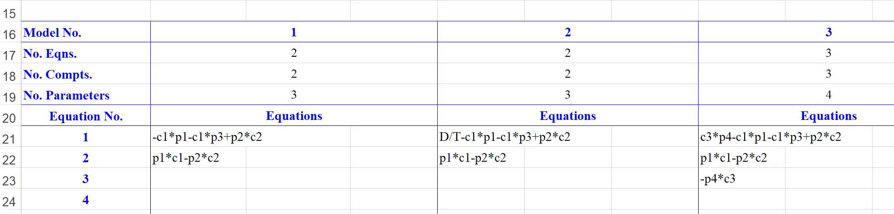

**Second step**

Slightly further down the spreadsheet (Row 46 onwards) other information needs to be supplied (screen clip shown in Figure 35). The ‘Minimum value for the logarithmic plot’ (Row 46) and the ‘Accuracy’ (Row 48) should be entered and the numbers shown for each is a guide for the user. These values can be modified if required, although these settings seem to work well for most simulations. Hopefully, the remainder of Step 2 is self-explanatory and should be adapted for the required regimen.

Note that the ‘No. pts.’ (Row 53) must be a multiple (or fraction multiple) of the ‘Profile time’ (and vice-versa). For instance, if the profile time is 100 h, then the number of points can take values of 25, 50, 100, 200, 1000 etc. depending on the concentration-time values required (100 points would calculate values every hour). Also, regarding the number of points, although the maximum is 5000, bear in mind that it will take longer to generate these particularly if there are numerous doses and equations. Numerical integration can be a fairly complex process and sometimes fussy with respect to accuracy but 1.0E-07 seems to be ok in most situations. For this particular example, using a computer with an i7 processor, the ‘number crunching’ procedure only took 2.4 seconds to complete the simulation.

#### Figure 35: Screen clip from spreadsheet detailing some values for the current simulation

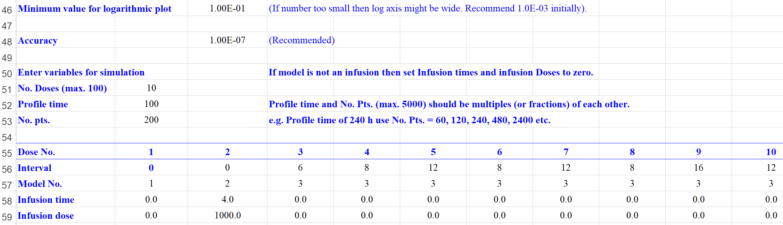

To move around the spreadsheet more easily, there are ‘Previous’ and ‘Next’ buttons at various places to avoid having to scroll the sheet to make life easier.

**Third step**

The next set of values to enter are the actual parameter values from Row 72 onwards. For this example, there are 3-parameters for Models 1 and 2 (p1, p2 and p3) with an additional one for Model 3 where the absorption rate (p4 ≡ ka) is added (p1, p2, p3 and p4). These parameters should be entered for each dose and can be different for each one, if required, to increase flexibility.

Note that the Volume terms are not added here but in a later Section of the sheet (Row 131 onwards).

As before, a screen clip of the Parameters section in the spreadsheet is shown (Figure 36) for information. The number of decimal places for each parameter can be changed depending on the simulation (or users) requirements.

#### Figure 36: Screen clip from spreadsheet detailing parameter values for the current simulation

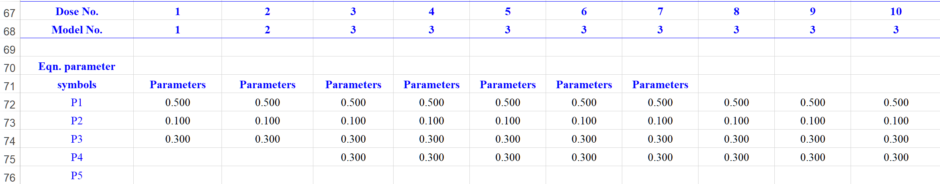

**Fourth step**

The next set of values to enter are the actual amounts of drug at time zero (C0 values) from Row 101 onwards (clip shown in Figure 37). For this example, Model 1 (bolus) will have a value for Compt. 1 (c1) equal to the bolus dose and for Model 3 (oral) the 3rd compartment (c3) should have the corresponding oral Dose. The infusion (Model 2) will have C0 values of zero for both compartments. Logically, other values will be all equal to zero as shown.

#### Figure 37: Screen clip from spreadsheet detailing C0 values for the current simulation

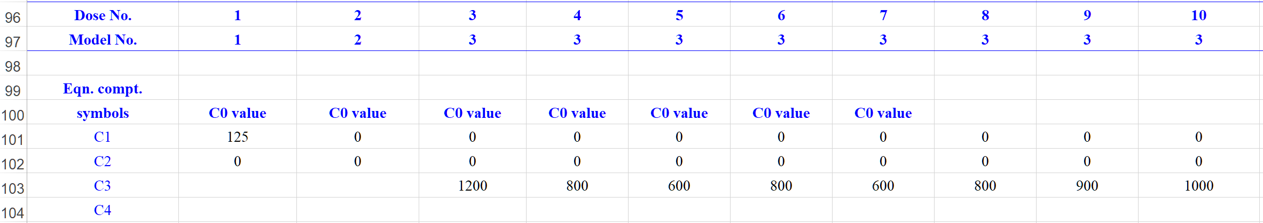

**Fifth step**

The last, but not least, set of values to enter are the Volumes for each compartment and model (screen clip shown in Figure 38) from Row 131 onwards in the spreadsheet. Note that, if the volume terms are set to 1.0, then the program will assume that the volumes are unknown and the results (Row 186 onwards) will represent amounts rather than concentrations. Often, for compartment 1, the volume term is known (maybe from modelling or NCA methods) but for the other compartments it is not. An approximation can be used to assign volume values for other compartments based on the rate constants for the purpose of simulations e.g. for a 3-compartment model where compartment 2 and 3 are separately connected to compartment 1, the following relationships can be used.

Volume 2 = Volume 1 × k12/k21 and Volume 3 = Volume 1 × k13/k31

#### Figure 38: Screen clip from spreadsheet detailing Volume values for the current simulation

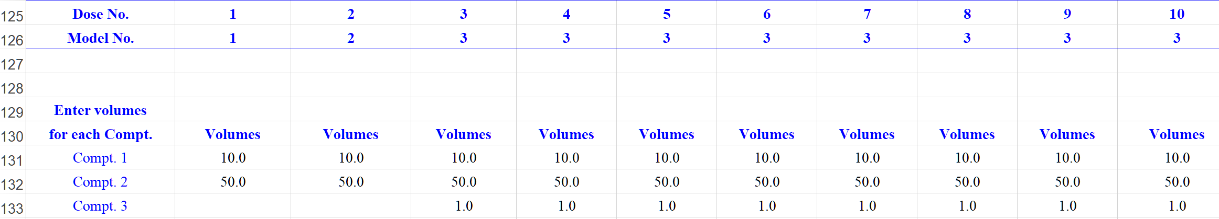

**Sixth step**

Assuming that all of the above data has been entered into the ‘Diff. Eqn. Simulator (RD)’ spreadsheet, then a final check, prior to running the simulation, can be made by clicking the ‘Initialise’ button (see Figure 40 screen clip). This will initiate the program to check all entries and set up the ‘number crunching’ variables (it must be clicked before running). There will be a sanity check made on the equations and it also tests the entered data to see if any variables are inconsistent or missing. After a successful initialisation, a small Window (Figure 39) will appear informing the user that no errors were found.

#### Figure 39: Message showing no errors were found after Initialisation

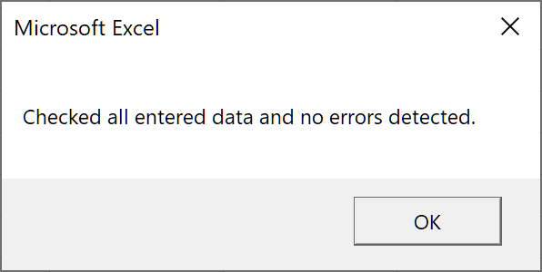

If an error is detected then an appropriate message box will pop-up, hopefully referencing where the culprit is! The usual ones are equation errors, where a parameter or an infusion term is missing or a parameter is absent. The majority of the error messages indicate which Row or region in the spreadsheet contains the anomalous data and/or empty cell(s).

Although there are numerous checks built into the program that will be carried out on initialisation and on execution of the numerical integrator but no doubt, the odd one may be missed. However, the graphs and the concentration/amount-time data (Row 187 onwards) will normally show an unexpected result.

#### Figure 40: Screen clip from spreadsheet showing ‘Initialise’ and ‘Run’ buttons

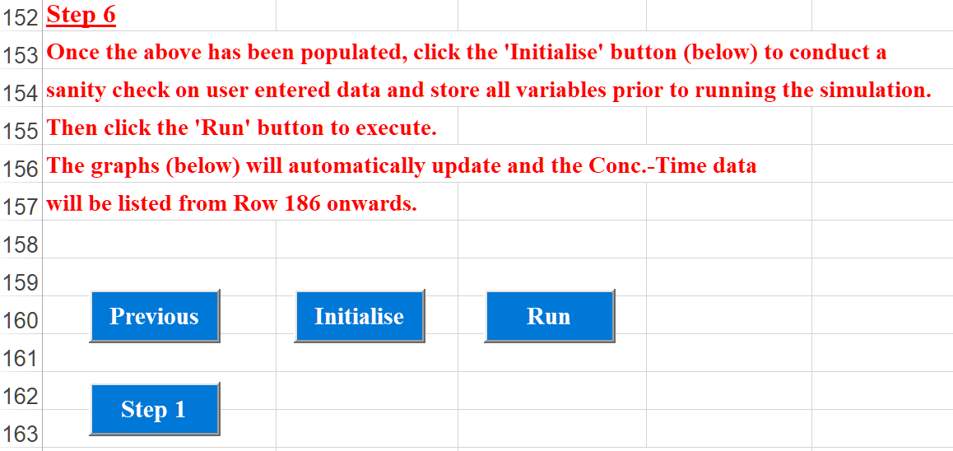

Finally, when the ‘Run’ button is clicked, the simulation will be activated and start. If 5 or more doses are requested, then a ‘Busy’ bar will appear on the screen indicating how much longer it will take to finish…usually just a few seconds but this will be dependent on the computer processor and the number of equations.

The two graphs on the spreadsheet will automatically update together with the concentration/amount data. The results from this example simulation are shown in Figure 41 through to Figure 43, all copied directly from the spreadsheet. The Profile time was 100 h with 200 data points requested and hence the concentration/amount values were calculated every 0.5 h.

#### Figure 41: Simulation result graphic for compartment 1

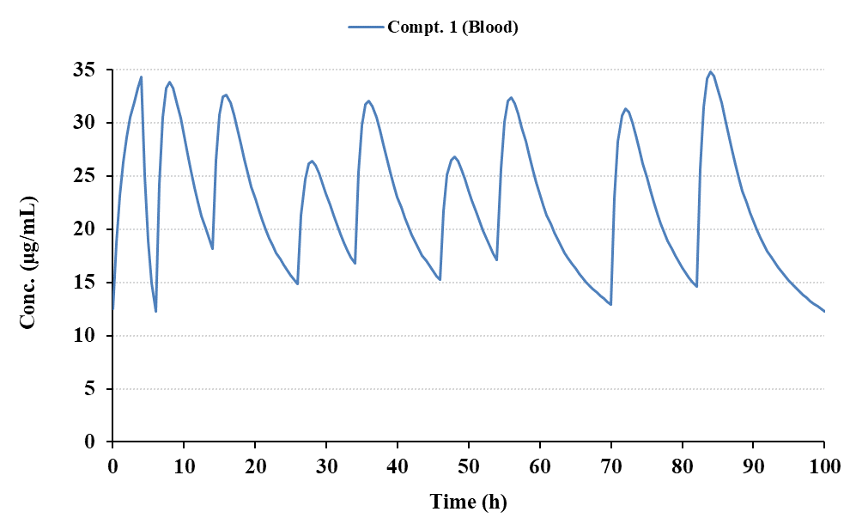

#### 

#### Figure 42: Simulation result graphic for all 3-compartments

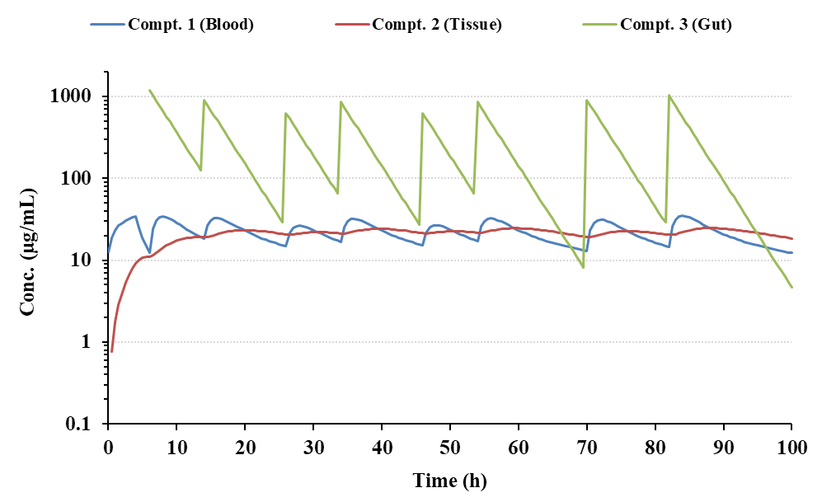

#### Figure 43: Numerical results from the bolus + infusion followed by oral maintenance simulation

|  |
| --- |
| **Etc.** |
|  |

Out of interest, the same simulation was conducted using the Repeat Dose Simulator with explicit models rather than those requiring differential equations and the results were essentially identical. The graphical result is shown below.



## **Superposition option**

PCModfit V7.2 onwards is now twice as fast for the Superposition option when compared to previous versions due to code modifications on cell Fonts used in the results transfer process into Excel; the numerical values are not changed. There is an additional option in V7.1 and V6.9 which allows ‘Superposition’ to be conducted for oral profiles (or others that have zero concentration at time zero) that are inappropriate for full modelling and only a half-life estimate is available. This is a common phenomenon in both non-clinical and clinical studies. There is a Summary table within the spreadsheet indicating the accumulation values by comparing parameters from Dose 1 to the last Dose for a quick assessment. In addition (new to V7.1) the user can now manually override the estimated t½ value (cell G4) when required (sometimes useful for very sparse data but when the t½ is known) and can now add their own data points to the repeat dose plots very easily, which is good for showing pre-dose values at later time points within a repeat dosing regimen (add data to cell K6 down).

Assuming that a single dose profile of a drug is available and an assessment of potential concentrations at, for instance, steady state is required, then the principle of Superposition can be used. However, it makes the assumption that the PK model is unknown, and that the kinetics are linear and unchanging over a repeat dose regimen in addition to the premise that all doses are independent of each other. Having said that, it is a valuable tool to estimate concentration-time repeat dose profiles from single dose data without resorting to full modelling procedures particularly when data are sparse. Earlier versions of PCModfit contained a Superposition option but they were limited as the doses and dosing intervals had to be equal.

In V7.1, this upgrade, due to popular usage, the module has been rewritten in Fortran (for speed), extensively updated and also verified by two independent users in addition to many who have tested it. In addition to being able to vary the dosing interval, users can now change each dose across the entire regimen as well (thanks to suggestions by Angus McLean, Ph.D., from the USA and Dr med. Christian de Mey from ACPS in Germany). There are several further additions including various plots of the results together with selection of accuracy to dictate the number of points required for each run. Using the highest accuracy, which can take some time, there can be up to 1,000,000 points generated which is getting close to the number that Excel® can handle. The author recommends a value of 0.01 which seems to be a very good compromise.

Summary plots and various parameters are output for each dose, which are useful for both simple and complex regimens. To assist the user, there are a couple of examples with start-up variables and associated output shown below.

Example 1, is a single oral dose data set and a Superposition profile (10 doses) was generated with the same dose but with different dosing intervals and utilising the last 7 points for estimation of t½ (all setup data taken from the Superposition Sheet and shown in Figure 44).

As a suggestion to the user, start the sequence of events by entering the concentration-time data, the dose for this data set and number of doses and the profile time. Then enter the number points required for t½ assignment (yellow cells). Finally, enter the doses (relative to cell B3) and the dosing intervals required. The next option to select is the ‘Accuracy’ – a brief explanation is required for this. The three options are 0.1, 0.01 and 0.001 and whichever is selected will dictate the frequency of time values (and thus concentrations) which will directly impact on the accuracy of the final numbers. After much use, the author recommends that 0.01 is a good compromise and overall, oftentimes produces accurate values. A value of 0.1 is fast and will yield to the user a very rough estimate before perhaps selecting a lower value. If 0.001 is chosen, a time point every 0.001 of the time unit will be generated. This can take a while and will produce hundreds of thousands of values which usually doesn’t show much, if any for some regimens, improvement over 0.01. Pragmatism is a good rule of thumb when it comes to Accuracy values and a trade off against time. Also note, that if a value of say 0.1 is chosen and some of the time points are to 3 decimal places then these values may be skipped by the procedure as they can’t be calculated e.g., time of 3.233 with step sizes of 0.1 cannot be attained. Taking a blood sample with such a degree of time precision is not feasible anyway. Experimenting with the program will be of great value in helping to decide which Accuracy figure is most appropriate for your work. In the meantime, go for 0.01 as this is easily good enough for the majority of profiles and shows values that are very close indeed to theoretical ones.

#### Figure 44: Example 1 - input data (time, concentrations, intervals and no. of doses etc.)

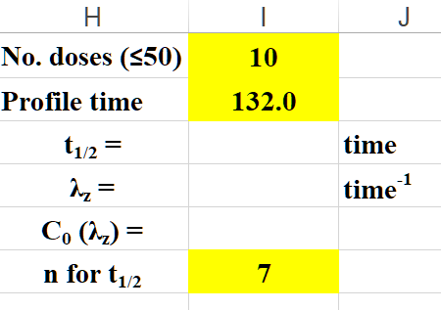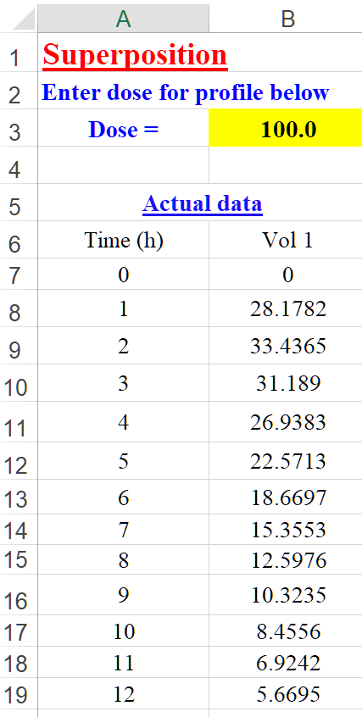

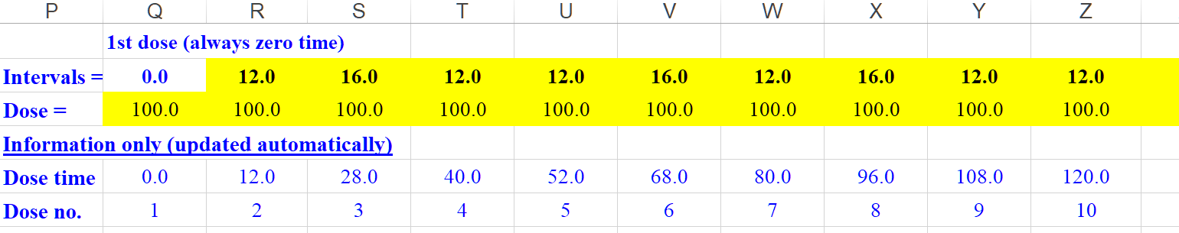

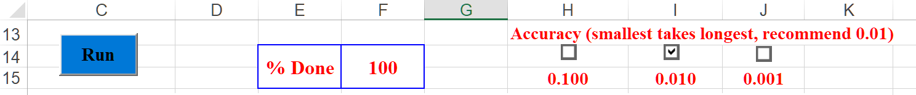

The graphical output from the program for Example 1 is shown in Figure 45 wherein; the concentration-time profile is depicted for information.

#### Figure 45: Output graphics from Example 1 simulation (10 doses)

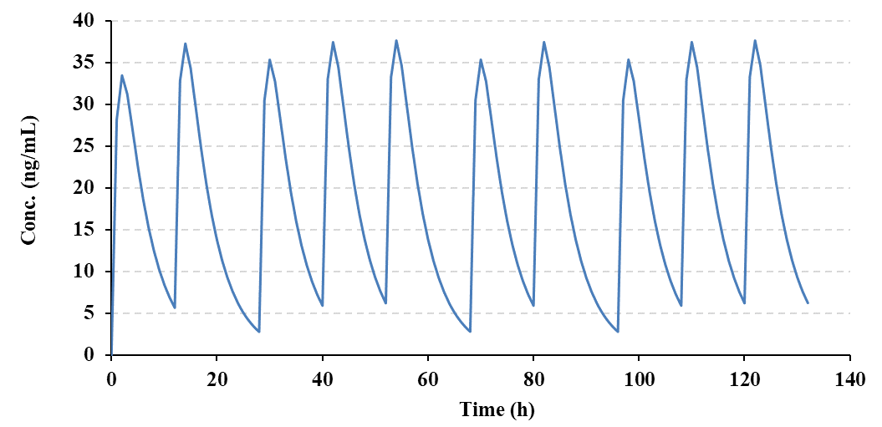

The numerical results from the Superposition Example 1, are shown in Figure 46 and contain Cmin and Cmax in addition to AUC0-τ, for all doses, together with the predicted concentration data for the t½ assignment. There are also plots for Cmin and Cmax vs. Dose number and for the 1st and last dose.

#### Figure 46: Results showing Cmin and Cmax in addition to AUC0-τ for all doses (Example 1)

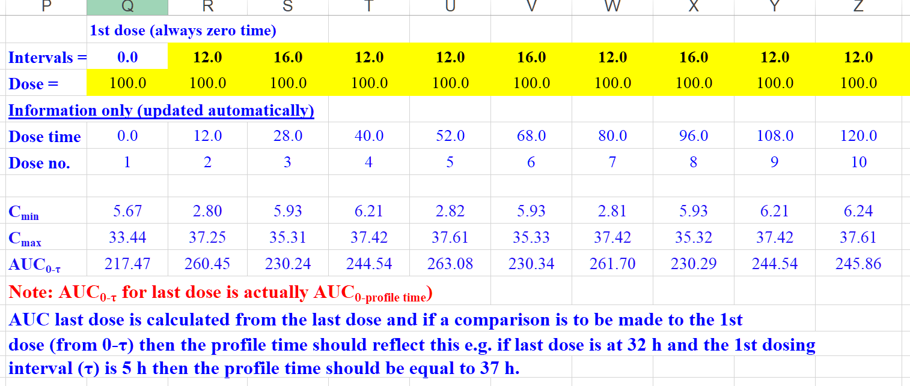

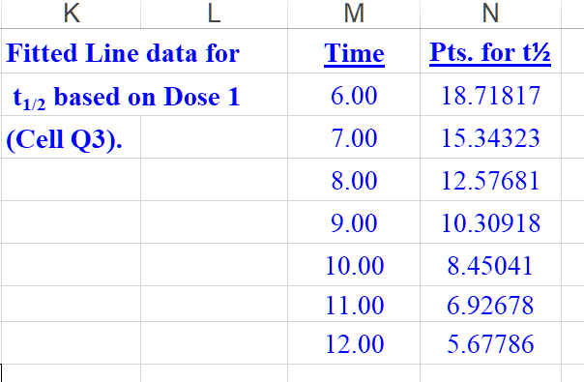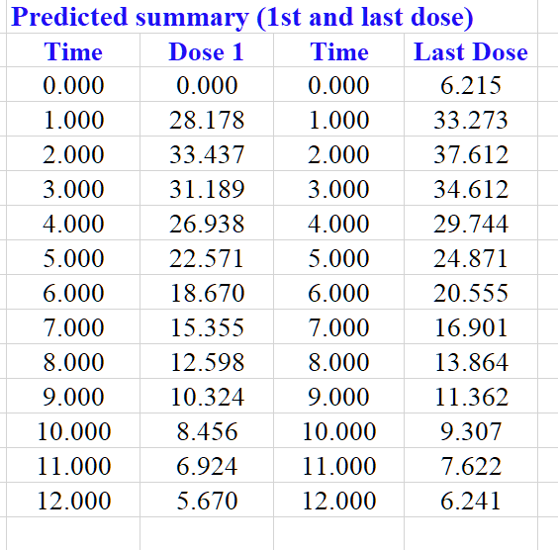

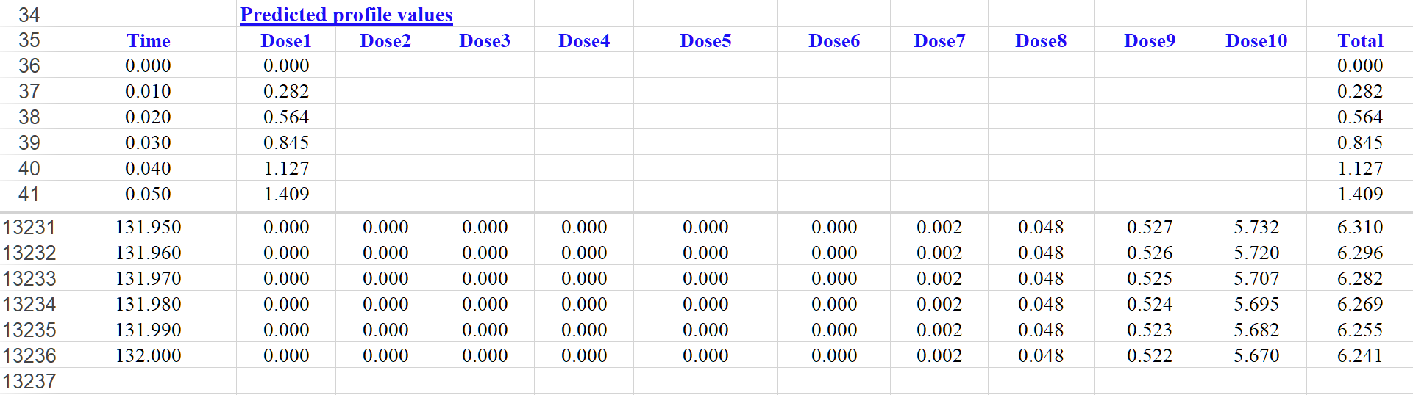

**Additional plots shown for Example 1 output.**

|  |  |
| --- | --- |
|  |  |
|  |  |

Example 2; the same set of concentration time data was used as for Example 1, however this time different doses were used just to demonstrate its versatility. Note that each dose (shown in Figure 47) is compared to the original data dose (cell B3) and the concentrations adjusted automatically for this scenario. All of the output both numerical and pictorial will automatically update in the spreadsheet on completion of the run. The graphic output from this run is shown in Figure 48 for information.

#### Figure 47: Example 2 setup parameters showing different doses and intervals.

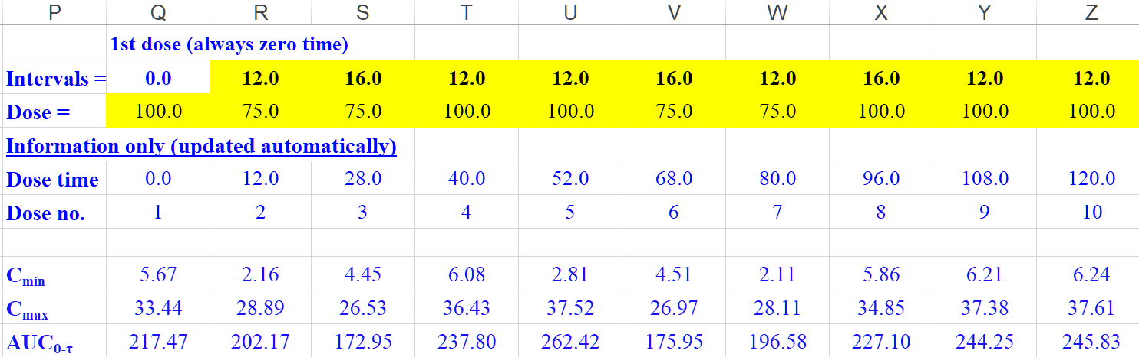

#### Figure 48: Output graphics from Example 2 simulation (different doses and intervals)

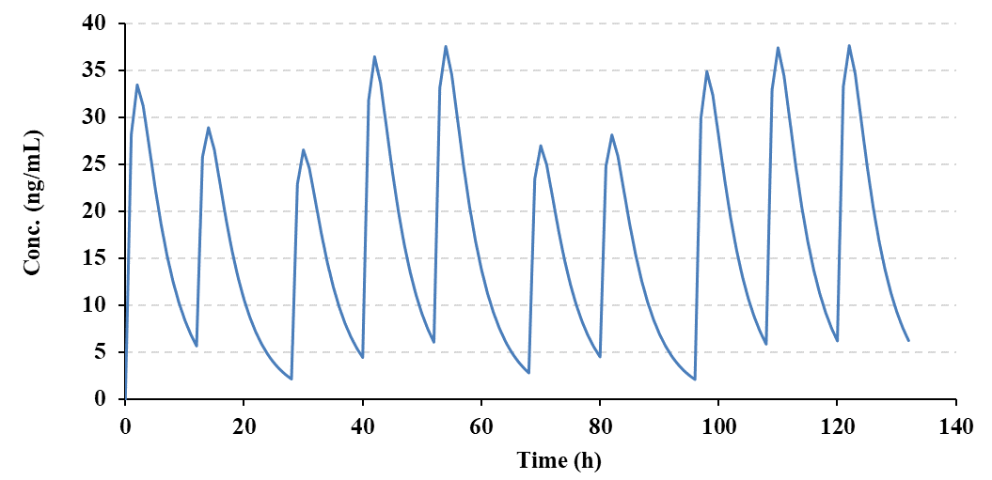

## **Deconvolution**

The deconvolution method in PCModfit for oral data has been completely rewritten and now uses a Loo-Riegelman approach (Ref. J. Pharm. Sci., 57:918, 1968) with modified equations by Wagner (Ref. J. Pharm. Sci., Vol. 72, No. 7, July 1983) both of which require intravenous parameters to be available. One of the primary reasons for conducting Deconvolution is to gain an estimate of a drug input rate which can be very useful when comparing different formulations for oral administration or in inhalation studies in addition to other dosing routes. For information, the pictorial model (3 compartment oral) and equations used in PCModfit are shown for 1, 2 and 3 compartment oral models to indicate the transfer rate parameters.

ka

Gut

Blood (1)

Tissue (2)

Tissue (3)

Waste

k10

k12

k21

k31

k13

1-compartment: ${A_{T}}/{V_{p}}=C_{T}+k_{10}\int_{0}^{T}{Cdt}$

2-compartment: ${A_{T}}/{V_{p}}=C_{T}+k_{10}\int_{0}^{T}{Cdt+}k_{12}e^{-k_{21}T}\int_{0}^{T}{Ce^{k_{21}t}dt}$

3-compartment: ${A_{T}}/{V_{p}}=C_{T}+k_{10}\int_{0}^{T}{Cdt+}k_{12}e^{-k_{21}T}\int_{0}^{T}{Ce^{k_{21}t}dt+k_{13}e^{-k_{31}T}\int_{0}^{T}{Ce^{k_{31}t}dt}}$

where:

CT is the concentration at time T, AT is the amount of drug absorbed from time 0 to T (sampling time) and Vp the volume of the central compartment. For the analyses, the volume term is not required; just the rate constants as shown in the spreadsheet options.

The functions contain various integration steps and for all of these the appropriate AUC values are calculated using methods wherein; ascending values are analysed using linear trapezoidal and descending values with logarithmic trapezoidal approach to try and minimise the summation errors.

The procedure (‘LR Deconvolution’ sheet in PCModfit) will, depending on the model chosen, estimate either the % Absorbed or % Remaining to be absorbed of a drug vs. Time data. The data results and plots produced can be utilised to estimate absorption rates (ka values) either by simple regression on ‘% Remaining *vs.* Time’ data or by an increasing exponential function for the ‘% Absorbed *vs*. Time’. The procedure is relatively easy to execute with all calculations conducted in Excel® for ease of use. In the examples below, the LR Deconvolution routine was run using sets of simulated oral data exhibiting 1, 2 and 3-compartment kinetics, all with known i.v. parameters. The oral data were generated using the ‘SD Simulator’ option with the parameters shown in the following Tables.

Note that there is a % Cut-off value which can be varied by the user depending on the data sets. Specifying a value too low can cause error accumulation at later time points due to the nature of the functions so a value around 1-10 % usually works ok. Another reason for a defining a Cut-off setting is the fact that at later time points, for most profiles, the absorption would be complete so the later values would be essentially redundant. During the analysis, the picture in the spreadsheet (containing the Deconvolution profile) will automatically update and a high-quality graphic file will be created in directory C:\PCModfit Vx.x\Results\ (x.x being the version number) with names such as LR3.PNG or LR15.PNG which can be used in other documents. In addition to the text file output, the deconvoluted data can be copied into the clipboard for pasting into other documents.

As an estimate of ka is often required, the following examples for all models (1, 2 and 3 compartment) show both % Remaining and % Absorbed approaches with a 1 % Cut-off level together with the input parameters required for the analyses. The 3-sets of oral data are shown in Figure 49 together with the parameters used to generate the oral data (utilising the ‘SD Simulator’ option in the program).

#### Figure 49: Example profiles of oral data for Deconvolution analysis (parameters included)

|  |  |  |  |  |  |
| --- | --- | --- | --- | --- | --- |
| **Concentration-time data for 1, 2 and 3-compartment oral profiles** | | | | | |
| Time | 1-Compartment | Time | 2-Compartment | Time | 3-Compartment |
| 0 | 0.0 | 0 | 0.0 | 0.0 | 0.000 |
| 0.1 | 13.5782 | 0.05 | 6.9582 | 0.05 | 9.1404 |
| 0.2 | 24.6029 | 0.10 | 12.9117 | 0.10 | 16.7126 |
| 0.3 | 33.4620 | 0.15 | 17.9702 | 0.20 | 27.9573 |
| 0.4 | 40.4879 | 0.25 | 25.7880 | 0.25 | 31.9732 |
| 0.5 | 45.9651 | 0.50 | 35.5163 | 0.50 | 41.1683 |
| 1.0 | 57.5101 | 0.75 | 36.7513 | 0.75 | 40.1184 |
| 1.5 | 55.0451 | 1.0 | 33.8825 | 1.0 | 35.1676 |
| 2.0 | 47.7139 | 2.0 | 16.1379 | 2.0 | 16.0230 |
| 3.0 | 31.8032 | 3.0 | 6.6452 | 3.0 | 8.9043 |
| 4.0 | 19.9285 | 4.0 | 3.2592 | 4.0 | 6.8564 |
| 5.0 | 12.2298 | 6.0 | 1.7742 | 5.0 | 6.1221 |
| 6.0 | 7.4495 | 8.0 | 1.4781 | 6.0 | 5.6942 |
| 8.0 | 2.7464 | 12.0 | 1.1342 | 8.0 | 5.0330 |
| 10.0 | 1.0106 | 16.0 | 0.8740 | 10.0 | 4.4698 |
| 12.0 | 0.3718 | 20.0 | 0.6735 | 12.0 | 3.9782 |
| Dose | 1000 | 24.0 | 0.5190 | 16.0 | 3.1707 |
| V | 10 | 30.0 | 0.3510 | 20.0 | 2.5477 |
| ka | 1.5 | 36.0 | 0.2375 | 24.0 | 2.0634 |
| **k10** | **0.50** | 40.0 | 0.1830 | 30.0 | 1.5251 |
|  |  | 48.0 | 0.1087 | 36.0 | 1.1447 |
|  |  | Dose | 1000 | 40.0 | 0.9527 |
|  |  | V | 10 | 48.0 | 0.6705 |
|  |  | ka | 1.5 | 60.0 | 0.4085 |
|  |  | **k10** | **1.0** | 72.0 | 0.2555 |
|  |  | **k12** | **0.5** | 84.0 | 0.1625 |
|  |  | **k21** | **0.1** | 96.0 | 0.1044 |
|  |  |  |  | 108.0 | 0.0675 |
|  |  |  |  | 112.0 | 0.0584 |
|  |  |  |  | 116.0 | 0.0506 |
|  |  |  |  | 120.0 | 0.0438 |
|  |  |  |  | Dose | 1000 |
|  |  |  |  | V | 10 |
|  |  |  |  | ka | 2.0 |
|  |  |  |  | **k10** | **0.5** |
|  |  |  |  | **k12** | **1.0** |
|  |  |  |  | **k21** | **0.2** |
|  |  |  |  | **k13** | **0.1** |
|  |  |  |  | **k31** | **0.05** |

Note: the parameters (obtained from i.v. data) below each data set were used to generate the oral profiles shown here. The parameters in ‘Blue’ will be the ones required for running the program.

Specifically, the steps required to perform a Deconvolution analysis are detailed as follows for the 2-compartment data although the results are also presented for all 3 profiles shown later in this Section.

**Step 1**

Enter the data and parameters for a particular model, in this example a 2-compartment, into the spreadsheet shown in Figure 50 (although many profiles can be analysed in one batch, the number of compartments must be the same for each run as the ‘Options’ section requires a single model to be defined, shown in Figure 51). Note that the oral profile requires AUC0-∞ so the correct calculations can be expedited. This can be easily conducted using the NCA option within the program. For information, the points used for the oral NCA are shown below which yielded values for AUC0-∞ and λz of 99.2555 and 0.065153, respectively, for n=4 points.

#### Figure 50: PCModfit input for a 2-compt. model data set (with NCA results for estimating AUC0-∞)

|  |  |  |  |  |  |  |  |  |  |  |  |  |  |  |  |  |  |  |  |  |  |  |  |  |  |  |  |  |  |  |  |  |  |  |  |  |  |  |  |  |  |  |  |  |  |  |  |  |  |  |  |  |  |  |  |  |  |  |  |  |  |  |  |  |  |  |  |  |  |  |  |  |  |  |  |  |  |  |  |  |  |  |  |  |  |  |  |  |  |  |  |  |  |  |  |  |  |  |  |  |  |  |  |  |  |  |  |  |  |  |  |  |  |  |  |  |  |  |  |  |  |  |  |  |  |  |  |  |  |  |  |  |  |  |  |  |  |  |  |  |  |  |  |  |  |  |  |  |  |  |  |
| --- | --- | --- | --- | --- | --- | --- | --- | --- | --- | --- | --- | --- | --- | --- | --- | --- | --- | --- | --- | --- | --- | --- | --- | --- | --- | --- | --- | --- | --- | --- | --- | --- | --- | --- | --- | --- | --- | --- | --- | --- | --- | --- | --- | --- | --- | --- | --- | --- | --- | --- | --- | --- | --- | --- | --- | --- | --- | --- | --- | --- | --- | --- | --- | --- | --- | --- | --- | --- | --- | --- | --- | --- | --- | --- | --- | --- | --- | --- | --- | --- | --- | --- | --- | --- | --- | --- | --- | --- | --- | --- | --- | --- | --- | --- | --- | --- | --- | --- | --- | --- | --- | --- | --- | --- | --- | --- | --- | --- | --- | --- | --- | --- | --- | --- | --- | --- | --- | --- | --- | --- | --- | --- | --- | --- | --- | --- | --- | --- | --- | --- | --- | --- | --- | --- | --- | --- | --- | --- | --- | --- | --- | --- | --- | --- | --- | --- | --- | --- | --- | --- | --- |
| |  |  |  | | --- | --- | --- | | **Enter the oral AUC0-∞ values from NCA** | | | |  |  |  | |  | **AUC0-∞** | 99.2555 | |  |  |  | |  |  | **V1** | |  | **(k10)** | 1.00 | |  | **(k12)** | 0.50 | |  | **(k21)** | 0.10 | |  | **(k13)** |  | |  | **(k31)** |  | |  |  |  | | **Oral Data** | Time | Compts.2 | |  | 0 | 0.0 | |  | 0.05 | 6.9582 | |  | 0.10 | 12.9117 | |  | 0.15 | 17.9702 | |  | 0.25 | 25.7880 | |  | 0.50 | 35.5163 | |  | 0.75 | 36.7513 | |  | 1.00 | 33.8825 | |  | 2.00 | 16.1379 | |  | 3.00 | 6.6452 | |  | 4.00 | 3.2592 | |  | 6.00 | 1.7742 | |  | 8.00 | 1.4781 | |  | 12.00 | 1.1342 | |  | 16.00 | 0.8740 | |  | 20.00 | 0.6735 | |  | 24.00 | 0.5190 | |  | 30.00 | 0.3510 | |  | 36.00 | 0.2375 | |  | 40.00 | 0.1830 | |  | 48.00 | 0.1087 | | **NCA analysis for AUC0-∞**     |  |  |  | | --- | --- | --- | | **NCA** | **Profile** | Compts.2 | | **Results** | **AUC time range** | 0 to 48 | |  | **Tmax** | 0.75 | |  | **Cmax** | 36.75 | |  | **Lin AUC** | 99.8994 | |  | **Log AUC** | 97.4765 | |  | **Lin/Log AUC** | 97.5879 | |  | **AUMC** | 559.6810 | |  | **AUMC∞** | 665.3225 | |  | **λz** | 0.065153 | |  | **t½** | 10.64 | |  | **Lin AUC∞** | 101.5670 | |  | **Log AUC∞** | 99.1442 | | **Value used** | **Lin/Log AUC∞** | **99.2555** | |  | **R²** | 1.0000 | |  | **No. pts. for t½** | 4 | |  | **No. pts. (total)** | 21 | |

**Step 2**

After entering the data as outlined in Step 1, the Options section in the spreadsheet (Figure 51) will require populating by clicking the appropriate Check Boxes to define the type of analysis, model, data layout and entering a % Cut-off value (recommend 1 to 10 %).

#### 

#### Figure 51: Example LR analysis (input and options)

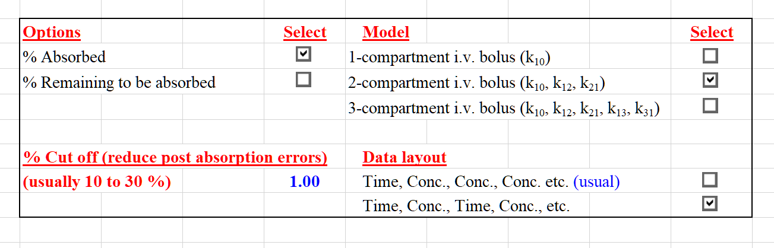

Once this is setup, click the ‘Run’ button and the graph will be updated (Figure 52). Then click ‘Next’ to finish or to continue with the next profile. At the end, click ‘Next’ again to ensure a small Window pops-up (similar to the one below) to indicate that the program has finished and to show where the generated files are stored.

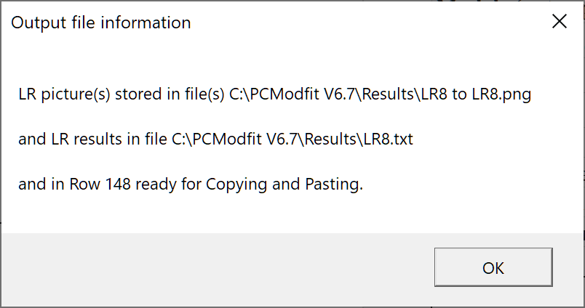

#### Figure 52: Example graphic output (% Absorbed) for 2-compartment oral data

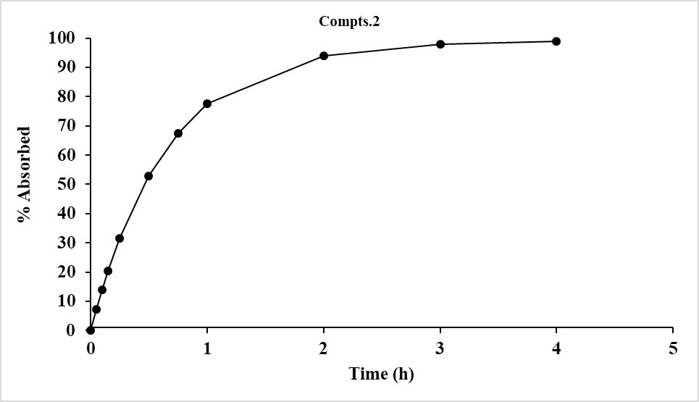

The shortcut button ‘Row 148’ will scroll down to display the results (in column E onwards) and these can be copied for use to either estimate ka values or to use in other documents. If a result is required for % Remaining instead of % Absorbed, then simply select this option and repeat ‘Run’.

The set of results for the 3-profiles in these example sets, shown in Figure 49, using both types of analysis are displayed in Figure 53 using a 1 % Cut-off value to reduce later time point cumulative errors post-absorption.

#### Figure 53: Both types of Deconvoluted results from 1, 2 and 3-compartment oral data (1 % cut off)

|  |  |  |  |  |  |  |  |  |  |  |  |
| --- | --- | --- | --- | --- | --- | --- | --- | --- | --- | --- | --- |
| **1-compt. data** | | | | **2-compt. data** | | | | **3-compt. data** | | | |
| Time | Conc. | %Abs | %Rem | Time | Conc. | %Abs | %Rem | Time | Conc. | %Abs | %Rem |
| 0 | 0.0 | 0 | 100.0 | 0 | 0.0 | 0 | 100.0 | 0.0 | 0.0 | 0 | 100.0 |
| 0.1 | 13.5782 | 14.05 | 85.950 | 0.05 | 6.9582 | 7.273 | 92.727 | 0.05 | 9.1404 | 9.511 | 90.489 |
| 0.2 | 24.6029 | 26.14 | 73.857 | 0.10 | 12.9117 | 14.021 | 85.979 | 0.10 | 16.7126 | 18.117 | 81.883 |
| 0.3 | 33.4620 | 36.55 | 63.449 | 0.15 | 17.9702 | 20.282 | 79.718 | 0.20 | 27.9573 | 32.908 | 67.092 |
| 0.4 | 40.4879 | 45.51 | 54.490 | 0.25 | 25.7880 | 31.453 | 68.547 | 0.25 | 31.9732 | 39.286 | 60.714 |
| 0.5 | 45.9651 | 53.22 | 46.778 | 0.50 | 35.5163 | 52.750 | 47.250 | 0.50 | 41.1683 | 62.695 | 37.305 |
| 1.0 | 57.5101 | 77.93 | 22.067 | 0.75 | 36.7513 | 67.453 | 32.547 | 0.75 | 40.1184 | 76.989 | 23.011 |
| 1.5 | 55.0451 | 89.65 | 10.354 | 1.0 | 33.8825 | 77.597 | 22.403 | 1.0 | 35.1676 | 85.708 | 14.292 |
| 2.0 | 47.7139 | 95.19 | 4.810 | 2.0 | 16.1379 | 93.880 | 6.120 | 2.0 | 16.0230 | 97.199 | 2.801 |
| 3.0 | 31.8032 | 98.93 | 1.075 | 3.0 | 6.6452 | 97.888 | 2.112 |  |  |  |  |
|  |  |  |  | 4.0 | 3.2592 | 98.967 | 1.033 |  |  |  |  |

%Abs % Absorbed

%Rem % Remaining to be absorbed

#### Figure 54: Deconvoluted graphic results from 1, 2 and 3-compartment oral data (1 % cut off)

**1-compartment**

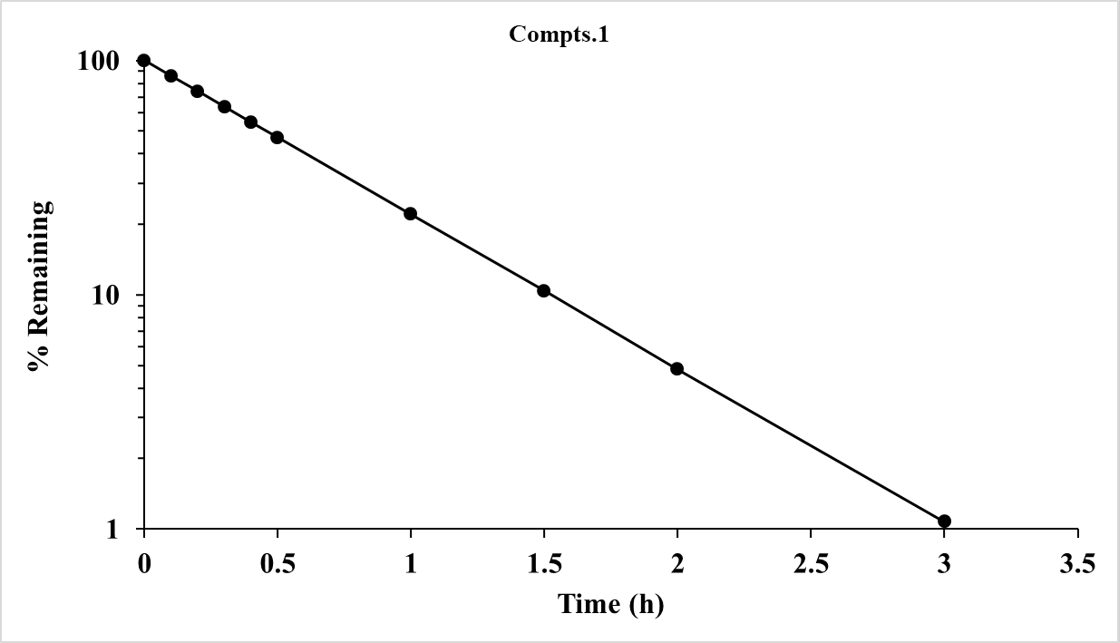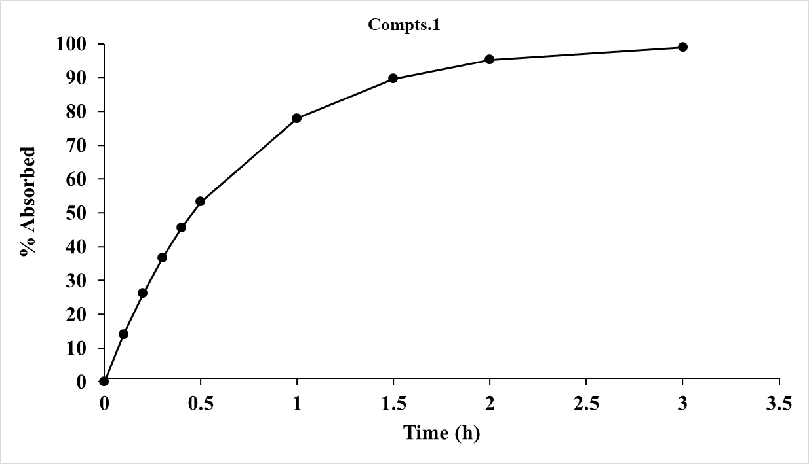

**2-compartment**

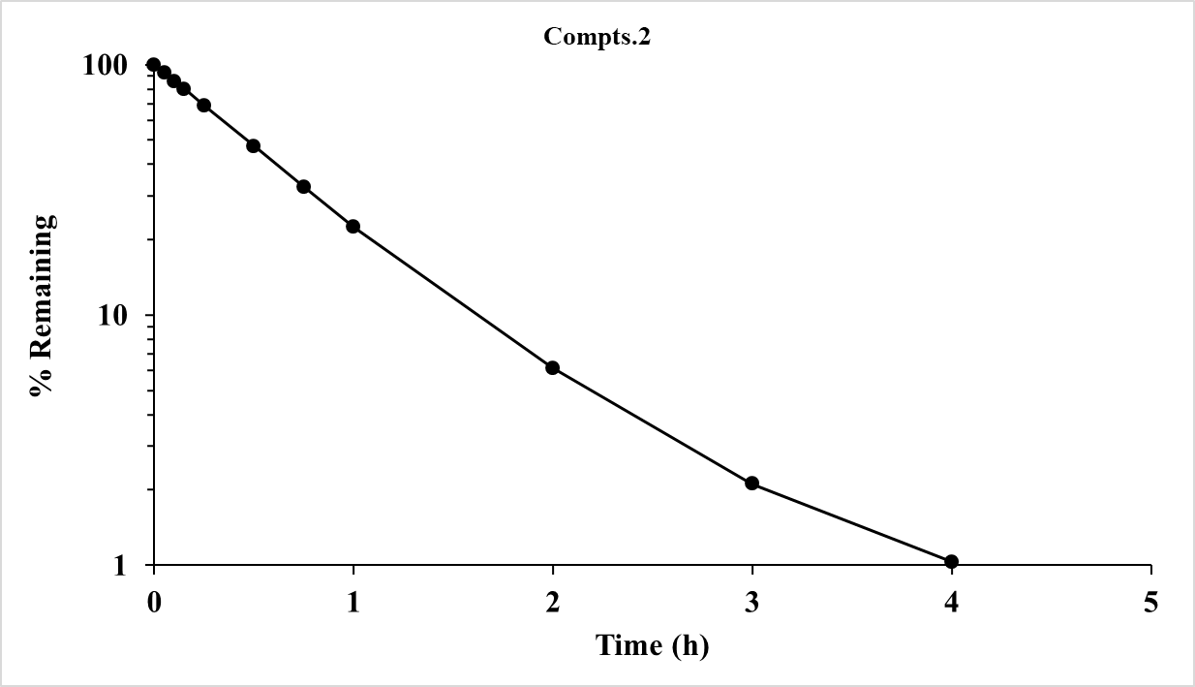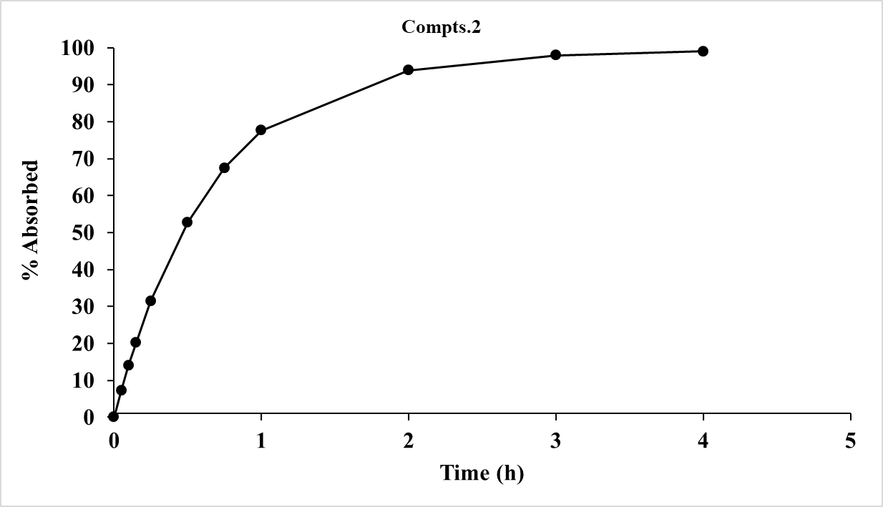

**3-compartment**

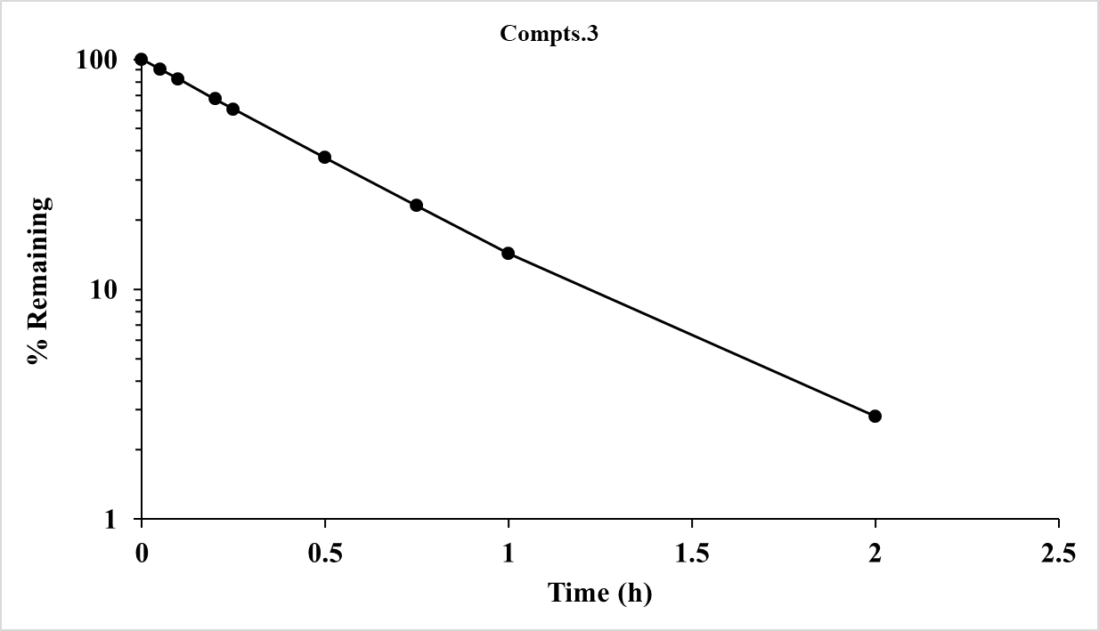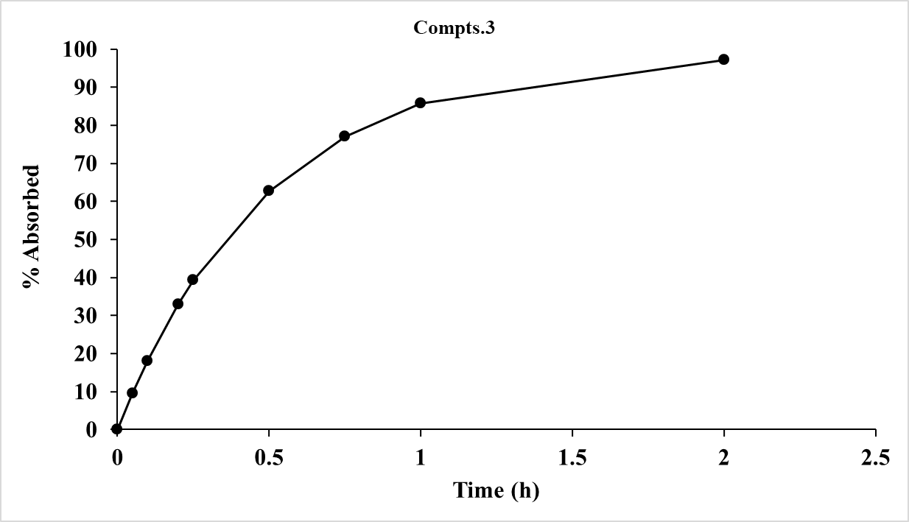

**Step 3**

To obtain estimates of the absorption parameter (ka) for each of the 3-profiles, two approaches can be used depending on how good the results are and a summary of both types for these examples are presented together in Figure 55.

#### Figure 55: Results of ka estimates from %Absorbed and %Remaining data

|  |  |  |  |  |  |  |  |  |  |  |  |
| --- | --- | --- | --- | --- | --- | --- | --- | --- | --- | --- | --- |
| **1-compt. data** | | | | **2-compt. data** | | | | **3-compt. data** | | | |
| Time | Conc. | %Abs | %Rem | Time | Conc. | %Abs | %Rem | Time | Conc. | %Abs | %Rem |
| 0 | 0.0 | 0 | 100.0 | 0 | 0.0 | 0 | 100.0 | 0.0 | 0.0 | 0 | 100.0 |
| 0.1 | 13.5782 | 14.05 | 85.950 | 0.05 | 6.9582 | 7.273 | 92.727 | 0.05 | 9.1404 | 9.511 | 90.489 |
| 0.2 | 24.6029 | 26.14 | 73.857 | 0.10 | 12.9117 | 14.021 | 85.979 | 0.10 | 16.7126 | 18.117 | 81.883 |
| 0.3 | 33.4620 | 36.55 | 63.449 | 0.15 | 17.9702 | 20.282 | 79.718 | 0.20 | 27.9573 | 32.908 | 67.092 |
| 0.4 | 40.4879 | 45.51 | 54.490 | 0.25 | 25.7880 | 31.453 | 68.547 | 0.25 | 31.9732 | 39.286 | 60.714 |
| 0.5 | 45.9651 | 53.22 | 46.778 | 0.50 | 35.5163 | 52.750 | 47.250 | 0.50 | 41.1683 | 62.695 | 37.305 |
| 1.0 | 57.5101 | 77.93 | 22.067 | 0.75 | 36.7513 | 67.453 | 32.547 | 0.75 | 40.1184 | 76.989 | 23.011 |
| 1.5 | 55.0451 | 89.65 | 10.354 | 1.0 | 33.8825 | 77.597 | 22.403 | 1.0 | 35.1676 | 85.708 | 14.292 |
| 2.0 | 47.7139 | 95.19 | 4.810 | 2.0 | 16.1379 | 93.880 | 6.120 | 2.0 | 16.0230 | 97.199 | 2.801 |
| 3.0 | 31.8032 | 98.93 | 1.075 | 3.0 | 6.6452 | 97.888 | 2.112 |  |  |  |  |
|  |  |  |  | 4.0 | 3.2592 | 98.967 | 1.033 |  |  |  |  |
| **Analysis type** | | **Modelling** | **NCA** | **Analysis type** | | **Modelling** | **NCA** | **Analysis type** | | **Modelling** | **NCA** |
| ka Deconv. | | 1.517 | 1.512 | ka Deconv. | | 1.520 | 1.495 | ka Deconv. | | 2.017 | 1.946 |
| ka Theory | | 1.50 | | ka Theory | | 1.50 | | ka Theory | | 2.00 | |
| No. pts. | | 10 | 10 | No. pts. | | 11 | 8 | No. pts. | | 9 | 8 |

## **Time above an MIC option**

There are occasions when it is useful to gain an estimate of time and/or AUC of a profile above a certain concentration (e.g., MIC level) that are typically used for drugs that are antibiotic and antifungal in nature. The PCModfit spreadsheet option ‘Time above’, will allow users to conduct this sort of analysis easily and quickly. As an example, 7 different sets of data were analysed (2 doses over a 24 h time period) to gain an estimate of time and exposure above a MIC value of 150 ng/mL across the complete profiles. The data used for the analysis are shown in Figure 56 with the results and a graphical representation of the analysis depicted in Figure 57. These were copied from the ‘Time above’ spreadsheet in PCModfit and note that there is now an additional option in V7.1 onwards that allows the user to enter data in 2 different ways by the appropriate CheckBox selection before clicking the ‘Run’ button. V7.2 onwards now allows axis titles and legends to be added before running.

1. The same nominal time for all data sets (select ‘Time, Conc., Conc., Conc’. etc.) as used in this example.

**or**

1. Different time values for each data set (select ‘Time, Conc., Time, Conc.’ etc.) as is often encountered in Phase II studies (brief layout also shown below - the time values are the same as shown in this example but can be different if required).

#### Figure 56: Example time-concentration data (ng/mL) sets used for analysis (n=7)

|  |  |  |  |  |  |  |  |
| --- | --- | --- | --- | --- | --- | --- | --- |
| **Time (h)** | **Set1** | **Set2** | **Set3** | **Set4** | **Set5** | **Set6** | **Set7** |
| 0 | 0.0 | 0.0 | 0.0 | 0.0 | 0.0 | 0.0 | 0.0 |
| 0.25 | 107.77 | 150.88 | 106.69 | 130.40 | 85.14 | 94.84 | 129.32 |
| 0.5 | 186.44 | 208.82 | 229.32 | 165.93 | 261.02 | 193.90 | 124.92 |
| 0.75 | 242.71 | 157.76 | 242.71 | 245.14 | 179.61 | 281.55 | 235.43 |
| 1 | 281.78 | 318.41 | 388.86 | 180.34 | 211.34 | 231.06 | 315.60 |
| 1.25 | 307.69 | 396.91 | 421.53 | 338.45 | 341.53 | 295.38 | 276.92 |
| 1.5 | 323.56 | 326.79 | 449.74 | 236.20 | 310.61 | 407.68 | 430.33 |
| 1.75 | 331.82 | 252.18 | 451.28 | 434.69 | 391.55 | 438.00 | 401.50 |
| 2 | 334.37 | 270.84 | 224.02 | 234.06 | 347.74 | 384.52 | 431.33 |
| 3 | 311.89 | 230.80 | 308.77 | 324.37 | 277.58 | 361.79 | 233.92 |
| 4 | 269.38 | 358.28 | 180.49 | 323.26 | 164.32 | 226.28 | 355.59 |
| 6 | 186.70 | 112.02 | 160.56 | 153.09 | 175.50 | 248.31 | 261.38 |
| 8 | 125.98 | 148.65 | 163.77 | 152.43 | 129.76 | 122.20 | 100.78 |
| 10 | 84.56 | 96.39 | 104.00 | 81.17 | 62.57 | 74.41 | 104.00 |
| 12 | 56.70 | 56.70 | 53.29 | 78.24 | 47.62 | 73.14 | 34.02 |
| 14 | 372.37 | 361.20 | 338.86 | 484.08 | 472.91 | 312.79 | 502.70 |
| 16 | 294.86 | 386.27 | 191.66 | 188.71 | 380.37 | 271.27 | 244.73 |
| 18 | 203.77 | 167.09 | 283.25 | 132.45 | 144.68 | 181.36 | 197.66 |
| 20 | 137.42 | 115.44 | 83.83 | 177.28 | 167.66 | 185.52 | 170.40 |
| 22 | 92.23 | 112.52 | 58.10 | 75.63 | 65.48 | 75.63 | 81.16 |
| 24 | 61.84 | 43.29 | 76.06 | 51.33 | 47.62 | 82.24 | 56.89 |

**or**

|  |  |  |  |  |  |  |  |
| --- | --- | --- | --- | --- | --- | --- | --- |
| **Time (h)** | **Set1** | **Time (h)** | **Set2** | **Time (h)** | **Set3** | **etc.** |  |
| 0 | 0.0 | 0 | 0.0 | 0 | 0.0 |  |  |
| 0.25 | 107.77 | 0.25 | 150.88 | 0.25 | 106.69 |  |  |
| 0.5 | 186.44 | 0.5 | 208.82 | 0.5 | 229.32 |  |  |
| 0.75 | 242.71 | 0.75 | 157.76 | 0.75 | 242.71 |  |  |
| 1 | 281.78 | 1 | 318.41 | 1 | 388.86 |  |  |
| **etc.** |  |  |  |  |  |  |  |

#### Figure 57: Time and exposure results and graph

|  |  |  |  |  |  |  |  |  |  |  |  |  |  |  |  |
| --- | --- | --- | --- | --- | --- | --- | --- | --- | --- | --- | --- | --- | --- | --- | --- |
|  | **No. Profiles found =** | | **7** |  |  |  |  |  |  |  |  |  |  |  |  |
| **Profile Ref.** |  | Set1 | Set2 | Set3 | Set4 | Set5 | Set6 | Set7 | Min. | Max. | Mean | GMean | Median | SD | CV |
| **No. pts. at or above MIC** |  | 13 | 13 | 14 | 14 | 13 | 14 | 13 | 13 | 14 | 13 | 13 | 13 | 1 | 4 |
| **Time at or above MIC** |  | 13.9 | 11.5 | 14.8 | 14.5 | 14.1 | 15.2 | 14.8 | 11.5 | 15.2 | 14.1 | 14.0 | 14.5 | 1.2 | 8.7 |
| **AUC0-t values** |  | 4541.4 | 4546.3 | 4242.8 | 4485.8 | 4527.3 | 4598.6 | 4965.9 | 4242.8 | 4965.9 | 4558.3 | 4554.1 | 4541.4 | 213.7 | 4.7 |
| **AUC above MIC** |  | 1472.2 | 1479.9 | 1225.6 | 1367.9 | 1546.4 | 1507.2 | 1909.7 | 1225.6 | 1909.7 | 1501.3 | 1489.4 | 1479.9 | 209.8 | 14.0 |
| **No. pts. in data set** |  | 21.0 | 21.0 | 21.0 | 21.0 | 21.0 | 21.0 | 21.0 | 21.0 | 21.0 | 21.0 | 21.0 | 21.0 | 0.0 | 0.0 |
| **Cmax/MIC** |  | 2.48 | 2.65 | 3.01 | 3.23 | 3.2 | 2.9 | 3.4 | 2.5 | 3.4 | 3.0 | 3.0 | 3.0 | 0.3 | 10.6 |
| **Last time pt. found** |  | 24.0 | 24.0 | 24.0 | 24.0 | 24.0 | 24.0 | 24.0 | 24.0 | 24.0 | 24.0 | 24.0 | 24.0 | 0.0 | 0.0 |

Notes: AUC values are calculated using the linear trapezoidal method.

MIC concentration must be in the same units as the concentration values.

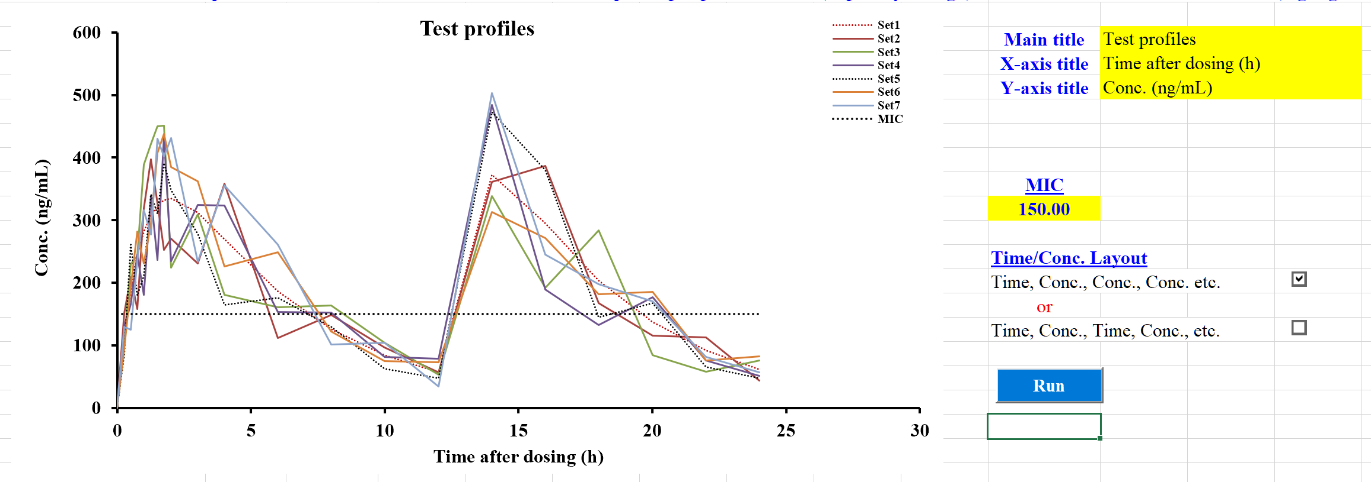

## **Compartmental analysis (principles and modelling data)**

There are occasions when compartmental analysis of data sets is desirable to gain a further understanding of the pharmacokinetics of a particular drug and to then conduct predictions under various conditions. The concept of compartments has been around for many years and essentially considers a biological system to be made up of hypothetical regions or compartments. As an example, a biological entity (human, rodent etc.) could contain one or more compartments (numbered accordingly) such as the Gut (0), blood (1), highly perfused tissues (2) and poorly perfused tissues (3) with sometimes additional ones depending on the drug behaviour. These compartments are not isolated or simply enclosed systems (as portrayed in the pictures below) but rather the drug being investigated may happily transfer between compartments and indeed ‘leak’ into other areas of the body thus making for an overall dynamic process and not a static one. Compartmental analysis (with all of its mathematical intricacies and nuances) can be considered an approximation into the biological fate of a particular drug. It can be particularly helpful in trying to decipher the what the drug and/or metabolites are doing mathematically in a biological system and potentially, how long it resides in a particular region or compartment. Simplistically, the following pictures represent a few different scenarios to help any naïve reader understand the basic concepts. The parameters such as ka, k12 etc., are mathematical transfer rates of drug molecules moving from one compartment to another over various time periods.

**2-compt. oral (3-exponentials). Dose administered into compartment 0.**

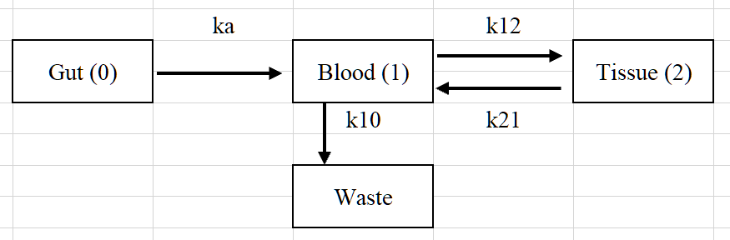

**3-compt. oral (4-exponentials). Dose administered into compartment 0.**

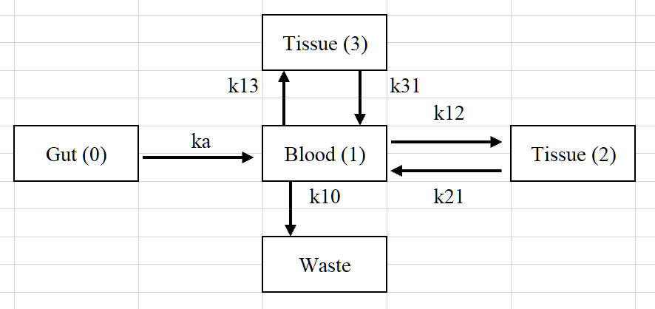

**Intravenous 2-compt. (2 exponentials) and 3-compt. (3-exponentials). Doses administered into compartment 1.**

|  |  |
| --- | --- |
|  |  |

### Control data set up and initialisation

In the ‘Modelling’ spreadsheet (Row 18) and in Figure 58 there is a description of the Keywords that can be used for Control initiation. To make life easier for the user, select the requirements for a fitting run first, then click the ‘Keywords’ button to show what the layout should be e.g.,



For this example, clicking the Keywords button (on row 52 of the Sheet) will generate a layout as follows. Then enter your own values into the cells as shown for this example. Once the setup values have been entered, click the ‘Activate’ button which stores the information ready for running after the concentration-time data have been added.

‘Keywords’ output User entered values

 

For information, all the Keywords are shown as follows for information.

#### Figure 58: Keyword information for Control parameters (user options)

|  |  |  |
| --- | --- | --- |
| **Keywords for single dose profiles** | | |
| **Title** | Each profile should have a title | Compulsory (will be added if absent) |
| **Dose** | Dose of drug (careful with units) | Compulsory (oral or bolus only. Zero if infusion) |
| **Ndoses** | Number of doses given | Compulsory but updated automatically to 1 |
| **Pars** | Model parameters (in sequence) | Optional (some models generate starting parameters) |
| **Inftime** | Infusion time | Compulsory (infusion models only) |
| **Infrate** | Infusion rate | Compulsory (infusion models only) |
| **Infbol** | Bolus dose for bolus + infusion only | Compulsory (bolus dose for bolus + infusion models) |
| **Conmin** | Minimum parameter value | Optional |
| **Conmax** | Maximum parameter value | Optional |
| **Keywords for repeat dose profiles**  **Example model no. for each dose (for Mixed models only). Not used for Single or Repeat dose only**   |  |  |  |  |  |  | | --- | --- | --- | --- | --- | --- | | **Model number for each dose.** | 16 | 10 | 16 | 10 | 16 | | | |

|  |  |  |
| --- | --- | --- |
| **Title** | Each profile should have a title | Compulsory (will be added if absent) |
| **Dose** | Not used but must be present | Compulsory (0.0 will be added automatically) |
| **Ndoses** | Number of doses given | Compulsory |
| **Pars** | Parameters | Compulsory |
| **Doseint** | Dosing interval (1 less than Ndoses) | Compulsory (1st dose starts at time 0.0) |
| **Inftime** | Infusion time | Compulsory (infusion models) |
| **Infrate** | Infusion rate | Compulsory (infusion models) |
| **Infbol** | Bolus dose for bolus + infusion only | Compulsory (bolus dose for bolus + infusion models) |
| **Repdose** | Dose for each interval | Compulsory (oral or bolus without infusion) |
| **Conmin** | Minimum parameter value | Optional |
| **Conmax** | Maximum parameter value | Optional |

In Figure 59 there are several examples of single dose scenarios and how to set up the Control layout prior to modelling data to help the user. The Control data must be entered into the ‘Modelling’ spreadsheet starting at Row 54.

#### Figure 59: Examples of Control layout for various models using single a dose

|  |  |  |
| --- | --- | --- |
| **Control layout** | **Model description** | **Comments** |
| |  |  | | --- | --- | | Title | Subject_1 | | Dose | 0 | | Inftime | 4 | | Infrate | 100 | | Model 19: infusion 3-compartment, single dose with program starting estimates. | In this case, the Dose will be zero but calculated in PCModfit from the infusion time and rate. Subject_1 can be changed to the user requirement; without spaces e.g., Sub1, Vol1 etc. |
| |  |  | | --- | --- | | Title | Vol_1 | | Dose | 10 | | Model 10: oral 2-compartment, single dose with program starting estimates. | Dose as 10 units. Be cautious with units e.g., use mg if the Vol. is in L so the output will be in µg/mL. |
| |  |  | | --- | --- | | Title | Vol-1 | | Dose | 100 | | Pars | 8 | |  | 1.2 | |  | 0.08 | |  | 0.8 | | Model 7: oral 1-compartment with lag-time, single dose with user starting estimates (sequence: V, ka, k10, tlag) lag-time is tlag. | Pars is the keyword for user parameters. |
| |  |  | | --- | --- | | Title | Ref:1 | | Dose | 0 | | Pars | 24 | |  | 1.0 | |  | 0.12 | |  | 0.06 | |  | 0.04 | |  | 1.30 | | Inftime | 5 | | Infrate | 20 | | Model 19: infusion 3-compartment, single dose with user starting estimates (sequence: V, k12, k21, k13, k31, k10. | In this case, the Dose will be zero but calculated in PCModfit from the infusion time and rate. The parameters must be entered in sequence. |
| |  |  | | --- | --- | | Title | S99 | | Dose | 0 | | Pars | 12 | |  | 1.0 | |  | 0.12 | |  | 0.06 | |  | 0.04 | |  | 1.30 | | Inftime | 5 | | Infrate | 20 | | Conmin | 0.5 | |  | 1.0 | |  | 0.12 | |  | 0.06 | |  | 0.04 | |  | 1.30 | | Conmax | 100 | |  | 1.0 | |  | 0.12 | |  | 0.06 | |  | 0.04 | |  | 1.30 | | Model 19: infusion 3-compartment, single dose with user starting estimates (sequence: V, k12, k21, k13, k31, k10. Same as above except; see Comments to the right. | In this case, constraints have been used such that 5-parameters (k12, k21, k13, k31, k10) will be fixed during the modelling process whereas, the volume term V, will be allowed to change within the limits 0.5 to 100. When a parameter has both constraints equal to the parameter it will not be used in the fitting as in this example. This facility is sometimes useful but will only work properly when iteratively reweighted least squares (IRWLS, Marquardt) is selected at run-time. |

#### Figure 60: Examples of Control layout for repeat dose scenarios

|  |  |  |
| --- | --- | --- |
| **Control layout** | **Model description** | **Comments** |
| |  |  | | --- | --- | | Title | Vol25 | | Dose | 0 | | Ndoses | 5 | | Pars | 20 | |  | 1.2 | |  | 0.08 | | Doseint | 24 | |  | 16 | |  | 24 | |  | 18 | | Repdose | 100 | |  | 80 | |  | 90 | |  | 100 | |  | 100 | |  |  | | Model 8: oral 1-compartment without lag-time, repeat dose with user starting estimates because program starting estimates are not allowed for repeat dose scenarios (sequence: V, ka, k10). This example shows how a regimen with different doses and dosing intervals can be created for modelling. | In this case, Dose is zero because the dose for each administration is picked from the ‘Repdose’ keyword. The dosing interval is defined in the ‘Doseint’ keyword and please note that this will have one less value than the number of doses (‘Ndoses’) as the first dose is assumed to be at time zero. |
| |  |  | | --- | --- | | Title | Vol25 | | Dose | 0 | | Ndoses | 4 | | Pars | 12.0 | |  | 0.3 | |  | 0.1 | |  | 0.4 | | Doseint | 24.0 | |  | 36.0 | |  | 24.0 | | Inftime | 10.0 | |  | 8.0 | |  | 10.0 | |  | 20.0 | | Infrate | 100.0 | |  | 125.0 | |  | 100.0 | |  | 50.0 | | Model 17: infusion 2-compartment, repeat dose (n=4) with user starting estimates because program starting estimates are not allowed for repeat dose scenarios (sequence: V, k12, k21, k10).  This example shows how a regimen with different infusion times, rates and dosing intervals can be created for modelling. | In this case, Dose is zero because the dose for each administration is picked from the ‘Inftime’ and ‘Infrate’ keywords. The dosing interval is defined in the ‘Doseint’ keyword and please note that this will have one less value than the number of doses (‘Ndoses’) as the first dose is assumed to be at time zero.  Please note how the infusion time and rate are laid out for each dose. These must be entered in the order they are given. |

### Concentration-time data layout for modelling

The concentration-time data can be entered into the ‘Modelling’ spreadsheet starting at Row 154. There are two options for data layout both in columns, namely, Time-Conc-Conc or if they were different times, as for Vol.2, then Time-Conc-Time-Conc the same as the NCA option (Section 3.1). An example of each layout is shown below in Figure 61.

#### Figure 61: Concentration-time data layout for modelling (two options)

|  |  |  |  |  |  |  |  |
| --- | --- | --- | --- | --- | --- | --- | --- |
| Time | Vol.1 | Vol.2 |  | Time | Vol.1 | Time | Vol.2 |
| 0 | - | - | or | 0 | - | 0 | - |
| 1.0 | 1.26 | 0.623 |  | 1.0 | 1.26 | 1.1 | 0.623 |
| 2.0 | 2.02 | 1.18 |  | 2.0 | 2.02 | 1.9 | 1.18 |
| 4.0 | 4.09 | 2.72 |  | 4.0 | 4.09 | 4.2 | 2.72 |
| 4.50 | 4.29 | 2.25 |  | 4.50 | 4.29 | 4.4 | 2.25 |
| 5.0 | 2.76 | 1.44 |  | 5.0 | 2.76 | 5.0 | 1.44 |
| 6.0 | 1.27 | 1.1 |  | 6.0 | 1.27 | 6.0 | 1.1 |
| 7.0 | 0.87 | 0.786 |  | 7.0 | 0.87 | 7.0 | 0.786 |
| 8.0 | 0.99 | 0.733 |  | 8.0 | 0.99 | 8.1 | 0.733 |
| 12.0 | 1.0 | 0.465 |  | 12.0 | 1.0 | 12.0 | 0.465 |
| 24.0 | 0.43 | 0.201 |  | 24.0 | 0.43 | 24.5 | 0.201 |

There is one further alternative for layout of concentration-time data modelling; if for example, more than a single subject was to be modelled within the same run, Figure 62 shows a typical layout. When the fitting process is initiated, the data shown (Vol.1 &Vol.2) will be treated as 1-profile and the Control data should also depict a single subject. This can be useful when there are data available for say, 10 volunteers and all of these are to be analysed in one go, so an overall picture of data and modelled line can be generated.

Note: if there are zero values within the combined data set then just leave these cells blank, as shown or the weighting scheme may bias the result.

#### Figure 62: Data layout for analysing more than 1 profile in a single run.

|  |  |
| --- | --- |
| Time | Vol.1 & 2 |
| 0 | - |
| 1.0 | 1.26 |
| 2.0 | 2.02 |
| 4.0 | 4.09 |
| 4.50 | 4.29 |
| 5.0 | 2.76 |
| 6.0 | 1.27 |
| 7.0 | 0.87 |
| 8.0 | 0.99 |
| 12.0 | 1.0 |
| 24.0 | 0.43 |
| 0 | - |
| 1.0 | 0.623 |
| 2.0 | 1.18 |
| 4.0 | 2.72 |
| 4.50 | 2.25 |
| 5.0 | 1.44 |
| 6.0 | 1.1 |
| 7.0 | 0.786 |
| 8.0 | 0.733 |
| 12.0 | 0.465 |
| 24.0 | 0.201 |

When the fitting process has been started, summary progress will be shown in a Window (like the one below) at the top left of the screen.

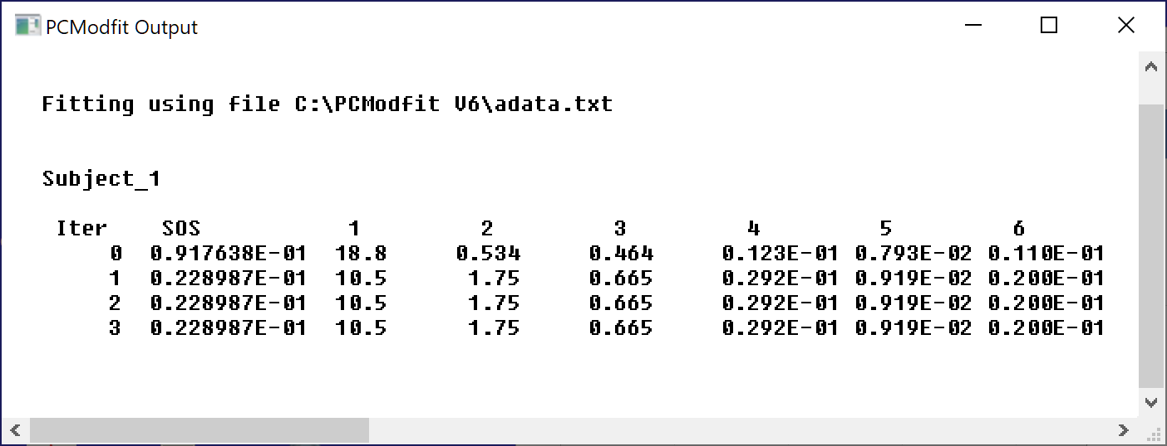

If plotting was selected, then the Charts in the spreadsheet will be updated with the data and modelled line.

The information described in this section outlines what to expect when modelling concentration-time data. Please appreciate though, as for other modelling software, that if the data are rubbish to start with, so too will be the modelling results! One important factor to note concerns the number of data points. If for example the chosen model has 8 parameters, then the number of points will need to be significantly greater than 8 and realistically, may require 16-20 points as not all phases (or compartments) will be adequately defined and the parameter errors could well be much higher than the parameter values themselves; thus, indicating that the model is either over-defined or the data are inadequate.

Regarding the choice of algorithm, it is sometimes pertinent to try out more than one approach with different weighting schemes due to the varying nature of the profiles; these can be quite different even between data sets within the same study. As a rough guide, weighting as 1/Ĉ2 (IRWLS) or 1/C2 (WLS) will tend to emphasise the lower values whereas unweighted will ‘home in’ to the higher values. A weighting of 1/Ĉ or 1/C is a compromise and tends to emphasise the middle concentrations which can be useful for some types of profile and can minimise bias towards the extreme values.

For the modelling of data using PCModfit, besides unweighted, there are two additional options for helping with the type of weighting scheme; Weighted Least Squares (WLS) or Iteratively Reweighted Least Squares (IRWLS). The best choice can only be made by trying both types as each profile could be very different to others in the same group. The WLS uses the actual data points for the weighting whereas, the IRWLS will make use of the predicted values at each time point which will change throughout the run. There are occasions when one or more points visually seem to be ‘outliers’ and for these situations the IRWLS may be the best option as it can, but not always, show less bias towards the aberrant values.

The results generated from a modelling process, should be examined in detail to try, and help the user decide if the answers are meaningful; or not! If, for example, the curve through the data visually appears acceptable, it doesn’t necessarily mean that the final parameters are valid. The percentage errors on the parameters are important and, for example, if one or more values are showing errors as 300 %, the probability is, that there is no confidence in the variable so using it elsewhere for further work, should be conducted with caution. As a specific example, consider the fictitious results from modelling a 1-compartment oral profile data set with parameters and errors shown below.

|  |  |  |  |  |
| --- | --- | --- | --- | --- |
|  | V | ka | k10 | tlag |
| Subj.1 | 10.34 | 0.49 | 0.062 | 1.51 |
| %Error | 10.1 | 125.2 | 3.3 | 147.2 |

These results would indicate that there is considerable error in the parameters ka (absorption rate) and tlag (lag-time). Without scrutinising the profile, the results are suggesting that there may not be any, or a very limited number of data points during the absorption phase, hence the large errors. For this example, it might be more appropriate to use a similar model but without a lag-time parameter!

The next Section (3.9) has several examples of data layout and fitting output/results to help the user either ‘try out’ or to use as a basis for their own analysis of data sets.

Note that for all examples, from V7.5 onwards the summary Excel file will contain more information than shown below.

## **Compartmental analysis (Example data and results)**

The itemised data sets were fitted using simulated data to demonstrate that the parameter results were very close to the theoretical values and to show the data layout, modelling settings and graphical output. For additional help with setting up the Control layout it is worth looking at the new Section 4.2.

### 3-exponential i.v. bolus repeat dose (Model 6).

**V7.3 onwards allows repeat dose with polyexponential models 1 to 6.**

**Data layout Control layout**

|  |  |  |  |  |  |  |  |  |  |  |  |  |  |  |  |  |  |  |  |  |  |  |  |  |  |  |  |  |  |  |  |  |  |  |  |  |  |  |  |  |  |  |  |  |  |  |  |  |  |  |  |  |  |  |  |  |  |  |  |  |  |  |  |  |  |  |  |  |  |  |  |  |  |  |  |  |  |  |  |  |  |  |  |  |  |  |  |  |  |  |  |  |  |  |  |  |  |  |  |  |  |  |  |  |  |  |  |  |  |  |  |  |  |  |  |  |  |  |  |  |  |  |  |  |  |  |  |  |  |  |  |  |  |  |  |  |  |  |  |  |  |  |  |  |  |  |  |  |  |  |  |  |  |  |  |  |  |  |  |  |  |  |  |  |  |  |  |  |  |  |  |  |  |  |  |  |  |  |  |  |  |  |  |  |  |  |  |  |  |  |  |  |  |  |  |  |  |  |  |  |  |  |  |  |  |  |  |  |  |  |  |  |  |  |  |  |  |  |  |  |  |  |  |  |  |  |  |  |  |  |  |  |  |  |  |  |  |  |  |  |  |  |  |  |  |  |  |  |  |  |  |  |  |  |  |  |  |  |  |  |  |  |  |  |  |  |  |  |  |  |  |  |  |  |  |  |  |  |  |  |  |  |  |  |  |  |  |  |  |  |  |  |  |  |  |  |  |  |  |  |  |  |  |  |  |  |  |  |  |  |  |  |  |  |  |  |  |  |  |  |  |  |  |  |  |  |  |  |  |  |  |  |  |  |  |  |  |  |  |  |  |  |  |  |  |  |  |  |  |  |  |  |  |  |  |  |  |  |  |  |  |  |  |  |  |  |  |
| --- | --- | --- | --- | --- | --- | --- | --- | --- | --- | --- | --- | --- | --- | --- | --- | --- | --- | --- | --- | --- | --- | --- | --- | --- | --- | --- | --- | --- | --- | --- | --- | --- | --- | --- | --- | --- | --- | --- | --- | --- | --- | --- | --- | --- | --- | --- | --- | --- | --- | --- | --- | --- | --- | --- | --- | --- | --- | --- | --- | --- | --- | --- | --- | --- | --- | --- | --- | --- | --- | --- | --- | --- | --- | --- | --- | --- | --- | --- | --- | --- | --- | --- | --- | --- | --- | --- | --- | --- | --- | --- | --- | --- | --- | --- | --- | --- | --- | --- | --- | --- | --- | --- | --- | --- | --- | --- | --- | --- | --- | --- | --- | --- | --- | --- | --- | --- | --- | --- | --- | --- | --- | --- | --- | --- | --- | --- | --- | --- | --- | --- | --- | --- | --- | --- | --- | --- | --- | --- | --- | --- | --- | --- | --- | --- | --- | --- | --- | --- | --- | --- | --- | --- | --- | --- | --- | --- | --- | --- | --- | --- | --- | --- | --- | --- | --- | --- | --- | --- | --- | --- | --- | --- | --- | --- | --- | --- | --- | --- | --- | --- | --- | --- | --- | --- | --- | --- | --- | --- | --- | --- | --- | --- | --- | --- | --- | --- | --- | --- | --- | --- | --- | --- | --- | --- | --- | --- | --- | --- | --- | --- | --- | --- | --- | --- | --- | --- | --- | --- | --- | --- | --- | --- | --- | --- | --- | --- | --- | --- | --- | --- | --- | --- | --- | --- | --- | --- | --- | --- | --- | --- | --- | --- | --- | --- | --- | --- | --- | --- | --- | --- | --- | --- | --- | --- | --- | --- | --- | --- | --- | --- | --- | --- | --- | --- | --- | --- | --- | --- | --- | --- | --- | --- | --- | --- | --- | --- | --- | --- | --- | --- | --- | --- | --- | --- | --- | --- | --- | --- | --- | --- | --- | --- | --- | --- | --- | --- | --- | --- | --- | --- | --- | --- | --- | --- | --- | --- | --- | --- | --- | --- | --- | --- | --- | --- | --- | --- | --- | --- | --- | --- | --- | --- | --- | --- | --- | --- | --- | --- | --- | --- | --- | --- | --- | --- | --- | --- | --- | --- | --- | --- | --- | --- | --- | --- | --- | --- | --- | --- | --- | --- | --- | --- | --- | --- | --- | --- | --- | --- | --- | --- | --- | --- | --- | --- | --- | --- | --- |
| |  |  |  |  |  |  | | --- | --- | --- | --- | --- | --- | | **Time** | **Subj.1** | **Subj.2** | **Subj.3** | **Subj.4** | **Subj.5** | | 0.0 | 100.0 | 104.0 | 96.0 | 103.0 | 97.0 | | 0.25 | 81.90877 | 81.90877 | 81.08969 | 86.00421 | 86.00421 | | 0.5 | 67.74115 | 66.38632 | 69.09597 | 68.41856 | 65.70891 | | 0.75 | 56.63104 | 56.63104 | 57.19735 | 57.19735 | 59.46259 | | 1 | 47.90392 | 45.50872 | 49.34103 | 46.46680 | 45.50872 | | **1.5** | 35.61327 | 37.03780 | 35.61327 | 36.32554 | 36.68167 | | 2 | 27.91175 | 26.51616 | 27.07439 | 28.74910 | 29.02822 | | 3 | 19.80408 | 19.20996 | 18.81388 | 20.59624 | 19.80408 | | 4 | 16.13566 | 15.65159 | 16.45837 | 15.49023 | 15.97430 | | 5 | 14.16120 | 14.30282 | 14.44443 | 14.01959 | 14.58604 | | 6 | 12.86510 | 12.47915 | 12.22184 | 12.22184 | 13.50835 | | 8 | 11.02751 | 11.57889 | 11.24806 | 11.13779 | 10.69668 | | 12 | 8.45156 | 8.45156 | 8.53608 | 8.78962 | 8.62059 | | 16 | 6.65922 | 6.65922 | 6.52603 | 6.39285 | 6.59262 | | 20 | 5.38164 | 5.43546 | 5.59691 | 5.22019 | 5.27401 | | 24 | 104.45470 | 101.32106 | 109.67743 | 105.49924 | 102.36560 | | 25 | 52.16785 | 54.77625 | 52.68953 | 52.68953 | 49.55946 | | 44 | 7.63972 | 7.56332 | 8.02171 | 7.48693 | 7.48693 | | 74 | 53.08783 | 53.61871 | 53.08783 | 55.21134 | 55.74222 | | 76 | 16.90697 | 17.75232 | 16.06162 | 16.56883 | 17.41418 | | 92 | 5.07956 | 5.28274 | 4.92717 | 4.87638 | 4.87638 | | 94 | 4.70168 | 4.70168 | 4.70168 | 4.79571 | 4.46660 | | 98 | 104.07983 | 109.28383 | 106.16143 | 107.20223 | 100.95744 | | 99 | 51.85094 | 49.77690 | 49.77690 | 49.25839 | 49.25839 | | 100 | 31.73353 | 31.09886 | 31.09886 | 30.46419 | 33.00287 | | 105 | 15.15802 | 14.40012 | 15.15802 | 15.46118 | 14.85486 | | 122 | 106.61466 | 103.41622 | 108.74695 | 106.61466 | 103.41622 | | 124 | 34.06484 | 33.38354 | 33.04289 | 35.08678 | 35.08678 | | 126 | 21.88193 | 21.00665 | 21.44429 | 21.88193 | 21.88193 | | 130 | 16.09078 | 16.89532 | 16.41260 | 16.57351 | 16.41260 | | 135 | 12.33408 | 12.95079 | 12.45742 | 12.82745 | 12.21074 | | 140 | 9.824984 | 9.62848 | 9.33373 | 9.72673 | 10.31623 | | 150 | 6.820056 | 6.95646 | 7.02466 | 6.47905 | 6.75186 | | 162 | 4.880039 | 5.07524 | 5.02644 | 4.78244 | 4.88004 | | 168 | 4.226501 | 4.01518 | 4.01518 | 4.39556 | 4.05744 | | 180 | 3.244545 | 3.40677 | 3.37433 | 3.17965 | 3.11476 | | 190 | 2.633991 | 2.55497 | 2.50229 | 2.58131 | 2.66033 | | 200 | 2.148283 | 2.083834 | 2.148283 | 2.083834 | 2.234214 | | 210 | 1.755831 | 1.843623 | 1.703156 | 1.843623 | 1.755831 | | 224 | 1.325768 | 1.339026 | 1.299253 | 1.299253 | 1.312511 | | 248 | 0.820041 | 0.828241 | 0.836442 | 0.820041 | 0.795440 | | 260 | 0.645040 | 0.670842 | 0.612788 | 0.677292 | 0.638590 | | |  |  |  |  |  |  | | --- | --- | --- | --- | --- | --- | | **Title** | **Subj.1** | **Subj.2** | **Subj.3** | **Subj.4** | **Subj.5** | | **Dose** | 0.00E+00 | 0.00E+00 | 0.00E+00 | 0.00E+00 | 0.00E+00 | | **Ndoses** | 5.00E+00 | 5.00E+00 | 5.00E+00 | 5.00E+00 | 5.00E+00 | | **Pars** | 7.50E+01 | 7.50E+01 | 7.50E+01 | 7.50E+01 | 7.50E+01 | |  | 8.00E-01 | 8.00E-01 | 8.00E-01 | 8.00E-01 | 8.00E-01 | |  | 1.20E+01 | 1.20E+01 | 1.20E+01 | 1.20E+01 | 1.20E+01 | |  | 1.50E-01 | 1.50E-01 | 1.50E-01 | 1.50E-01 | 1.50E-01 | |  | 4.00E+00 | 4.00E+00 | 4.00E+00 | 4.00E+00 | 4.00E+00 | |  | 1.00E-02 | 1.00E-02 | 1.00E-02 | 1.00E-02 | 1.00E-02 | | **Doseint** | 2.40E+01 | 2.40E+01 | 2.40E+01 | 2.40E+01 | 2.40E+01 | |  | 5.00E+01 | 5.00E+01 | 5.00E+01 | 5.00E+01 | 5.00E+01 | |  | 2.40E+01 | 2.40E+01 | 2.40E+01 | 2.40E+01 | 2.40E+01 | |  | 2.40E+01 | 2.40E+01 | 2.40E+01 | 2.40E+01 | 2.40E+01 | | **Repdose** | 1.00E+03 | 1.00E+03 | 1.00E+03 | 1.00E+03 | 1.00E+03 | |  | 1.00E+03 | 1.00E+03 | 1.00E+03 | 1.00E+03 | 1.00E+03 | |  | 5.00E+02 | 5.00E+02 | 5.00E+02 | 5.00E+02 | 5.00E+02 | |  | 1.00E+03 | 1.00E+03 | 1.00E+03 | 1.00E+03 | 1.00E+03 | |  | 1.00E+03 | 1.00E+03 | 1.00E+03 | 1.00E+03 | 1.00E+03 | |

1.5 is the correct time but previous manuals stated 2 which was an error.

**Summary Results (stored in Excel file automatically)**

|  |  |  |  |  |  |  |  |  |
| --- | --- | --- | --- | --- | --- | --- | --- | --- |
| **Date** | **22/12/2022 19:17** |  |  |  |  |  |  |  |
| Algorithm | Marquardt (IRWLS) |  |  |  |  |  |  |  |
| Weighting | 1/Conc2 |  |  |  |  |  |  |  |
| Model | 6 |  |  |  |  |  |  |  |
|  |  |  |  |  |  |  |  |  |
| **Parameter** | **Pars A** | **λ1** | **B** | **λ2** | **C** | **λ3** | **Akaike** | **Sos** |
| Subj.1 | 79.99997 | 1.00000 | 15.00002 | 0.10000 | 5.00001 | 0.02000 | -1139.35430 | 0.00000 |
| %Error | 0.00 | 0.00 | 0.00 | 0.00 | 0.00 | 0.00 |  |  |
| Subj.2 | 81.20399 | 1.01068 | 14.60025 | 0.09451 | 4.83280 | 0.01962 | -117.94338 | 0.04533 |
| %Error | 1.85 | 2.94 | 4.27 | 6.02 | 5.48 | 2.33 |  |  |
| Subj.3 | 81.87724 | 1.02509 | 14.53135 | 0.09544 | 4.96638 | 0.02010 | -130.15740 | 0.03389 |
| %Error | 1.60 | 2.53 | 3.71 | 5.24 | 4.68 | 1.96 |  |  |
| Subj.4 | 82.15728 | 1.02621 | 15.43145 | 0.09978 | 4.78457 | 0.01958 | -128.54669 | 0.03521 |
| %Error | 1.65 | 2.63 | 3.77 | 5.05 | 4.54 | 1.97 |  |  |
| Subj.5 | 78.21083 | 0.99464 | 15.73731 | 0.10469 | 5.02496 | 0.02011 | -123.56559 | 0.03965 |
| %Error | 1.81 | 2.96 | 4.28 | 5.50 | 4.59 | 1.96 |  |  |
| **The Parameter stats. below will be omitted for a single profile** | | | | | | | | |
| **Parameter stats.** | |  |  |  |  |  |  |  |
| Mean | 80.68986 | 1.01132 | 15.06008 | 0.09888 | 4.92175 | 0.01988 |  |  |
| Geom. Mean | 80.67680 | 1.01124 | 15.05286 | 0.09882 | 4.92082 | 0.01988 |  |  |
| SD | 1.61625 | 0.01430 | 0.52229 | 0.00408 | 0.10665 | 0.00026 |  |  |
| SEM | 0.72281 | 0.00640 | 0.23358 | 0.00183 | 0.04770 | 0.00012 |  |  |
| %CV | 2.00 | 1.41 | 3.47 | 4.13 | 2.17 | 1.32 |  |  |

**Result Plots (separately stored automatically and can be viewed within ‘Modelling’ spreadsheet)**

**10,000 points selected in Fitting to allow for rapid peaks. Subj. 1 and 5 shown for brevity.**

**Linear Logarithmic**

|  |  |
| --- | --- |
|  |  |
|  |  |

### 1-Compt. bolus (Model 11)

**Data layout Control layout**

|  |  |  |  |  |  |  |  |  |  |  |  |  |  |  |  |  |  |  |  |  |  |  |  |  |  |  |  |  |  |  |  |  |  |  |  |  |  |  |  |  |  |  |  |  |  |  |  |  |  |  |  |  |  |  |  |  |  |  |  |  |  |  |  |  |  |  |  |  |  |  |  |  |  |  |  |  |  |  |  |  |  |  |  |  |  |  |  |  |  |
| --- | --- | --- | --- | --- | --- | --- | --- | --- | --- | --- | --- | --- | --- | --- | --- | --- | --- | --- | --- | --- | --- | --- | --- | --- | --- | --- | --- | --- | --- | --- | --- | --- | --- | --- | --- | --- | --- | --- | --- | --- | --- | --- | --- | --- | --- | --- | --- | --- | --- | --- | --- | --- | --- | --- | --- | --- | --- | --- | --- | --- | --- | --- | --- | --- | --- | --- | --- | --- | --- | --- | --- | --- | --- | --- | --- | --- | --- | --- | --- | --- | --- | --- | --- | --- | --- | --- | --- | --- | --- |
| |  |  |  |  | | --- | --- | --- | --- | | Time | **Subj.1** | **Subj.2** | **Subj.3** | | 0 | 4.8 | 5.3 | 4.85 | | 0.125 | 5.019 | 5.1 | 5.019 | | 0.25 | 4.938 | 5.1 | 4.987 | | 0.5 | 5.02 | 4.8 | 4.828 | | 0.75 | 4.96 | 4.7 | 4.671 | | 1.0 | 4.86 | 5.00 | 4.71 | | 2.0 | 4.43 | 4.66 | 4.43 | | 4.0 | 3.97 | 4.26 | 4.18 | | 6.0 | 3.67 | 3.82 | 3.78 | | 8.0 | 3.18 | 3.18 | 3.29 | | 10.0 | 3.06 | 2.91 | 3.03 | | 12.0 | 2.77 | 2.66 | 2.63 | | 16.0 | 2.31 | 2.29 | 2.34 | | 24.0 | 1.431 | 1.4307 | 1.4759 | | 36.0 | 0.827 | 0.8678 | 0.8678 | | 48.0 | 0.467 | 0.4536 | 0.4581 | | 60.0 | 0.256 | 0.2365 | 0.2564 | | 72.0 | 0.137 | 0.1325 | 0.1434 | | |  |  |  |  | | --- | --- | --- | --- | | **Title** | Subj.1 | Subj.2 | Subj.3 | | **Dose** | 5.00E+02 | 5.00E+02 | 5.00E+02 | | **Ndoses** | 1.00E+00 | 1.00E+00 | 1.00E+00 | |

**Summary Results (stored in Excel file automatically)**

|  |  |  |  |  |  |  |  |  |
| --- | --- | --- | --- | --- | --- | --- | --- | --- |
| **Date** | **22/12/2022 17:46** |  |  |  |  |  |  |  |
| Algorithm | Marquardt (IRWLS) |  |  |  |  |  |  |  |
| Weighting | 1/Conc2 |  |  |  |  |  |  |  |
| Model | 11 |  |  |  |  |  |  |  |
|  |  |  |  |  |  |  |  |  |
| **Parameter** | **Pars Viv** | **k10** | **Akaike** | **Sos** |  |  |  |  |
| Subj.1 | 100.45344 | 0.04974 | -74.8031 | 0.012551 |  |  |  |  |
| %Error | 0.83 | 0.61 |  |  |  |  |  |  |
| Subj.2 | 98.60480 | 0.05068 | -64.6697 | 0.022038 |  |  |  |  |
| %Error | 1.10 | 0.79 |  |  |  |  |  |  |
| Subj.3 | 100.88546 | 0.04928 | -81.2097 | 0.008792 |  |  |  |  |
| %Error | 0.70 | 0.51 |  |  |  |  |  |  |
| **The Parameter stats. below will be omitted for a single profile** | | | | | | | | |
| **Parameter stats.** |  |  |  |  |  |  |  |  |
| Mean | 99.98123 | 0.04990 |  |  |  |  |  |  |
| Geom. Mean | 99.97632 | 0.04990 |  |  |  |  |  |  |
| SD | 1.21144 | 0.00072 |  |  |  |  |  |  |
| SEM | 0.69942 | 0.00041 |  |  |  |  |  |  |
| %CV | 1.21 | 1.44 |  |  |  |  |  |  |

**Result Plots (separately stored automatically and can be viewed within ‘Modelling’ spreadsheet)**

**Linear Logarithmic**

|  |  |
| --- | --- |
|  |  |
|  |  |
|  |  |

### 2-Compt. bolus (Model 12)

**Data layout Control layout**

|  |  |  |  |  |  |  |  |  |  |  |  |  |  |  |  |  |  |  |  |  |  |  |  |  |  |  |  |  |  |  |  |  |  |  |  |  |  |  |  |  |  |  |  |  |  |  |  |  |  |  |  |  |  |  |  |  |  |  |  |  |  |  |  |  |  |  |  |  |  |  |  |  |  |  |  |  |  |  |  |  |  |  |  |  |  |  |  |  |  |
| --- | --- | --- | --- | --- | --- | --- | --- | --- | --- | --- | --- | --- | --- | --- | --- | --- | --- | --- | --- | --- | --- | --- | --- | --- | --- | --- | --- | --- | --- | --- | --- | --- | --- | --- | --- | --- | --- | --- | --- | --- | --- | --- | --- | --- | --- | --- | --- | --- | --- | --- | --- | --- | --- | --- | --- | --- | --- | --- | --- | --- | --- | --- | --- | --- | --- | --- | --- | --- | --- | --- | --- | --- | --- | --- | --- | --- | --- | --- | --- | --- | --- | --- | --- | --- | --- | --- | --- | --- | --- |
| |  |  |  |  | | --- | --- | --- | --- | | Time | **Subj.1** | **Subj.2** | **Subj.3** | | 0.0 | 4.66 | 4.513 | 4.893 | | 0.125 | 4.188 | 3.94 | 3.98 | | 0.25 | 3.477 | 3.55 | 3.48 | | 0.50 | 2.381 | 2.26 | 2.31 | | 0.75 | 1.608 | 1.64 | 1.71 | | 1.0 | 1.187 | 1.13 | 1.14 | | 2.0 | 0.332 | 0.338 | 0.322 | | 4.0 | 0.111 | 0.112 | 0.110 | | 6.0 | 0.100 | 0.097 | 0.106 | | 8.0 | 0.093 | 0.102 | 0.095 | | 10.0 | 0.095 | 0.094 | 0.092 | | 12.0 | 0.0931 | 0.096 | 0.091 | | 16.0 | 0.0881 | 0.083 | 0.082 | | 24.0 | 0.0713 | 0.077 | 0.074 | | 36.0 | 0.0642 | 0.064 | 0.064 | | 48.0 | 0.0493 | 0.053 | 0.051 | | 60.0 | 0.0422 | 0.0405 | 0.0405 | | 72.0 | 0.0361 | 0.0326 | 0.0357 | | |  |  |  |  | | --- | --- | --- | --- | | **Title** | Subj.1 | Subj.2 | Subj.3 | | **Dose** | 5.00E+02 | 5.00E+02 | 5.00E+02 | | **Ndoses** | 1.00E+00 | 1.00E+00 | 1.00E+00 | |

**Summary Results (stored in Excel file automatically)**

|  |  |  |  |  |  |  |  |  |
| --- | --- | --- | --- | --- | --- | --- | --- | --- |
| **Date** | **22/12/2022 12:07** |  |  |  |  |  |  |  |
| Algorithm | Marquardt (IRWLS) |  |  |  |  |  |  |  |
| Weighting | 1/Conc2 |  |  |  |  |  |  |  |
| Model | 12 |  |  |  |  |  |  |  |
|  |  |  |  |  |  |  |  |  |
| **Parameter** | **Pars Viv** | **k12** | **k21** | **k10** | **Akaike** | **Sos** |  |  |
| Subj.1 | 101.68484 | 1.00183 | 0.04896 | 0.48552 | -67.1803 | 0.015349 |  |  |
| %Error | 1.88 | 1.90 | 2.20 | 2.18 |  |  |  |  |
| Subj.2 | 104.85710 | 0.98794 | 0.05181 | 0.48496 | -59.2201 | 0.023886 |  |  |
| %Error | 2.34 | 2.41 | 2.70 | 2.63 |  |  |  |  |
| Subj.3 | 101.01492 | 1.01549 | 0.04953 | 0.49360 | -68.9248 | 0.013932 |  |  |
| %Error | 1.79 | 1.80 | 2.08 | 2.06 |  |  |  |  |
| **The Parameter stats. below will be omitted for a single profile** | | | | | | | | |
| Mean | 102.51895 | 1.00175 | 0.05010 | 0.48803 |  |  |  |  |
| Geom. Mean | 102.50535 | 1.00169 | 0.05009 | 0.48801 |  |  |  |  |
| SD | 2.05241 | 0.01378 | 0.00151 | 0.00483 |  |  |  |  |
| SEM | 1.18496 | 0.00795 | 0.00087 | 0.00279 |  |  |  |  |
| %CV | 2.00 | 1.38 | 3.01 | 0.99 |  |  |  |  |
|  |  |  |  |  |  |  |  |  |

**Result Plots (separately stored automatically and can be viewed within ‘Modelling’ spreadsheet)**

**Linear Logarithmic**

|  |  |
| --- | --- |
|  |  |
|  |  |
|  |  |

### 3-Compt. bolus (Model 13)

**Data layout Control layout**

|  |  |  |  |  |  |  |  |  |  |  |  |  |  |  |  |  |  |  |  |  |  |  |  |  |  |  |  |  |  |  |  |  |  |  |  |  |  |  |  |  |  |  |  |  |  |  |  |  |  |  |  |  |  |  |  |  |  |  |  |  |  |  |  |  |  |  |  |  |  |  |  |  |  |  |  |  |  |  |  |  |  |  |  |  |  |  |  |  |  |  |  |  |  |  |  |  |  |
| --- | --- | --- | --- | --- | --- | --- | --- | --- | --- | --- | --- | --- | --- | --- | --- | --- | --- | --- | --- | --- | --- | --- | --- | --- | --- | --- | --- | --- | --- | --- | --- | --- | --- | --- | --- | --- | --- | --- | --- | --- | --- | --- | --- | --- | --- | --- | --- | --- | --- | --- | --- | --- | --- | --- | --- | --- | --- | --- | --- | --- | --- | --- | --- | --- | --- | --- | --- | --- | --- | --- | --- | --- | --- | --- | --- | --- | --- | --- | --- | --- | --- | --- | --- | --- | --- | --- | --- | --- | --- | --- | --- | --- | --- | --- | --- | --- | --- |
| |  |  |  |  | | --- | --- | --- | --- | | Time | **Subj.1** | **Subj.2** | **Subj.3** | | 0.0 | 4.750 | 5.200 | 4.750 | | 0.125 | 3.608 | 3.796 | 3.833 | | 0.25 | 2.695 | 2.894 | 2.837 | | 0.50 | 1.731 | 1.682 | 1.567 | | 0.75 | 1.035 | 0.965 | 0.985 | | 1.0 | 0.667 | 0.654 | 0.635 | | 2.0 | 0.225 | 0.227 | 0.214 | | 4.0 | 0.152 | 0.163 | 0.165 | | 6.0 | 0.141 | 0.142 | 0.131 | | 8.0 | 0.121 | 0.126 | 0.126 | | 10.0 | 0.109 | 0.110 | 0.109 | | 12.0 | 0.0899 | 0.0945 | 0.0936 | | 16.0 | 0.0722 | 0.0729 | 0.0790 | | 24.0 | 0.0513 | 0.0544 | 0.0507 | | 36.0 | 0.0324 | 0.0334 | 0.0334 | | 48.0 | 0.0244 | 0.0225 | 0.0235 | | 60.0 | 0.0168 | 0.0175 | 0.0170 | | 72.0 | 0.0122 | 0.0126 | 0.0124 | | |  |  |  |  | | --- | --- | --- | --- | | **Title** | Subj.1 | Subj.2 | Subj.3 | | **Dose** | 5.00E+02 | 5.00E+02 | 5.00E+02 | | **Ndoses** | 1.00E+00 | 1.00E+00 | 1.00E+00 | |  |  |  |  | |  |  |  |  | |

**Summary Results (stored in Excel file automatically)**

|  |  |  |  |  |  |  |  |  |
| --- | --- | --- | --- | --- | --- | --- | --- | --- |
| **Date** | **22/12/2022 10:38** |  |  |  |  |  |  |  |
| Algorithm | Marquardt (IRWLS) |  |  |  |  |  |  |  |
| Weighting | 1/Conc2 |  |  |  |  |  |  |  |
| Model | 13 |  |  |  |  |  |  |  |
|  |  |  |  |  |  |  |  |  |
| **Parameter** | **Pars Viv** | **k12** | **k21** | **k13** | **k31** | **k10** | **Akaike** | **Sos** |
| Subj.1 | 105.43632 | 0.97181 | 0.18983 | 0.43335 | 0.04461 | 0.75924 | -66.817 | 0.012541 |
| %Error | 2.14 | 6.60 | 7.68 | 14.78 | 12.86 | 2.11 |  |  |
| Subj.2 | 97.37270 | 1.11661 | 0.19059 | 0.41500 | 0.04015 | 0.80127 | -71.608 | 0.009611 |
| %Error | 1.89 | 4.62 | 5.78 | 11.74 | 12.01 | 1.91 |  |  |
| Subj.3 | 101.61009 | 1.13610 | 0.18172 | 0.38310 | 0.03951 | 0.78104 | -64.937 | 0.013922 |
| %Error | 2.27 | 5.93 | 7.14 | 16.66 | 16.89 | 2.36 |  |  |
| **The Parameter stats. below will be omitted for a single profile** | | | | | | | | |
| **Parameter stats.** |  |  |  |  |  |  |  |  |
| Mean | 101.47304 | 1.07484 | 0.18738 | 0.41049 | 0.04142 | 0.78052 |  |  |
| Geom. Mean | 101.41949 | 1.07226 | 0.18734 | 0.40995 | 0.04136 | 0.78033 |  |  |
| SD | 4.03356 | 0.08976 | 0.00491 | 0.02543 | 0.00277 | 0.02102 |  |  |
| SEM | 2.32877 | 0.05182 | 0.00284 | 0.01468 | 0.00160 | 0.01214 |  |  |
| %CV | 3.98 | 8.35 | 2.62 | 6.19 | 6.70 | 2.69 |  |  |

**Result Plots (separately stored automatically and can be viewed within ‘Modelling’ spreadsheet**

**Linear Logarithmic**

|  |  |
| --- | --- |
|  |  |
|  |  |
|  |  |

### 1-Compt. infusion (Model 15)

**Data layout Control layout**

|  |  |  |  |  |  |  |  |  |  |  |  |  |  |  |  |  |  |  |  |  |  |  |  |  |  |  |  |  |  |  |  |  |  |  |  |  |  |  |  |  |  |  |  |  |  |  |  |  |  |  |  |  |  |  |  |  |  |  |  |  |  |  |  |  |  |  |  |  |  |  |  |  |  |  |  |  |  |  |  |  |  |  |  |  |  |  |  |  |  |  |  |  |  |  |  |  |  |
| --- | --- | --- | --- | --- | --- | --- | --- | --- | --- | --- | --- | --- | --- | --- | --- | --- | --- | --- | --- | --- | --- | --- | --- | --- | --- | --- | --- | --- | --- | --- | --- | --- | --- | --- | --- | --- | --- | --- | --- | --- | --- | --- | --- | --- | --- | --- | --- | --- | --- | --- | --- | --- | --- | --- | --- | --- | --- | --- | --- | --- | --- | --- | --- | --- | --- | --- | --- | --- | --- | --- | --- | --- | --- | --- | --- | --- | --- | --- | --- | --- | --- | --- | --- | --- | --- | --- | --- | --- | --- | --- | --- | --- | --- | --- | --- | --- | --- |
| |  |  |  |  | | --- | --- | --- | --- | | Time | **Subj.1** | **Subj.2** | **Subj.3** | | 0 | 0.000 | 0.000 | 0.000 | | 0.125 | 0.592 | 0.648 | 0.617 | | 0.25 | 1.292 | 1.205 | 1.267 | | 0.5 | 2.346 | 2.444 | 2.518 | | 0.75 | 3.497 | 3.533 | 3.533 | | 1.0 | 5.072 | 4.926 | 4.975 | | 2.0 | 4.593 | 4.407 | 4.454 | | 4.0 | 4.030 | 4.198 | 4.114 | | 6.0 | 3.874 | 3.950 | 3.608 | | 8.0 | 3.471 | 3.334 | 3.574 | | 10.0 | 3.234 | 3.079 | 3.079 | | 12.0 | 2.7575 | 2.9264 | 2.7294 | | 16.0 | 2.3038 | 2.2346 | 2.3498 | | 24.0 | 1.6060 | 1.4979 | 1.5288 | | 36.0 | 0.8136 | 0.8645 | 0.8814 | | 48.0 | 0.4791 | 0.4651 | 0.4465 | | 60.0 | 0.2680 | 0.2502 | 0.2451 | | 72.0 | 0.1401 | 0.1331 | 0.1443 | | |  |  |  |  | | --- | --- | --- | --- | | **Title** | Subj.1 | Subj.2 | Subj.3 | | **Dose** | 0.00E+00 | 0.00E+00 | 0.00E+00 | | **Ndoses** | 1.00E+00 | 1.00E+00 | 1.00E+00 | | **Inftime** | 1.00E+00 | 1.00E+00 | 1.00E+00 | | **Infrate** | 5.00E+02 | 5.00E+02 | 5.00E+02 | |

**Summary Results (stored in Excel file automatically)**

|  |  |  |  |  |  |  |  |  |
| --- | --- | --- | --- | --- | --- | --- | --- | --- |
| **Date** | **21/12/2022 10:32** |  |  |  |  |  |  |  |
| Algorithm | Marquardt (IRWLS) |  |  |  |  |  |  |  |
| Weighting | 1/Conc2 |  |  |  |  |  |  |  |
| Model | 15 |  |  |  |  |  |  |  |
|  |  |  |  |  |  |  |  |  |
| **Parameter** | **Pars Viv** | **k10** | **Akaike** | **Sos** |  |  |  |  |
| Subj.1 | 100.74745 | 0.04953 | -62.82166 | 0.01963 |  |  |  |  |
| %Error | 1.11 | 0.81 |  |  |  |  |  |  |
| Subj.2 | 100.38113 | 0.05029 | -68.19147 | 0.01431 |  |  |  |  |
| %Error | 0.95 | 0.68 |  |  |  |  |  |  |
| Subj.3 | 100.70590 | 0.04993 | -66.58536 | 0.01573 |  |  |  |  |
| %Error | 1.00 | 0.72 |  |  |  |  |  |  |
| **The Parameter stats. below will be omitted for a single profile** | | | | | | | | |
| **Parameter stats.** |  |  |  |  |  |  |  |  |
| Mean | 100.61149 | 0.04992 |  |  |  |  |  |  |
| Geom. Mean | 100.61136 | 0.04992 |  |  |  |  |  |  |
| SD | 0.20058 | 0.00038 |  |  |  |  |  |  |
| SEM | 0.11580 | 0.00022 |  |  |  |  |  |  |
| %CV | 0.20 | 0.77 |  |  |  |  |  |  |

**Result Plots (separately stored automatically and can be viewed within ‘Modelling’ spreadsheet**

**Linear Logarithmic**

|  |  |
| --- | --- |
|  |  |
|  |  |
|  |  |

### 2-Compt. infusion (Model 17)

**Data layout Control layout**

|  |  |  |  |  |  |  |  |  |  |  |  |  |  |  |  |  |  |  |  |  |  |  |  |  |  |  |  |  |  |  |  |  |  |  |  |  |  |  |  |  |  |  |  |  |  |  |  |  |  |  |  |  |  |  |  |  |  |  |  |  |  |  |  |  |  |  |  |  |  |  |  |  |  |  |  |  |  |  |  |  |  |  |  |  |  |  |  |  |  |  |  |  |  |  |  |  |  |
| --- | --- | --- | --- | --- | --- | --- | --- | --- | --- | --- | --- | --- | --- | --- | --- | --- | --- | --- | --- | --- | --- | --- | --- | --- | --- | --- | --- | --- | --- | --- | --- | --- | --- | --- | --- | --- | --- | --- | --- | --- | --- | --- | --- | --- | --- | --- | --- | --- | --- | --- | --- | --- | --- | --- | --- | --- | --- | --- | --- | --- | --- | --- | --- | --- | --- | --- | --- | --- | --- | --- | --- | --- | --- | --- | --- | --- | --- | --- | --- | --- | --- | --- | --- | --- | --- | --- | --- | --- | --- | --- | --- | --- | --- | --- | --- | --- | --- |
| |  |  |  |  | | --- | --- | --- | --- | | Time | **Subj.1** | **Subj.2** | **Subj.3** | | 0 | 0.0 | 0.0 | 0.0 | | 0.125 | 0.581 | 0.553 | 0.576 | | 0.25 | 1.043 | 1.022 | 0.991 | | 0.5 | 1.710 | 1.727 | 1.833 | | 0.75 | 2.216 | 2.239 | 2.239 | | 1.0 | 2.558 | 2.532 | 2.532 | | 2.0 | 0.615 | 0.667 | 0.661 | | 4.0 | 0.131 | 0.127 | 0.134 | | 6.0 | 0.105 | 0.098 | 0.098 | | 8.0 | 0.101 | 0.096 | 0.103 | | 10.0 | 0.098 | 0.095 | 0.097 | | 12.0 | 0.096 | 0.088 | 0.091 | | 16.0 | 0.082 | 0.084 | 0.086 | | 24.0 | 0.072 | 0.075 | 0.073 | | 36.0 | 0.0610 | 0.0598 | 0.0629 | | 48.0 | 0.0512 | 0.0507 | 0.0497 | | 60.0 | 0.0408 | 0.0429 | 0.0408 | | 72.0 | 0.0353 | 0.0332 | 0.0360 | | |  |  |  |  | | --- | --- | --- | --- | | **Title** | Subj.1 | Subj.2 | Subj.3 | | **Dose** | 0.00E+00 | 0.00E+00 | 0.00E+00 | | **Ndoses** | 1.00E+00 | 1.00E+00 | 1.00E+00 | | **Inftime** | 1.00E+00 | 1.00E+00 | 1.00E+00 | | **Infrate** | 5.00E+02 | 5.00E+02 | 5.00E+02 | |

**Summary Results (stored in Excel file automatically)**

|  |  |  |  |  |  |  |  |  |
| --- | --- | --- | --- | --- | --- | --- | --- | --- |
| **Date** | **22/12/2022 14:52** |  |  |  |  |  |  |  |
| Algorithm | Marquardt (IRWLS) |  |  |  |  |  |  |  |
| Weighting | 1/Conc2 |  |  |  |  |  |  |  |
| Model | 17 |  |  |  |  |  |  |  |
|  |  |  |  |  |  |  |  |  |
| **Parameter** | Pars Viv | k12 | k21 | k10 | **Akaike** | **Sos** |  |  |
| Subj.1 | 100.27528 | 1.02969 | 0.05186 | 0.50747 | -67.67456 | 0.01166 |  |  |
| %Error | 1.64 | 2.22 | 2.12 | 1.94 |  |  |  |  |
| Subj.2 | 102.84593 | 0.97248 | 0.04874 | 0.49134 | -81.76746 | 0.00509 |  |  |
| %Error | 1.07 | 1.44 | 1.43 | 1.29 |  |  |  |  |
| Subj.3 | 101.34703 | 0.97679 | 0.04961 | 0.49273 | -63.27023 | 0.01511 |  |  |
| %Error | 1.85 | 2.50 | 2.45 | 2.22 |  |  |  |  |
| **The Parameter stats. below will be omitted for a single profile** | | | | | | | | |
| **Parameter stats.** |  |  |  |  |  |  |  |  |
| Mean | 101.48941 | 0.99299 | 0.05007 | 0.49718 |  |  |  |  |
| Geom. Mean | 101.48394 | 0.99265 | 0.05005 | 0.49713 |  |  |  |  |
| SD | 1.29123 | 0.03186 | 0.00161 | 0.00894 |  |  |  |  |
| SEM | 0.74549 | 0.01839 | 0.00093 | 0.00516 |  |  |  |  |
| %CV | 1.27 | 3.21 | 3.22 | 1.80 |  |  |  |  |

**Result Plots (separately stored automatically and can be viewed within ‘Modelling’ spreadsheet**

**Linear Logarithmic**

|  |  |
| --- | --- |
|  |  |
|  |  |
|  |  |

### 3-Compt. infusion (Model 19, using V7.6 onwards)

**Data layout Control layout**

|  |  |  |  |  |  |  |  |  |  |  |  |  |  |  |  |  |  |  |  |  |  |  |  |  |  |  |  |  |  |  |  |  |  |  |  |  |  |  |  |  |  |  |  |  |  |  |  |  |  |  |  |  |  |  |  |  |  |  |  |  |  |  |  |  |  |  |  |  |  |  |  |  |  |  |  |  |  |  |  |  |  |  |  |  |  |  |  |  |  |  |  |  |  |  |  |  |  |
| --- | --- | --- | --- | --- | --- | --- | --- | --- | --- | --- | --- | --- | --- | --- | --- | --- | --- | --- | --- | --- | --- | --- | --- | --- | --- | --- | --- | --- | --- | --- | --- | --- | --- | --- | --- | --- | --- | --- | --- | --- | --- | --- | --- | --- | --- | --- | --- | --- | --- | --- | --- | --- | --- | --- | --- | --- | --- | --- | --- | --- | --- | --- | --- | --- | --- | --- | --- | --- | --- | --- | --- | --- | --- | --- | --- | --- | --- | --- | --- | --- | --- | --- | --- | --- | --- | --- | --- | --- | --- | --- | --- | --- | --- | --- | --- | --- | --- |
| |  |  |  |  | | --- | --- | --- | --- | | Time | **Subj.1** | **Subj.2** | **Subj.3** | | 0 | 0 | 0 | 0 | | 0.125 | 0.571 | 0.527 | 0.560 | | 0.25 | 0.981 | 1.000 | 0.915 | | 0.5 | 1.529 | 1.574 | 1.469 | | 0.75 | 1.730 | 1.858 | 1.876 | | 1.0 | 2.041 | 2.021 | 2.061 | | 2.0 | 0.376 | 0.368 | 0.347 | | 4.0 | 0.167 | 0.164 | 0.169 | | 6.0 | 0.143 | 0.150 | 0.148 | | 8.0 | 0.118 | 0.130 | 0.122 | | 10.0 | 0.105 | 0.111 | 0.112 | | 12.0 | 0.096 | 0.097 | 0.093 | | 16.0 | 0.075 | 0.076 | 0.075 | | 24.0 | 0.054 | 0.054 | 0.055 | | 36.0 | 0.0340 | 0.0360 | 0.0340 | | 48.0 | 0.0245 | 0.0240 | 0.0240 | | 60.0 | 0.0172 | 0.0179 | 0.0162 | | 72.0 | 0.0122 | 0.0123 | 0.0120 | | |  |  |  |  | | --- | --- | --- | --- | | **Title** | Subj.1 | Subj.2 | Subj.3 | | **Dose** | 0.00E+00 | 0.00E+00 | 0.00E+00 | | **Ndoses** | 1.00E+00 | 1.00E+00 | 1.00E+00 | | **Inftime** | 1.00E+00 | 1.00E+00 | 1.00E+00 | | **Infrate** | 5.00E+02 | 5.00E+02 | 5.00E+02 | |

**Summary Results (stored in Excel file automatically)**

|  |  |  |  |  |  |  |  |  |  |  |  |
| --- | --- | --- | --- | --- | --- | --- | --- | --- | --- | --- | --- |
| Date | 13/01/2023 12:53 | Linear Plotting files stored in C:\PCModfit V7.6\Results\Fitplotlin3.png to Fitplotlin5.png | | | | | | | | | |
| Algorithm | Marquardt (IRWLS) | Log. Plotting files stored in C:\PCModfit V7.6\Results\Fitplotlog3.png to Fitplotlog5.png | | | | | | | | | |
| Weighting | 1/Conc2 |  |  |  |  |  |  |  |  |  |  |
| Model | 19 |  |  |  |  |  |  |  |  |  |  |
| Setup information used for this run is shown at the end of this summary. | | | | |  |  |  |  |  |  |  |
| **Parameter** | **Pars Viv** | **k12** | **k21** | **k13** | **k31** | **k10** | **Akaike** | **Sos** | **λ1** | **λ2** | **λ3** |
| Profile_1 | 98.98078 | 0.88093 | 0.21744 | 0.58779 | 0.05454 | 0.80763 | -66.666 | 0.00978 | 2.37877 | 0.14100 | 0.02855 |
| %Error | 1.90 | 7.79 | 9.20 | 12.32 | 8.88 | 1.98 |  |  |  |  |  |
| Profile_2 | 98.55711 | 0.97258 | 0.20410 | 0.51474 | 0.05081 | 0.79670 | -65.519 | 0.01046 | 2.38619 | 0.12505 | 0.02769 |
| %Error | 1.96 | 7.48 | 8.77 | 14.50 | 10.86 | 2.08 |  |  |  |  |  |
| Profile_3 | 98.59068 | 0.99749 | 0.21391 | 0.54688 | 0.05359 | 0.81942 | -64.672 | 0.01100 | 2.47047 | 0.13201 | 0.02880 |
| %Error | 2.05 | 7.61 | 9.13 | 14.44 | 10.34 | 2.15 |  |  |  |  |  |

**Result Plots (separately stored automatically and can be viewed within ‘Modelling’ spreadsheet**

**Linear Logarithmic**

|  |  |
| --- | --- |
|  |  |
|  |  |
|  |  |

### 1-Compt. infusion + bolus (Model 14)

**Data layout Control layout**

|  |  |  |  |  |  |  |  |  |  |  |  |  |  |  |  |  |  |  |  |  |  |  |  |  |  |  |  |  |  |  |  |  |  |  |  |  |  |  |  |  |  |  |  |  |  |  |  |  |  |  |  |  |  |  |  |  |  |  |  |  |  |  |  |  |  |  |  |  |  |  |  |  |  |  |  |  |  |  |  |  |  |  |  |  |  |  |  |  |  |  |  |  |  |  |  |  |  |  |  |  |  |
| --- | --- | --- | --- | --- | --- | --- | --- | --- | --- | --- | --- | --- | --- | --- | --- | --- | --- | --- | --- | --- | --- | --- | --- | --- | --- | --- | --- | --- | --- | --- | --- | --- | --- | --- | --- | --- | --- | --- | --- | --- | --- | --- | --- | --- | --- | --- | --- | --- | --- | --- | --- | --- | --- | --- | --- | --- | --- | --- | --- | --- | --- | --- | --- | --- | --- | --- | --- | --- | --- | --- | --- | --- | --- | --- | --- | --- | --- | --- | --- | --- | --- | --- | --- | --- | --- | --- | --- | --- | --- | --- | --- | --- | --- | --- | --- | --- | --- | --- | --- | --- | --- |
| |  |  |  |  | | --- | --- | --- | --- | | Time | **Subj.1** | **Subj.2** | **Subj.3** | | 0 | 2.625 | 2.375 | 2.425 | | 0.125 | 3.014 | 3.139 | 3.076 | | 0.25 | 3.600 | 3.897 | 3.563 | | 0.5 | 4.907 | 4.711 | 4.662 | | 0.75 | 6.210 | 6.089 | 5.906 | | 1.0 | 7.400 | 7.400 | 7.183 | | 2.0 | 7.039 | 6.901 | 6.901 | | 4.0 | 6.494 | 6.369 | 5.995 | | 6.0 | 5.933 | 5.707 | 5.707 | | 8.0 | 5.061 | 5.266 | 5.317 | | 10.0 | 4.441 | 4.857 | 4.626 | | 12.0 | 4.1858 | 4.1440 | 4.3533 | | 16.0 | 3.4614 | 3.3928 | 3.2900 | | 24.0 | 2.3662 | 2.3891 | 2.3891 | | 36.0 | 1.2355 | 1.2103 | 1.2355 | | 48.0 | 0.6988 | 0.7265 | 0.6712 | | 60.0 | 0.3797 | 0.3873 | 0.3797 | | 72.0 | 0.2147 | 0.2021 | 0.2167 | | |  |  |  |  | | --- | --- | --- | --- | | **Title** | Subj.1 | Subj.2 | Subj.3 | | **Dose** | 0.00E+00 | 0.00E+00 | 0.00E+00 | | **Ndoses** | 1.00E+00 | 1.00E+00 | 1.00E+00 | | **Inftime** | 1.00E+00 | 1.00E+00 | 1.00E+00 | | **Infrate** | 5.00E+02 | 5.00E+02 | 5.00E+02 | | **Infbol** | 2.50E+02 | 2.50E+02 | 2.50E+02 | |

**Summary Results (stored in Excel file automatically)**

|  |  |  |  |  |  |  |  |  |
| --- | --- | --- | --- | --- | --- | --- | --- | --- |
| **Date** | **22/12/2022 13:32** |  |  |  |  |  |  |  |
| Algorithm | Marquardt (IRWLS) |  |  |  |  |  |  |  |
| Weighting | 1/Conc2 |  |  |  |  |  |  |  |
| Model | 14 |  |  |  |  |  |  |  |
|  |  |  |  |  |  |  |  |  |
| **Parameter** | Pars Viv | k10 | **Akaike** | **Sos** |  |  |  |  |
| Subj.1 | 99.23910 | 0.04996 | -75.23095 | 0.01226 |  |  |  |  |
| %Error | 0.82 | 0.60 |  |  |  |  |  |  |
| Subj.2 | 99.23869 | 0.05005 | -69.17595 | 0.01716 |  |  |  |  |
| %Error | 0.97 | 0.71 |  |  |  |  |  |  |
| Subj.3 | 101.45704 | 0.04955 | -72.03295 | 0.01464 |  |  |  |  |
| %Error | 0.89 | 0.66 |  |  |  |  |  |  |
| **The Parameter stats. below will be omitted for a single profile** | | | | | | | | |
| **Parameter stats.** |  |  |  |  |  |  |  |  |
| Mean | 99.97828 | 0.04985 |  |  |  |  |  |  |
| Geom. Mean | 99.97284 | 0.04985 |  |  |  |  |  |  |
| SD | 1.28065 | 0.00027 |  |  |  |  |  |  |
| SEM | 0.73938 | 0.00016 |  |  |  |  |  |  |
| %CV | 1.28 | 0.54 |  |  |  |  |  |  |

**Result Plots (separately stored automatically and can be viewed within ‘Modelling’ spreadsheet**

**Linear Logarithmic**

|  |  |
| --- | --- |
|  |  |
|  |  |
|  |  |

### 2-Compt. infusion + bolus (Model 16)

**Data layout Control layout**

|  |  |  |  |  |  |  |  |  |  |  |  |  |  |  |  |  |  |  |  |  |  |  |  |  |  |  |  |  |  |  |  |  |  |  |  |  |  |  |  |  |  |  |  |  |  |  |  |  |  |  |  |  |  |  |  |  |  |  |  |  |  |  |  |  |  |  |  |  |  |  |  |  |  |  |  |  |  |  |  |  |  |  |  |  |  |  |  |  |  |  |  |  |  |  |  |  |  |  |  |  |  |
| --- | --- | --- | --- | --- | --- | --- | --- | --- | --- | --- | --- | --- | --- | --- | --- | --- | --- | --- | --- | --- | --- | --- | --- | --- | --- | --- | --- | --- | --- | --- | --- | --- | --- | --- | --- | --- | --- | --- | --- | --- | --- | --- | --- | --- | --- | --- | --- | --- | --- | --- | --- | --- | --- | --- | --- | --- | --- | --- | --- | --- | --- | --- | --- | --- | --- | --- | --- | --- | --- | --- | --- | --- | --- | --- | --- | --- | --- | --- | --- | --- | --- | --- | --- | --- | --- | --- | --- | --- | --- | --- | --- | --- | --- | --- | --- | --- | --- | --- | --- | --- | --- |
| |  |  |  |  | | --- | --- | --- | --- | | Time | **Subj.1** | **Subj.2** | **Subj.3** | | 0 | 2.450 | 2.450 | 2.475 | | 0.125 | 2.538 | 2.776 | 2.723 | | 0.25 | 2.654 | 2.847 | 2.819 | | 0.5 | 2.923 | 3.012 | 2.923 | | 0.75 | 2.966 | 3.059 | 3.214 | | 1.0 | 3.256 | 3.064 | 3.192 | | 2.0 | 0.774 | 0.840 | 0.815 | | 4.0 | 0.182 | 0.182 | 0.185 | | 6.0 | 0.161 | 0.159 | 0.147 | | 8.0 | 0.150 | 0.143 | 0.150 | | 10.0 | 0.149 | 0.141 | 0.135 | | 12.0 | 0.1363 | 0.1446 | 0.1336 | | 16.0 | 0.1226 | 0.1329 | 0.1252 | | 24.0 | 0.1110 | 0.1087 | 0.1178 | | 36.0 | 0.0931 | 0.0969 | 0.0913 | | 48.0 | 0.0774 | 0.0804 | 0.0751 | | 60.0 | 0.0655 | 0.0623 | 0.0642 | | 72.0 | 0.0497 | 0.0502 | 0.0528 | | |  |  |  |  | | --- | --- | --- | --- | | **Title** | Subj.1 | Subj.2 | Subj.3 | | **Dose** | 0.00E+00 | 0.00E+00 | 0.00E+00 | | **Ndoses** | 1.00E+00 | 1.00E+00 | 1.00E+00 | | **Inftime** | 1.00E+00 | 1.00E+00 | 1.00E+00 | | **Infrate** | 5.00E+02 | 5.00E+02 | 5.00E+02 | | **Infbol** | 2.50E+02 | 2.50E+02 | 2.50E+02 | |

**Summary Results (stored in Excel file automatically)**

|  |  |  |  |  |  |  |  |  |
| --- | --- | --- | --- | --- | --- | --- | --- | --- |
| **Date** | **22/12/2022 14:12** |  |  |  |  |  |  |  |
| Algorithm | Marquardt (IRWLS) |  |  |  |  |  |  |  |
| Weighting | 1/Conc2 |  |  |  |  |  |  |  |
| Model | 16 |  |  |  |  |  |  |  |
|  |  |  |  |  |  |  |  |  |
| **Parameter** | Pars Viv | k12 | k21 | k10 | **Akaike** | **Sos** |  |  |
| Subj.1 | 101.71031 | 1.02711 | 0.05190 | 0.49923 | -67.82955 | 0.01481 |  |  |
| %Error | 1.71 | 2.33 | 2.25 | 2.07 |  |  |  |  |
| Subj.2 | 99.02216 | 1.00314 | 0.05038 | 0.50353 | -63.56208 | 0.01877 |  |  |
| %Error | 1.91 | 2.61 | 2.54 | 2.32 |  |  |  |  |
| Subj.3 | 98.86905 | 1.00134 | 0.04814 | 0.49963 | -76.11530 | 0.00934 |  |  |
| %Error | 1.34 | 1.82 | 1.82 | 1.68 |  |  |  |  |
| **The Parameter stats. below will be omitted for a single profile** | | | | | | | | |
| **Parameter stats.** |  |  |  |  |  |  |  |  |
| Mean | 99.86717 | 1.01053 | 0.05014 | 0.50080 |  |  |  |  |
| Geom. Mean | 99.85870 | 1.01046 | 0.05012 | 0.50079 |  |  |  |  |
| SD | 1.59804 | 0.01439 | 0.00189 | 0.00237 |  |  |  |  |
| SEM | 0.92263 | 0.00831 | 0.00109 | 0.00137 |  |  |  |  |
| %CV | 1.60 | 1.42 | 3.77 | 0.47 |  |  |  |  |

**Result Plots (separately stored automatically and can be viewed within ‘Modelling’ spreadsheet**

**Linear Logarithmic**

|  |  |
| --- | --- |
|  |  |
|  |  |
|  |  |

### 3-Compt. infusion + bolus (Model 18)

**Data layout Control layout**

|  |  |  |  |  |  |  |  |  |  |  |  |  |  |  |  |  |  |  |  |  |  |  |  |  |  |  |  |  |  |  |  |  |  |  |  |  |  |  |  |  |  |  |  |  |  |  |  |  |  |  |  |  |  |  |  |  |  |  |  |  |  |  |  |  |  |  |  |  |  |  |  |  |  |  |  |  |  |  |  |  |  |  |  |  |  |  |  |  |  |  |  |  |  |  |  |  |  |  |  |  |  |  |  |  |  |  |  |  |  |  |  |  |  |  |  |  |  |  |  |  |  |
| --- | --- | --- | --- | --- | --- | --- | --- | --- | --- | --- | --- | --- | --- | --- | --- | --- | --- | --- | --- | --- | --- | --- | --- | --- | --- | --- | --- | --- | --- | --- | --- | --- | --- | --- | --- | --- | --- | --- | --- | --- | --- | --- | --- | --- | --- | --- | --- | --- | --- | --- | --- | --- | --- | --- | --- | --- | --- | --- | --- | --- | --- | --- | --- | --- | --- | --- | --- | --- | --- | --- | --- | --- | --- | --- | --- | --- | --- | --- | --- | --- | --- | --- | --- | --- | --- | --- | --- | --- | --- | --- | --- | --- | --- | --- | --- | --- | --- | --- | --- | --- | --- | --- | --- | --- | --- | --- | --- | --- | --- | --- | --- | --- | --- | --- | --- | --- | --- | --- | --- | --- | --- |
| |  |  |  |  | | --- | --- | --- | --- | | Time | **Subj.1** | **Subj.2** | **Subj.3** | | 0 | 2.400 | 2.600 | 2.500 | | 0.125 | 2.350 | 2.447 | 2.544 | | 0.25 | 2.300 | 2.419 | 2.490 | | 0.5 | 2.347 | 2.416 | 2.416 | | 0.75 | 2.273 | 2.342 | 2.203 | | 1.0 | 2.268 | 2.315 | 2.431 | | 2.0 | 0.470 | 0.447 | 0.480 | | 4.0 | 0.239 | 0.244 | 0.237 | | 6.0 | 0.201 | 0.212 | 0.209 | | 8.0 | 0.175 | 0.181 | 0.177 | | 10.0 | 0.158 | 0.162 | 0.154 | | 12.0 | 0.1389 | 0.1503 | 0.1432 | | 16.0 | 0.1171 | 0.1113 | 0.1125 | | 24.0 | 0.0756 | 0.0795 | 0.0827 | | 36.0 | 0.0533 | 0.0496 | 0.0517 | | 48.0 | 0.0352 | 0.0362 | 0.0362 | | 60.0 | 0.0268 | 0.0247 | 0.0260 | | 72.0 | 0.0184 | 0.0175 | 0.0188 | | |  |  |  |  | | --- | --- | --- | --- | | **Title** | Subj.1 | Subj.2 | Subj.3 | | **Dose** | 0.00E+00 | 0.00E+00 | 0.00E+00 | | **Ndoses** | 1.00E+00 | 1.00E+00 | 1.00E+00 | | **Inftime** | 1.00E+00 | 1.00E+00 | 1.00E+00 | | **Infrate** | 5.00E+02 | 5.00E+02 | 5.00E+02 | | **Infbol** | 2.50E+02 | 2.50E+02 | 2.50E+02 | |  |  |  |  | |  |  |  |  | |  |  |  |  | |  |  |  |  | |  |  |  |  | |

**Summary Results (stored in Excel file automatically)**

|  |  |  |  |  |  |  |  |  |
| --- | --- | --- | --- | --- | --- | --- | --- | --- |
| **Date** | **22/12/2022 14:01** |  |  |  |  |  |  |  |
| Algorithm | Marquardt (IRWLS) |  |  |  |  |  |  |  |
| Weighting | 1/Conc2 |  |  |  |  |  |  |  |
| Model | 18 |  |  |  |  |  |  |  |
|  |  |  |  |  |  |  |  |  |
| **Parameter** | Pars Viv | k12 | k21 | k13 | k31 | k10 | **Akaike** | **Sos** |
| Subj.1 | 103.96193 | 0.94330 | 0.19313 | 0.50561 | 0.04990 | 0.77768 | -74.70333 | 0.00809 |
| %Error | 1.60 | 6.94 | 7.71 | 13.43 | 10.01 | 1.73 |  |  |
| Subj.2 | 96.10493 | 1.07029 | 0.19440 | 0.49078 | 0.04931 | 0.83870 | -77.52794 | 0.00692 |
| %Error | 1.52 | 5.70 | 6.56 | 12.76 | 9.51 | 1.64 |  |  |
| Subj.3 | 98.38804 | 0.93717 | 0.18972 | 0.51969 | 0.05011 | 0.80668 | -68.79722 | 0.01123 |
| %Error | 1.88 | 8.59 | 9.29 | 16.16 | 11.80 | 2.02 |  |  |
| **The Parameter stats. below will be omitted for a single profile** | | | | | | | | |
| **Parameter stats.** |  |  |  |  |  |  |  |  |
| Mean | 99.48497 | 0.98359 | 0.19242 | 0.50536 | 0.04977 | 0.80768 |  |  |
| Geom. Mean | 99.43076 | 0.98173 | 0.19241 | 0.50522 | 0.04977 | 0.80730 |  |  |
| SD | 4.04173 | 0.07515 | 0.00242 | 0.01446 | 0.00041 | 0.03052 |  |  |
| SEM | 2.33349 | 0.04339 | 0.00140 | 0.00835 | 0.00024 | 0.01762 |  |  |
| %CV | 4.06 | 7.64 | 1.26 | 2.86 | 0.83 | 3.78 |  |  |

**Result Plots (separately stored automatically and can be viewed within ‘Modelling’ spreadsheet**

**Linear Logarithmic**

|  |  |
| --- | --- |
|  |  |
|  |  |
|  |  |

### 1-Compt. oral (Model 8)

**Data layout Control layout**

|  |  |  |  |  |  |  |  |  |  |  |  |  |  |  |  |  |  |  |  |  |  |  |  |  |  |  |  |  |  |  |  |  |  |  |  |  |  |  |  |  |  |  |  |  |  |  |  |  |  |  |  |  |  |  |  |  |  |  |  |  |  |  |  |  |  |  |  |  |  |  |  |  |  |  |  |  |  |  |  |  |  |  |  |  |  |  |  |  |  |  |  |  |  |
| --- | --- | --- | --- | --- | --- | --- | --- | --- | --- | --- | --- | --- | --- | --- | --- | --- | --- | --- | --- | --- | --- | --- | --- | --- | --- | --- | --- | --- | --- | --- | --- | --- | --- | --- | --- | --- | --- | --- | --- | --- | --- | --- | --- | --- | --- | --- | --- | --- | --- | --- | --- | --- | --- | --- | --- | --- | --- | --- | --- | --- | --- | --- | --- | --- | --- | --- | --- | --- | --- | --- | --- | --- | --- | --- | --- | --- | --- | --- | --- | --- | --- | --- | --- | --- | --- | --- | --- | --- | --- | --- | --- | --- | --- |
| |  |  |  |  | | --- | --- | --- | --- | | Time | **Subj.1** | **Subj.2** | **Subj.3** | | 0.0 | - | - | - | | 0.5 | 2.672 | 2.672 | 2.594 | | 1.0 | 3.863 | 3.748 | 3.786 | | 1.5 | 4.318 | 4.274 | 4.318 | | 2.0 | 4.492 | 4.675 | 4.629 | | 2.5 | 4.611 | 4.657 | 4.750 | | 3.0 | 4.614 | 4.661 | 4.754 | | 3.5 | 4.586 | 4.586 | 4.632 | | 4.0 | 4.588 | 4.680 | 4.634 | | 5.0 | 4.574 | 4.395 | 4.574 | | 6.0 | 4.332 | 4.332 | 4.332 | | 8.0 | 4.1214 | 4.1214 | 4.1214 | | 10.0 | 3.9600 | 3.9600 | 3.9600 | | 12.0 | 3.6916 | 3.7669 | 3.8422 | | 16.0 | 3.4766 | 3.4425 | 3.3402 | | 24.0 | 2.7348 | 2.8464 | 2.7627 | | 36.0 | 2.0260 | 2.0673 | 2.0880 | | 48.0 | 1.5315 | 1.5162 | 1.5621 | | |  |  |  |  |  | | --- | --- | --- | --- | --- | | **Title** | Subj.1 | Subj.2 | Subj.3 | | | **Dose** | 1000 | 1000 | 1000 | | | **Ndoses** | 1.00E+00 | 1.00E+00 | | 1.00E+00 | | |

**Summary Results (stored in Excel file automatically)**

|  |  |  |  |  |  |  |  |  |
| --- | --- | --- | --- | --- | --- | --- | --- | --- |
| **Date** | **22/12/2022 14:32** |  |  |  |  |  |  |  |
| Algorithm | Marquardt (IRWLS) |  |  |  |  |  |  |  |
| Weighting | 1/Conc2 |  |  |  |  |  |  |  |
| Model | 8 |  |  |  |  |  |  |  |
|  |  |  |  |  |  |  |  |  |
| **Parameter** | Pars Vpo | ka | k10 | **Akaike** | **Sos** |  |  |  |
| Subj.1 | 201.31445 | 1.54501 | 0.02501 | -94.50718 | 0.00271 |  |  |  |
| %Error | 0.51 | 1.99 | 1.13 |  |  |  |  |  |
| Subj.2 | 200.40647 | 1.51193 | 0.02493 | -91.34219 | 0.00326 |  |  |  |
| %Error | 0.56 | 2.15 | 1.25 |  |  |  |  |  |
| Subj.3 | 199.16524 | 1.46780 | 0.02493 | -94.09527 | 0.00277 |  |  |  |
| %Error | 0.52 | 1.96 | 1.15 |  |  |  |  |  |
| **The Parameter stats. below will be omitted for a single profile** | | | | | | | | |
| **Parameter stats.** |  |  |  |  |  |  |  |  |
| Mean | 200.29539 | 1.50825 | 0.02496 |  |  |  |  |  |
| Geom. Mean | 200.29345 | 1.50792 | 0.02496 |  |  |  |  |  |
| SD | 1.07890 | 0.03874 | 0.00005 |  |  |  |  |  |
| SEM | 0.62290 | 0.02236 | 0.00003 |  |  |  |  |  |
| %CV | 0.54 | 2.57 | 0.19 |  |  |  |  |  |

**Result Plots (separately stored automatically and can be viewed within ‘Modelling’ spreadsheet**

**Linear Logarithmic**

|  |  |
| --- | --- |
|  |  |
|  |  |
|  |  |

### 1-Compt. oral with lag-time (Model 7)

**Data layout Control layout**

|  |  |  |  |  |  |  |  |  |  |  |  |  |  |  |  |  |  |  |  |  |  |  |  |  |  |  |  |  |  |  |  |  |  |  |  |  |  |  |  |  |  |  |  |  |  |  |  |  |  |  |  |  |  |  |  |  |  |  |  |  |  |  |  |  |  |  |  |  |  |  |  |  |  |  |  |  |  |  |  |  |  |  |  |  |  |  |  |  |  |  |  |  |  |
| --- | --- | --- | --- | --- | --- | --- | --- | --- | --- | --- | --- | --- | --- | --- | --- | --- | --- | --- | --- | --- | --- | --- | --- | --- | --- | --- | --- | --- | --- | --- | --- | --- | --- | --- | --- | --- | --- | --- | --- | --- | --- | --- | --- | --- | --- | --- | --- | --- | --- | --- | --- | --- | --- | --- | --- | --- | --- | --- | --- | --- | --- | --- | --- | --- | --- | --- | --- | --- | --- | --- | --- | --- | --- | --- | --- | --- | --- | --- | --- | --- | --- | --- | --- | --- | --- | --- | --- | --- | --- | --- | --- | --- | --- |
| |  |  |  |  | | --- | --- | --- | --- | | Time | **Subj.1** | **Subj.2** | **Subj.3** | | 0.0 | - | - | - | | 0.5 | - | - | - | | 1.0 | - | - | - | | 1.5 | 2.646 | 2.620 | 2.646 | | 2.0 | 3.863 | 3.748 | 3.825 | | 2.5 | 4.274 | 4.362 | 4.274 | | 3.0 | 4.584 | 4.492 | 4.675 | | 3.5 | 4.657 | 4.611 | 4.611 | | 4.0 | 4.614 | 4.754 | 4.754 | | 5.0 | 4.634 | 4.588 | 4.680 | | 6.0 | 4.485 | 4.485 | 4.485 | | 8.0 | 4.2256 | 4.2256 | 4.2683 | | 10.0 | 3.9790 | 4.0602 | 3.9790 | | 12.0 | 3.9008 | 3.9008 | 3.9394 | | 16.0 | 3.4947 | 3.5296 | 3.4598 | | 24.0 | 2.9184 | 2.8612 | 2.8612 | | 36.0 | 2.0984 | 2.0984 | 2.1620 | | 48.0 | 1.5703 | 1.5389 | 1.5546 | | |  |  |  |  |  | | --- | --- | --- | --- | --- | | **Title** | Subj.1 | Subj.2 | Subj.3 | | | **Dose** | 1000 | 1000 | 1000 | | | **Ndoses** | 1.00E+00 | 1.00E+00 | | 1.00E+00 | | |

**Summary Results (stored in Excel file automatically)**

|  |  |  |  |  |  |  |  |  |
| --- | --- | --- | --- | --- | --- | --- | --- | --- |
| **Date** | **22/12/2022 14:27** |  |  |  |  |  |  |  |
| Algorithm | Marquardt (IRWLS) |  |  |  |  |  |  |  |
| Weighting | 1/Conc2 |  |  |  |  |  |  |  |
| Model | 7 |  |  |  |  |  |  |  |
|  |  |  |  |  |  |  |  |  |
| **Parameter** | Pars Vpo | ka | k10 | tlag | **Akaike** | **Sos** |  |  |
| Subj.1 | 200.35519 | 1.47141 | 0.02493 | 0.97962 | -87.52345 | 0.00172 |  |  |
| %Error | 0.57 | 5.07 | 1.14 | 2.94 |  |  |  |  |
| Subj.2 | 198.70707 | 1.36594 | 0.02550 | 0.95575 | -92.76954 | 0.00121 |  |  |
| %Error | 0.48 | 4.05 | 0.94 | 2.53 |  |  |  |  |
| Subj.3 | 198.79492 | 1.43108 | 0.02517 | 0.97268 | -79.60868 | 0.00291 |  |  |
| %Error | 0.74 | 6.46 | 1.47 | 3.83 |  |  |  |  |
| **The Parameter stats. below will be omitted for a single profile** | | | | | | | | |
| **Parameter stats.** |  |  |  |  |  |  |  |  |
| Mean | 199.28573 | 1.42281 | 0.02520 | 0.96935 |  |  |  |  |
| Geom. Mean | 199.28429 | 1.42214 | 0.02520 | 0.96929 |  |  |  |  |
| SD | 0.92722 | 0.05322 | 0.00028 | 0.01228 |  |  |  |  |
| SEM | 0.53533 | 0.03072 | 0.00016 | 0.00709 |  |  |  |  |
| %CV | 0.47 | 3.74 | 1.13 | 1.27 |  |  |  |  |

**Result Plots (separately stored automatically and can be viewed within ‘Modelling’ spreadsheet**

**Linear Logarithmic**

|  |  |
| --- | --- |
|  |  |
|  |  |
|  |  |

### 2-Compt. oral (Model 10)

**Data layout Control layout**

|  |  |  |  |  |  |  |  |  |  |  |  |  |  |  |  |  |  |  |  |  |  |  |  |  |  |  |  |  |  |  |  |  |  |  |  |  |  |  |  |  |  |  |  |  |  |  |  |  |  |  |  |  |  |  |  |  |  |  |  |  |  |  |  |  |  |  |  |  |  |  |  |  |  |  |  |  |  |  |  |  |  |  |  |  |  |  |  |  |  |  |  |  |  |  |  |  |  |  |  |  |  |  |  |  |  |  |  |  |  |  |  |  |  |  |  |  |  |  |  |  |  |
| --- | --- | --- | --- | --- | --- | --- | --- | --- | --- | --- | --- | --- | --- | --- | --- | --- | --- | --- | --- | --- | --- | --- | --- | --- | --- | --- | --- | --- | --- | --- | --- | --- | --- | --- | --- | --- | --- | --- | --- | --- | --- | --- | --- | --- | --- | --- | --- | --- | --- | --- | --- | --- | --- | --- | --- | --- | --- | --- | --- | --- | --- | --- | --- | --- | --- | --- | --- | --- | --- | --- | --- | --- | --- | --- | --- | --- | --- | --- | --- | --- | --- | --- | --- | --- | --- | --- | --- | --- | --- | --- | --- | --- | --- | --- | --- | --- | --- | --- | --- | --- | --- | --- | --- | --- | --- | --- | --- | --- | --- | --- | --- | --- | --- | --- | --- | --- | --- | --- | --- | --- | --- |
| |  |  |  |  | | --- | --- | --- | --- | | Time | **Subj.1** | **Subj.2** | **Subj.3** | | 0.00 | - | - | - | | 0.25 | 1.464 | 1.478 | 1.478 | | 0.50 | 2.393 | 2.322 | 2.346 | | 0.75 | 2.836 | 2.808 | 2.836 | | 1.00 | 2.975 | 3.065 | 3.005 | | 1.25 | 3.062 | 3.032 | 3.002 | | 1.50 | 3.013 | 2.954 | 2.983 | | 2.00 | 2.636 | 2.584 | 2.663 | | 2.50 | 2.227 | 2.227 | 2.205 | | 3.00 | 1.876 | 1.857 | 1.894 | | 4.00 | 1.238 | 1.238 | 1.263 | | 5.00 | 0.8199 | 0.8534 | 0.8534 | | 6.00 | 0.5581 | 0.5525 | 0.5470 | | 8.00 | 0.2384 | 0.2384 | 0.2408 | | 10.00 | 0.1097 | 0.1119 | 0.1108 | | 12.00 | 0.0540 | 0.0540 | 0.0546 | | 16.00 | 0.0193 | 0.0193 | 0.0191 | | 20.00 | 0.0120 | 0.0117 | 0.0121 | | 24.00 | 0.01020 | 0.01010 | 0.00980 | | 28.00 | 0.00927 | 0.00900 | 0.00900 | | 32.00 | 0.00848 | 0.00831 | 0.00848 | | 36.00 | 0.00778 | 0.00778 | 0.00794 | | 48.00 | 0.00627 | 0.00609 | 0.00634 | | 60.00 | 0.00506 | 0.00486 | 0.00501 | | 72.00 | 0.00388 | 0.00388 | 0.00400 | | |  |  |  |  |  | | --- | --- | --- | --- | --- | | **Title** | Subj.1 | Subj.2 | Subj.3 | | | **Dose** | 1000 | 1000 | 1000 | | | **Ndoses** | 1.00E+00 | 1.00E+00 | | 1.00E+00 | | |

**Summary Results (stored in Excel file automatically)**

|  |  |  |  |  |  |  |  |  |
| --- | --- | --- | --- | --- | --- | --- | --- | --- |
| **Date** | **22/12/2022 14:12** |  |  |  |  |  |  |  |
| Algorithm | Marquardt (IRWLS) |  |  |  |  |  |  |  |
| Weighting | 1/Conc2 |  |  |  |  |  |  |  |
| Model | 10 |  |  |  |  |  |  |  |
|  |  |  |  |  |  |  |  |  |
| **Parameter** | Pars Vpo | ka | k12 | k21 | k10 | **Akaike** | **Sos** |  |
| Subj.1 | 200.29728 | 1.52010 | 0.02510 | 0.02057 | 0.40035 | -128.88527 | 0.00307 |  |
| %Error | 0.60 | 1.24 | 0.72 | 1.37 | 0.39 |  |  |  |
| Subj.2 | 201.66261 | 1.52019 | 0.02456 | 0.02043 | 0.39862 | -129.54670 | 0.00298 |  |
| %Error | 0.59 | 1.22 | 0.71 | 1.36 | 0.38 |  |  |  |
| Subj.3 | 200.13006 | 1.50576 | 0.02522 | 0.01975 | 0.39907 | -130.11220 | 0.00291 |  |
| %Error | 0.59 | 1.20 | 0.73 | 1.39 | 0.38 |  |  |  |
| **The Parameter stats. below will be omitted for a single profile** | | | | | | | | |
| **Parameter stats.** |  |  |  |  |  |  |  |  |
| Mean | 200.69665 | 1.51535 | 0.02496 | 0.02025 | 0.39935 |  |  |  |
| Geom. Mean | 200.69548 | 1.51533 | 0.02496 | 0.02025 | 0.39935 |  |  |  |
| SD | 0.84071 | 0.00831 | 0.00035 | 0.00044 | 0.00090 |  |  |  |
| SEM | 0.48539 | 0.00479 | 0.00020 | 0.00025 | 0.00052 |  |  |  |
| %CV | 0.42 | 0.55 | 1.40 | 2.18 | 0.22 |  |  |  |

**Result Plots (separately stored automatically and can be viewed within ‘Modelling’ spreadsheet**

**Linear Logarithmic**

|  |  |
| --- | --- |
|  |  |
|  |  |
|  |  |

### 2-Compt. oral with lag-time (Model 9)

**Data layout Control layout**

|  |  |  |  |  |  |  |  |  |  |  |  |  |  |  |  |  |  |  |  |  |  |  |  |  |  |  |  |  |  |  |  |  |  |  |  |  |  |  |  |  |  |  |  |  |  |  |  |  |  |  |  |  |  |  |  |  |  |  |  |  |  |  |  |  |  |  |  |  |  |  |  |  |  |  |  |  |  |  |  |  |  |  |  |  |  |  |  |  |  |  |  |  |  |  |  |  |  |  |  |  |  |  |  |  |  |  |  |  |  |  |  |  |  |  |  |  |  |  |  |  |  |
| --- | --- | --- | --- | --- | --- | --- | --- | --- | --- | --- | --- | --- | --- | --- | --- | --- | --- | --- | --- | --- | --- | --- | --- | --- | --- | --- | --- | --- | --- | --- | --- | --- | --- | --- | --- | --- | --- | --- | --- | --- | --- | --- | --- | --- | --- | --- | --- | --- | --- | --- | --- | --- | --- | --- | --- | --- | --- | --- | --- | --- | --- | --- | --- | --- | --- | --- | --- | --- | --- | --- | --- | --- | --- | --- | --- | --- | --- | --- | --- | --- | --- | --- | --- | --- | --- | --- | --- | --- | --- | --- | --- | --- | --- | --- | --- | --- | --- | --- | --- | --- | --- | --- | --- | --- | --- | --- | --- | --- | --- | --- | --- | --- | --- | --- | --- | --- | --- | --- | --- | --- | --- |
| |  |  |  |  | | --- | --- | --- | --- | | Time | **Subj.1** | **Subj.2** | **Subj.3** | | 0.00 | - | - | - | | 0.25 | - | - | - | | 0.50 | - | - | - | | 0.75 | - | - | - | | 1.00 | - | - | - | | 1.25 | 1.464 | 1.478 | 1.478 | | 1.50 | 2.322 | 2.369 | 2.322 | | 2.00 | 2.975 | 2.945 | 2.945 | | 2.50 | 2.895 | 3.013 | 3.013 | | 3.00 | 2.636 | 2.663 | 2.610 | | 4.00 | 1.876 | 1.857 | 1.838 | | 5.00 | 1.2375 | 1.2754 | 1.2502 | | 6.00 | 0.8367 | 0.8367 | 0.8450 | | 8.00 | 0.3693 | 0.3620 | 0.3693 | | 10.00 | 0.1648 | 0.1664 | 0.1615 | | 12.00 | 0.0780 | 0.0773 | 0.0780 | | 16.00 | 0.0237 | 0.0237 | 0.0230 | | 20.00 | 0.0128 | 0.0130 | 0.0131 | | 24.00 | 0.01021 | 0.01021 | 0.01042 | | 28.00 | 0.00947 | 0.00919 | 0.00947 | | 32.00 | 0.00856 | 0.00847 | 0.00856 | | 36.00 | 0.00809 | 0.00777 | 0.00785 | | 48.00 | 0.00639 | 0.00646 | 0.00633 | | 60.00 | 0.00495 | 0.00495 | 0.00505 | | 72.00 | 0.00407 | 0.00407 | 0.00399 | | |  |  |  |  |  | | --- | --- | --- | --- | --- | | **Title** | Subj.1 | Subj.2 | Subj.3 | | | **Dose** | 1000 | 1000 | 1000 | | | **Ndoses** | 1.00E+00 | 1.00E+00 | | 1.00E+00 | | |

**Summary Results (stored in Excel file automatically)**

|  |  |  |  |  |  |  |  |  |
| --- | --- | --- | --- | --- | --- | --- | --- | --- |
| **Date** | **22/12/2022 10:52** |  |  |  |  |  |  |  |
| Algorithm | Marquardt (IRWLS) |  |  |  |  |  |  |  |
| Weighting | 1/Conc2 |  |  |  |  |  |  |  |
| Model | 9 |  |  |  |  |  |  |  |
|  |  |  |  |  |  |  |  |  |
| **Parameter** | Pars Vpo | ka | k12 | k21 | k10 | tlag | **Akaike** | **Sos** |
| Subj.1 | 202.80842 | 1.50333 | 0.02497 | 0.02005 | 0.39666 | 0.99933 | -111.25082 | 0.00211 |
| %Error | 0.69 | 2.41 | 0.77 | 1.40 | 0.45 | 0.77 |  |  |
| Subj.2 | 201.31737 | 1.53723 | 0.02469 | 0.01979 | 0.39665 | 1.00465 | -103.35205 | 0.00313 |
| %Error | 0.83 | 2.95 | 0.94 | 1.73 | 0.53 | 0.92 |  |  |
| Subj.3 | 201.12157 | 1.48631 | 0.02493 | 0.02044 | 0.39942 | 0.99626 | -106.53358 | 0.00267 |
| %Error | 0.78 | 2.70 | 0.85 | 1.55 | 0.51 | 0.88 |  |  |
| **The Parameter stats. below will be omitted for a single profile** | | | | | | | | |
| **Parameter stats.** |  |  |  |  |  |  |  |  |
| Mean | 201.74912 | 1.50896 | 0.02486 | 0.02009 | 0.39758 | 1.00008 |  |  |
| Geom. Mean | 201.74772 | 1.50881 | 0.02486 | 0.02009 | 0.39758 | 1.00007 |  |  |
| SD | 0.92259 | 0.02592 | 0.00015 | 0.00033 | 0.00160 | 0.00425 |  |  |
| SEM | 0.53266 | 0.01497 | 0.00009 | 0.00019 | 0.00092 | 0.00245 |  |  |
| %CV | 0.46 | 1.72 | 0.60 | 1.63 | 0.40 | 0.42 |  |  |

**Result Plots (separately stored automatically and can be viewed within ‘Modelling’ spreadsheet**

**Linear Logarithmic**

|  |  |
| --- | --- |
|  |  |
|  |  |
|  |  |

### 3-Compt. oral (Model 43)

**Data layout Control layout**

|  |  |  |  |  |  |  |  |  |  |  |  |  |  |  |  |  |  |  |  |  |  |  |  |  |  |  |  |  |  |  |  |  |  |  |  |  |  |  |  |  |  |  |  |  |  |  |  |  |  |  |  |  |  |  |  |  |  |  |  |  |  |  |  |  |  |  |  |  |  |  |  |  |  |  |  |  |  |  |  |  |  |  |  |  |  |  |  |  |  |  |  |  |  |  |  |  |  |  |  |  |  |  |  |  |  |  |  |  |  |  |  |  |  |  |  |  |  |  |  |  |  |  |  |  |  |  |  |  |  |  |  |  |  |  |  |  |  |  |  |
| --- | --- | --- | --- | --- | --- | --- | --- | --- | --- | --- | --- | --- | --- | --- | --- | --- | --- | --- | --- | --- | --- | --- | --- | --- | --- | --- | --- | --- | --- | --- | --- | --- | --- | --- | --- | --- | --- | --- | --- | --- | --- | --- | --- | --- | --- | --- | --- | --- | --- | --- | --- | --- | --- | --- | --- | --- | --- | --- | --- | --- | --- | --- | --- | --- | --- | --- | --- | --- | --- | --- | --- | --- | --- | --- | --- | --- | --- | --- | --- | --- | --- | --- | --- | --- | --- | --- | --- | --- | --- | --- | --- | --- | --- | --- | --- | --- | --- | --- | --- | --- | --- | --- | --- | --- | --- | --- | --- | --- | --- | --- | --- | --- | --- | --- | --- | --- | --- | --- | --- | --- | --- | --- | --- | --- | --- | --- | --- | --- | --- | --- | --- | --- | --- | --- | --- | --- | --- | --- | --- |
| |  |  |  | | --- | --- | --- | | Time (h) | Subj.1 | Subj.2 | | 0 | - | - | | 0.05 | 1.222 | 1.028 | | 0.10 | 2.403 | 2.025 | | 0.25 | 5.716 | 4.839 | | 0.30 | 6.747 | 5.721 | | 0.40 | 8.704 | 7.403 | | 0.50 | 10.527 | 8.981 | | 1.0 | 17.891 | 15.497 | | 2.0 | 26.073 | 23.260 | | 3.0 | 28.858 | 26.486 | | 4.0 | 28.760 | 27.127 | | 6.0 | 25.070 | 24.904 | | 8.0 | 20.468 | 21.337 | | 10.0 | 16.466 | 17.952 | | 12.0 | 13.309 | 15.123 | | 14.0 | 10.887 | 12.846 | | 16.0 | 9.030 | 11.023 | | 20.0 | 6.461 | 8.346 | | 24.0 | 4.825 | 6.505 | | 30.0 | 3.305 | 4.650 | | 36.0 | 2.387 | 3.441 | | 40.0 | 1.966 | 2.860 | | 44.0 | 1.643 | 2.405 | | 48.0 | 1.391 | 2.044 | | 50.0 | 1.284 | 1.891 | | 55.0 | 1.063 | 1.571 | | 60.0 | 0.889 | 1.321 | | 64.0 | 0.775 | 1.159 | | 66.0 | 0.724 | 1.088 | | 70.0 | 0.635 | 0.961 | | 72.0 | 0.595 | 0.905 | | 96.0 | 0.282 | 0.465 | | 120.0 | 0.137 | 0.251 | | 144.0 | 0.0665 | 0.137 | | 168.0 | 0.0324 | 0.0750 | | |  |  |  | | --- | --- | --- | | **Title** | Subj.1 | Subj.2 | | **Dose** | 1.00E+03 | 1.00E+03 | | **Ndoses** | 1.00E+00 | 1.00E+00 | | **Pars V1** | 8.00E+00 | 8.00E+00 | | **ka** | 2.00E-01 | 2.00E-01 | | **k12** | 1.50E-01 | 1.50E-01 | | **k21** | 1.80E-01 | 1.80E-01 | | **k13** | 5.00E-02 | 5.00E-02 | | **k31** | 3.00E-02 | 3.00E-02 | | **k10** | 1.80E-01 | 1.80E-01 | |

**Summary Results (stored in Excel file automatically)**

|  |  |  |  |  |  |  |  |  |  |
| --- | --- | --- | --- | --- | --- | --- | --- | --- | --- |
| **Date** | **22/12/2022 15:47** |  |  |  |  |  |  |  |  |
| Algorithm | Marquardt (IRWLS) |  |  |  |  |  |  |  |  |
| Weighting | 1/Conc2 |  |  |  |  |  |  |  |  |
| Model | 43 |  |  |  |  |  |  |  |  |
|  |  |  |  |  |  |  |  |  |  |
| **Parameter** | Pars Vpo | ka | k12 | k21 | k13 | k31 | k10 | **Akaike** | **Sos** |
| Set1 | 10.01025 | 0.24876 | 0.14735 | 0.16987 | 0.05410 | 0.04031 | 0.21876 | -395.16999 | 5.94E-06 |
| %Error | 0.65 | 0.64 | 0.14 | 0.62 | 0.69 | 0.05 | 0.65 |  |  |
| Set2 | 12.51483 | 0.26123 | 0.15804 | 0.17554 | 0.03526 | 0.03378 | 0.15161 | -417.21177 | 3.10E-06 |
| %Error | 0.58 | 0.58 | 0.41 | 0.43 | 0.60 | 0.05 | 0.59 |  |  |
|  |  |  |  |  |  |  |  |  |  |
|  |  |  |  |  |  |  |  |  |  |
| **The Parameter stats. below will be omitted for a single profile** | | | | | | | | | |
| **Parameter stats.** |  |  |  |  |  |  |  |  |  |
| Mean | 11.26254 | 0.25499 | 0.15270 | 0.17270 | 0.04468 | 0.03704 | 0.18518 |  |  |
| Geom. Mean | 11.19270 | 0.25492 | 0.15260 | 0.17268 | 0.04367 | 0.03690 | 0.18211 |  |  |
| SD | 1.77100 | 0.00882 | 0.00756 | 0.00400 | 0.01332 | 0.00462 | 0.04748 |  |  |
| SEM | 1.25229 | 0.00624 | 0.00535 | 0.00283 | 0.00942 | 0.00326 | 0.03357 |  |  |
| %CV | 15.72 | 3.46 | 4.95 | 2.32 | 29.82 | 12.46 | 25.64 |  |  |

**Result Plots (separately stored automatically and can be viewed within ‘Modelling’ spreadsheet**

**Linear Logarithmic**

|  |  |
| --- | --- |
|  |  |
|  |  |

### 3-Compt. oral with lag-time (Model 42)

**Data layout Control layout**

|  |  |  |  |  |  |  |  |  |  |  |  |  |  |  |  |  |  |  |  |  |  |  |  |  |  |  |  |  |  |  |  |  |  |  |  |  |  |  |  |  |  |  |  |  |  |  |  |  |  |  |  |  |  |  |  |  |  |  |  |  |  |  |  |  |  |  |  |  |  |  |  |  |  |  |  |  |  |  |  |  |  |  |  |  |  |  |  |  |  |  |  |  |  |  |  |  |  |  |  |  |  |  |  |  |  |  |  |  |  |  |  |  |  |  |  |  |  |  |  |  |  |  |  |  |  |  |  |  |  |  |  |  |  |  |  |  |  |  |  |  |  |  |
| --- | --- | --- | --- | --- | --- | --- | --- | --- | --- | --- | --- | --- | --- | --- | --- | --- | --- | --- | --- | --- | --- | --- | --- | --- | --- | --- | --- | --- | --- | --- | --- | --- | --- | --- | --- | --- | --- | --- | --- | --- | --- | --- | --- | --- | --- | --- | --- | --- | --- | --- | --- | --- | --- | --- | --- | --- | --- | --- | --- | --- | --- | --- | --- | --- | --- | --- | --- | --- | --- | --- | --- | --- | --- | --- | --- | --- | --- | --- | --- | --- | --- | --- | --- | --- | --- | --- | --- | --- | --- | --- | --- | --- | --- | --- | --- | --- | --- | --- | --- | --- | --- | --- | --- | --- | --- | --- | --- | --- | --- | --- | --- | --- | --- | --- | --- | --- | --- | --- | --- | --- | --- | --- | --- | --- | --- | --- | --- | --- | --- | --- | --- | --- | --- | --- | --- | --- | --- | --- | --- | --- | --- | --- |
| |  |  |  | | --- | --- | --- | | Time (h) | Subj.1 | Subj.2 | | 0 | - | - | | 1.05 | 1.222 | 1.028 | | 1.10 | 2.403 | 2.025 | | 1.25 | 5.716 | 4.839 | | 1.30 | 6.747 | 5.721 | | 1.40 | 8.704 | 7.403 | | 1.50 | 10.527 | 8.981 | | 2.00 | 17.891 | 15.497 | | 3.00 | 26.073 | 23.260 | | 4.00 | 28.858 | 26.485 | | 5.00 | 28.760 | 27.127 | | 7.00 | 25.070 | 24.903 | | 9.00 | 20.468 | 21.337 | | 11.00 | 16.466 | 17.952 | | 13.00 | 13.309 | 15.123 | | 15.00 | 10.887 | 12.846 | | 17.00 | 9.030 | 11.023 | | 21.00 | 6.461 | 8.346 | | 25.00 | 4.825 | 6.505 | | 31.00 | 3.305 | 4.650 | | 37.00 | 2.387 | 3.441 | | 41.00 | 1.966 | 2.860 | | 45.00 | 1.643 | 2.405 | | 49.00 | 1.391 | 2.044 | | 51.00 | 1.284 | 1.891 | | 56.00 | 1.062 | 1.571 | | 61.00 | 0.888 | 1.321 | | 65.00 | 0.775 | 1.159 | | 67.00 | 0.724 | 1.088 | | 71.00 | 0.6351 | 0.9613 | | 73.00 | 0.5953 | 0.9053 | | 97.00 | 0.2824 | 0.4651 | | 121.00 | 0.1368 | 0.2506 | | 145.00 | 0.0665 | 0.1369 | | 169.00 | 0.0324 | 0.0750 | | |  |  |  | | --- | --- | --- | | **Title** | Subj.1 | Subj.2 | | **Dose** | 1.00E+03 | 1.00E+03 | | **Ndoses** | 1.00E+00 | 1.00E+00 | | **Pars V1** | 8.00E+00 | 8.00E+00 | | **ka** | 2.00E-01 | 2.00E-01 | | **k12** | 1.50E-01 | 1.50E-01 | | **k21** | 1.80E-01 | 1.80E-01 | | **k13** | 5.00E-02 | 5.00E-02 | | **k31** | 3.00E-02 | 3.00E-02 | | **k10** | 1.80E-01 | 1.80E-01 | | **tlag** | 8.00E-01 | 8.50E-01 | |

**Summary Results (stored in Excel file automatically)**

|  |  |  |  |  |  |  |  |  |  |  |
| --- | --- | --- | --- | --- | --- | --- | --- | --- | --- | --- |
| **Date** | **22/12/2022 15:56** | |  |  |  |  |  |  |  |  |
| Algorithm | Marquardt (IRWLS) | |  |  |  |  |  |  |  |  |
| Weighting | 1/Conc2 |  |  |  |  |  |  |  |  |  |
| Model | 42 |  |  |  |  |  |  |  |  |  |
|  |  |  |  |  |  |  |  |  |  |  |
| **Parameter** | Pars Vpo | ka | k12 | k21 | k13 | k31 | k10 | tlag | **Akaike** | **Sos** |
| Subj.1 | 10.06678 | 0.25015 | 0.14730 | 0.17090 | 0.05381 | 0.04033 | 0.21753 | 1.00000 | -438.70039 | 1.56E-06 |
| %Error | 0.36 | 0.35 | 0.09 | 0.33 | 0.38 | 0.03 | 0.36 | 0.0016 |  |  |
| Subj.2 | 12.44466 | 0.25978 | 0.15863 | 0.17476 | 0.03545 | 0.03377 | 0.15247 | 1.00001 | -476.90413 | 5.06E-07 |
| %Error | 0.25 | 0.25 | 0.18 | 0.18 | 0.26 | 0.02 | 0.25 | 0.0009 |  |  |
|  |  |  |  |  |  |  |  |  |  |  |
|  |  |  |  |  |  |  |  |  |  |  |
| **The Parameter stats. below will be omitted for a single profile** | | | | | | | | | | |
| **Parameter stats.** |  |  |  |  |  |  |  |  |  |  |
| Mean | 11.25572 | 0.25497 | 0.15297 | 0.17283 | 0.04463 | 0.03705 | 0.18500 | 1.00000 |  |  |
| Geom. Mean | 11.19275 | 0.25492 | 0.15286 | 0.17282 | 0.04368 | 0.03691 | 0.18212 | 1.00000 |  |  |
| SD | 1.68142 | 0.00681 | 0.00801 | 0.00273 | 0.01299 | 0.00463 | 0.04600 | 0.00000 |  |  |
| SEM | 1.18894 | 0.00482 | 0.00567 | 0.00193 | 0.00918 | 0.00328 | 0.03253 | 0.00000 |  |  |
| %CV | 14.94 | 2.67 | 5.24 | 1.58 | 29.10 | 12.50 | 24.87 | 0.00 |  |  |

**Result Plots (separately stored automatically and can be viewed within ‘Modelling’ spreadsheet**

**Linear Logarithmic**

|  |  |
| --- | --- |
|  |  |
|  |  |

### Repeat dose infusion, varying rate, time, & interval (Model 17: 2-Compt., V7.7)

|  |  |  |  |  |  |  |  |  |  |  |  |  |  |  |  |  |  |  |  |  |  |  |  |  |  |  |  |  |  |  |  |  |  |  |  |  |  |  |  |  |  |  |  |  |  |  |  |  |  |  |  |  |  |  |  |  |  |  |  |  |  |  |  |  |  |  |  |  |  |  |  |  |  |  |  |  |  |  |  |  |  |  |  |  |  |  |  |  |  |  |  |  |  |  |  |  |  |  |  |  |  |  |  |  |  |  |  |  |  |  |  |  |  |  |  |  |  |  |  |  |  |  |  |  |  |  |  |  |  |  |  |  |  |  |  |  |  |  |  |  |  |  |  |  |  |  |  |  |  |  |  |  |  |  |  |  |  |  |  |  |  |  |  |  |  |  |  |  |  |  |  |  |
| --- | --- | --- | --- | --- | --- | --- | --- | --- | --- | --- | --- | --- | --- | --- | --- | --- | --- | --- | --- | --- | --- | --- | --- | --- | --- | --- | --- | --- | --- | --- | --- | --- | --- | --- | --- | --- | --- | --- | --- | --- | --- | --- | --- | --- | --- | --- | --- | --- | --- | --- | --- | --- | --- | --- | --- | --- | --- | --- | --- | --- | --- | --- | --- | --- | --- | --- | --- | --- | --- | --- | --- | --- | --- | --- | --- | --- | --- | --- | --- | --- | --- | --- | --- | --- | --- | --- | --- | --- | --- | --- | --- | --- | --- | --- | --- | --- | --- | --- | --- | --- | --- | --- | --- | --- | --- | --- | --- | --- | --- | --- | --- | --- | --- | --- | --- | --- | --- | --- | --- | --- | --- | --- | --- | --- | --- | --- | --- | --- | --- | --- | --- | --- | --- | --- | --- | --- | --- | --- | --- | --- | --- | --- | --- | --- | --- | --- | --- | --- | --- | --- | --- | --- | --- | --- | --- | --- | --- | --- | --- | --- | --- | --- | --- | --- | --- | --- | --- | --- | --- | --- | --- | --- |
| |  |  |  |  | | --- | --- | --- | --- | | Time | **Subj.1** | **Time** | **Subj.2** | | 0 | - | 0 | - | | 2 | 10.44 | 2 | 10.41 | | 4 | 13.02 | 4 | 13.0 | | 6 | 13.89 | 6 | 13.80 | | 8 | 14.36 | 8 | 14.40 | | 10 | 14.74 | 10 | 14.70 | | 12 | 4.64 | 12 | 4.71 | | 16 | 1.79 | 16 | 1.77 | | 24 | 1.28 | 24 | 1.31 | | 26 | 14.25 | 26 | 14.14 | | 28 | 17.4 | 28 | 17.35 | | 32 | 18.94 | 32 | 18.98 | | 60 | 1.24 | 60 | 1.22 | | 62 | 11.6 | 62 | 11.56 | | 68 | 15.32 | 68 | 15.17 | | 70 | 15.63 | 70 | 15.63 | | 72 | 5.47 | 72 | 5.44 | | 80 | 2.11 | 80 | 2.16 | | 84 | 1.85 | 84 | 1.84 | | 86 | 6.95 | 86 | 6.91 | | 90 | 8.46 | 90 | 8.49 | | 96 | 8.79 | 96 | 8.78 | | 104 | 9.07 | 104 | 9.06 | | 106 | 3.91 | 106 | 3.92 | | 112 | 2.1 | 112 | 2.12 | | 120 | 1.61 | 120 | 1.59 | | |  |  |  | | --- | --- | --- | | **Title** | Subj.1 | Subj.2 | | **Dose** | 0 | 0 | | **Ndoses** | 4 | 4 | | **Pars V1** | 8 | 8 | | **k12** | 0.3 | 0.3 | | **k21** | 0.1 | 0.1 | | **k10** | 0.7 | 0.7 | | **Doseint** | 24 | 24 | |  | 36 | 36 | |  | 24 | 24 | | **Inftime** | 10 | 10 | |  | 8 | 8 | |  | 10 | 10 | |  | 20 | 20 | | **Infrate** | 100 | 100 | |  | 125 | 125 | |  | 100 | 100 | |  | 50 | 50 | |  |  |  | |  |  |  | |  |  |  | |

**Summary Results (stored in Excel file automatically)**

|  |  |  |  |  |  |  |  |  |
| --- | --- | --- | --- | --- | --- | --- | --- | --- |
| **Date** | **22/12/2022 16:51** | Linear Plotting files stored in C:\PCModfit V7.6\Results\Fitplotlin7.png to Fitplotlin8.png | | | | | | |
| Algorithm | Marquardt (IRWLS) | Log. Plotting files stored in C:\PCModfit V7.6\Results\Fitplotlog7.png to Fitplotlog8.png | | | | | | |
| Weighting | 1/Conc2 |  |  |  |  |  |  |  |
| Model | 17 |  |  |  |  |  |  |  |
|  |  |  |  |  |  |  |  |  |
| **Parameter** | **Pars Viv** | **k12** | **k21** | **k10** | **Akaike** | **Sos** | **λ1** | **λ2** |
| Subj.1 | 10.00968 | 0.24982 | 0.04975 | 0.49922 | -285.16474 | 0.0000081 | 0.76637 | 0.03241 |
| %Error | 0.04 | 0.06 | 0.08 | 0.04 |  |  |  |  |
| Subj.2 | 10.05049 | 0.25009 | 0.05086 | 0.49845 | -150.63381 | 0.0017549 | 0.76632 | 0.03308 |
| %Error | 0.66 | 0.91 | 1.18 | 0.65 |  |  |  |  |
| **The Parameter stats. below will be omitted for a single profile** | | | | | | |  |  |
| **Parameter stats.** | |  |  |  |  |  |  |  |
| Mean | 10.03008 | 0.24995 | 0.05031 | 0.49883 |  |  |  |  |
| Geom. Mean | 10.03006 | 0.24995 | 0.05030 | 0.49883 |  |  |  |  |
| SD | 0.02886 | 0.00020 | 0.00079 | 0.00055 |  |  |  |  |
| SEM | 0.02041 | 0.00014 | 0.00056 | 0.00039 |  |  |  |  |
| %CV | 0.29 | 0.08 | 1.57 | 0.11 |  |  |  |  |

**Result Plots (separately stored automatically and can be viewed within ‘Modelling’ spreadsheet**

**Linear Logarithmic**

|  |  |
| --- | --- |
|  |  |
|  |  |

### Repeat dose infusion, varying rate, time, & interval (with constraints, V7.7)

This example used the same data as the previous one except the first parameter Viv was fixed. The algorithm used was Marquardt (IRWLS) and note that the starting estimate was close to theoretical one (from the previous results) and the same value was defined for Conmin and Conmax (min. and max. constraint, respectively). By setting this (selected under constraints in the ‘Fitting options’) it informs PCModfit to ignore the Viv parameter during the iteration process and thus, no error calculation was reported for Viv in the results (both sets showing a zero value). Note that several of the other parameter errors were slightly lower than the previous one, as the number of variables was reduced by one which influences the error calculations.

|  |  |  |  |  |  |  |  |  |  |  |  |  |  |  |  |  |  |  |  |  |  |  |  |  |  |  |  |  |  |  |  |  |  |  |  |  |  |  |  |  |  |  |  |  |  |  |  |  |  |  |  |  |  |  |  |  |  |  |  |  |  |  |  |  |  |  |  |  |  |  |  |  |  |  |  |  |  |  |  |  |  |  |  |  |  |  |  |  |  |  |  |  |  |  |  |  |  |  |  |  |  |  |  |  |  |  |  |  |  |  |  |  |  |  |  |  |  |  |  |  |  |  |  |  |  |  |  |  |  |  |  |  |  |  |  |  |  |  |  |  |  |  |  |  |  |  |  |  |  |  |  |  |  |  |  |  |  |  |  |  |  |  |  |  |  |  |  |  |  |  |  |  |  |  |  |  |  |  |  |  |  |  |  |  |  |  |  |  |
| --- | --- | --- | --- | --- | --- | --- | --- | --- | --- | --- | --- | --- | --- | --- | --- | --- | --- | --- | --- | --- | --- | --- | --- | --- | --- | --- | --- | --- | --- | --- | --- | --- | --- | --- | --- | --- | --- | --- | --- | --- | --- | --- | --- | --- | --- | --- | --- | --- | --- | --- | --- | --- | --- | --- | --- | --- | --- | --- | --- | --- | --- | --- | --- | --- | --- | --- | --- | --- | --- | --- | --- | --- | --- | --- | --- | --- | --- | --- | --- | --- | --- | --- | --- | --- | --- | --- | --- | --- | --- | --- | --- | --- | --- | --- | --- | --- | --- | --- | --- | --- | --- | --- | --- | --- | --- | --- | --- | --- | --- | --- | --- | --- | --- | --- | --- | --- | --- | --- | --- | --- | --- | --- | --- | --- | --- | --- | --- | --- | --- | --- | --- | --- | --- | --- | --- | --- | --- | --- | --- | --- | --- | --- | --- | --- | --- | --- | --- | --- | --- | --- | --- | --- | --- | --- | --- | --- | --- | --- | --- | --- | --- | --- | --- | --- | --- | --- | --- | --- | --- | --- | --- | --- | --- | --- | --- | --- | --- | --- | --- | --- | --- | --- | --- | --- | --- | --- | --- | --- |
| **Data layout**   |  |  |  |  | | --- | --- | --- | --- | | Time | **Subj.1** | **Time** | **Subj.2** | | 0 | - | 0 | - | | 2 | 10.44 | 2 | 10.41 | | 4 | 13.02 | 4 | 13.0 | | 6 | 13.89 | 6 | 13.80 | | 8 | 14.36 | 8 | 14.40 | | 10 | 14.74 | 10 | 14.70 | | 12 | 4.64 | 12 | 4.71 | | 16 | 1.79 | 16 | 1.77 | | 24 | 1.28 | 24 | 1.31 | | 26 | 14.25 | 26 | 14.14 | | 28 | 17.4 | 28 | 17.35 | | 32 | 18.94 | 32 | 18.98 | | 60 | 1.24 | 60 | 1.22 | | 62 | 11.6 | 62 | 11.56 | | 68 | 15.32 | 68 | 15.17 | | 70 | 15.63 | 70 | 15.63 | | 72 | 5.47 | 72 | 5.44 | | 80 | 2.11 | 80 | 2.16 | | 84 | 1.85 | 84 | 1.84 | | 86 | 6.95 | 86 | 6.91 | | 90 | 8.46 | 90 | 8.49 | | 96 | 8.79 | 96 | 8.78 | | 104 | 9.07 | 104 | 9.06 | | 106 | 3.91 | 106 | 3.92 | | 112 | 2.1 | 112 | 2.12 | | 120 | 1.61 | 120 | 1.59 | | **Control layout**   |  |  |  |  |  |  |  |  |  |  |  |  |  |  |  |  |  |  |  |  |  |  |  |  |  |  |  |  |  |  |  |  |  |  |  |  |  |  |  |  |  |  |  |  |  |  |  |  |  |  |  |  |  |  |  |  |  |  |  |  |  |  |  |  |  |  |  |  |  |  |  |  |  |  |  |  |  |  |  | | --- | --- | --- | --- | --- | --- | --- | --- | --- | --- | --- | --- | --- | --- | --- | --- | --- | --- | --- | --- | --- | --- | --- | --- | --- | --- | --- | --- | --- | --- | --- | --- | --- | --- | --- | --- | --- | --- | --- | --- | --- | --- | --- | --- | --- | --- | --- | --- | --- | --- | --- | --- | --- | --- | --- | --- | --- | --- | --- | --- | --- | --- | --- | --- | --- | --- | --- | --- | --- | --- | --- | --- | --- | --- | --- | --- | --- | --- | --- | | |  |  |  | | --- | --- | --- | | **Title** | **Subj.1** | **Subj.2** | | **Dose** | 0 | 0 | | **Ndoses** | 4 | 4 | | **Pars Viv** | 10.00968 | 10.05049 | | **k12** | 0.3 | 0.3 | | **k21** | 0.1 | 0.1 | | **k10** | 0.7 | 0.7 | | **Doseint** | 24 | 24 | |  | 36 | 36 | |  | 24 | 24 | | **Inftime** | 10 | 10 | |  | 8 | 8 | |  | 10 | 10 | |  | 20 | 20 | | **Infrate** | 100 | 100 | |  | 125 | 125 | |  | 100 | 100 | |  | 50 | 50 | | **Conmin** | 10.00968 | 10.05049 | |  | 1.00E-06 | 1.00E-06 | |  | 1.00E-06 | 1.00E-06 | |  | 1.00E-06 | 1.00E-06 | | **Conmax** | 10.00968 | 10.05049 | |  | 1.00E+06 | 1.00E+06 | |  | 1.00E+06 | 1.00E+06 | |  | 1.00E+06 | 1.00E+06 | | |

**Summary Results (stored in Excel file automatically)**

|  |  |  |  |  |  |  |  |  |
| --- | --- | --- | --- | --- | --- | --- | --- | --- |
| **Date** | **23/12/2022 13:51** | Linear Plotting files stored in C:\PCModfit V7.6\Results\Fitplotlin2.png to Fitplotlin3.png | | | | | | |
| Algorithm | Marquardt (IRWLS) | Log. Plotting files stored in C:\PCModfit V7.6\Results\Fitplotlog2.png to Fitplotlog3.png | | | | | | |
| Weighting | 1/Conc2 |  |  |  |  |  |  |  |
| Model | 17 |  |  |  |  |  |  |  |
|  |  |  |  |  |  |  |  |  |
| **Parameter** | **Pars Viv** | **k12** | **k21** | **k10** | **Akaike** | **Sos** | **λ1** | **λ2** |
| Subj.1 | 10.00968 | 0.24982 | 0.04975 | 0.49922 | -285.16474 | 0.0000081 | 0.76637 | 0.03241 |
| %Error | 0.00 | 0.04 | 0.07 | 0.01 |  |  |  |  |
| Subj.2 | 10.05049 | 0.25009 | 0.05086 | 0.49844 | -150.63376 | 0.0017549 | 0.76632 | 0.03308 |
| %Error | 0.00 | 0.59 | 1.10 | 0.20 |  |  |  |  |
| **The Parameter stats. below will be omitted for a single profile** | | | | | | |  |  |
| **Parameter stats.** | |  |  |  |  |  |  |  |
| Mean | 10.03008 | 0.24995 | 0.05031 | 0.49883 |  |  |  |  |
| Geom. Mean | 10.03006 | 0.24995 | 0.05030 | 0.49883 |  |  |  |  |
| SD | 0.02886 | 0.00020 | 0.00079 | 0.00055 |  |  |  |  |
| SEM | 0.02041 | 0.00014 | 0.00056 | 0.00039 |  |  |  |  |
| %CV | 0.29 | 0.08 | 1.57 | 0.11 |  |  |  |  |

**Result Plots (separately stored automatically and can be viewed within ‘Modelling’ spreadsheet**

**Linear Logarithmic**

|  |  |
| --- | --- |
|  |  |
|  |  |

### Repeat dose oral, varying dose and interval (Model 10: 2-Compt.)

**Data layout Control layout**

|  |  |  |  |  |  |  |  |  |  |  |  |  |  |  |  |  |  |  |  |  |  |  |  |  |  |  |  |  |  |  |  |  |  |  |  |  |  |  |  |  |  |  |  |  |  |  |  |  |  |  |  |  |  |  |  |  |  |  |  |  |  |  |  |  |  |  |  |  |  |  |  |  |  |  |  |  |  |  |  |  |  |  |  |  |  |  |  |  |  |  |  |  |  |  |  |  |  |  |  |  |  |  |  |  |  |  |  |  |  |  |  |  |  |  |  |  |  |  |  |  |  |  |  |  |  |  |  |  |  |  |  |  |  |  |  |  |  |  |  |  |  |  |  |  |  |  |  |  |  |  |  |  |  |  |  |  |  |  |  |  |  |  |  |  |  |  |  |  |  |  |  |  |  |  |  |  |  |  |  |  |  |  |  |  |  |  |  |  |  |  |  |  |  |  |  |  |  |  |  |  |  |  |
| --- | --- | --- | --- | --- | --- | --- | --- | --- | --- | --- | --- | --- | --- | --- | --- | --- | --- | --- | --- | --- | --- | --- | --- | --- | --- | --- | --- | --- | --- | --- | --- | --- | --- | --- | --- | --- | --- | --- | --- | --- | --- | --- | --- | --- | --- | --- | --- | --- | --- | --- | --- | --- | --- | --- | --- | --- | --- | --- | --- | --- | --- | --- | --- | --- | --- | --- | --- | --- | --- | --- | --- | --- | --- | --- | --- | --- | --- | --- | --- | --- | --- | --- | --- | --- | --- | --- | --- | --- | --- | --- | --- | --- | --- | --- | --- | --- | --- | --- | --- | --- | --- | --- | --- | --- | --- | --- | --- | --- | --- | --- | --- | --- | --- | --- | --- | --- | --- | --- | --- | --- | --- | --- | --- | --- | --- | --- | --- | --- | --- | --- | --- | --- | --- | --- | --- | --- | --- | --- | --- | --- | --- | --- | --- | --- | --- | --- | --- | --- | --- | --- | --- | --- | --- | --- | --- | --- | --- | --- | --- | --- | --- | --- | --- | --- | --- | --- | --- | --- | --- | --- | --- | --- | --- | --- | --- | --- | --- | --- | --- | --- | --- | --- | --- | --- | --- | --- | --- | --- | --- | --- | --- | --- | --- | --- | --- | --- | --- | --- | --- | --- | --- | --- |
| |  |  |  | | --- | --- | --- | | Time | **Subj.1** | **Subj.2** | | 0 | - | - | | 0.25 | 47.25 | 47.24 | | 0.5 | 59.57 | 59.57 | | 1 | 47.49 | 47.49 | | 2 | 15.40 | 15.40 | | 3 | 4.06 | 4.06 | | 4 | 1.23 | 1.23 | | 5 | 0.60 | 0.60 | | 5.5 | 48.16 | 48.16 | | 6 | 38.45 | 38.45 | | 7 | 12.74 | 12.74 | | 10 | 0.84 | 0.84 | | 10.5 | 40.5 | 40.47 | | 11 | 32.4 | 32.37 | | 12 | 10.93 | 10.93 | | 22 | 0.642 | 0.64 | | 22.5 | 60.2 | 60.20 | | 23 | 48.1 | 48.10 | | 24 | 16.0 | 15.99 | | 25 | 4.6 | 4.62 | | 26 | 1.77 | 1.77 | | 28 | 0.951 | 0.95 | | 30 | 0.845 | 0.85 | | 30.5 | 48.5 | 48.48 | | 31 | 38.8 | 38.80 | | 32 | 13.1 | 13.10 | | 33 | 3.983 | 3.98 | | 34 | 1.693 | 1.69 | | 35 | 1.159 | 1.16 | | 42 | 0.761 | 0.76 | | 42.25 | 63.7 | 63.75 | | 42.5 | 80.2 | 80.17 | | 43 | 64.0 | 64.04 | | 44 | 21.2 | 21.24 | | 45 | 6.073 | 6.07 | | 46 | 2.28 | 2.28 | | 47 | 1.4 | 1.41 | | 48 | 1.2 | 1.20 | | 52 | 0.969 | 0.97 | | 53 | 0.927 | 0.93 | | 54 | 0.887 | 0.89 | | 55 | 0.849 | 0.85 | | 56 | 0.813 | 0.81 | | 57 | 0.778 | 0.78 | | 58 | 0.744 | 0.74 | | 59 | 0.712 | 0.71 | | 60 | 0.682 | 0.68 | | |  |  |  | | --- | --- | --- | | **Title** | Subj.1 | Subj.2 | | **Dose** | 0 | 0 | | **Ndoses** | 6 | 6 | | **Pars V1** | 8 | 8 | | **ka** | 1.5 | 1.5 | | **k12** | 0.15 | 0.15 | | **k21** | 0.07 | 0.07 | | **k10** | 1.2 | 1.2 | | **Doseint** | 5 | 5 | |  | 5 | 5 | |  | 12 | 12 | |  | 8 | 8 | |  | 12 | 12 | | **Repdose** | 1500 | 1500 | |  | 1200 | 1200 | |  | 1000 | 1000 | |  | 1500 | 1500 | |  | 1200 | 1200 | |  | 2000 | 2000 | |

**Summary Results (stored in Excel file automatically)**

|  |  |  |  |  |  |  |  |
| --- | --- | --- | --- | --- | --- | --- | --- |
| **Date** | **22/12/2022 16:51** |  |  |  |  |  |  |
| Algorithm | Marquardt (IRWLS) |  |  |  |  |  |  |
| Weighting | 1/Conc2 |  |  |  |  |  |  |
| Model | 10 |  |  |  |  |  |  |
|  |  |  |  |  |  |  |  |
| **Parameter** | Pars Vpo | ka | k12 | k21 | k10 | **Akaike** | **Sos** |
| Subj.1 | 9.95366 | 1.98992 | 0.20094 | 0.04996 | 1.50691 | -405.83270 | 0.0001186 |
| %Error | 0.41 | 0.48 | 0.43 | 0.19 | 0.41 |  |  |
| Subj.2 | 9.92200 | 1.98246 | 0.20155 | 0.05016 | 1.51182 | -391.08764 | 0.0001634 |
| %Error | 0.51 | 0.59 | 0.53 | 0.22 | 0.51 |  |  |
| **The Parameter stats. below will be omitted for a single profile** | | | | | | | |
| **Parameter stats.** |  |  |  |  |  |  |  |
| Mean | 9.93783 | 1.98619 | 0.20125 | 0.05006 | 1.50937 |  |  |
| Geom. Mean | 9.93782 | 1.98619 | 0.20124 | 0.05006 | 1.50936 |  |  |
| SD | 0.02239 | 0.00528 | 0.00044 | 0.00014 | 0.00347 |  |  |
| SEM | 0.01583 | 0.00373 | 0.00031 | 0.00010 | 0.00246 |  |  |
| %CV | 0.23 | 0.27 | 0.22 | 0.28 | 0.23 |  |  |

**Result Plots (separately stored automatically and can be viewed within ‘Modelling’ spreadsheet**

**Linear Logarithmic**

|  |  |
| --- | --- |
|  |  |
|  |  |

### IVIVC using published data. RD i.v., varying dose and interval.

An IVIVC convolution application using model 11 (1-compartment i.v.) with published data.

**Literature Reference:**

In Vitro-In Vivo Correlation (IVIVC) and Determining Drug Concentrations in Blood from Dissolution Testing - A Simple and Practical Approach. Saeed A. Qureshi, The Open Drug Delivery Journal, 2010, 4, 38-47.

**Data layout Control layout**

|  |  |  |  |  |  |  |  |  |  |  |  |  |  |  |  |  |  |  |  |  |  |  |  |  |  |  |  |  |  |  |  |  |  |  |  |  |  |  |  |  |  |  |  |  |  |  |  |  |  |  |  |  |  |  |  |  |  |  |  |  |  |  |  |  |  |  |  |  |  |  |  |  |  |  |  |  |  |  |  |  |  |  |  |  |  |  |  |  |  |  |  |  |  |  |  |  |  |  |  |  |  |  |  |  |  |  |  |  |  |  |  |  |  |  |  |  |  |  |  |  |  |  |  |  |  |  |  |  |  |  |  |  |  |  |  |  |  |  |  |  |  |  |  |  |  |
| --- | --- | --- | --- | --- | --- | --- | --- | --- | --- | --- | --- | --- | --- | --- | --- | --- | --- | --- | --- | --- | --- | --- | --- | --- | --- | --- | --- | --- | --- | --- | --- | --- | --- | --- | --- | --- | --- | --- | --- | --- | --- | --- | --- | --- | --- | --- | --- | --- | --- | --- | --- | --- | --- | --- | --- | --- | --- | --- | --- | --- | --- | --- | --- | --- | --- | --- | --- | --- | --- | --- | --- | --- | --- | --- | --- | --- | --- | --- | --- | --- | --- | --- | --- | --- | --- | --- | --- | --- | --- | --- | --- | --- | --- | --- | --- | --- | --- | --- | --- | --- | --- | --- | --- | --- | --- | --- | --- | --- | --- | --- | --- | --- | --- | --- | --- | --- | --- | --- | --- | --- | --- | --- | --- | --- | --- | --- | --- | --- | --- | --- | --- | --- | --- | --- | --- | --- | --- | --- | --- | --- | --- | --- | --- | --- | --- |
| |  |  |  | | --- | --- | --- | | Time | **Diltiazem**  **data** | **Diltiazem (Fitted result)** | | 0.000 | - | - | | 0.080 | 4.471 | 4.471 | | 0.170 | 10.160 | 10.160 | | 0.250 | 15.204 | 15.204 | | 0.500 | 28.550 | 28.550 | | 0.750 | 42.128 | 42.128 | | 1.000 | 49.486 | 49.486 | | 1.500 | 58.132 | 58.132 | | 2.000 | 56.448 | 56.448 | | 3.000 | 46.943 | 46.943 | | 4.000 | 37.786 | 37.786 | | 5.000 | 30.415 | 30.415 | | 6.000 | 24.482 | 24.482 | | 7.000 | 19.706 | 19.706 | | 8.000 | 15.862 | 15.862 | | 9.000 | 12.768 | 12.768 | | 10.000 | 10.277 | 10.277 | | 11.000 | 8.272 | 8.272 | | 12.000 | 6.659 | 6.659 | | 13.000 | 5.360 | 5.360 | | 14.000 | 4.314 | 4.314 | | 15.000 | 3.473 | 3.473 | | 16.000 | 2.795 | 2.795 | | 17.000 | 2.250 | 2.250 | | 18.000 | 1.811 | 1.811 | | 19.000 | 1.458 | 1.458 | | 20.000 | 1.173 | 1.173 | | 21.000 | 0.945 | 0.945 | | 22.000 | 0.760 | 0.760 | | 23.000 | 0.612 | 0.612 | | 24.000 | 0.493 | 0.493 | | |  |  | | --- | --- | | **Title** | Diltiazem | | **Dose** | 0.00E+00 | | **Ndoses** | 1.00E+01 | | **Pars** | 300000 | |  | 0.180000 | | **Doseint** | 0.080 | |  | 0.090 | |  | 0.080 | |  | 0.250 | |  | 0.250 | |  | 0.250 | |  | 0.500 | |  | 0.500 | |  | 1.000 | | **Repdose** | 0 | |  | 1658800 | |  | 2142800 | |  | 1936000 | |  | 5249200 | |  | 5596800 | |  | 3555200 | |  | 5095200 | |  | 1592800 | |  | 558800 |   **No. of points for graphics fitted line was 1000.**  **Model used was No. 11 with 10 doses.** |

**Summary Results (stored in Excel file automatically)**

|  |  |  |  |  |  |  |  |
| --- | --- | --- | --- | --- | --- | --- | --- |
| Date | 24/12/2022 16:09 |  |  |  |  |  |  |
| Algorithm | Marquardt (IRWLS) |  |  |  |  |  |  |
| Weighting | 1/Conc2 |  |  |  |  |  |  |
| Model | 11 |  |  |  |  |  |  |
|  |  |  |  |  |  |  |  |
| Parameter | Pars Viv | k10 | Akaike | Sos |  |  |  |
| Diltiazem | 371167.63 | 0.2169976 | -388.22834 | 0.209852E-05 |  |  |  |
| %Error | 0.0078 | 0.0030 |  |  |  |  |  |
|  |  |  |  |  |  |  |  |

**Result Plots (separately stored automatically and can be viewed within ‘Modelling’ spreadsheet**

**Linear Logarithmic**

|  |  |
| --- | --- |
|  |  |

# Compartmental analysis using Mixed inputs (i.v. and oral)

## **4.1 Introduction**

There are occasions when modelling data from repeated doses with mixed inputs such as intravenous, infusion, bolus, or oral dosing is required. At the request of several users, PCModfit V7.5 onwards, will now allow such scenarios. An example could comprise, i.v. bolus and infusion followed by oral maintenance with the option of varying doses and intervals. This can often be applicable to drugs such as antibiotics and antifungals, as examples. The new Fitting options layout is shown below as an example.



Obviously, if intravenous and oral models are combined, there will be an increase in the number of parameters used in the fitting procedure. If a 2-compartment model is the desired choice, as an example, the i.v. parameters Viv (volume of compt. 1 after i.v.), k12, k21 and k10 will be required but with the addition of Vpo (volume of compt. 1 after oral) and ka (absorption rate). Note that the rate constants k12, k21 and k10 are assumed to be the same for both i.v. and oral administration. The parameter Vpo will likely be different to Viv as the former, will include the fraction of dose absorbed (F) after oral dosing.

When mixing inputs, the program does not permit changes in the number of compartments within the same profile. Specifically, if an i.v. model is to be mixed with an oral model and the PK after i.v. is described by a 2-compartment system, as an example, then the oral dose would be assumed to be a 2-compartment as well. The beginning of Section 3.9 describes the compartments pictorially for information.

As an aide memoir, the combinations of allowable models within a repeat dose profile are shown below for information.

For 1-compartment: use model numbers 7 and/or 8 (oral), 11 (i.v. bolus), 14 and/or 15 (i.v. infusions).

For 2-compartment: use model numbers 9 and/or 10 (oral), 12 (i.v. bolus), 16 and/or 17 (i.v. infusions).

For 3-compartment: use model numbers 42 and/or 43 (oral), 13 (i.v. bolus), 18 and/or 19 (i.v. infusions).

Whichever compartment number is best for a given set of data, the sequence of the dose route can be varied together with the doses and intervals. Examples are shown in this Section to help with the approach to fitting such varied scenarios.

## **Examples**

For this Section, the data are not real but serve to demonstrate that the new methods used (V7.5 onwards), and the fitting results are correct. The information below should help the user with setting up the Modelling sheet for solving such scenarios. Other examples will be added in due course.

### 4.2.1 2-compartment bolus + infusion followed by oral maintenance (varying doses and intervals)

For this example, the dosing regimen is a realistic one wherein; a bolus injection + infusion was given at the start (e.g., patient in hospital), followed by an oral maintenance (at home) with different doses and over varying dosing intervals (much like some patients who forget dose times and doses!).

Specifically, the 2-compartment models used for this example were numbers 16 (bolus + infusion) and 10 (oral with no lag-time). To begin with, populate the Fitting options section on the modelling spreadsheet as shown below. Note the boxes that are ticked and specify the No. of Profiles (1 in this case) and the No. of Doses (10). Hopefully, the remainder are self-explanatory.



Once the above is populated, move down to Row 54, and enter the model numbers for each dose, in this case model 16 for the initial doses (bolus + infusion) and 10 (oral) for the remainder, as shown.

|  |  |  |  |  |  |  |  |  |  |  |
| --- | --- | --- | --- | --- | --- | --- | --- | --- | --- | --- |
| **Model number for each dose.** | 16 | 10 | 10 | 10 | 10 | 10 | 10 | 10 | 10 | 10 |

Then click the ‘Keywords’ button which will lay out the expected input data for the user to add the appropriate values. Some values will be set to zero as they would not be required for certain models. The program will sort out the sequence of parameters for populating using ‘Mixed models’. To store the input setup data for the program, just click ‘Activate’ to show a message that it is stored in a file. Then click the ‘Row 1154’ button to enter the time and concentration data. Once entered, click the ‘Activate’ button to store the values and then return to the Fitting options by clicking ‘Row 45’. If everything is looking good, click the ‘Run’ button and within a few seconds the modelling will be completed, and an Excel window will appear with a detailed summary of the results. The graphics (both linear and log) can be shown by clicking the ‘Next’ button on the ‘Modelling’ sheet (just below the graphs) which prompts the program to update both plots and store these in separate files (location and names shown at the end of the summary sheet). The input data should look like that shown on the next page followed by a snippet of the results file and pictures from the Modelling spreadsheet.

Note that the fitted volume terms for i.v. (10 L) and oral (20 L) are different as the F value was different when the data were generated. In other words, only 50% of the drug was absorbed after oral dosing.

**Setup parameters Time-Concentration Data (rounded)**

|  |  |  |  |  |
| --- | --- | --- | --- | --- |
| **Title** | Set1 | **Comments** | **Time (h)** | **Set1** |
| **Dose** | 0.0 |  | 0.00 | 10.000 |
| **Ndoses** | 10 |  | 1.00 | 14.540 |
| **Pars Viv** | 8.000 | User starting estimates. | 2.00 | 18.000 |
| **k12** | 0.050 |  | 3.00 | 20.630 |
| **k21** | 0.015 |  | 4.00 | 22.650 |
| **k10** | 0.150 |  | 5.00 | 24.210 |
| **Vpo** | 15.000 |  | 8.00 | 27.110 |
| **ka** | 0.800 |  | 10.00 | 28.190 |
| **Doseint** | 24.0 | Only 9 needed as the | 11.00 | 21.610 |
|  | 20.0 | first dose is assumed | 12.00 | 16.660 |
|  | 24.0 | to be time zero. | 13.00 | 12.940 |
|  | 18.0 |  | 15.00 | 8.020 |
|  | 24.0 |  | 17.00 | 5.230 |
|  | 24.0 |  | 20.00 | 3.110 |
|  | 24.0 |  | 24.00 | 2.000 |
|  | 30.0 |  | 26.00 | 24.880 |
|  | 24.0 |  | 27.00 | 25.440 |
| **Inftime** | 10.0 | Infusion time (e.g., | 30.00 | 17.320 |
|  | 0.0 | h, min etc.). | 32.00 | 11.900 |
|  | 0.0 |  | 34.00 | 8.100 |
|  | 0.0 | For the models that | 36.00 | 5.660 |
|  | 0.0 | do not require certain | 40.00 | 3.260 |
|  | 0.0 | values just use zero | 44.00 | 2.380 |
|  | 0.0 | as shown e.g., oral | 45.00 | 10.740 |
|  | 0.0 | models have no bolus | 47.00 | 13.970 |
|  | 0.0 | or infusion info. | 48.00 | 12.940 |
|  | 0.0 |  | 50.00 | 9.830 |
| **Infrate** | 80.0 | Infusion rate (e.g., | 52.00 | 7.080 |
|  | 0 | mg/h, µg/min etc.). | 56.00 | 3.890 |
|  | 0 |  | 60.00 | 2.630 |
|  | 0 | For the models that | 66.00 | 2.000 |
|  | 0 | do not require certain | 69.00 | 18.830 |
|  | 0 | values just use zero | 75.00 | 14.650 |
|  | 0 | as shown e.g., oral | 80.00 | 5.930 |
|  | 0 | models have no bolus | 86.00 | 2.960 |
|  | 0 | or infusion info. | 87.00 | 19.740 |
|  | 0 |  | 89.00 | 26.280 |
| **Infbol** | 100 | Bolus dose for model | 95.00 | 10.520 |
|  | 0 | 16 (bolus + infusion). | 100.00 | 4.830 |
|  | 0 |  | 108.00 | 2.750 |
|  | 0 |  | 113.00 | 26.200 |
|  | 0 | Not required for oral | 124.00 | 4.940 |
|  | 0 | models. | 134.00 | 2.700 |
|  | 0 |  | 137.00 | 14.410 |
|  | 0 |  | 152.00 | 2.770 |
|  | 0 |  | 158.00 | 2.310 |
|  | 0 |  | 161.00 | 25.970 |
| **Repdose** | 0 | Not required for model | 188.00 | 2.250 |
|  | 1000 | 16 but would be if the | 189.00 | 19.180 |
|  | 500 | model was bolus only | 191.00 | 25.930 |
|  | 1000 | (models 11, 12 or 13). | 212.00 | 2.520 |
|  | 1000 |  | 216.00 | 24.160 |
|  | 1000 | The remainder are the | 220.00 | 12.660 |
|  | 500 | oral doses. | 225.00 | 5.560 |
|  | 1000 |  | 240.00 | 2.430 |
|  | 1000 |  | 244.00 | 2.280 |
|  | 1000 |  | 248.00 | 2.140 |
|  |  |  | 255.00 | 1.940 |
|  |  |  | 270.00 | 1.570 |
|  |  |  | 280.00 | 1.370 |
|  |  |  | 290.00 | 1.190 |
|  |  |  | 294.00 | 1.130 |
|  |  |  | 296.00 | 1.090 |
|  |  |  | 300.00 | 1.030 |

**Modelling result from summary file (much more detailed in the actual file).**

|  |  |  |  |  |  |  |  |  |
| --- | --- | --- | --- | --- | --- | --- | --- | --- |
| Date | 20/12/2022 14:03 |  |  |  |  |  |  |  |
| Algorithm | Marquardt (IRWLS) | |  |  |  |  |  |  |
| Weighting | 1/Conc2 |  |  |  |  |  |  |  |
| Model | Mixed |  |  |  |  |  |  |  |
| **Setup information and plot files detailed for this run at the end of this summary Workbook as a record.** | | | | | | | | |
| Parameter | Pars Viv | k12 | k21 | k10 | Vpo | ka | Akaike | Sos |
| Set1 | 9.9984959 | 8.00E-02 | 2.00E-02 | 0.200026 | 20.00104 | 0.5001066 | -590.3523 | 8.18E-05 |
| %Error | 5.48E-02 | 7.31E-02 | 7.34E-02 | 4.16E-02 | 4.76E-02 | 7.71E-02 |  |  |

Although the concentration data were rounded to 2 decimal places, these final parameter values are very close to the theoretical ones (shown below).

|  |  |  |  |  |  |  |
| --- | --- | --- | --- | --- | --- | --- |
| Parameter | Pars Viv | k12 | k21 | k10 | Vpo | ka |
| Set1 | 10.0 | 0.080 | 0.020 | 0.20 | 20.0 | 0.50 |

**Plots generated (copied from spreadsheet, Log and Linear)**

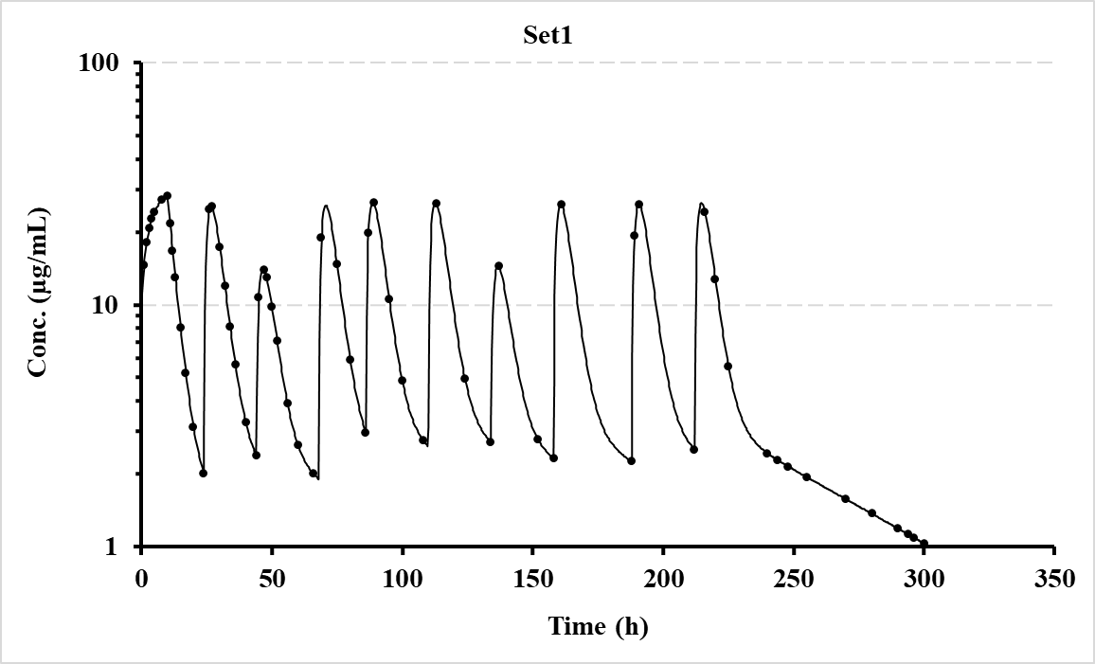

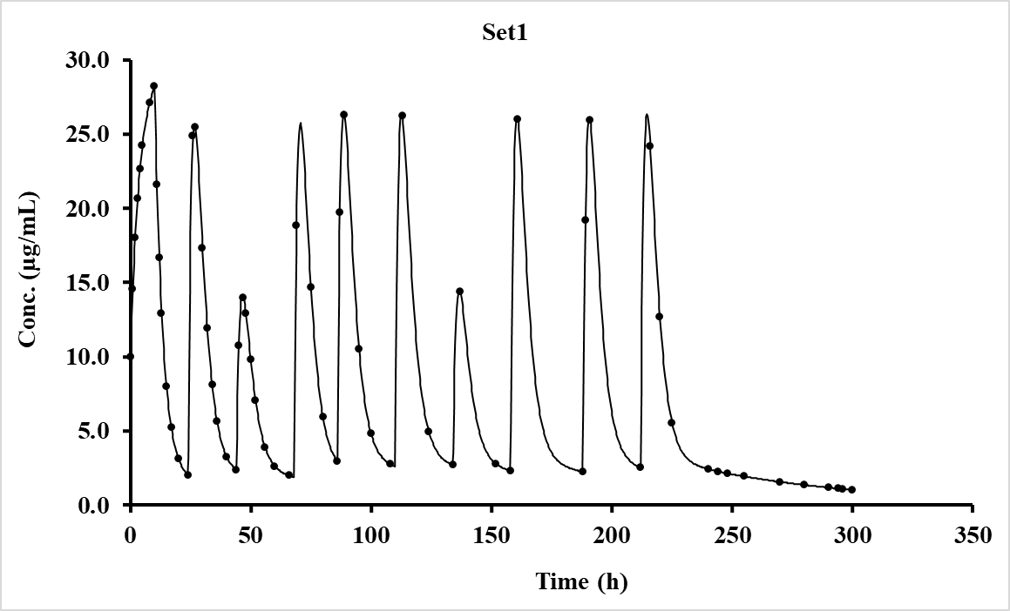

### 4.2.2 1-compartment bolus + infusion, oral (lag), bolus, oral (lag) then bolus + infusion (V7.6)

For this example, the dosing regimen is just for testing wherein; a bolus + infusion, oral with lag-time, a bolus, oral with lag-time and finally with a bolus + infusion with different doses and over varying dosing intervals.

Specifically, the 1-compartment models used for this example were numbers 14 (bolus + infusion), 7 (oral with lag-time) and 11 (bolus). To begin with, populate the Fitting options section on the modelling spreadsheet as shown below. Note the boxes that are ticked and specify the No. of Profiles (1 in this case) and the No. of Doses (5). Hopefully, the remainder are self-explanatory.



Once the above is populated, move down to Row 54, and enter the model numbers for each dose, in this case model 16 for the initial doses (bolus + infusion) and 10 (oral) for the remainder, as shown.

|  |  |  |  |  |  |
| --- | --- | --- | --- | --- | --- |
| **Model number for each dose.** | 14 | 7 | 11 | 7 | 14 |

Then click the ‘Keywords’ button which will lay out the expected input data for the user to add the appropriate values. Some values will be set to zero as they would not be required for certain models. The program will sort out the sequence of parameters for populating using ‘Mixed models’. To store the input setup data for the program, just click ‘Activate’ to show a message that it is stored in a file. Then click the ‘Row 1154’ button to enter the time and concentration data. Once entered, click the ‘Activate’ button to store the values and then return to the Fitting options by clicking ‘Row 45’. If everything is looking good, click the ‘Run’ button and within a few seconds the modelling will be completed, and an Excel window will appear with a detailed summary of the results. The graphics (both linear and log) can be shown by clicking the ‘Next’ button on the ‘Modelling’ sheet (just below the graphs) which prompts the program to update both plots and store these in separate files (location and names shown at the end of the summary sheet). The input data should look like that shown on the next page followed by a snippet of the results file and pictures from the Modelling spreadsheet.

Note that the fitted volume terms for i.v. (30 L) and oral (50 L) are different as the F value was different when the data were generated.

**Setup parameters Time-Concentration Data (rounded)**

|  |  |  |  |  |
| --- | --- | --- | --- | --- |
| **Title** | Set1 | **Comments** | **Time (h)** | **Set1** |
| **Dose** | 0 |  | 0 | 16.667 |
| **Ndoses** | 5 |  | 1 | 48.368 |
| **Pars Viv** | 25 | User starting estimates. | 2 | 46.009 |
| **k10** | 0.04 |  | 3 | 43.765 |
| **Vpo** | 40 |  | 4 | 41.63 |
| **ka** | 0.6 |  | 8 | 34.084 |
| **tlag** | 0.25 |  | 12 | 27.906 |
| **Doseint** | 24 | Only 4 needed as the | 16 | 22.847 |
|  | 36 | first dose is assumed | 20 | 18.706 |
|  | 24 | to be time zero. | 24 | 15.315 |
|  | 24 |  | 25 | 21.075 |
| **Inftime** | 1 | Infusion time (e.g., | 26 | 27.224 |
|  | 0 | h, min etc.). | 27 | 29.121 |
|  | 0 |  | 28 | 29.15 |
|  | 0 |  | 30 | 27.288 |
|  | 1 |  | 36 | 20.407 |
| **Infrate** | 1000 | For the models that | 40 | 16.71 |
|  | 0 | do not require values | 45 | 13.014 |
|  | 0 | just use zero as shown | 48 | 11.201 |
|  | 0 | e.g., oral models have | 59 | 6.462 |
|  | 1000 | no bolus or infusion. | 60 | 19.481 |
| **Infbol** | 500 | Bolus dose for model | 61 | 18.53 |
|  | 0 | 14 (bolus + infusion). | 62 | 17.627 |
|  | 0 |  | 66 | 14.432 |
|  | 0 |  | 80 | 7.167 |
|  | 250 |  | 84 | 5.867 |
| **Repdose** | 0 |  | 85 | 12.088 |
|  | 1000 | Oral (model 7) | 86 | 18.675 |
|  | 400 | Bolus (model 11) | 87 | 20.99 |
|  | 1000 | Oral (model 7) | 88 | 21.415 |
|  | 0 |  | 89 | 21.022 |
|  |  |  | 90 | 20.289 |
|  |  |  | 91 | 19.431 |
|  |  |  | 98 | 13.775 |
|  |  |  | 104 | 10.205 |
|  |  |  | 107 | 8.784 |
|  |  |  | 108 | 16.689 |
|  |  |  | 109 | 48.389 |
|  |  |  | 110 | 46.029 |
|  |  |  | 112 | 41.648 |
|  |  |  | 116 | 34.099 |
|  |  |  | 120 | 27.918 |
|  |  |  | 130 | 16.933 |
|  |  |  | 140 | 10.27 |
|  |  |  | 149 | 6.549 |
|  |  |  | 150 | 6.229 |
|  |  |  |  |  |
|  |  |  |  |  |
|  |  |  |  |  |

**Modelling result from summary file (much more detailed in the actual file).**

|  |  |  |  |  |  |  |  |  |
| --- | --- | --- | --- | --- | --- | --- | --- | --- |
| Date | 24/12/2022 15:37 |  |  |  |  |  |  |  |
| Algorithm | Marquardt (IRWLS) | |  |  |  |  |  |  |
| Weighting | 1/Conc2 |  |  |  |  |  |  |  |
| Model | Mixed |  |  |  |  |  |  |  |
| **Setup information used for this run is shown at the end of this summary.** | | | | | | | | |
| **Parameter** | **Pars Viv** | **k10** | **Vpo** | **ka** | **tlag** | **Akaike** | **Sos** | **λ1** |
| Set1 | 29.999616 | 5.00E-02 | 49.99934 | 0.7999517 | 0.4999443 | -792.1537 | 2.67E-08 | 0.0500 |
| %Error | 7.95E-04 | 6.99E-04 | 1.33E-03 | 7.14E-03 | 9.52E-03 |  |  |  |

Although the concentration data were rounded to 3 decimal places, these final parameter values are very close to the theoretical ones (shown below).

|  |  |  |  |  |  |  |
| --- | --- | --- | --- | --- | --- | --- |
| Parameter | Pars Viv | k10 | Vpo | ka | tlag |  |
| Set1 | 30.0 | 0.050 | 50.0 | 0.80 | 0.50 |  |

**Plots generated (copied from spreadsheet, Log and Linear)**

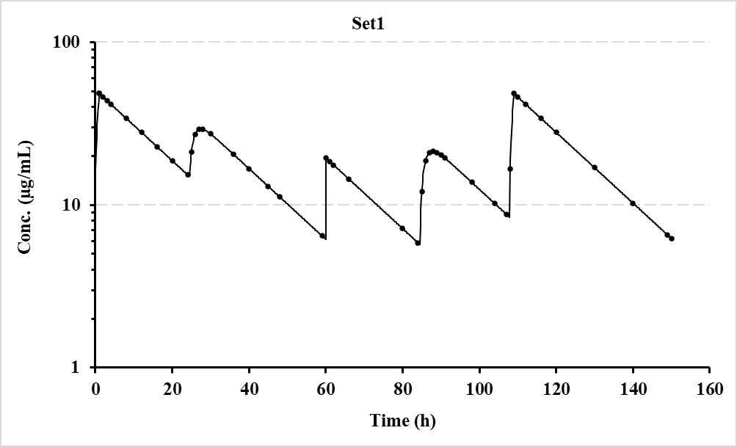

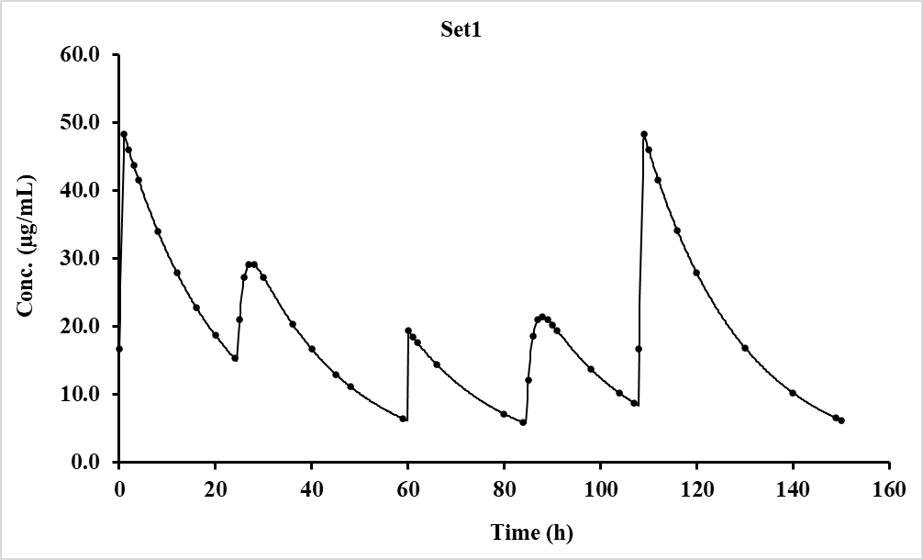

### 4.2.3 3-compartment bolus + infusion followed by oral maintenance (varying doses and intervals)

For this example, the dosing regimen is a bolus injection + infusion followed by an oral maintenance with different doses and over varying dosing intervals.

Specifically, the 3-compartment models used for this example were numbers 18 (bolus + infusion) and 43 (oral with no lag-time). To begin with, populate the Fitting options section on the modelling spreadsheet as shown below. Note the boxes that are ticked and specify the No. of Profiles (1 in this case) and the No. of Doses (10). Hopefully, the remainder are self-explanatory.



Once the above is populated, move down to Row 54, and enter the 3-compartment model numbers for each dose, in this case model 18 for the initial doses (bolus + infusion) and 43 (oral) for the remainder, as shown.

|  |  |  |  |  |  |  |  |  |  |  |
| --- | --- | --- | --- | --- | --- | --- | --- | --- | --- | --- |
| **Model number for each dose.** | 18 | 43 | 43 | 43 | 43 | 43 | 43 | 43 | 43 | 43 |

Then click the ‘Keywords’ button which will lay out the expected input data for the user to add the appropriate values. Some values will be set to zero as they would not be required for certain models. The program will sort out the sequence of parameters for populating using ‘Mixed models’. To store the input setup data for the program, just click ‘Activate’ to show a message that it is stored in a file. Then click the ‘Row 1154’ button to enter the time and concentration data. Once entered, click the ‘Activate’ button to store the values and then return to the Fitting options by clicking ‘Row 45’. If everything is looking good, click the ‘Run’ button and within a few seconds the modelling will be completed, and an Excel window will appear with a detailed summary of the results. The graphics (both linear and log) can be shown by clicking the ‘Next’ button on the ‘Modelling’ sheet (just below the graphs) which prompts the program to update both plots and store these in separate files (location and names shown at the end of the summary sheet). The input data should look like that shown on the next page followed by a snippet of the results file and pictures from the Modelling spreadsheet.

Note that the fitted volume terms for i.v. (10 L) and oral (20 L) are different as the F value was different when the data were generated.

**Setup parameters Time-Concentration Data (rounded)**

|  |  |  |  |  |  |  |
| --- | --- | --- | --- | --- | --- | --- |
| **Title** | Set1 | **Comments** | **Time (h)** | **Set1** | **Time (h)** | **Set1** |
| **Dose** | 0 |  | 0.0 | 10.00 | 130.0 | 4.288 |
| **Ndoses** | 10 |  | 0.5 | 10.298 | 134.0 | 3.665 |
| **Pars Viv** | 8.0 | User starting estimates. | 1.0 | 10.665 | 135.5 | 12.959 |
| **k12** | 0.50 | Note there are 8 | 1.5 | 11.070 | 137.0 | 10.457 |
| **k21** | 0.25 | parameters. | 2.0 | 11.494 | 142.0 | 5.387 |
| **k13** | 0.15 |  | 2.5 | 11.925 | 148.0 | 3.975 |
| **k31** | 0.020 |  | 3.0 | 12.355 | 150.0 | 3.664 |
| **k10** | 0.20 |  | 4.0 | 13.194 | 158.0 | 2.746 |
| **Vpo** | 25.0 |  | 5.0 | 13.993 | 158.5 | 15.636 |
| **ka** | 0.5 |  | 6.0 | 14.746 | 159.5 | 21.595 |
| **Doseint** | 24.0 | Only 9 needed as the | 8.0 | 16.115 | 160.0 | 20.587 |
|  | 20.0 | first dose is assumed | 9.0 | 16.737 | 166.0 | 7.349 |
|  | 24.0 | to be time zero. | 10.0 | 17.320 | 178.0 | 3.893 |
|  | 18.0 |  | 10.5 | 14.251 | 188.0 | 2.683 |
|  | 24.0 |  | 11.0 | 12.166 | 189.5 | 21.535 |
|  | 24.0 |  | 12.0 | 9.693 | 212.0 | 3.281 |
|  | 24.0 |  | 14.0 | 7.539 | 214.0 | 21.056 |
|  | 30.0 |  | 16.0 | 6.463 | 218.0 | 9.574 |
|  | 24.0 |  | 18.0 | 5.679 | 228.0 | 4.858 |
| **Inftime** | 10 | Infusion time (e.g., | 20.0 | 5.033 | 248.0 | 2.328 |
|  | 0 | h, min etc.). | 24.0 | 4.016 | 270.0 | 1.349 |
|  | 0 |  | 24.5 | 16.844 | 290.0 | 0.889 |
|  | 0 | For the models that | 25.0 | 21.805 | 296.0 | 0.788 |
|  | 0 | do not require certain | 25.5 | 22.687 | 300.0 | 0.727 |
|  | 0 | values just use zero | 26.5 | 19.782 |  |  |
|  | 0 | as shown e.g., oral | 28.0 | 14.196 |  |  |
|  | 0 | models have no bolus | 30.0 | 9.889 |  |  |
|  | 0 | or infusion info. | 36.0 | 6.001 |  |  |
|  | 0 |  | 40.0 | 4.845 |  |  |
| **Infrate** | 80 | Infusion rate (e.g., | 44.0 | 3.998 |  |  |
|  | 0 | mg/h, µg/min etc.). | 45.0 | 12.820 |  |  |
|  | 0 |  | 45.5 | 13.227 |  |  |
|  | 0 | For the models that | 46.0 | 12.662 |  |  |
|  | 0 | do not require certain | 48.0 | 8.824 |  |  |
|  | 0 | values just use zero | 52.0 | 5.463 |  |  |
|  | 0 | as shown e.g., oral | 56.0 | 4.345 |  |  |
|  | 0 | models have no bolus | 60.0 | 3.626 |  |  |
|  | 0 | or infusion info. | 65.0 | 2.969 |  |  |
|  | 0 |  | 68.0 | 2.663 |  |  |
| **Infbol** | 100 | Bolus dose for model | 69.0 | 20.571 |  |  |
|  | 0 | 18 (bolus + infusion). | 69.5 | 21.508 |  |  |
|  | 0 |  | 70.0 | 20.499 |  |  |
|  | 0 |  | 72.0 | 13.261 |  |  |
|  | 0 | Not required for oral | 74.0 | 9.113 |  |  |
|  | 0 | models. | 76.0 | 7.253 |  |  |
|  | 0 |  | 80.0 | 5.563 |  |  |
|  | 0 |  | 86.0 | 4.149 |  |  |
|  | 0 |  | 87.5 | 22.863 |  |  |
|  | 0 |  | 89.0 | 17.979 |  |  |
| **Repdose** | 0 | Not required for model | 91.0 | 11.873 |  |  |
|  | 1000 | 18 but would be if the | 96.0 | 7.095 |  |  |
|  | 500 | model was bolus only | 100.0 | 5.707 |  |  |
|  | 1000 | (models 11, 12 or 13). | 106.0 | 4.338 |  |  |
|  | 1000 |  | 110.0 | 3.692 |  |  |
|  | 1000 | The remainder are the | 111.5 | 22.468 |  |  |
|  | 500 | oral doses. | 113.0 | 17.637 |  |  |
|  | 1000 |  | 118.0 | 7.982 |  |  |
|  | 1000 |  | 120.0 | 6.928 |  |  |
|  | 1000 |  |  |  |  |  |

**Modelling result from summary file (much more detailed in the actual file).**

|  |  |  |  |  |  |  |  |  |  |  |
| --- | --- | --- | --- | --- | --- | --- | --- | --- | --- | --- |
| Date | 29/12/2022 16:59 |  |  |  |  |  |  |  |  |  |
| Algorithm | Marquardt (IRWLS) | |  |  |  |  |  |  |  |  |
| Weighting | 1/Conc2 |  |  |  |  |  |  |  |  |  |
| Model | Mixed |  |  |  |  |  |  |  |  |  |
| **Setup information and plot files detailed for this run at the end of this summary Workbook as a record.** | | | | | | | | |  |  |
| Parameter | Pars Viv | k12 | k21 | k13 | k31 | k10 | Vpo | ka | Akaike | Sos |
| Set1 | 10.00009 | 0.4000142 | 0.2000284 | 0.1000056 | 0.0300009 | 0.2500013 | 19.99978 | 0.7500121 | -1128.681 | 8.66E-07 |
| %Error | 7.97E-03 | 1.76E-02 | 2.18E-02 | 4.05E-02 | 3.17E-02 | 8.61E-03 | 9.16E-03 | 1.02E-02 |  |  |

Although the concentration data were rounded to 3 decimal places, these final parameter values are very close to the theoretical ones (shown below).

|  |  |  |  |  |  |  |  |
| --- | --- | --- | --- | --- | --- | --- | --- |
| Pars Viv | k12 | k21 | k13 | k31 | k10 | Vpo | ka |
| 10.0 | 0.40 | 0.20 | 0.10 | 0.030 | 0.25 | 20.0 | 0.75 |

**Plots generated (copied from spreadsheet, Log and Linear)**

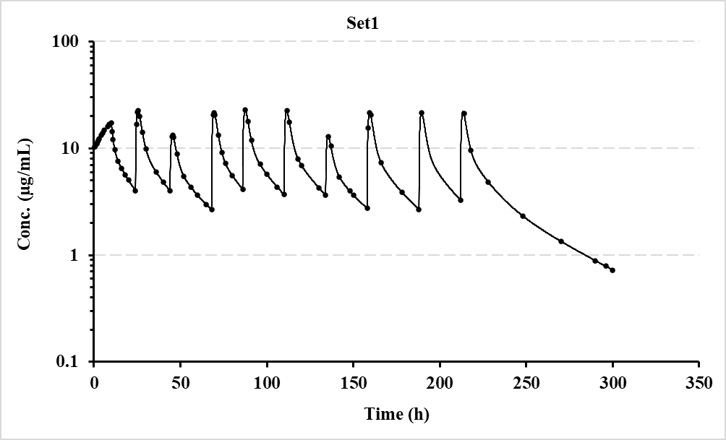

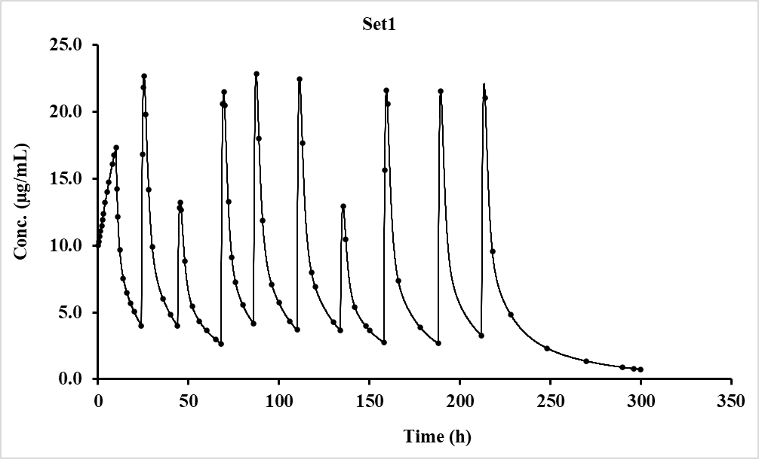

### 4.2.4 2-compt. bolus + infusion followed by oral maintenance V7.6, varying dose, and interval.

For this example, using V7.6, the dosing regimen is a bolus injection + infusion followed by an oral maintenance with different doses and over varying dosing intervals. The sampling is taken on Days 1 and 10 only, to reflect what may be chosen for a study (the data is hypothetical, but the result demonstrates the validity of the procedure). In V7.6 output, note the additions of plot file names at the beginning and the λn values in the Excel summary file, which are now added after several users requested these additions.

The other update to note is that for compartmental models the λn values are now calculated for ‘Single’ and ‘Repeat’ dose options in addition to ‘Mixed’, as for this example.

Specifically, the 2-compartment models used for this example were numbers 16 (bolus + infusion) and 10 (oral with no lag-time). To begin with, populate the Fitting options section on the modelling spreadsheet as shown below. Note the boxes that are ticked and specify the No. of Profiles (1 in this case) and the No. of Doses (10). Hopefully, the remainder are self-explanatory.



Once the above is populated, move down to Row 54, and enter the 2-compartment model numbers for each dose, in this case model 16 for the initial doses (bolus + infusion) and 10 (oral) for the remainder, as shown.

|  |  |  |  |  |  |  |  |  |  |  |
| --- | --- | --- | --- | --- | --- | --- | --- | --- | --- | --- |
| **Model number for each dose.** | 16 | 10 | 10 | 10 | 10 | 10 | 10 | 10 | 10 | 10 |

Then click the ‘Keywords’ button which will lay out the expected input data for the user to add the appropriate values. Some values will be set to zero as they would not be required for certain models. The program will sort out the sequence of parameters for populating using ‘Mixed models’. To store the input setup data for the program, just click ‘Activate’ to show a message that it is stored in a file. Then click the ‘Row 1154’ button to enter the time and concentration data. Once entered, click the ‘Activate’ button to store the values and then return to the Fitting options by clicking ‘Row 45’. If everything is looking good, click the ‘Run’ button and within a few seconds the modelling will be completed, and an Excel window will appear with a detailed summary of the results. The graphics (both linear and log) can be shown by clicking the ‘Next’ button on the ‘Modelling’ sheet (just below the graphs) which prompts the program to update both plots and store these in separate files (location and names shown at the beginning of the summary sheet). The input data should look like that shown on the next page followed by a snippet of the results file and pictures from the Modelling spreadsheet.

Note that the fitted volume terms for i.v. (20 L) and oral (30 L) are different as the F value was different when the data were generated.

**Setup parameters Time-Concentration Data (rounded)**

|  |  |  |  |  |
| --- | --- | --- | --- | --- |
| **Title** | Set1 | **Comments** | **Time (h)** | **Set1** |
| **Dose** | 0 | Automatically set when | 0.00 | 50.00 |
| **Ndoses** | 10 | Keywords’ is clicked. | 1.00 | 53.15 |
| **Pars Viv** | 15.000 | User starting estimates. | 3.00 | 60.06 |
| **k12** | 0.080 | Note there are 6 | 4.00 | 63.70 |
| **k21** | 0.170 | parameters. | 5.00 | 67.39 |
| **k10** | 0.060 |  | 8.00 | 53.50 |
| **Vpo** | 25.000 |  | 10.00 | 47.92 |
| **ka** | 0.300 |  | 12.00 | 43.92 |
| **Doseint** | 24.0 | Only 9 needed as the | 16.00 | 38.44 |
|  | 23.0 | first dose is assumed | 20.00 | 34.55 |
|  | 24.0 | to be time zero. | 24.00 | 31.39 |
|  | 25.0 |  | 216.00 | 23.08 |
|  | 24.0 |  | 217.00 | 34.76 |
|  | 22.0 |  | 218.00 | 40.22 |
|  | 26.0 |  | 219.00 | 42.22 |
|  | 24.0 |  | 220.00 | 42.35 |
|  | 24.0 |  | 221.00 | 41.54 |
| **Inftime** | 5.0 | Infusion time | 222.00 | 40.30 |
|  | 0.0 |  | 223.00 | 38.91 |
|  | 0.0 | For the models that | 224.00 | 37.51 |
|  | 0.0 | do not require certain | 225.00 | 36.18 |
|  | 0.0 | values just use zero | 230.00 | 30.86 |
|  | 0.0 | as shown e.g., oral | 240.00 | 24.10 |
|  | 0.0 | models have no bolus | 250.00 | 19.22 |
|  | 0.0 | or infusion info. | 254.00 | 17.57 |
|  | 0.0 |  | 256.00 | 16.80 |
|  | 0.0 |  | 260.00 | 15.36 |
| **Infrate** | 200.0 | Infusion rate (e.g., | 270.00 | 12.27 |
|  | 0.0 | mg/h, µg/min etc.). | 280.00 | 9.81 |
|  | 0.0 |  |  |  |
|  | 0.0 | For the models that |  |  |
|  | 0.0 | do not require certain |  |  |
|  | 0.0 | values just use zero |  |  |
|  | 0.0 | as shown e.g., oral |  |  |
|  | 0.0 | models have no bolus |  |  |
|  | 0.0 | or infusion info. |  |  |
|  | 0.0 |  |  |  |
| **Infbol** | 1000.0 | Bolus dose for model |  |  |
|  | 0.0 | 16 (bolus + infusion). |  |  |
|  | 0.0 |  |  |  |
|  | 0.0 | Not required for oral |  |  |
|  | 0.0 | models (use 0.0). |  |  |
|  | 0.0 |  |  |  |
|  | 0.0 |  |  |  |
|  | 0.0 |  |  |  |
|  | 0.0 |  |  |  |
|  | 0.0 |  |  |  |
| **Repdose** | 0.0 | Not required for model |  |  |
|  | 2000.0 | 16 but would be if the |  |  |
|  | 1000.0 | model was bolus only |  |  |
|  | 1000.0 | (models 11, 12 or 13). |  |  |
|  | 500.0 |  |  |  |
|  | 1000.0 | The remainder are the |  |  |
|  | 500.0 | oral doses. |  |  |
|  | 1000.0 |  |  |  |
|  | 1000.0 |  |  |  |
|  | 1000.0 |  |  |  |
|  |  |  |  |  |
|  |  |  |  |  |

**Modelling result from summary file (much more detailed in the actual file).**

|  |  |  |  |  |  |  |  |  |  |  |
| --- | --- | --- | --- | --- | --- | --- | --- | --- | --- | --- |
| Date | 12/01/2023 10:10 | Linear Plotting files stored in C:\PCModfit V7.6\Results\Fitplotlin85.png to Fitplotlin85.png | | | | | | | | |
| Algorithm | Marquardt (IRWLS) | Log. Plotting files stored in C:\PCModfit V7.6\Results\Fitplotlog85.png to Fitplotlog85.png | | | | | | | | |
| Weighting | 1/Conc2 |  |  |  |  |  |  |  |  |  |
| Model | Mixed |  |  |  |  |  |  |  |  |  |
| Setup information used for this run is shown at the end of this summary. | | | | | | |  |  |  |  |
| **Parameter** | **Pars Viv** | **k12** | **k21** | **k10** | **Vpo** | **ka** | **Akaike** | **Sos** | **λ1** | **λ2** |
| Profile_1 | 20.00540 | 0.099610 | 0.149446 | 0.039995 | 30.18546 | 0.500212 | -295.8807 | 2.45E-05 | 0.26663 | 0.02242 |
| %Error | 0.08 | 0.43 | 0.36 | 0.10 | 0.11 | 0.30 |  |  |  |  |

**New additions in V7.6**

Even though the concentration data were rounded to 2 decimal places, these final parameter values are very close to the theoretical ones (shown below).

|  |  |  |  |  |  |
| --- | --- | --- | --- | --- | --- |
| **Pars Viv** | **k12** | **k21** | **k10** | **Vpo** | **ka** |
| 20.0 | 0.10 | 0.15 | 0.04 | 30.0 | 0.500 |

**Plots generated (copied from spreadsheet, Linear and Log)**

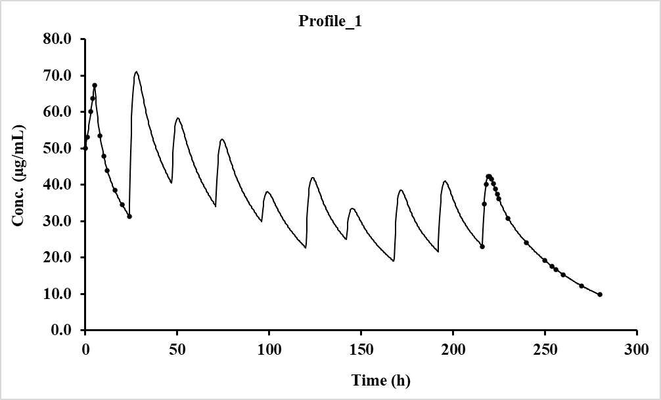

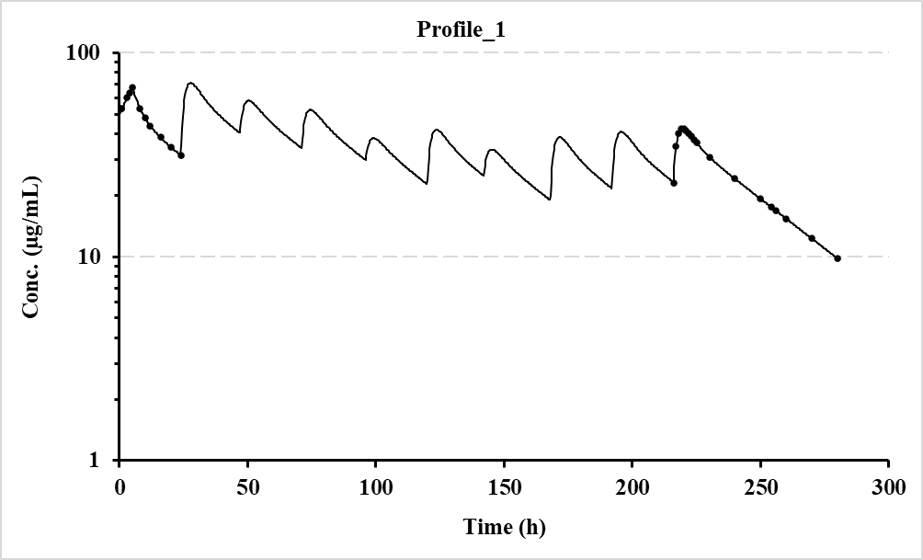

### 4.2.5 2-compt. Oral, varying with and without lag-time models and doses and intervals.

For this example, using V7.7, the dosing regimen alternates oral with lag-time then oral without, as shown in the Model numbers below. The doses and dosing intervals are also varied.

Specifically, the 2-compartment models used for this example were numbers 9 (with lag-time) and 10 (without lag-time). Note the boxes that are ticked and specify the No. of Profiles (1 in this case) and the No. of Doses (6). Hopefully, the remainder are self-explanatory.



Once the above is populated, move down to Row 54, and enter the 2-compartment oral model numbers for each dose, as shown.

|  |  |  |  |  |  |  |
| --- | --- | --- | --- | --- | --- | --- |
| **Model number for each dose.** | 9 | 10 | 9 | 10 | 9 | 10 |

Then click the ‘Keywords’ button which will lay out the expected input data for the user to add the appropriate values. The program will sort out the sequence of parameters for populating using ‘Mixed models’. To store the input setup data for the program, just click ‘Activate’ to show a message that it is stored in a file. Then click the ‘Row 1154’ button to enter the time and concentration data. Once entered, click the ‘Activate’ button to store the values and then return to the Fitting options by clicking ‘Row 45’. If everything is looking good, click the ‘Run’ button and within a few seconds the modelling will be completed, and an Excel window will appear with a detailed summary of the results. The graphics (both linear and log) can be shown by clicking the ‘Next’ button on the ‘Modelling’ sheet (just below the graphs) which prompts the program to update both plots and store these in separate files (location and names shown at the beginning of the summary sheet). The input data should look like that shown on the next page followed by a snippet of the results file and pictures from the Modelling spreadsheet.

**Setup parameters Time-Concentration Data (rounded)**

|  |  |  |  |  |
| --- | --- | --- | --- | --- |
| **Title** | Profile_1 | **Comments** | **Time** | **Profile_1** |
| **Dose** | 0.0 | Automatically set when | 0 | 0 |
| **Ndoses** | 6 | Keywords’ is clicked. | 1 | 0 |
| **Pars Vpo** | 18.00 |  | 2 | 0 |
| **ka** | 0.40 | Note there are 6 parameters. | 3 | 8.48 |
| **k12** | 0.10 |  | 4 | 11.57 |
| **k21** | 0.03 |  | 5 | 11.89 |
| **k10** | 0.15 |  | 6 | 10.93 |
| **tlag** | 1.50 |  | 7 | 9.46 |
| **Doseint** | 24.0 | Only 5 needed as the first dose | 8 | 7.92 |
|  | 20.0 | is assumed to be time zero. | 9 | 6.49 |
|  | 24.0 |  | 10 | 5.25 |
|  | 18.0 |  | 11 | 4.21 |
|  | 24.0 |  | 12 | 3.38 |
| **Repdose** | 500.0 | Oral doses. | 14 | 2.18 |
|  | 1000.0 |  | 15 | 1.77 |
|  | 500.0 |  | 16 | 1.46 |
|  | 1000.0 |  | 19 | 0.88 |
|  | 1000.0 |  | 20 | 0.77 |
|  | 1000.0 |  | 24 | 0.52 |
|  |  |  | 25 | 17.46 |
|  |  |  | 26 | 23.6 |
|  |  |  | 27 | 24.23 |
|  |  |  | 28 | 22.28 |
|  |  |  | 29 | 19.34 |
|  |  |  | 30 | 16.24 |
|  |  |  | 110 | 2.38 |
|  |  |  | 111 | 19.26 |
|  |  |  | 112 | 25.36 |
|  |  |  | 113 | 25.95 |
|  |  |  | 114 | 23.97 |
|  |  |  | 115 | 21 |
|  |  |  | 116 | 17.87 |
|  |  |  | 118 | 12.45 |
|  |  |  | 119 | 10.36 |
|  |  |  | 120 | 8.65 |
|  |  |  | 122 | 6.21 |
|  |  |  | 124 | 4.7 |
|  |  |  | 126 | 3.78 |
|  |  |  | 127 | 3.47 |
|  |  |  | 128 | 3.22 |
|  |  |  | 129 | 3.02 |
|  |  |  | 130 | 2.87 |
|  |  |  | 144 | 2.06 |
|  |  |  | 152 | 1.84 |
|  |  |  | 160 | 1.64 |
|  |  |  | 168 | 1.47 |
|  |  |  | 175 | 1.33 |
|  |  |  | 180 | 1.24 |
|  |  |  | 185 | 1.16 |
|  |  |  | 190 | 1.08 |
|  |  |  | 194 | 1.02 |
|  |  |  | 195 | 1.01 |
|  |  |  | 197 | 0.98 |
|  |  |  | 200 | 0.94 |

**Modelling result from summary file (much more detailed in the actual file).**

|  |  |  |  |  |  |  |  |  |  |  |
| --- | --- | --- | --- | --- | --- | --- | --- | --- | --- | --- |
| Date | 21/01/2023 15:10 | Linear Plotting files stored in C:\PCModfit V7.7\Results\Fitplotlin13.png to Fitplotlin13.png | | | | | | | | |
| Algorithm | Marquardt (IRWLS) | Log. Plotting files stored in C:\PCModfit V7.7\Results\Fitplotlog13.png to Fitplotlog13.png | | | | | | | | |
| Weighting | 1/Conc2 |  |  |  |  |  |  |  |  |  |
| Model | Mixed |  |  |  |  |  |  |  |  |  |
| Setup information used for this run is shown at the end of this summary. | | | | | | |  |  |  |  |
| **Parameter** | **Pars Vpo** | **ka** | **k12** | **k21** | **k10** | **tlag** | **Akaike** | **Sos** | **λ1** | **λ2** |
| Profile_1 | 20.03772 | 0.50121 | 0.07979 | 0.01995 | 0.19960 | 2.00021 | -464.7346 | 8.72E-05 | 0.28539 | 0.01395 |
| %Error | 0.14 | 0.21 | 0.18 | 0.13 | 0.13 | 0.11 |  |  |  |  |

Even though the concentration data were rounded to 2 decimal places, these final parameter values are very close to the theoretical ones (shown below).

|  |  |  |  |  |  |
| --- | --- | --- | --- | --- | --- |
| **Pars Vpo** | **ka** | **k12** | **k21** | **k10** | **tlag** |
| 20.0 | 0.5 | 0.08 | 0.02 | 0.2 | 2.0 |

**Plots generated (copied from spreadsheet, Linear and Log)**

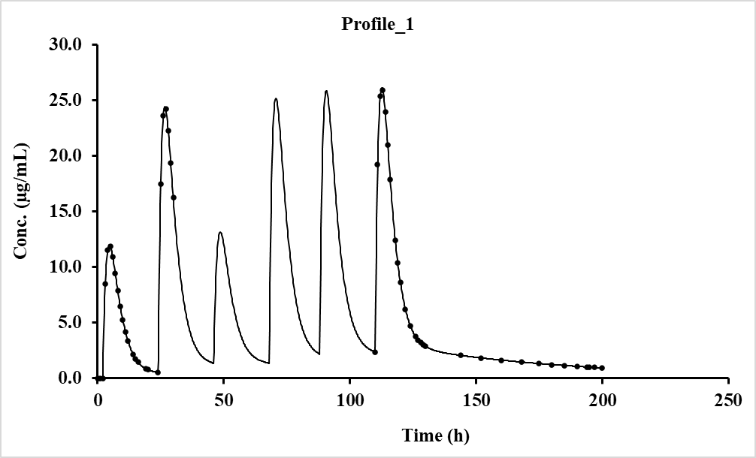

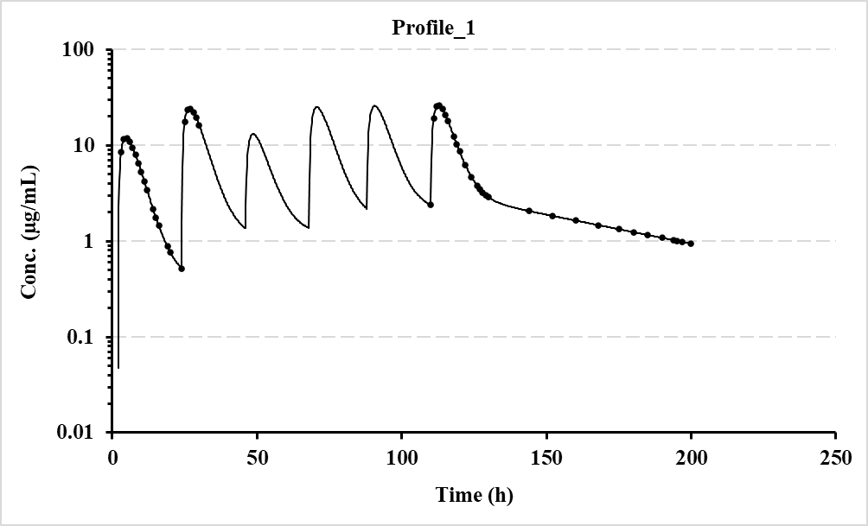

### 4.2.6 3-compartment oral with and without lag-time (varying doses and intervals, V7.7)

For this example, the dosing regimen is a 3-compt. repeat dose oral, alternating with and without lag-time and with different doses and dosing intervals.

Specifically, the 3-compartment oral models used for this example were numbers 42 (with lag-time) and 43 (no lag-time) varying doses and intervals. To begin with, populate the Fitting options section on the modelling spreadsheet as shown below. Note the boxes that are ticked and specify the No. of Profiles (1 in this case) and the No. of Doses (10). Hopefully, the remainder are self-explanatory.



Once the above is populated, move down to Row 54, and enter the 3-compartment model numbers for each dose, in this case model 18 for the initial doses (bolus + infusion) and 43 (oral) for the remainder, as shown.

|  |  |  |  |  |  |  |  |  |  |  |
| --- | --- | --- | --- | --- | --- | --- | --- | --- | --- | --- |
| **Model number for each dose.** | 42 | 43 | 42 | 43 | 42 | 43 | 42 | 43 | 42 | 43 |

Then click the ‘Keywords’ button which will lay out the expected input data for the user to add the appropriate values. Some values will be set to zero as they would not be required for certain models. The program will sort out the sequence of parameters for populating using ‘Mixed models’. To store the input setup data for the program, just click ‘Activate’ to show a message that it is stored in a file. Then click the ‘Row 1154’ button to enter the time and concentration data. Once entered, click the ‘Activate’ button to store the values and then return to the Fitting options by clicking ‘Row 45’. If everything is looking good, click the ‘Run’ button and within a few seconds the modelling will be completed, and an Excel window will appear with a detailed summary of the results.

The graphics (both linear and log) can be shown by clicking the ‘Next’ button on the ‘Modelling’ sheet (just below the graphs) which prompts the program to update both plots and store these in separate files (location and names shown at the end of the summary sheet). The input data should look like that shown on the next page followed by a snippet of the results file and pictures from the Modelling spreadsheet.

**Setup parameters Time-Concentration Data (rounded)**

|  |  |  |  |  |
| --- | --- | --- | --- | --- |
| **Title** | Profile_1 | **Comments** | **Time (h)** | **Profile_1** |
| **Dose** | 0.0 |  | 0.0 | 0.00 |
| **Ndoses** | 10 |  | 1.00 | 0.00 |
| **Pars Vpo** | 20.00 | User starting estimates. Note there | 2.00 | 0.00 |
| **ka** | 0.60 | are 8 parameters. | 2.50 | 9.779 |
| **k12** | 0.35 |  | 3.00 | 13.778 |
| **k21** | 0.22 |  | 3.50 | 14.705 |
| **k13** | 0.08 |  | 4.00 | 14.117 |
| **k31** | 0.02 |  | 6.00 | 8.872 |
| **k10** | 0.20 |  | 10.00 | 4.232 |
| **tlag** | 1.60 |  | 11.00 | 3.811 |
| **Doseint** | 24.0 | Only 9 needed as the first dose | 12.00 | 3.488 |
|  | 20.0 | is assumed to be time zero. | 13.00 | 3.227 |
|  | 24.0 |  | 15.00 | 2.810 |
|  | 18.0 |  | 17.00 | 2.476 |
|  | 24.0 |  | 20.00 | 2.073 |
|  | 24.0 |  | 24.00 | 1.665 |
|  | 24.0 |  | 210.00 | 2.248 |
|  | 30.0 |  | 210.25 | 6.612 |
|  | 22.0 |  | 210.50 | 9.543 |
| **Repdose** | 1000 | Oral doses, one for each dose. | 210.75 | 11.412 |
|  | 500 |  | 211.00 | 12.503 |
|  | 500 |  | 211.50 | 13.161 |
|  | 1000 |  | 212.00 | 12.683 |
|  | 1000 |  | 212.50 | 11.722 |
|  | 1000 |  | 213.00 | 10.624 |
|  | 1000 |  | 214.00 | 8.613 |
|  | 1000 |  | 215.00 | 7.119 |
|  | 500 |  | 216.00 | 6.093 |
|  | 750 |  | 220.00 | 4.244 |
|  |  |  | 224.00 | 3.431 |
|  |  |  | 230.00 | 2.637 |
|  |  |  | 236.00 | 2.103 |
|  |  |  | 242.00 | 1.727 |
|  |  |  | 250.00 | 1.376 |
|  |  |  | 260.00 | 1.075 |
|  |  |  | 270.00 | 0.860 |
|  |  |  | 280.00 | 0.698 |
|  |  |  | 295.00 | 0.516 |
|  |  |  | 300.00 | 0.467 |
|  |  |  |  |  |
|  |  |  |  |  |
|  |  |  |  |  |
|  |  |  |  |  |
|  |  |  |  |  |

**Modelling result from summary file (much more detailed in the actual file).**

|  |  |  |  |  |  |  |  |  |  |  |  |  |  |  |
| --- | --- | --- | --- | --- | --- | --- | --- | --- | --- | --- | --- | --- | --- | --- |
| Date 22/01/2023 11:46 | | | | Linear Plotting files stored in C:\PCModfit V7.7\Results\Fitplotlin16.png to Fitplotlin16.png | | | | | | | | | | |
| Algorithm Marquardt (IRWLS) | | | | Log. Plotting files stored in C:\PCModfit V7.7\Results\Fitplotlog16.png to Fitplotlog16.png | | | | | | | | | | |
| Weighting 1/Conc2 | |  |  | |  |  |  |  |  |  |  |  |  |  |
| Model | Mixed |  |  | |  |  |  |  |  |  |  |  |  |  |
| Setup information used for this run is shown at the end of this summary. | | | | | | | | | | | |  |  |  |
| **Parameter** | **Pars Vpo** | **ka** | **k12** | | **k21** | **k13** | **k31** | **k10** | **tlag** | **Akaike** | **Sos** | **λ1** | **λ2** | **λ3** |
| Profile_1 | 25.0224 | 0.70059 | 0.39963 | | 0.19999 | 0.09984 | 0.02997 | 0.24978 | 2.00001 | -456.68 | 6.02E-07 | 0.87177 | 0.08790 | 0.01954 |
| %Error | 0.31 | 0.28 | 0.36 | | 0.07 | 0.28 | 0.06 | 0.30 | 0.01 |  | | | | |

Although the concentration data were rounded to 3 decimal places, these final parameter values are very close to the theoretical ones (shown below).

|  |  |  |  |  |  |  |  |
| --- | --- | --- | --- | --- | --- | --- | --- |
| **Pars Vpo** | **ka** | **k12** | **k21** | **k13** | **k31** | **k10** | **tlag** |
| 25.0 | 0.70 | 0.40 | 0.20 | 0.10 | 0.03 | 0.25 | 2.0 |

**Plots generated (copied from spreadsheet, Log and Linear)**





# Models and symbols

There are many pharmacokinetic models available in PCModfit and this section of the manual details the models and the parameters in the sequence used by other aspects of the program. The fitting options use the model parameters exactly as they are shown here and should not be entered in any other sequence. Additional models will be added – note that some models have been removed as these are currently being sorted out.

|  |  |  |  |
| --- | --- | --- | --- |
| **Model** | **Type and parameter sequence** | **Number of Parameters** | **With starting Estimates** |
| 1 | Two exponentials (oral) | 4 | Yes |
|  | (B, ka, A, λ1) |  |  |
| 2 | Three exponentials (oral) | 6 | Yes |
|  | (C, ka, A, λ1, B, λ2) |  |  |
| 3 | Four exponentials (oral) | 8 | No |
|  | (D, ka, A, λ1, B, λ2, C, λ3) |  |  |
| 4 | One exponential i.v. | 2 | Yes |
|  | (A, λ) |  |  |
| 5 | Two exponentials i.v. | 4 | Yes |
|  | (A, λ1, B, λ2) |  |  |
| 6 | Three exponentials i.v. | 6 | Yes |
|  | (A, λ1, B, λ2, C, λ3) |  |  |
| 7 | One compartment oral (with lag time) | 4 | Yes |
|  | (V, ka, k10, tl) |  |  |
| 8 | One compartment oral | 3 | Yes |
|  | (V, ka, k10) |  |  |
| 9 | Two compartment oral (with lag time) | 6 | Yes |
|  | (V, ka, k12, k21, k10, tl) |  |  |
| 10 | Two compartment oral | 5 | Yes |
|  | (V, ka, k12, k21, k10) |  |  |
| 11 | One compartment i.v. bolus | 2 | Yes |
|  | (V, k10) |  |  |
| 12 | Two compartment i.v. bolus | 4 | Yes |
|  | (V, k12, k21, k10) |  |  |
| 13 | Three compartment i.v. bolus | 6 | Yes |
|  | (V, k12, k21, k13, k31, k10) |  |  |
| 14 | One compartment infusion with bolus | 2 | Yes |
|  | (V, k10) |  |  |
| 15 | One compartment infusion | 2 | Yes |
|  | (V, k10) |  |  |
| 16 | Two compartment infusion with bolus | 4 | Yes |
|  | (V, k12, k21, k10) |  |  |
| 17 | Two compartment infusion | 4 | Yes |
|  | (V, k12, k21, k10) |  |  |
| 18 | Three compartment infusion with bolus | 6 | Yes |
|  | (V, k12, k21, k13, k31, k10) |  |  |
| 19 | Three compartment infusion | 6 | Yes |
|  | (V, k12, k21, k13, k31, k10) |  |  |
| 20 | Weibull function (with lag time) | 4 | No |
|  | (F, t1, td, λ) |  |  |
| 21 | Weibull function | 3 | No |
|  | (F, td, λ) |  |  |

|  |  |  |  |
| --- | --- | --- | --- |
| 23 | Zero order input one compartment oral | 3 | No |
|  | (V, k10, T) |  |  |
| 24 | Zero order input two compartment oral (with lag time) | 6 | No |
|  | (V, k12, k21, k10, T, tl) |  |  |
| 38 | One compartment infusion (with bolus coefficients) | 2 | Yes |
|  | (A, λ 1) |  |  |
| 39 | Two compartment infusion (with bolus coefficients) | 4 | Yes |
|  | (A, λ 1, B, λ 2) |  |  |
| 40 | Three compartment infusion (with bolus coefficients) | 6 | Yes |
|  | (A, λ 1, B, λ 2, C, λ 3) |  |  |
| 42 | Three compartment oral (with lag time) | 8 | No |
|  | (V, ka, k12, k21, k13, k31, k10, tl) |  |  |
| 43 | Three compartment oral | 7 | No |
|  | (V, ka, k12, k21, k13, k31, k10) |  |  |
| 45 | Power function (p1 t-p2) | 2 | No |
| 46 | Gamma function (p1t-p2e-p3t) | 3 | No |
| 54 | One compartment oral (equal rate constant, with lag time) | 3 | No |
|  | (V, k, tl) |  |  |
| 55 | One compartment oral (equal rate constant) | 2 | No |
|  | (V, k) |  |  |
| 60 | y = p1 (1 - e-p2(t-t1)) | 3 | No |
| 68 | Polynomial (degree 1) | 2 | No |
|  | (p1 + p2 x) |  |  |
| 69 | Polynomial (degree 2) | 3 | No |
|  | (p1 + p2 x + p3 x2) |  |  |
| 70 | Polynomial (degree 3) | 4 | No |
|  | (p1 + p2 x + p3 x2 + p4 x3) |  |  |
| 71 | Polynomial (degree 4) | 5 | No |
|  | (p1 + p2 x + p3 x2 + p4 x3 + p5 x4) |  |  |

**Summary of Symbols Used**

|  |  |
| --- | --- |
| **Parameter** | **Interpretation** |
| AUC  C1, C2 | Area under concentration-time data  Coefficients of appropriate exponentials |
| 1, 2...... n | Eigenvalues of model (or alpha, beta, gamma phases) |
| ki,j  k0 | Microrate constants from compartment i to j  Infusion rate |
| ke or k10 | Elimination rate constants from compartment 1 (not necessarily ) |
| ka | Absorption rate constant (oral models) |
| Viv or Vpo  V1, V2, V3 | Vol. of distribution (central compartment 1) for i.v. or oral models  Vols. of compartments 1, 2 and 3 i.e., V2 = k12 / k21 × V1 and V3 = k13 / k31 × V1 |
| tl or tlag | Lag time (absorption delay) |
| td | Mean dissolution time |
|  | Shape parameter (equals 1 for 1st order) |
| T | Infusion time |
| p1, p2......pn | Parameters used in fitting |
| CL | Clearance (Dose/AUC0-∞) |

# Appendix 1 (Modelling Approaches)

The pharmacokinetic program ‘PCModfit’, primarily written in Fortran for speed, is used for the mathematical analysis of drug concentration–time data. Drug data may be numerically fitted using a variety of explicit models with relative ease. The program will automatically generate parameter-starting estimates for many of the models prior to the data fitting (manually, a time-consuming task). There is an option for user estimates if required, with or without parameter constraints. If a satisfactory fit of the model to the data is achieved then PCModfit will generate text files and high-quality graphics. Regarding the graphics, the program will generate linear and logarithmic plots of the experimental data with the computed line to help the user to visually assess the result in addition to numerical output. There are two mathematical approaches for minimising functions which are briefly explained in this Appendix.

One of the mathematical algorithms for the iterative function minimisation is a modified version of the one developed by Davidon-Fletcher-Powell. This routine was coded by the author of PCModfit and incorporates numerical differentiation with options for parameter constraints. An additional algorithm, Marquardt, has been incorporated in this version for iteratively reweighted least squares. Again, numerical differentiation with constraints are available. Additionally, on using this method, if the lower and upper constraints are equal for a parameter then this parameter will be dropped from the iteration process. Function derivatives, gradients, sum of squares and parameter errors etc. at the final solution are automatically computed.

This section of the document deals with the general background to the computer fitting of pharmacokinetic data. The concept of ‘least squares’ is described and how this may be used in determining a satisfactory line. The mathematical algorithms used in PCModfit are explained briefly with an additional section on how parameter errors are calculated. The final part deals with acceptance of fit criteria that may be of assistance to the user. This is important for deciding which model is correct, when two are chosen, for a particular set of data and whether the results are both meaningful and acceptable.

The method of least squares is an established technique for the regression analysis of linear and non-linear functions. To explain the principle of least squares, a simple function such as a straight line is a good starting point. The equation of a straight line is y = ax + b and this may be formulated into a sum of squares function S.

|  |  |
| --- | --- |
| $$S=\sum_{i=1}^{n}{{\left(y_{i}-\left(ax_{i}+b\right)\right)}^{2}}$$ | Eqn. 1 |

The yi and xi represent the n experimental y-values and x-values respectively. The parameters 'a' and 'b' represent the slope and the intercept, respectively, of the line through the data. The equation of a straight line can be pictorially represented as shown.

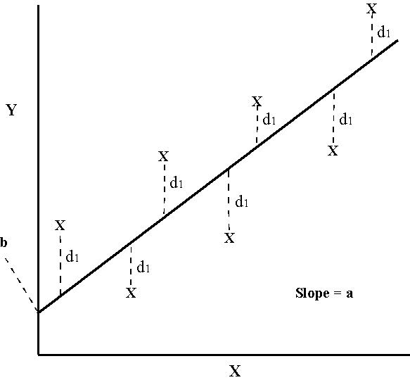

The usual approach to obtain the ‘best line’ through the data is to adjust the line such that the sum of the squares of the deviations (di) are minimised i.e.

|  |  |
| --- | --- |
| $$S=d_{1}^{2}+d_{2}^{2}+⋯+d_{n}^{2}=\sum_{i=1}^{n}{d_{i}^{2}}$$ | Eqn. 2 |

which is equivalent to equation 1. The straight-line problem is relatively simple because the parameters 'a' and 'b' are linear and their explicit solutions are relatively simple. Given a fixed value of one parameter and allowing the other to vary for a set of data, a plot of the sum of squares versus the variable parameter will yield graphs of the form:

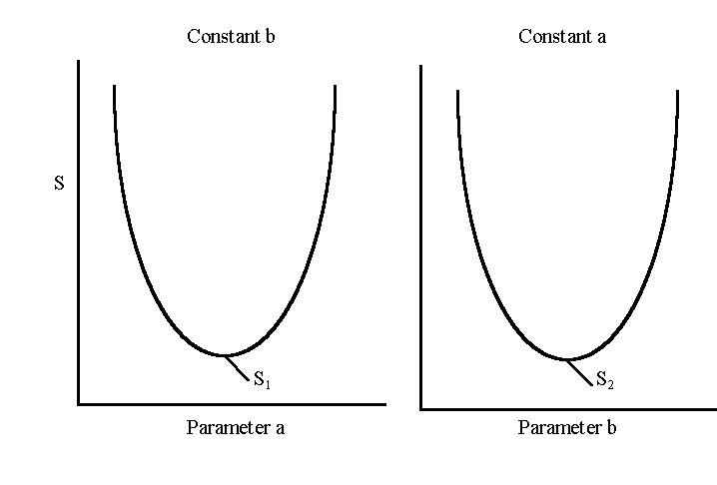

For the line of ‘best fit’, the minimum sum of squares will probably be smaller than either S1 or S2. The sum of squares surface is actually 3-dimensional and can be represented thus;

|  |  |
| --- | --- |
|  | Where p1 and p2 (or a and b) are the 2-parameters and S is the sum of squares function (SOS). For the line of ‘best fit’, the minimum SOS is shown. |

The values of parameters 'a' and 'b' can be determined by the solution of equation 3, shown below:

|  |  |
| --- | --- |
| $$S=\sum_{i=1}^{n}{{\left(y_{i}-\left(ax_{i}+b\right)\right)}^{2}}$$ | Eqn. 3 |

taking partial differentials,

|  |  |
| --- | --- |
| $${\left(\frac{∂S}{∂a}\right)}_{b}=-2\sum_{i=1}^{n}{\left(y_{i}-\left(ax_{i}+b\right)\right)x_{i}}$$ | Eqn. 4 |

|  |  |
| --- | --- |
|  | Eqn. 5 |

at the true minimum, both gradients (Eqns. 4 and 5) and both approximate to zero. Thus equations 4 and 5 can be solved simultaneously:

from equation 4;

|  |  |
| --- | --- |
| $$a=\frac{\left(\sum{xy}-b\sum{x}\right)}{\sum{x^{2}}}$$ | Eqn. 6 |

and from equation 5:

|  |  |
| --- | --- |
| $$b=\frac{\left(\sum{y-a\sum{x}}\right)}{n}$$ | Eqn. 7 |

Substitution for b in equation 6 yields the familiar equation for the slope 'a':

|  |  |
| --- | --- |
| $$a=\frac{\sum{xy-\frac{\sum{x\sum{y}}}{n}}}{\sum{x^{2}-\frac{{\left(\sum{x}\right)}^{2}}{n}}}$$ | Eqn. 8 |

and 'b' can be calculated from equation 7, given 'a'.

This straight-line solution demonstrates that equations with linear parameters, such as 'a' and 'b', may be solved exactly. In pharmacokinetics, however, the majority of the equations usually contain non-linear parameters and these cannot be solved using simple conventional methods, as just described.

As an example, consider a drug concentration-time profile that exhibits a bi-exponential decline. The sum of squares function for this model can be formulated into equation 8.

|  |  |
| --- | --- |
| $$S=\sum_{i=1}^{n}{{\left(C_{i}-\left(Ae^{-λ_{1}t_{i}}+Be^{-λ_{2}t_{i}}\right)\right)}^{2}}$$ | Eqn. 9 |

where Ci represents the experimental concentrations at times ti, A and B are the linear coefficients and λ1 and λ2 are the initial and terminal rate constants respectively. These poly-exponential, or other such transcendental functions, are linear in their coefficients A and B and non-linear in λ1 and λ2. The approaches to solving these types of problems are usually iterative in nature. A schematic to demonstrate a simple approach to iteration theory is shown.

Initially, the four parameters have to be estimated and the sum of squares function calculated using equation 9. The parameters are then modified and the sum of squares recalculated until a final minimum value of S is achieved.

The following simplified flow diagram to illustrate an iterative process for finding the best line through a set of data (S is the sum of squares of deviations of the experimental data from the fitted equation).

Yes

Model parameter estimates

calculate S

Change parameters with

chosen algorithm

Calculate new S

End

No

New S

smaller?

The solution to this problem appears superficially straightforward, however there are several issues that need addressing. Parameters require a constraint of some sort to avoid numerical overflow; computers can only deal with numbers of a limited size. An additional very common problem arises when object-functions exhibit more than one minimum. In these situations, where the object function surface becomes distorted, it is not always easy to determine the desired global minimum.

Representation of a 3-D sum of squares surface, exhibiting two minima.

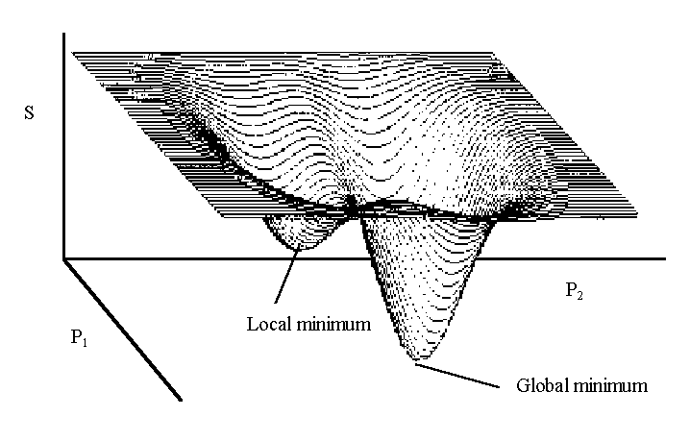

The problem becomes more complex when models containing n>8 parameters are involved and a (n+1) dimensional space exhibits multiple minima. The mathematics of minimising functions is very complex and is a disciplined subject in its’ own right. An example of three such powerful algorithms is described in this manual and these are the ones used in PCModfit. A very important point to note in minimising functions is that however good the algorithm, very poor data will almost invariably produce a meaningless set of parameters with errors significantly larger than the parameters themselves.

**WLS with DFP or Simplex algorithms**

There are many examples of algorithms in the literatureused for minimising a multiparameter function like those encountered in pharmacokinetics. The program PCModfit uses three algorithms. One of these is a modified Davidon-Fletcher-Powell (DFP) algorithm is one of several quasi-Newton or Variable-Metric methods that build up an approximation to the inverse of the second derivative, or Hessian, matrix. They are analytically complex and represent the culmination of years of research into the detailed analysis of functions. A brief summary of the DFP method is given here to help the reader to appreciate the elegance of the strategy devised by Davidon for solving functions by iterative methods. The three-dimensional surface can be projected into two dimensions as a contour diagram for a two-parameter function with a minimum sum of squares at M (the contours represent positions of equal sum of squares).

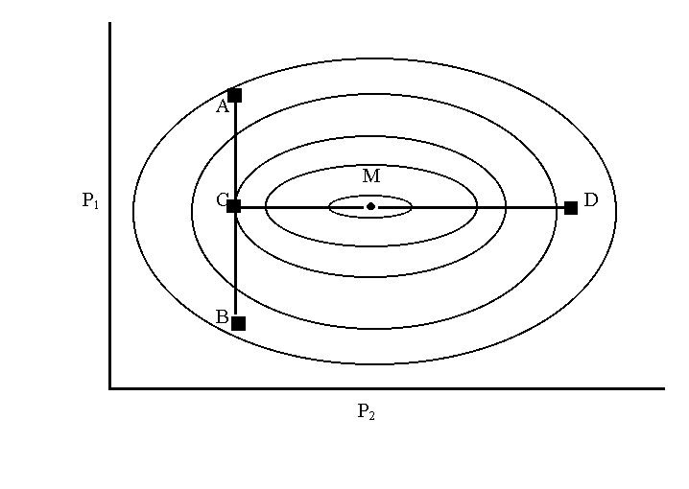

Assume that the starting estimates have p1 and p2 corresponding to a sum of squares value represented by point A. The first direction is along the line AB using a method devised by Powell, where a new sum of squares value is computed at point B. Along the line AB there is a minimum sum of squares in the valley at point C. Parameters at the starting point A are modified to generate a new sum of squares at B. Between these points the valley at C may be found by cubic interpolation.

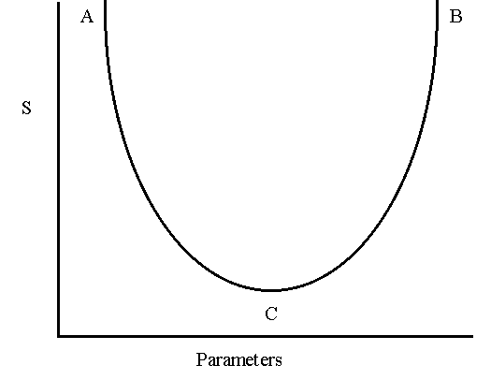

The method used to find the local minimum at C, along the line AB, is the one suggested by Davidon, which utilises cubic polynomial interpolation. From the point C, a new search is established in the direction CD, where the final sum of squares at M can be found, again using cubic interpolation.

The extrapolation from A to B is often achieved using a simple linear method but this often causes numerical problems, especially for poorly defined data. A better method, which is used in PCModfit, is a quadratic extrapolation, which roughly approximates to the cubic used in the interpolation process and ensures that a reasonable sum of squares will be determined at B.

The pictorial method, above, may be translated into mathematical terms in a simpler form than that used by Fletcher and Powell, where Dirac Bra-ket notation was used (often seen in quantum mechanics).

The direction of search corresponding to AB, can be estimated in normalised form:

|  |  |
| --- | --- |
| $$D_{i}^{k}=-\sum_{j=1}^{n}{{\left(H_{i,j}\left(\frac{∂S}{∂p_{j}}\right)\right)/\left[\sum_{L=1}^{n}{\left(\sum_{j=1}^{n}{H_{L.j}}\left(\frac{∂S}{∂p_{j}}\right)\right)}\right]}^{1/2}}$$ | Eqn. 10 |

where k is the iteration number. The partial derivatives of the sum of squares function S with respect to the n parameters pj. Hi,j are the elements of a symmetric and positive matrix, initially chosen using the method of Powell.

Once the search direction has been established a line search is performed using quadratic extrapolation and subsequent cubic interpolation, to find the desired direction minimum sum of squares. For multiple parameter models’ new directions of search and line minima are found.

The sum of squares and function gradients etc., are checked, to establish if a minimum has been reached. During the iteration procedure the Hessian matrix, used for parameter corrections, is updated by the method of Fletcher and Powell. The equations used in the algorithm are included for completeness. Briefly, the parameter corrections are made using equation 11.

|  |  |
| --- | --- |
| $$p_{k+1}=p_{k}-c_{k}H_{k}g_{k} , H_{k+1}=H_{k}+A_{k}$$ | Eqn. 11 |

where Hk is an approximation to the inverse Hessian matrix, gk is the gradient of S (sum of squares) at pk. ck is a chosen scalar and Ak is chosen to ensure that Hk+1 satisfies the quasi-Newton equation:

|  |  |
| --- | --- |
| $$H_{k+1}B_{k}=E_{k} , B_{k}=g_{k+1}-g_{k} , E_{k}=p_{k+1}-p_{k}$$ | Eqn. 12 |

The DFP update to the Hessian can be defined as:

|  |  |
| --- | --- |
| $$H(new)=H+\frac{EE^{'}}{E^{'}B}-\frac{HBB^{'}H}{B^{'}HE}$$ | Eqn. 13 |

The formal proof of this algorithm is provided by Fletcher and Powell. It is very elegant but somewhat difficult to follow for anyone not conversant with such detailed mathematics. Users of PCModfit, fortunately, do not have to be concerned with the mathematics of the method.

It should be appreciated that any algorithm may fail under certain conditions. If reasonable parameter starting estimates are found, then any good algorithm should find a minimum sum of squares with however, varying degrees of efficiency. DFP has been tested extensively and when compared with other algorithms; notably the Marquardt, Newton and Gauss-Newton, it was found to be at least comparable. It has been tested on thousands of data sets by many users over years of use and no major problems have been encountered to date.

**IRWLS with Marquardt or Simplex** **algorithms**

The Iteratively Reweighted Nonlinear Least Squares (IRWLS) algorithm used in PCModfit is one by Marquardt or a Simplex approach and was incorporated into PCModfit to allow iterative reweighting to be used for non-linear least squares regression analysis. Conventional weighted least squares (WLS) use the actual data for weighting schemes whereas IRWLS uses the predicted values calculated at each iteration. For the most part the results are similar and it is left to the user to decide which is preferable. It is quite permissible to try both and then choose the most appropriate one.

The strategy for minimising functions using the Marquardt method is quite different from that used in DFP. At the time the Marquardt approach was devised, there was no way to directly evaluate the Hessian matrix, which is required for parameter corrections and for error calculations at the end of the fitting process. Therefore, iterative methods had to be used, not just because of function non-linearity but also to build up Hessian information from the starting unit matrix of steepest descent. A brief description of the Marquardt algorithm is given here to demonstrate to the reader the elegance of how it changes, very smoothly, between inverse Hessians and steepest descent approaches - very clever at the time! The following equations can be used to develop the strategy:

|  |  |
| --- | --- |
| $$β_{i}≡-1/2\frac{∂S}{∂p_{i}}$$ | $$∝_{ij}≡1/2\frac{∂^{2}S}{∂p_{i}∂p_{j}}$$ |

where pn are model parameters and S is the sum of squares function. A set of linear equations can be set up:

$$\sum_{k=1}^{n}{∝_{ik}δp_{k}=}β_{k },i=1, n$$

where the δpk are increments of parameters pk.

In practical terms, matrix α is equal to one half times the Hessian matrix and the steepest descent method translates to:

$$δp_{k}∝β_{k}$$

Components of αij are dependent on both first and second derivatives of the object function (S). However, the second derivatives are often tiny and can sometimes destabilise the modelling process and it is common to use a first derivative approximation to the actual second derivative. Altering the correction vector to an approximate value does not affect the final estimates of parameters but only the iterative route that is taken in getting there; βk should still be zero at the minimum. Marquardt’s approach, in part, makes use of the steepest descent method by realising that

$$δp_{k}=\frac{1}{λα_{kk}}β_{k}$$

Where λ is a constant that may change during the iterations proceed. The next mathematical development was to generate a new matrixα’:

$$α_{jj}^{'}≡α_{jj}(1+λ)$$

$$α_{jk}^{'}≡α_{jk} (j≠k)$$

and finally:

$$\sum_{i=1}^{m}{α_{ik}^{'}∂p_{i}=}β_{k }$$

Therefore, as λ becomes large, matrix  is forced to diagonally dominate and tend to steepest descent and as λ becomes small, the inverse Hessian method is approached. Further details are available in Marquardt’s original paper. The algorithm coded into PCModfit performs well; it is robust, fast and lends itself very easily to iteratively reweighted least squares. It has been tested on numerous data sets with no major problems to date.

**Simplex**

The Simplex algorithm, based on the one by Nelder-Mead, was added to PCModfit recently and has the option of WLS or IRWLS for modelling. It differs from the DFP and Marquardt methods in that, during the minimisation process only the model function is used without the need to calculate numerical derivatives. All three algorithms have their advantages and disadvantages and it is worth trying out all of these to assess the validity of the results from modelling.

As for the other algorithms, the theory can be complicated and for all three of these the reader is referred to the original publications. Very briefly, the Simplex approach can be explained (below).

The Nelder–Mead method (also downhill simplex method, amoeba method etc.) is a commonly used approach to find the minimum or maximum of an object function in a multidimensional space. It is a direct search method and is often applied to nonlinear optimisation problems. The Nelder–Mead technique is a heuristic search method that can converge to non-stationary points on problems that can sometimes be solved by alternative methods; but not always. The version coded into the Simplex in PCModfit contains an extra step which includes quadratic extrapolation and interpolation which can help with avoiding function local minima; but again, not in all cases.

In geometry, a simplex is a general term to describe of the notion of a triangle or tetrahedron to arbitrary dimensions. On the surface of a plot where parameters *vs*. a sum of squares (SOS) can be generated, the topology can be ‘Himalayan’ or ‘Andes’ in its appearance and the exercise to try and find the true global minimum for ‘best fit’ can sometimes be troublesome. The Nelder–Mead approach is to set up a triangle on the SOS surface and allow it to expand, contract and reflect itself and, at each point, recalculate the sum of squares function until a minimum value is achieved. Clever stuff! For a detailed description, please refer to the original publication (Nelder & Mead, The Computer Journal, January 1965).

Modelling data sets has proven quite challenging over history and even now, new numerical methods are being created or changed from earlier ones to try and achieve an efficient conclusion. However; if the data are garbage to start with, no algorithm will produce a valid set of results! The author personally finds that pragmatism and common-sense rules the day in the world of PK modelling.

**Estimation of parameter errors**

The estimation of parameter errors, for a given mathematical model, is important for quantifying the confidence of a given parameter. The calculation of standard errors is often considered a difficult procedure, especially for functions that contain both linear and non-linear parameters. This is mainly due to sparse or complicated explanations found in the literature. The following logical arguments may help the reader to appreciate some of the background to error estimation, utilising maximum likelihood theory.

For a normal distribution the familiar probability ‘bell-shaped’ curve is shown. It is clear that at the top of the curve there is a maximum value where the probability is highest, and this is often referred to as the maximum likelihood. The mathematical equation describing the curve is the normal density function, equation 1.

|  |  |
| --- | --- |
| $$Pr⁡(x_{i})=\frac{1}{\sqrt{(2πσ^{2})}}e^{-(x_{i}-μ)/2σ^{2}}$$ | Eqn. 1 |

where Pr(xi) is the probability of a given xi-µ is the true centre of the distribution and  is the variance of the distribution. A Normal distribution probability curve described by the above equation is shown.



From the Pr equation the probability for a set of xi’s may be written as:

|  |  |
| --- | --- |
| $$\operatorname{Pr}\left(x_{1}\right)∙Pr\left(x_{2}\right)…Pr⁡(x_{n})=\prod_{i=1}^{n}{\left(\frac{1}{\sqrt{(2πσ^{2})}}e^{-(x_{i}-μ)/2σ^{2}}\right)}$$ | Eqn. 2 |

taking logarithms,

|  |  |
| --- | --- |
| $$\ln\left(Pr\right)=\ln{{\left(\frac{1}{\sqrt{\left(2πσ^{2}\right)}}\right)}^{n}}-\sum_{i=1}^{n}{\frac{{(x_{i}-μ)}^{2}}{{2σ}^{2}}}$$ | Eqn. 3 |

and rearranging,

|  |  |
| --- | --- |
| $$-ln\left(Pr\right)=\frac{n}{2}\left. ln⁡(2πσ^{2})\right.+\sum_{i=1}^{n}{\frac{{(x_{i}-μ)}^{2}}{{2σ}^{2}}}$$ | Eqn. 4 |

The maximum likelihood probability may be found by the partial differentiation of equation 4 with respect to variables μ and σ2.

|  |  |
| --- | --- |
|  | Eqn. 5 |

For the maximum of a function, with a single turning point, the gradient equals zero therefore the partial derivative, equation 22, may be equated to zero and rearranged into equation 6

|  |  |
| --- | --- |
| $$σ^{2}=\frac{1}{n}\sum_{i=1}^{n}{{(x_{i}-μ)}^{2}}$$ | Eqn. 6 |

Equation 6 is the common biased estimator for the variance of a normal distribution. Differentiating equation 4 with respect to parameter μ, yields equation 7, which may be solved for maximum likelihood by equating to zero,

|  |  |
| --- | --- |
| $$\frac{∂(-ln\left(Pr\right))}{∂μ}=-\frac{1}{σ^{2}}\sum_{i=1}^{n}{\left(x_{i}-μ\right)}=0$$ | Eqn. 7 |

and rearranging,

|  |  |
| --- | --- |
| $$μ=\frac{1}{n}\sum_{i=1}^{n}{(x_{i})}=x̄$$ | Eqn. 8 |

Equation 8 may be recognised as the equation for the arithmetic mean x̄ for a set of xi values. Equation 8 is a biased estimator of the variance. Transforming the true centre μ to the mean x̄, thus reducing the degrees of freedom by one, an equation for the common unbiased variance can be formulated:

|  |  |
| --- | --- |
| $$σ^{2}=\sum_{i=1}^{n}{\frac{{(x_{i}-x̄)}^{2}}{n-1}}$$ | Eqn. 9 |

Differentiating equation 7 to yield the following equation can extend the theory further:

|  |  |
| --- | --- |
| $$\frac{∂^{2}(-ln\left(Pr\right))}{∂μ^{2}}=\frac{n}{σ^{2}}$$ | Eqn. 10 |

The inverse of this equation 10 can be combined with equation 9 to form an expression for the standard error of the mean (SEM).

|  |  |
| --- | --- |
| $$SEM=\sqrt{\sum_{i=1}^{n}{{((x_{i}-x ̄)}^{2}}/n(n-1))}$$ | Eqn. 11 |

This approach can be used for the estimation of parameter errors, utilising the method of least squares, for the types of functions that are encountered in pharmacokinetics.

As a specific example, consider a mono-exponential model containing two parameters A and k. Assume that the ‘best’ values of A and k have been estimated for a set of data by an iterative procedure and that the parameter errors are required. For a mono-exponential model the sum of squares object function is:

|  |  |
| --- | --- |
| $$S=\sum_{i=1}^{n}{{\left(C_{i}-\left.Ae^{-kt_{i}}\right.\right)}^{2}}$$ | Eqn. 12 |

where S is the sum of squares and Ci the n concentration values at times ti. Differentiating equation 12 with respect to A and k,

|  |  |
| --- | --- |
| $$\frac{∂S}{∂A}=-2\sum_{i=1}^{n}{\left(C_{i}-\left.Ae^{-kt_{i}}\right.\right)}e^{-kt_{i}}$$ | Eqn. 13 |
| $$\frac{∂S}{∂k}=2\sum_{i=1}^{n}{\left(C_{i}-\left.Ae^{-kt_{i}}\right.\right)t_{i}}{Ae}^{-kt_{i}}$$ | Eqn. 14 |

and differentiating equations 13 and 14 to form

|  |  |
| --- | --- |
| $$\frac{∂^{2}S}{∂A^{2}}=2\sum_{i=1}^{n}{e^{-2kt_{i}}}$$ | Eqn. 15 |
| $$\frac{∂^{2}S}{∂k^{2}}=2\left.\sum_{i=1}^{n}{\left.\left.\left(2t_{i}^{2}A^{2}e^{-2kt_{i}}-C_{i}t_{i}^{2}{Ae}^{-kt_{i}}\right)\right.\right.}\right.$$ | Eqn. 16 |

and the cross-term

|  |  |
| --- | --- |
| $$\frac{∂^{2}S}{∂A∂k}=2\left.\sum_{i=1}^{n}{\left.\left.\left(C_{i}t_{i}e^{-kt_{i}}-2{t_{i}Ae}^{-2kt_{i}}\right)\right.\right.}\right.$$ | Eqn. 17 |

these second derivatives may be set up in matrix form:

|  |  |
| --- | --- |
| $$\left(\begin{matrix}\frac{∂^{2}S}{∂A^{2}} & \frac{∂^{2}S}{∂A∂k} \\ \frac{∂^{2}S}{∂A∂k} & \frac{∂^{2}S}{∂k^{2}}\end{matrix}\right)$$ | Eqn. 18 |

The inverse of this Hessian matrix provides the necessary information for the parameter errors to be calculated. For example, assume that the following matrix represents the inverse of equation 18:

|  |  |
| --- | --- |
| $$\left(\begin{matrix}a & b \\ c & d\end{matrix}\right)$$ | Eqn. 19 |

The parameter errors (SE) can be calculated from the diagonal elements a and d thus:

|  |  |
| --- | --- |
| $$SE of a=\sqrt{\frac{a×S}{\left(n{-}2\right)}}$$ | Eqn. 20 |

and

|  |  |
| --- | --- |
| $$SE of d=\sqrt{\frac{d×S}{\left(n-2\right)}}$$ | Eqn. 21 |

where S is the residual sum of squares, n is the number of experimental points and (n-2) represents a loss of two degrees of freedom due to the number of parameters. A similar argument may be applied to more complex models containing many more parameters. The program PCModfit will allow models containing up to twenty parameters, but fortunately for the user, the errors are automatically calculated by the program, thus precluding the lengthy and almost impossible task of calculating them manually!

# Appendix 2 (creating differential equations from models)

This short section has been added to help with setting up differential equations from proposed models that can be used in the simulation part of the program. Those users conversant with these types of techniques, may want to skip this Appendix.

**Infusion**

Consider an example of a 2-compartment intravenous infusion model, pictorially represented below.

k0

p1

Dose

Blood (c1)

Tissue (c2)

p2

p3

Waste

The symbols indicate:

|  |  |
| --- | --- |
| c1, c2 | Compartment number  (c1 is commonly assigned blood, c2 is highly perfused tissue) |
| p1, p2, p3 | Parameter  (transfer rate of drug from one compartment to another. Traditionally, p1, p2 and p3 would be called k12, k21 and k10) |
| k0 | Infusion rate into compartment 1 (Rate = Dose / T, where T is infusion time) |
| Waste | Usually urine or other excreta |

Practically, the model transfer rates are linked to the compartments simply to show the amounts of drug moving from one compartment to another e.g. c1 to c2 etc. – it is a dynamic process.

To setup a series of differential equations that can be used in PCModfit (and possibly other software) for solving such problems, consideration of the rate of change of drug amount with respect to time (dAn/dt) comes into play. Without going into more complex mathematics e.g. Laplace transforms etc. the differential equations can be arrived at by the general simplified expression for each compartment:

$$\frac{dA_{n}}{dt}=Input rate-Output rate$$

where An is the amount in compartment n, Input and Output are the rates of drug gain and loss into a particular compartment n. Consider the drug input and output for compartment 2 (c2) to start with:

$Input c2=A_{1}×p_{1}$ and $Output c2=-A_{2}×p_{2}$

Note that the input to c2 is coming from c1 (amount A1) and the output (denoted by a minus to show loss of drug) from c2 (amount A2) is going to c1. Combining these yields the differential equation for compartment 2.

$$\frac{dA_{2}}{dt}=A_{1}×p_{1}-{(A}_{2}×p_{2})$$

For compartment 1 (c1) the situation is slightly more complicated due to more inputs and outputs than for c2 but the same principle holds.

$Input c1= k_{0}+(A_{2}×p_{2})$ and $Output c1=-{(A}_{1}×p_{1})-{(A}_{1}×p_{3})$

Combining these yields the differential equation for compartment 1.

|  |  |
| --- | --- |
| Compartment 1 | Compartment 2 |
| $$\frac{dA_{1}}{dt}=k_{0}+(A_{2}×p_{2})-{(A}_{1}×p_{1})-{(A}_{1}×p_{3})$$ | $$\frac{dA_{2}}{dt}=A_{1}×p_{1}-{(A}_{2}×p_{2})$$ |

These would be the equations used by the Diff. Eqn. Simulator to solve this infusion model. PCModfit would actually use the equations as shown below (where cn is the amount in compartment n and pn is the appropriate parameter). After running the program, the amounts in compartments 1 and 2 are generated and if Volumes are supplied, then the output will be concentration values.

|  |  |  |
| --- | --- | --- |
| Eqn. 1 | D/T-c1*p1-c1*p3+p2*c2 | (Note addition of infusion rate, D/T in the equation) |
| Eqn. 2 | (p1*c1-p2*c2) | (D is the dose and T is infusion time). |

Amounts of drug at time zero have not been taken into account as all compartments will be zero at time zero. For other models such as oral and intravenous bolus, the dose at zero time will need to be taken into account. There are a few examples in the ‘Diff. Eqn. Simulator (SD)’ spreadsheet to help the user set up their own models for simulations.

# Brief history updates

This short section has been added to help with Version updates should the user wish to see these.

**Version 7.8 (1st September 2023)**

The Non-Compartmental module (NCA) has been further updated in V7.8. There was a minor anomaly in earlier versions, which was noticed by a very astute user, in the NCA graphs (Dr Tony Jarman from Category 1 Pharma Consulting Pty Ltd Australia) wherein; the λz value was shown as a minus value when it should have been positive. None of the numerical results were affected but just the sign of λz values on the graphs! The numerical examples in all sections (including NCA) of the manual have been re-analysed using V7.8 and yield the correct results.

**Version 7.7 (1st March 2023)**

Compartmental modelling has been further updated. Using option ‘Mixed models’, profiles containing no i.v. models but oral models only (mixing with and without lag-time dosing) can now be analysed. This may be useful when for example, when oral doses are administered alternately, with and without a lag-time. There are example data sets on p. 105 and p. 108 to demonstrate that this option is working and yields the correct answer. As long as the number of compartments remain the same, this will work for 1, 2 and 3-compartment oral models. The λn values are also calculated as for the other possible Mixed models.

The subtitles for each profile can now contain spaces as previous versions sometimes got muddled with these. They have also been expanded to 30 characters/profile whereas previous versions only allowed for 20.

All of the examples in the Modelling sections of the manual have been re-analysed using V7.7 and yield the correct results.

**Version 7.6 (1st February 2023)**

Compartmental modelling has been further upgraded. In the results summary Excel file, the lambda values (λ1, λ2 and λ3 for relevant compartmental models) are now calculated, being generated from the rate constants k12, k21 etc., as this was requested by several users (example on p.102). This applies to Single, Repeat and Mixed model dosing. Further testing for all fitting options (Single, Repeat and Mixed) has been expedited and some minor bugs when clicking the ‘Keywords’ button have been corrected. A couple of users experienced an ‘out of memory’ message when the Modelling summary file was generated in V7.5. In the ‘Fitting Options Selected’ details, which was added as a helpful reminder for the settings used in a particular run, the size of picture was apparently the culprit. This has now been fixed by using a different and more efficient method. It has been tested on several computers with no further warning or error messages.

The Modelling Summary output file now has the file names of the pictures generated from a run which are detailed at the top of the Excel file at the request of several users. The same addition is also added to the NCA module as a complete record.

The ‘Stats’ spreadsheet for CI’s etc. has been expanded to allow for up to 100 values (previous versions only allowed for 50).

**Version 7.5 (1st December 2023)**

PCModfit V7.5 with updates from previous versions is now released. A further update to modelling now has more information added to the Excel summary results file including the ‘Fitting Options’ choices used, and the cells where Doses, Parameters, Titles etc. are added as a complete record should the user wish to access these as a reminder. Also, after completion of a Fitting run (when the ‘Next’ button is clicked) the names of the Plot files are sent to the Summary file as well, for completeness. When these Doses and Parameters etc. are highlighted in the ‘Modelling’ spreadsheet and ‘Activated’, the parameter labels were previously erased (when ‘User estimates’ was selected) but now they are retained in the Sheet and sent to the Summary file, at the request of some users.

**Version 7.4 (1st October 2022)**

PCModfit V7.4 with updates from previous versions is now released (still runs on 32 or 64-bit PC computers). The NCA module has been upgraded so the user can now have up to 100 profiles with 1000 points in each (previously 100) as some users requested this update. There is now a red ‘Cancel’ button in the NCA spreadsheet to stop a run at any point during analysis (also a request from a couple of users) which is useful if there are many profiles, and the user decides to abort the run for whatever the reason.

Modelling has been updated so that the Summary Excel file that now opens automatically after a completed run now specifies the parameter names instead of just numbers e.g., Parameters 1, 2, 3, 4 etc. becomes Parameters V1, k12, k21 k10 etc. In addition, the Summary file now contains individual profile data and the fitted data at the same time points with %Differences so users don’t have to manipulate text files (this was often bothersome for some users). The fitted parameters and errors together with brief statistics, if more than one profile is analysed, are still displayed.

The summary file is often used as a tracking mechanism as it shows the date, time and records the fitting information (algorithm, weighting etc.) used for a particular run.

**Version 7.3 (1st June 2022)**

PCModfit V7.3 with updates from previous versions is now released (runs on 32 or 64-bit PC computers). The modelling option has been modified to allow models 1 to 6 (polyexponentials i.v. and oral) to be used in repeat dosing regimens as this was suggested by a few users. The models worked fine for single dose regimens but not coded for repeated doses with different doses and intervals. This option is now available and has been tested. If the user prefers the compartmental models (recommended) with micro-rates e.g., k12, k21 etc. these models can still be used for single and repeat dose scenarios as before. In most of the spreadsheets there is now a facility (updated in V7.3) to calculate micro-rate values from λ values and vice-versa as these can be tricky to calculate with multiple compartments.

**Version 7.2 (30th April 2022)**

PCModfit V7.2 with updates from previous versions is now released (runs on 32 or 64-bit PC computers). The modelling module has been modified to show a progress bar after a fitting run is finished to let the user know how far the creation of the graphics in the spreadsheet and .png files has been completed. The fitting part is generally very fast but the data transfer from files into Excel can take a little while and is usually slower than the actual modelling. Useful to the user when numerous profiles are run within the same batch.

An intermittent runtime error was found for modelling data using model no. 2 (3-exponential oral). This is now fixed and updated in V7.2.

The Superposition module in V7.2 is now at least twice as fast when compared to previous versions and yields the same results as V7.1 (tested with several different regimens). This can be very useful for longer profile times with numerous doses. The increase in speed is primarily due to modifying Font changes in the spreadsheet.

Time above module has been modified to add a Profile reference to each result and Graph labels (axes, legends and title for completeness). The number of profiles maximum is 100 and each profile can now have up to 1000 data points (100 previously).

**Version 7.1 (31st Mar 2022)**

PCModfit V7.1, with minor updates from previous versions, is now released which runs on 32 or 64-bit computers. This can be downloaded from the website and includes an updated manual.

There is now a PCModfit Forum; web address <https://www.pcmodfit.co.uk/forum/index.php> and a link to it is also shown on the front page of the website; <https://www.pcmodfit.co.uk/>.

**Version 7.0 (1st May 2021)**

PCModfit V7.0 with major updates from previous versions is now released. When PCModfit is opened there is now a check to ‘clean up’ the numerous graphics and results files in the Results directory if desired (only if >100 is found). It is worth doing this regularly to save space and tidying up the Results directory to maintain a reasonable number of files.

The Non-Compartmental Analysis module (NCA) has been extensively modified to calculate CL, Vss, Vd and MRT parameters in addition to the usual AUC values and t½ etc., with options for the user to define the concentration units, the dose and infusion time if relevant (the latter for calculation of MRT, CL etc.). The results are still shown in the NCA spreadsheet but now, they are also output to a detailed Excel file with descriptive stats. as well (timed and dated for a paper trail record) together with the points selected for t½ determination of each profile. At the end of a ‘Run’, the Excel file containing the results will be automatically saved (Results directory) and the user can open the file and inspect the values immediately. Pictures of the NCA plots with points selected for t½ estimates are still stored in the Results directory as NCA*.png files which can be copied or imported in to Microsoft® Word etc.

The modelling option has been extensively updated (Sections 3.8 and 3.9. The setting up and the graphics (fitted line and data) are now all displayed in the ‘Modelling’ Excel® spreadsheet. For setting up the ‘Control’ parameters, which was often a bit tricky, there is now a ‘Keywords’ button which helps with the required layout based on the Fitting Options selected in the spreadsheet (models, algorithm, weighting etc.). The graphics are of high quality (both linear and logarithmic plots are now on separate Charts within Excel®) and the number of points for the computed line can now be selected to ensure a representative line over extended time periods - useful for repeat dose fitting where the overall time can be quite long (up to 10000 points maximum).

There is additional help describing the models and parameters which are also shown in the spreadsheet (drop down boxes containing model numbers and what the models actually are and if user parameter starting estimates are required). The graphics files produced within Excel®, are now stored as *.png and not *.wmf files to improve the whole appearance (Fitplotlin*.png for Linear and Fitplotlog*.png for Logarithmic Charts). Users can now analyse up to 1000 data points per profile and up to 100 profiles in a single run (should the user be so lucky!).

When modelling is completed, all of the graphs can be viewed within the spreadsheet to aid the user in deciding if it was acceptable or otherwise.

Mainly due to popular usage, the Superposition module (Section 3.5) has again been further updated by the author (now re-written in Fortran for speed) and also verified by two independent users in addition to many

who have tested it for accuracy and validity. In addition to being able to vary the dosing interval, users can still change each dose across the entire regimen as well (thanks to suggestions by Angus McLean, Ph.D., in the USA and Dr med. Christian de Mey from ACPS in Germany).

There are still various plots of the Superposition results together with a selection for accuracy/time increments to dictate the number of points required for each run. Using the highest accuracy (0.001) which can take some time (transferring so many numbers into Excel®) although the Fortran module is much quicker for longer repeat dose regimens wherein; up to 100 doses can now be defined) there can be up to 1,000,000 points generated which is getting close to the number that Excel® can handle without messing around too much. The author recommends a value of either 0.1 or 0.01 which is a very good compromise.

Summary Superposition plots and values for parameters such as Cmin, Cmax and AUC are still output for each dose. There is also a Summary table within the spreadsheet indicating the accumulation values by comparing parameters from Dose 1 to the last Dose for a quick assessment. In addition (new to V7.0) the user can now

manually override the estimated t½ value when required (sometimes useful for very sparse data but when the t½ is known) and can now add their own data points to the repeat dose plots very easily, if required, which is particularly good for showing pre-dose values at later time points within a repeat dosing regimen.

The ‘Time above’ a MIC has been extensively modified with more precision and parameters. There is now an option for different time values (often useful in Phase II studies) for each profile, whereas previous versions only allowed the same sampling times for all data sets. This version now allows up to 100 data points per profile and up to 100 data sets to be analysed in a single run. The graphics have also been improved with an increase in speed and visual appearance with all data lines now having the same thickness.

**Version 6.9 (1st Oct 2020)**

PCModfit V6.9 onwards will check the internet automatically to see if there is a newer version available each time it is executed (notified to the user). The Website now uses a Secure Socket Layer URL for security assurance.

The Superposition module has been extensively updated and now verified by two independent users in addition to many who have tested it out for ease of use and sense. In addition to being able to vary the dosing interval, users can now change each dose across the entire Superposition regimen as well (thanks to suggestions by Angus McLean, Ph.D., in the USA and Dr med. Christian de Mey from ACPS in Germany). There are several further additions including various plots of the results together with selection of accuracy to dictate the number of points required for each run. Using the highest accuracy, which can take some time, there can be up to 800,000 points generated which is getting close to the number that Excel® can handle.

The author recommends a value of 0.01 which is a very good compromise. Summary plots and values for parameters such as Cmin, Cmax and AUC are output for each dose, which may be useful for simple and complex regimens.

**Version 6.8 (1st Dec 2019)**

SD and RD simulations graphic display and legends have been tidied up. The SD and RD simulators will now allow user defined time values to be added in addition to the normal output (sometimes useful for modelling and for Tabular results for showing specific Conc-Time values).

A 3-compartment model (oral) was added for SD and RD simulations in V6.7 and is now available for modelling in V6.8, should the data be adequate, and shows a specific example in the manual (note that user parameter starting estimates are required). The model numbers are 42 and 43, with and without lag-time, respectively).

NCA intercept value is now displayed on the graph, in the Spreadsheet and txt results file. Useful for C0 values with bolus i.v. data and in other calculations.

Manual updated for all additions/modifications and an extra section for NCA with examples explaining how zero time points are dealt with for AUC calculations.

**Version 6.7 (21st June 2019)**

PCModfit now has an option for conducting Superposition repeat dose profiles (Section 3.4) with varying dosing intervals (thanks to a suggestion by Angus McLean in the USA) and with more precision.

Also, slightly revamped, repeated dose simulations can be conducted with user defined Differential Equations allowing varying doses, intervals, and models in any sequence.

The Loo-Riegelman Deconvolution module has been rewritten with more accuracy throughout, using Wagner’s exact equations (J. Pharm. Sci. 72, 7, July 1983) and has test profiles to show their validity (1, 2 and 3 compartment models) detailed in Section 3.5.

A three-compartment oral model has been added, by request, for single and repeat dose simulations. This has been checked against the Differential equation module and the results are identical.

Check boxes have been added to NCA and Deconvolution to make selections quicker and easier (not having to enter an asterisk character).

There is now a ‘Models’ button on the Modelling sheet as a quick aide-memoir for available model numbers.

**Version 6.6 (1st March 2019)**

Repeated dose simulations can now be conducted with user defined Differential Equations with varying doses, intervals, and models. This is a new addition and seems pretty fast with the testing done so far. The spreadsheet has lots of help for the user with an additional section in the V6.6 manual (Section 3.3.2) with a detailed and specific example to demonstrate its use and how to set it up.

**Version 6.5 (19th January 2019)**

This version will allow single dose simulations using differential equations (user defined) and will be enhanced in future versions. A Simplex algorithm has now been added to help with data modelling as an additional option to DFP and Marquardt.

# A few words about the author

The author of PCModfit (Graham Allen) since leaving ‘Big Pharma’ many years ago, has been a successful freelance Consultant in Pharmacokinetics for >30 years and has published in numerous Journals with *ca*. 50 papers to date. He initially graduated with the Royal Society of Chemistry and much later in Mathematics which he found very useful for sorting out some of the problems in PK. The original publication of Modfit, as it was then called back in 1990, has undergone countless updates and additions with most of the routines being completely re-written for correctness and versatility with its current name of **PCModfit.** There are currently >7000 users of the program and it has been referenced in over 100 publications in the literature and in countless drug submissions to regulatory bodies world-wide. The author hopes that it helps users in their study, work and/or research for furthering drug development and an understanding of the sometimes-complex field of Pharmacokinetics. The author is a Fellow of the Royal Society of Medicine (London, UK) which allows him to access thousands of books and Journals on-line to keep up with modern trends.

# Brief list of publications referencing PCModfit

Although there are >100 publications referencing PCModfit, just for information, some of these are listed below (*ca*. 63).

1. Pharmacokinetics of N,N-dimethyltryptamine in Humans

Meghan Good, Zelah Joel, Tiffanie Benway, Carol Routledge, Chris Timmermann, David Erritzoe, Richard Weaver, Graham Allen, Charlotte Hughes, Helen Topping, Amy Bowman & Ellen James

European Journal of Drug Metabolism and Pharmacokinetics, 48, 311-327 (Issue 3, May 2023).

2. Development of stabilized fuzapladib solution for injection: forced degradation study and pharmacokinetic evaluation

Hideyuki Sato, Chika Yamane, Koji Higuchi, Takeshi Shindo, Hiroshi Shikama, Kohei Yamada, Satomi Onoue.

Pharmaceutical Development and Technology, 09 Jun 2022

3. Neuropsychopharmacological profiling of scoparone in mice

Joanna Kowalczyk, Barbara Budzynska, Lukasz Kurach, Daniele Pellegata, Nesrine S. El Sayed, Jurg Gertsch and Krystyna Skalicka-Wozniak

Nature: Scientific Reports volume 12, Article number: 822 (2022)

4. Pharmacokinetics and milk extraction pattern of eprinomectin at different dose rates in dairy cattle

Mariana Ballent, Candela Canton, Paula Dominguez, Laura Mate, Laura Ceballos, Carlos Lanusse, Adrian Lifschitz

Veterinary Pharmacology and Therapeutics, Sept. 2021, 45, 92-98.

5. Metabolic Soft Spot and Pharmacokinetics: Functionalization of C-3 Position of an Eph-Ephrin Antagonist Featuring a Bile Acid Core as an Effective Strategy to Obtain Oral Bioavailability in Mice

Francesca Ferlenghi, Carmine Giorgio, Matteo Incerti, Lorenzo Guidetti, Paola Chiodelli, Marco Rusnati, Massimiliano Tognolini, Federica Vacondio, Marco Mor, Alessio Lodola

Pharmaceuticals 2022, 15(1), 41

6. Stem-cell mobilization of healthy sibling donors with pegfilgrastim-A prospective open-label phase II trial (EudraCT no: 2005-004971-39)

Vladan Vucinic, Madlen Jentzsch, Sabine Leiblein, Enrica Bach, Yvonne Remane, Kai Schulze-Forster, Michael Cross, Wolfram Ponisch, Sebastian Schwind, Georg-Nikolaus Franke, Uwe Platzbecker, Dietger Niederwieser

Transfusion. Dec. 2021, 1-8

7. Successive treatments with ivermectin (3.15%) to control the tick Rhipicephalus (Boophilus) microplus in cattle: Pharmacokinetic and efficacy assessment

Macarena Sarli, Maria Victoria Miro, Maria Victoria Rossner, Santiago Nava, Adrian Lifschitz

Ticks and Tick-borne Diseases, Volume 13, Issue 1, January 2022, 101848

8. Pharmacokinetics of Meropenem in Critically Ill Patients with Acute Renal Failure Treated by Continuous Hemodiafiltration

W. A. Krueger, T. H. Schroeder, M. Hutchison, E. Hoffmann, H.-J. Dieterich, A. Heininger, C. Erley, A. Wehrle, K. Unertl

Antimicrobial Agents and Chemotherapy, Vol. 42, No. 9, Research Article, 17 December 2020

9. A Pharmacokinetic Study of Native E-coli Asparaginase for Acute Lymphoblastic Leukemia Treated with ThaiPOG Protocol

Phumin Chaweephisal, Trai Tharnpanich, Aphinya Suroengrit, Pattramon Aungbamnet, Panya Seksarn, Darintr Sosothikul, Supanun Lauhasurayotin, Kanhatai Chiengthong, Hansamon Poparn, Piti Techavichit

Asian Pac J Cancer Prev. 22 (10), 3309-3315, Oct. 22, 2021

10. Phase I clinical trial repurposing all-trans retinoic acid as a stromal targeting agent for pancreatic cancer

Hemant M. Kocher, Bristi Basu, Fieke E. M. Froeling, Debashis Sarker, Sarah Slater, Dominic Carlin, Nandita M. deSouza, Katja N. De Paepe, Michelle R. Goulart, Christine Hughes, Ahmet Imrali, Rhiannon Roberts, Maria Pawula, Richard Houghton, Cheryl Lawrence, Yathushan Yogeswaran, Kelly Mousa, Carike Coetzee, Peter Sasieni, Aaron Prendergast & David J. Propper

Nature Communications volume 11, Article number: 4841 (2020)

11. SARS-CoV-2 Neutralization in Commercial Lots of Plasma-derived Immunoglobulin

Volk Andreas, Covini-Souris Caroline, Kuehnel Denis, De Mey Christian, Römisch Jürgen, Schmidt Torben

COVID-19 SARS-CoV-2 preprint from bioRxiv, Aug. 13, 2021.

12. Self-emulsifying drug delivery system of (R)-alpha-lipoic acid to improve its stability and oral absorption

Sujan Banik, Shimul Halder, Hideyuki Sato, Satomi Onoue

Biopharmaceutics and Drug Disposition, Vol. 42, Issue 5, May 2021, p. 226-233.

13. The GABA(B) receptor positive allosteric modulator COR659: in vitro metabolism, in vivo pharmacokinetics in rats, synthesis and pharmacological characterization of metabolically protected derivatives.

Francesca Ferlenghi, Paola Maccioni, Claudia Mugnaini, Antonella Brizzi, Federica Fara, Rafaela Mostallino, Maria Paola Castelli, Giancarlo Colombo, Marco Mor, Federica Vacondio, Federico Corelli.

European J. of Pharm. Sci., Vol. 155, 1 Dec. 2020, 105544.

14. Effect of e-cigarette flavors on nicotine delivery and puffing topography: results from a randomized clinical trial of daily smokers.

Voos N, Smith D, Kaiser L, Mahoney MC, Bradizza CM, Kozlowski LT, Benowitz NL, O'Connor RJ, Goniewicz ML.

Psychopharmacology (Berl). 2020 Feb;237(2):491-502. doi: 10.1007/s00213-019-05386-x. Epub 2019 Nov 26.

15. Taylor D.L. et al. (2019) Harnessing Human Microphysiology Systems as Key Experimental Models for Quantitative Systems Pharmacology. In: Barrett J., Page C., Michel M. (eds) Concepts and Principles of Pharmacology. Handbook of Experimental Pharmacology, Vol 260. Springer, Cham.

16. Long-Acting HIV-1 Fusion Inhibitory Peptides and their Mechanisms of Action.

Chen Wang, Shuihong Cheng, Yuanyuan Zhang, Yibo Ding, Huihui Chong, Hui Xing, Shibo Jiang, Xuebing Li, and Liying Ma.

Viruses, v.11(9); 2019 Sep, PMC6784077

17. Randomized within-subject trial to evaluate smokers initial perceptions, subjective effects and nicotine delivery across six vaporized nicotine products

Natalie Voos, Lisa Kaiser, Martin C. Mahoney, Clara M. Bradizza, Lynn T. Kozlowski, Neal L. Benowitz, Richard J. O'Connor, Maciej L. Goniewicz.

Addiction, 9-Mar-2019, Research Report, Society for the study of Addiction.

18. Safety and Pharmacokinetics of Multiple Doses of Aclidinium Bromide, a Novel Long-Acting Muscarinic Antagonist for the Treatment of Chronic Obstructive Pulmonary Disease, in Healthy Participants

Journal of Clin. Pharm., Vol. 49, Issue 10, 2009, 1239-1246.

Josep M. Jansat PhD, Dr Rosa Lamarca PhD, Dr Gonzalo de Miquel MD, Dr Andreas Schrodter MD, PhD, Dr Barbara Miletzki MD, Mr Matthias Gurniak MSc

19. Aluminium toxicokinetics after intramuscular, subcutaneous, and intravenous injection of Al citrate solution in rats.

Weisser, K., Goen, T., Oduro, J.D. et al,

Arch Toxicol. pp. 1-11 (2018)

20. A Peptide-Based HIV-1 Fusion Inhibitor with Two Tail-Anchors and Palmitic Acid Exhibits Substantially Improved In Vitro and Ex Vivo Anti-HIV-1 Activity and Prolonged In Vivo Half-Life

Shan Su, Giselle Rasquinha, Lanying Du, Qian Wang, Wei Xu, Weihua Li,

Lu Lu and Shibo Jiang. Molecules 2019, 24, 1134 (13 pages).

21. Imperatorin exhibits anticancer activities in human colon cancer cells via the caspase cascade

Yi Mei Zheng, Amy Xiaoxu Lu, James Zheng Shen, Amy Ho Yan Kwok, Wing Shing Ho

Oncology Reports, Jan. 21st 2016, pp 1995-2002.

22. Nicotine Intake from Electronic Cigarettes on Initial Use and After 4 Weeks of Regular Use

Peter Hajek, PhD Maciej L. Goniewicz, PharmD, PhD Anna Phillips, MSc Katie Myers Smith, PhD Oliver West, MSc Hayden McRobbie, PhD

Nicotine Tob Res (2015) 17 (2): 175-179.

23. Fluticasone furoate, a novel inhaled corticosteroid, demonstrates prolonged lung absorption kinetics in man compared with inhaled fluticasone propionate.

Philippe J Bareille; A. Allen; V.M Rousell

GlaxoSmithKline.

MedLine Citation: PMID: 23184737

Clinical pharmacokinetics, Volume: 52,2013 Jan, Clin Pharmacokinet.

24. Anti-oxidant and anti-cancer activities of Angelica dahurica extract via induction of apoptosis in colon cancer cells

YiMeiZhenga, James Zheng Shenb, Yan Wangb, Amy Xiaoxu Lub, Wing Shing Ho

Phytomedicine: international journal of phytotherapy and phytopharmacology 23(11) Dec.2015.

25. The pharmacokinetics of Casodex enantiomers in subjects with impaired liver function

D. Cockshott, E. A. Sotaniemi, K. J. Cooper and D. C. Jones, Zeneca Pharmaceuticals, Alderley Park, Macclesfield, Cheshire and Department of Internal Medicine, University of Oulu, Oulu, Finland

Br J Clin. Pharmacol. 1993; 36: 339-343

26. Lack of Pharmacologic Interaction Between Paroxetine and Alprazolam at Steady State in Healthy Volunteers

Calvo, Gonzalo MD, PhD; Garcia-Gea, Consuelo BSc; Luque, Antonio MD; Morte, Adelaida MD; Dal-Re, Rafael MD, PhD; Barbanoj, Manel MD, PhD

Journal of Clinical Psychopharmacology:

June 2004 - Volume 24 - Issue 3 - pp 268-276

27. A pharmacoscintigraphic study of three time-delayed capsule formulations in healthy male volunteers

McConville JT1, Hodges LA, Jones T, Band JP, O'Mahony B, Lindsay B, Ross AC, Florence, AJ, Stanley AJ, Humphrey MJ, Wilson CG, Stevens HN.

J Pharm Sci. 2009 Nov;98(11):4251-63. doi: 10.1002/jps.21739.

28. Pharmacological characteristics and side effects of a new galenic formulation of propofol without soyabean oil

M. Paul,M. Dueck,S. Kampe,H. Fruendt,S. M. Kasper

First published: 20 October 2003 Full publication history, DOI: 10.1046/j.1365-2044.2003.03345

29. Pharmacokinetic optimization of immunosuppressive therapy in thoracic transplantation:

C. Monchaud, P. Marquet.

Part I. Clin. Pharmaco., Springer Verlag, 2009, 48 (7), pp.419-62.

30. Inflammation-Mediated Abrogation of Androgen Signaling: An In Vitro Model of Prostate Cell Inflammation

Bilge Debelec-Butuner, Cansu Alapinar, Lokman Varisli, Burcu Erbaykent-Tepedelen, Syed Muhammad Hamid, Ceren Gonen-Korkmaz and Kemal Sami Korkmaz

Molecular Carcinogenesis 53:85-97 (2014)

31. Single-Dose, Randomized, Crossover Bioequivalence Study of Amlodipine Maleate versus Amlodipine Besylate in Healthy Volunteers

Fiorenzo Mignini, Daniele Tomassoni, Enea Traini & Francesco Amenta

Pages 539-552 | Received 14 May 2007, Accepted 26 Jun 2007, Published online: 03 Jul 2009

Download citation http://dx.doi.org/10.1080/10641960701744046

32. The GPVI Fc Fusion Protein Revacept Reduces Thrombus Formation and Improves Vascular Dysfunction in Atherosclerosis without Any Impact on Bleeding Times

Martin Ungerer, Zhongmin Li, Christine Baumgartner, Silvia Goebel, Jasmin Vogelmann, Hans-Peter Holthoff, Meinrad Gawaz, Gotz Munch

Published: August 12, 2013

http://dx.doi.org/10.1371/journal.pone.0071193

33. Effects of Recombinant Human Insulin-Like Growth Factor I (IGF-I) Therapy on the Growth Hormone-IGF System of a Patient with a Partial IGF-I Gene Deletion

Cecilia Camacho-Hubner Katie A. Woods Farideh Miraki-Moud Peter C. Hindmarsh Adrian J. Clark Yngve Hansson Atholl Johnston Robert C. Baxter Martin O. Savage

The Journal of Clinical Endocrin. & Metab. Vol. 84, No. 5 1611-1616 (1999) 84 (5): 1611-1616.

34. A Multicenter Study of the Pharmacokinetics of Tacrolimus Ointment after First and Repeated Application to Children with Atopic Dermatitis

John Harper, Catherine Smith, Andris Rubins, Adrian Green, Karina Jackson, Sanita Zigure,

John Bourke, Augusti Alomar, Paul Stevenson, Claire Foster, and Nasrullah Undre

Great Ormond Street Hospital for Children, London, UK;

Skin Therapy Research Unit, University Hospital Lewisham and Kings College London, London, UK; Medical Academy of Latvia, Riga, Latvia; South Infirmary Victoria Hospital, Cork, Ireland;

Hospital de la Santa Creu i Sant Peu, Barcelona, Spain;Fujisawa GmbH, Munich, Germany

J Invest Dermatol 124:695-699, 2005

35. Comparison of the Pharmacokinetic and Pharmacodynamic Profiles of One US-Marketed and Two European-Marketed Epoetin Alfas: A Randomized Prospective Study

Michael Lissy, Marite Ode, and Karsten Roth

Drugs R D. 2011 Mar; 11(1),61-75.

Published online 2012 Nov 27. doi: 10.2165/11588270-000000000-00000

PMCID: PMC3586119

36. Polyinosinic Acid and Polycationic Liposomes Attenuate the Hepatic Clearance of Circulating Plasmid DNA

Rodney F. Minchin, Denise Carpenter and Rebecca J. Orr

Journal of Pharmacology and Experimental Therapeutics March 2001, 296 (3) 1006-1012;

37. Absorption, Distribution, Metabolism and Excretion of 2,3-Dimethyl-2,3-Dinitrobutane.

John. Jenner, Christopher. H. Dalton, Haley. Bird and Stuart. G. Wood.

Biomedical Sciences Department, Dstl, Porton Down, Salisbury. SP4 0JQ, UK

Biodynamics Ltd, Pegasus Way, Rushden, Northants. NN10 6ER, UK, (C) Crown 2004

38. The pharmacokinetics, metabolism and urinary detection time of tramadol in camels

M. Elghazali, I.M. Barezaik, A.A. Abdel Hadi, F.M. Eltayeb, J. Al Masri, I.A. Wase

The Veterinary Journal 178 (2008) 272-27

39. Pharmacokinetic, metabolism and withdrawal time of orphenadrine in camels (Camelus dromedarius) after intravenous administration

M. Elghazali

The Veterinary Journal Oct (2016)

40. Absorption, metabolism and excretion studies on clavulanic acid in the rat and dog.

Allen G.D., Bolton G.C., Filer C.W. and Jeffery D.J.

Xenobiotica, Vol. 14, No. 6, 483-490, 1984.

41. The disposition of clavulanic acid in man.

Allen G.D., Bolton G.C., Davies B.E., Filer C.W. and Jeffery D.J.

Xenobiotica, Vol. 16, No. 9, 853-863, 1986.

42. On the absorption of clavulanic acid.

Allen G.D., Coates P.E. and Davies B.E.

Biopharmaceutics and Drug Disposition, Vol. 9, 127-136, 1988.

43. Absorption, metabolism and excretion of C14 denbufylline in man after i.v. and oral administration.

Allen G.D., Koester F.E., Langley P.F. and Palm M.

British Journal of Clinical Pharmacology, 33, 236, 1992.

44. Investigation of the single and repeat dose oral pharmacokinetics of denbufylline in healthy young and elderly subjects.

Allen G.D., Brett M.A., Gulati R., Hoetzel L., Hollis F.J., Pfeiffer P. and Thawley A.R.

British Journal of Clinical Pharmacology, 33, 235, 1992

45. Metabolic and PK studies following oral administration of C14 famciclovir to healthy subjects.

Allen G.D., Brown T.A., Filer C.W., Fowles S.E., Mort E., Prince W.T. and Ramji J.V.

Xenobiotica, 24(4), 357-368, 1994.

46. Disposition of famciclovir in healthy volunteers.

Filer C.W., Allen G.D., Mort E., Fowles S.E. and Ramji J.V.

6th International congress for infectious diseases, Prague, March, 1994.

47. Quantitative HPLC-MS-MS in support of a pharmacokinetic study involving simultaneous constant rate and accelerated infusions via the intravenous and intraportal routes.

Allen G.D., Griffiths R., Abbott R.W., Bartlett S., Brown T., Lewis V.A., Nash M. and Rontree J.

GlaxoSmithKline.

Proceedings of 13th International MS Conference, Budapest, September, 1994.

International Biomedical Symposium, Life Sciences, California, Sept. 1994

48. Phase I double blind, placebo controlled, ascending single intravenous dose study with a synthetic direct thrombin inhibitor, TGN255.

Combe S, Allen G.D. and Kennedy T.

The 18th International Congress on Thrombosis (ICT), June 20-24, 2004, Ljubljana, Slovenia.

49. A Phase I double blind 24-hour i.v. infusion study with TGN255, a direct thrombin inhibitor.

Combe S, Allen G.D. and Kennedy T., ASN (27 Sept.-1 Oct. 2004) Washington DC, USA.

50. Pharmacokinetics of TGN 255, a Novel Intravenous Low Molecular Weight Direct Thrombin Inhibitor, In Healthy Volunteers

Allen G.D., Combe S, Dupe R.and Kennedy T.

Poster P1714 at the XXth Congress of the International Society of Thrombosis and Haemostasis (ISTH), 6-12 August 2005, Sydney, Australia.

51. Comparative Pharmacodynamics of TGN 255, a Novel Direct Thrombin Inhibitor and Unfractionated Heparin in Healthy Volunteers

Combe S, Dupe R, Allen G. and Kennedy T.

Poster 1864 at the 47th Annual Meeting of the American Society of Hematology, 2-6 December 2005, Atlanta, Georgia, USA.

52. A Phase I Double-Blind, Ascending Dose Study of an Oral Synthetic Direct Thrombin Inhibitor, TGN167.

Combe S, Kennedy T, Allen G

Blood (ASH Annual Meeting Abstracts) 2005 106: Abstract 1863

53. A Phase I Interaction Study between TGN 255, a Direct Thrombin Inhibitor, and Aspirin plus Clopidogrel

Combe S, Kennedy T, Allen G

Poster Presentation at the World Congress of Cardiology, 2-6 September 2006, Barcelona, Spain.

54. Pharmacokinetics of F901318 in man from an Intravenous Single Ascending Dose Study.

T. Kennedy, J. Steiner, G.D. Allen, J. Oliver, M. Birch, G. Sibley, D. Law

Interscience Conf. Antimicrob. Agents and Chem. ICAAC 17-21 Sept. 2015. San Diego, California.

55. The relationship between paroxetine and the sparteine oxidation polymorphism.

Sindrup SH, Brosen K, Gram LF, Hallas J, Skjelbo E, Allen A, Allen GD, Cooper SM, Mellows G, Tasker TC, et al.

Clin Pharmacol Ther. 1992 Mar;51(3):278-87.

56. A Multicenter Study of the Pharmacokinetics of Tacrolimus Ointment after First and Repeated Application to Children with Atopic Dermatitis

Undre N et al

Journal of Investigative Dermatology (2005) 124, 695-699

57. Influence of albumin supplementation on tacrolimus and cyclosporine therapy early after liver transplantation

Andrew Trull, PhD, Victoria Hughes, Dawn Cooper, Matthew Wilkins, Alexander Gimson, Peter Friend, Atholl Johnston, Linda Sharples, Gilbert Park

Liver Transplantation

Volume 8, Issue 3, Pages 224-232, Published Online: 30 Dec 2003

Copyright (C) 2002 by the American Association for the Study of Liver Diseases

58. Pharmacokinetics of S- and R-Enantiomers of Aminoglutethimide following Oral Administration of Racemic Drug in Breast Cancer Patients

Dr. Ibrahim A. Alshowaier PhD, Dr. Adnan El-Yazigi PhD, FCP, Dr. Adnan Ezzat MD, Dr. Ahmad Abd El-Warith MD, Dr. IP. J. Nicholls PhD

Pharmacokinetics Laboratory, Department of Biological and Medical Research, MBC-03, King Faisal Specialist Hospital and Research Centre, Riyadh 11211, Saudi Arabia

J. Clin. Pharmacol. November 1999

59. Patent: Prodrugs of Substituted 1,3-Dioxanes and Their Uses, US 20150158838 A1

60. Patent: Thrombin inhibitor, CA 2691243 A1

61. Prediction of Plerixafor Pharmacokinetics in Mice Using PCModfit Software

Sihana AHMETI LIKA Dorentina BEXHETI, Edita Alili IDRIZI

2018, 3rd International Scientific Conference of the Medical Sciences - University of Tetova

62. Pharmacokinetic optimization of immunosuppressive therapy in thoracic transplantation: part I

Caroline Monchaud and Pierre Marquet

Clin Pharmacokinet. 2009; 48(7): 419-462.

63. IgG Fc-binding motif-conjugated HIV-1 fusion inhibitor exhibits improved potency and in vivo half-life: Potential application in combination with broad neutralizing antibodies

Wenwen Bi, Wei Xu, Liang Cheng, Jing Xue, Qian Wang, Fei Yu, Shuai Xia, Qi Wang, Guangming Li, Chuan Qin, Lu Lu , Lishan Su , Shibo Jiang

2019 (5 Dec.) Research Article, PLOS Pathogens 15 (12) e1008082.https://doi.org/ 10.1371/journal.ppat.1008082

# Symbols used throughout document

As an aide memoire for most of the acronyms used in the PCModfit manual, the following Table will hopefully be a useful guide.

|  |  |
| --- | --- |
| **Symbol** | **Interpretation** |
| AUC | Area under the concentration-time curve |
| AUCt1-t2 | Area under the concentration-time curve from time t1 to t2 (commonly 0 to t, tlast or ∞) |
| AUMCt1-t2 | Area under the concentration x time *vs*. time ‘moment’ curve (commonly 0 to t, tlast or ∞) |
| Ci | Actual concentration at the ith data point (sometimes Cn) |
| Ĉi | Predicted concentration at the ith data point (sometimes Ĉn for the last point) |
| CL | Clearance (normally, Dose/ AUC0-∞) |
| Cmax | Observed maximum concentration |
| D | Dose |
| F | Fraction of drug absorbed (normally ≤ 1) |
| IRWLS | Iteratively re-weighted least squares (the weighting factor at each time point changes throughout the minimisation process to try and eliminate bias) |
| k0 | Infusion rate (normally, Dose/T where T is the infusion time) |
| ka | Absorption rate (conventionally from gut to liver/blood) |
| ki,j | Transfer rate from compartment i to j in multi-compartment models (often used to estimate ki,j values) |
| LR | Loo-Riegelman deconvolution |
| MRT | Mean residence time (from moment analysis, *ca*. 62.4% of a process to complete). Defined as AUMC0-∞/AUC0-∞ (- T/2 for infusions) |
| pi | ith parameter |
| S (SS or SOS) | Sum of squares (used in modelling etc., see Modelling chapter) |
| SS | Steady state (an equilibrium situation, often used in repeat dosing regimens) |
| T | Infusion time |
| t½ | Conventionally, half-life (time for 50% of a process to complete) |
| ti | Time at the ith data point |
| tmax | Time of observed maximum concentration (Cmax) |
| V | Volume of distribution e.g., V1 or V2 are normally volumes of compartments 1 and 2 |
| WLS | Weighted least squares (weighting factor fixed, commonly defined as unweighted, 1/C or 1/C2) |
| λn | Conventionally, the nth elimination rate constant e.g. λz is the final rate often used for t½ estimation. For modelling a 2-compartment i.v. model, as another example, it would often represent λ1 and λ2 as the ‘fast’ and ‘slow’ elimination rates of decline, respectively. |